**HIVE ECOMMERCE DATA ANALYSIS PROJECT REPORT**

**Save data into HDFS from LFS:**

hadoop fs -mkdir e-commerce

hadoop fs -put ecom_data_csv.csv e-commerce

**Create internal table schema in hive to load csv into table:**

CREATE TABLE ecom_data ( order_id string, customer_id string, quantity INT, price_mrp FLOAT, payment FLOAT, TIMESTAMP string, rating INT, product_category string, product_id string, payment_type string, order_status string, product_weight_g INT, product_length_cm INT, product_height_cm INT, product_width_cm INT, customer_city string, customer_state string, seller_id string, seller_city string, seller_state string, payment_installments INT ) ROW format delimited fields terminated BY ',' tblproperties ("skip.header.line.count" = "1");

**Load data into table:**

> load data inpath 'e-commerce/ecom_data_csv.csv' into table ecom_data;

**Cleaning and transforming data in table:**

–removing extra rows as per quantity column

– removing duplicate values

–formatting timestamp as per default

**Table for cleaned data:**

CREATE TABLE ecom_data1 ( order_id string, customer_id string, quantity INT, price_mrp FLOAT, payment FLOAT, TIMESTAMP string, rating INT, product_category string, product_id string, payment_type string, order_status string, product_weight_g INT, product_length_cm INT, product_height_cm INT, product_width_cm INT, customer_city string, customer_state string, seller_id string, seller_city string, seller_state string, payment_installments INT ) ROW format delimited fields terminated BY ',' tblproperties ("skip.header.line.count" = "1");

**Loading cleaned data into new table:**

INSERT overwrite TABLE ecom_data1

SELECT DISTINCT

order_id,

customer_id,

quantity,

price_mrp,

payment,

from_unixtime ( unix_timestamp (TIMESTAMP, 'dd-MM-yyyy HH:mm'), 'yyyy-MM-dd HH:mm:ss' ),

rating,

product_category,

product_id,

payment_type,

order_status,

product_weight_g,

product_length_cm,

product_height_cm,

product_width_cm,

customer_city,

customer_state,

seller_id,

seller_city,

seller_state,

payment_installments

FROM

(

SELECT

*,

DENSE_RANK() OVER ( PARTITION BY customer_id, order_id, product_id

ORDER BY

quantity desc ) AS r

FROM

ecom_data

)

a

WHERE

r = 1;

**Creating partitions based on order status:**

CREATE TABLE ecom_partitions ( order_id string, customer_id string, quantity INT, price_mrp FLOAT, payment FLOAT, TIMESTAMP string, rating INT, product_category string, product_id string, payment_type string, product_weight_g INT, product_length_cm INT, product_height_cm INT, product_width_cm INT, customer_city string, customer_state string, seller_id string, seller_city string, seller_state string, payment_installments INT ) partitioned BY (order_status string) ROW format delimited fields terminated BY ',' tblproperties ("skip.header.line.count" = "1");

**Commands to enable partitions in hive:**

hive> set hive.exec.dynamic.partition=true;

hive> set hive.exec.dynamic.partition.mode=nonstrict;

INSERT overwrite TABLE ecom_partitions PARTITION (order_status)

SELECT DISTINCT

order_id,

customer_id,

quantity,

price_mrp,

payment,

from_unixtime ( unix_timestamp (TIMESTAMP, 'dd-MM-yyyy HH:mm'), 'yyyy-MM-dd HH:mm:ss' ),

rating,

product_category,

product_id,

payment_type,

product_weight_g,

product_length_cm,

product_height_cm,

product_width_cm,

customer_city,

customer_state,

seller_id,

seller_city,

seller_state,

payment_installments,

order_status

FROM

(

SELECT

*,

DENSE_RANK() OVER ( PARTITION BY customer_id, order_id, product_id

ORDER BY

quantity desc ) AS r

FROM

ecom_data

)

a

WHERE

r = 1;

—-------------------------------------------------------------------------------------------------------------------------

**Hive jobs:**

**1. Customer Segmentation**

**Query: Categorizing customers based on their spendings**

1. CREATE EXTERNAL TABLE customer_segmentation ( order_id string, customer_id string, payment FLOAT, payment_type string, payment_installments INT, customer_spending_category string ) ROW format delimited fields terminated BY ',' location '/user/hive/warehouse/e_com/customer_segmentation.txt';

insert overwrite table customer_segmentation

select

order_id,

customer_id,

payment,

payment_type,

payment_installments,

case

when

payment between average_payment*0.8 and average_payment*1.2

then

"Mid - range Purchasers"

when

payment > average_payment*1.2

then

"Exclusive Purchasers"

when

payment < average_payment*0.8

then

"Affordable Purchasers"

end

as customer_spending_category

from

(

select

order_id,

customer_id,

payment,

product_category,

payment_type,

payment_installments,

avg(payment) over() as average_payment

from

ecom_data1

)

A;

**Exporting to client Database:**

create table customer_segmentation(order_id varchar(200), customer_id varchar(200), payment float, payment_type varchar(40), payment_installments int, customer_spending_category varchar(40));

sqoop export --connect jdbc:mysql://localhost:3306/e_com --username root --password cloudera --table customer_segmentation --export-dir /user/hive/warehouse/e_com/customer_segmentation.txt/000000_0 --input-fields-terminated-by ','

**Output:**

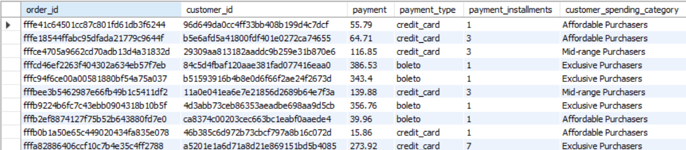

2. create external table customer_spending_segmentation(customer_spending_category string, payment_type string, customers_count int)row format delimited fields terminated by ',' location '/user/hive/warehouse/e_com/customer_spending_segmentation.txt';

insert overwrite table customer_spending_segmentation

select

customer_spending_category,

payment_type,

count(customer_id) as customers_count

from

customer_segmentation

group by

customer_spending_category,

payment_type

order by

customers_count desc;

**Exporting to client Database:**

create table customer_spending_segmentation(customer_spending_category varchar(40), payment_type varchar(40), customers_count int);

sqoop export --connect jdbc:mysql://localhost:3306/e_com --username root --password cloudera --table customer_spending_category --export-dir /user/hive/warehouse/e_com/customer_spending_category.txt/000000_0 --input-fields-terminated-by ','

**Output:**

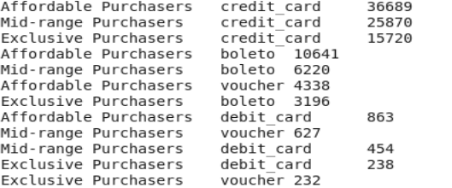

—-------------------------------------------------------------------------------------------------------------------------

**2. Monthly Trend Forecasting**

**Monthly trend of sales**

create external table monthly_sales(year int, month int, sales float)row format delimited fields terminated by ',' location '/user/hive/warehouse/e_com/monthly_sales.txt';

insert overwrite table monthly_sales

select

year(timestamp),

month(timestamp),

sum(payment)

from

ecom_data1

group by

year(timestamp),

month(timestamp);

**Exporting to client Database:**

create table monthly_sales(year int, month int, sales float);

sqoop export --connect jdbc:mysql://localhost:3306/e_com --username root --password cloudera --table monthly_sales --export-dir /user/hive/warehouse/e_com/monthly_sales.txt/000000_0 --input-fields-terminated-by ','

**output:**

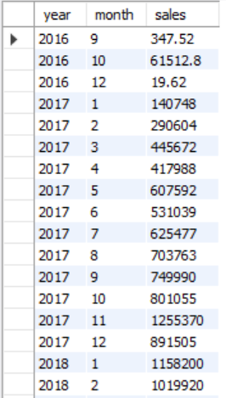

—---------------------------------------------------------------------------------------------------------------------------

**3. Hourly Sales Analysis Which hour has more no. of sales?**

create external table hourly_sales(hour int, no_of_sales int)row format delimited fields terminated by ',' location '/user/hive/warehouse/e_com/hourly_sales.txt';

insert overwrite table hourly_sales

select

hour(timestamp),

sum(quantity) as no_of_sales

from

ecom_data1

group by

hour(timestamp)

order by

no_of_sales desc limit 1;

**Exporting to client Database:**

create table hourly_sales(hour int, no_of_sales int);

sqoop export --connect jdbc:mysql://localhost:3306/e_com --username root --password cloudera --table hourly_sales --export-dir /user/hive/warehouse/e_com/hourly_sales.txt/000000_0 --input-fields-terminated-by ','

**Output:**

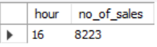

—---------------------------------------------------------------------------------------------------------------------------

**4. Product Based Analysis**

**Which category product has sold more?**

create external table product_category_sales(product_category string, sales int)row format delimited fields terminated by ',' location '/user/hive/warehouse/e_com/product_category_sales.txt';

insert overwrite table product_category_sales

select

product_category,

sum(quantity) as sales

from

ecom_data_buckets

where

order_status != 'canceled'

or order_status != 'unavailable'

group by

product_category

order by

sales desc limit 1;

**Exporting to client Database:**

create table product_category_sales(product_category varchar(60), sales int);

sqoop export --connect jdbc:mysql://localhost:3306/e_com --username root --password cloudera --table product_category_sales --export-dir /user/hive/warehouse/e_com/product_category_sales.txt/000000_0 --input-fields-terminated-by ','

**Output:**



**Which category product has more rating?**

create external table highest_rating_product(product_category string, rating float)row format delimited fields terminated by ',' location '/user/hive/warehouse/e_com/hightest_rating_prodcut.txt';

insert overwrite table highest_rating_product

select

product_category,

avg(rating) as rating

from

ecom_data_buckets

where

order_status = 'delivered'

or order_status != 'shipped'

group by

product_category

order by

sales desc limit 1;

**Exporting to client Database:**

create table highest_rating_product(product_category varchar(60), rating float);

sqoop export --connect jdbc:mysql://localhost:3306/e_com --username root --password cloudera --table highest_rating_product --export-dir /user/hive/warehouse/e_com/hightest_rating_prodcut.txt/000000_0 --input-fields-terminated-by ','

**Output:**



**Which product has sold more?**

create external table highest_sold_product(product_id string, sales_quantity int)row format delimited fields terminated by ',' location '/user/hive/warehouse/e_com/hightest_sold_product.txt';

insert overwrite table highest_sold_product

select

product_id,

sum(quantity) as sales_quantity

from

ecom_data_buckets

where

order_status = 'delivered'

or order_status = 'shipped'

group by

product_id

order by

sales_quantity desc limit 1;

**Exporting to client Database:**

create table highest_sold_product(product_id varchar(200), sales_quantity int);

sqoop export --connect jdbc:mysql://localhost:3306/e_com --username root --password cloudera --table highest_sold_product --export-dir /user/hive/warehouse/e_com/hightest_sold_prodcut.txt/000000_0 --input-fields-terminated-by ','

**Output:**

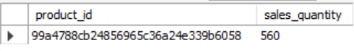

**Top 10 highest & least product rating?**

create external table top_10_rated_products(product_id string, rating float)row format delimited fields terminated by ',' location '/user/hive/warehouse/e_com/top_10_rated_products.txt';

insert overwrite table top_10_rated_products

select

product_id,

avg(rating) as rating

from

ecom_data_buckets

where

order_status = 'delivered'

or order_status = 'shipped'

group by

product_id

order by

rating desc limit 10;

**Exporting to client Database:**

create table top_10_rated_products(product_id varchar(200), rating float);

sqoop export --connect jdbc:mysql://localhost:3306/e_com --username root --password cloudera --table top_10_rated_products --export-dir /user/hive/warehouse/e_com/top_10_rated_products.txt/000000_0 --input-fields-terminated-by ','

**OUTPUT:**

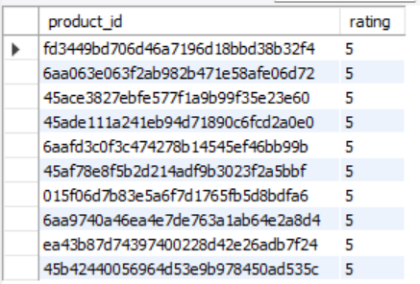

create external table least_10_rated_products(product_id string, rating float)row format delimited fields terminated by ',' location '/user/hive/warehouse/e_com/top_10_rated_products.txt';

insert overwrite table top_10_rated_products

select

product_id,

avg(rating) as rating

from

ecom_data_buckets

where

order_status = 'delivered'

or order_status = 'shipped'

group by

product_id

order by

rating limit 10;

**Exporting to client Database:**

create table least_10_rated_products(product_id varchar(200), rating float);

sqoop export --connect jdbc:mysql://localhost:3306/e_com --username root --password cloudera --table least_10_rated_products --export-dir /user/hive/warehouse/e_com/least_10_rated_products.txt/000000_0 --input-fields-terminated-by ','

**Output:**

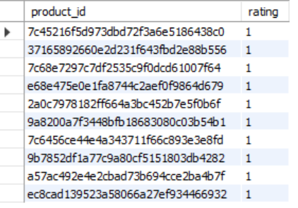

**Order Count for each rating**

create external table ratings_order_count(rating int, order_count int)row format delimited fields terminated by ',' location '/user/hive/warehouse/e_com/ratings_order_count.txt';

insert overwrite table ratings_order_count

select

rating,

count(order_id)

from

ecom_partitions

where

order_status = 'shipped'

or order_status = 'delivered'

group by

Rating;

**Exporting to client Database:**

create table ratings_order_count(rating int, order_count int);

sqoop export --connect jdbc:mysql://localhost:3306/e_com --username root --password cloudera --table ratings_order_count --export-dir /user/hive/warehouse/e_com/ratings_order_count.txt/000000_0 --input-fields-terminated-by ','

**Output:**

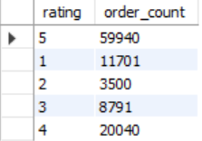

**5. Payment Preference**

**What are the most commonly used payment types?**

create external table most_common_payment_types(payment_type string, no_of_payments int)row format delimited fields terminated by ',' location '/user/hive/warehouse/e_com/most_common_payment_types.txt';

insert overwrite table most_common_payment_types

select

payment_type,

count(order_id) as no_of_payments

from

ecom_partitions

where

order_status != 'unavailable'

or order_status != 'canceled'

group by

payment_type

order by

no_of_payments desc;

**Exporting to client Database:**

create table most_common_payment_types(payment_type varchar(40), no_of_payments int);

sqoop export --connect jdbc:mysql://localhost:3306/e_com --username root --password cloudera --table most_common_payment_types --export-dir /user/hive/warehouse/e_com/most_common_payment_types.txt/000000_0 --input-fields-terminated-by ','

**Output:**

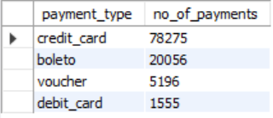

**Count of Orders With each No. of Payment Installments**

create external table payment_installment_counts(payment_installments int, no_of_orders int)row format delimited fields terminated by ',' location '/user/hive/warehouse/e_com/payment_installment_counts.txt';

insert overwrite table payment_installment

select

payment_type,

count(order_id) as no_of_payments

from

ecom_partitions

where

order_status != 'unavailable'

or order_status != 'canceled'

group by

payment_type

order by

no_of_payments desc;

**Exporting to client Database:**

create table payment_installment_counts(payment_installments int, no_of_orders int);

sqoop export --connect jdbc:mysql://localhost:3306/e_com --username root --password cloudera --table payment_installment_counts --export-dir /user/hive/warehouse/e_com/payment_installment_counts.txt/000000_0 --input-fields-terminated-by ','

**Output:**

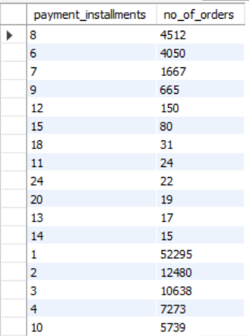

**6. Potential Customer's Location**

**Where do most customers come from?**

create external table customer_location_trends(customer_state string, no_of_customers int)row format delimited fields terminated by ',' location '/user/hive/warehouse/e_com/customer_location_trends.txt';

insert overwrite table customer_location_trends

select

customer_state,

count(customer_id) as no_of_customers

from

ecom_data1

group by

customer_state

order by

no_of_customers desc;

**Exporting to client Database:**

create table customer_location_trends(customer_state varchar(10), no_of_customers int);

sqoop export --connect jdbc:mysql://localhost:3306/e_com --username root --password cloudera --table customer_location_trends --export-dir /user/hive/warehouse/e_com/customer_location_trends.txt/000000_0 --input-fields-terminated-by ','

**Output:**

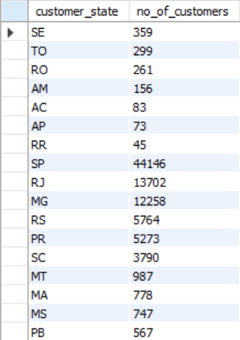

**7. Seller Rating**

**Which seller sold more?**

create external table sales_by_seller(seller_id string, sales_quantity int)row format delimited fields terminated by ',' location '/user/hive/warehouse/e_com/sales_by_seller.txt';

insert overwrite table sales_by_seller

select

seller_id,

sum(quantity) as sales_quantity

from

ecom_data1

group by

seller_id

order by

sales_quantity desc limit 1;

**Exporting to client Database:**

create table sales_by_seller(seller_id varchar(200), sales_quantity int);

sqoop export --connect jdbc:mysql://localhost:3306/e_com --username root --password cloudera --table sales_by_seller --export-dir /user/hive/warehouse/e_com/sales_by_seller.txt/000000_0 --input-fields-terminated-by ','

**Output:**



**Which seller got more rating?**

create external table ratings_by_seller(seller_id string, average_rating float)row format delimited fields terminated by ',' location '/user/hive/warehouse/e_com/ratings_by_seller.txt';

insert overwrite table ratings_by_seller

select

seller_id,

avg(rating) as average_rating

from

ecom_partitions

where

order_status = 'shipped'

or order_status = 'delivered'

group by

seller_id

order by

average_rating desc limit 1;

**Exporting to client Database:**

create table ratings_by_seller(seller_id varchar(200), average_rating float);

sqoop export --connect jdbc:mysql://localhost:3306/e_com --username root --password cloudera --table ratings_by_seller --export-dir /user/hive/warehouse/e_com/ratings_by_seller.txt/000000_0 --input-fields-terminated-by ','

**Output:**



**8. Logistics based Optimization Insights**

**Which city buys heavy weight products and low weight products?**

create external table heavy_product_weight_cities(customer_city string, sales_quantity int)row format delimited fields terminated by ',' location '/user/hive/warehouse/e_com/heavy_product_weight_cities.txt';

insert overwrite table heavy_product_weight_cities

SELECT

e1.customer_city,

sum(e1.quantity) as quantity

FROM

ecom_data1 e1

JOIN

(

SELECT

AVG(product_weight_g) AS avg_weight

FROM

ecom_data1

)

e2

WHERE

e1.product_weight_g > e2.avg_weight

group by

e1.customer_city

order by

quantity desc limit 5;

**Exporting to client Database:**

create table heavy_product_weight_cities(customer_city varchar(30), sales_quantity int);

sqoop export --connect jdbc:mysql://localhost:3306/e_com --username root --password cloudera --table heavy_product_weight_cities --export-dir /user/hive/warehouse/e_com/heavy_product_weight_cities.txt/000000_0 --input-fields-terminated-by ','

**Output:**

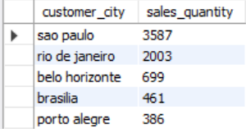

create external table least_product_weight_cities(customer_city string, sales_quantity int)row format delimited fields terminated by ',' location '/user/hive/warehouse/e_com/least_product_weight_cities.txt';

insert overwrite table lease_product_weight_cities

SELECT

e1.customer_city,

sum(e1.quantity) as quantity

FROM

ecom_data1 e1

JOIN

(

SELECT

AVG(product_weight_g) AS avg_weight

FROM

ecom_data1

)

e2

WHERE

e1.product_weight_g > e2.avg_weight

group by

e1.customer_city

order by

quantity limit 5;

**Exporting to client Database:**

create table least_product_weight_cities(customer_city varchar(30), sales_quantity int);

sqoop export --connect jdbc:mysql://localhost:3306/e_com --username root --password cloudera --table least_product_weight_cities --export-dir /user/hive/warehouse/e_com/least_product_weight_cities.txt/000000_0 --input-fields-terminated-by ','

**Output:**

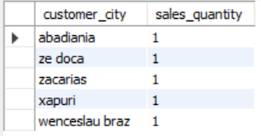

**How much products sold within seller state?**

create external table seller_state_product_sales(seller_state string, sales_quantity int)row format delimited fields terminated by ',' location '/user/hive/warehouse/e_com/seller_state_product_sales.txt';\

insert overwrite table seller_state_product_sales

select

seller_state,

sum(quantity) as sales_quantity

from

ecom_data1

group by

seller_state

order by

sales_quantity desc limit 1;

**Exporting to client Database:**

create table seller_state_product_sales(seller_state varchar(10), sales_quantity int);

sqoop export --connect jdbc:mysql://localhost:3306/e_com --username root --password cloudera --table seller_state_product_sales --export-dir /user/hive/warehouse/e_com/seller_state_product_sales.txt/000000_0 --input-fields-terminated-by ','

**Output:**



**Visualization:**

