STEPS TO SETUP JENKINS FOR DOCKER PUBLISH
- Install below plugin
  - CloudBees Docker Build and Publish pluginVersion1.4.0
- Generated Docker Personal Access Token from Docker Hub
- Create Environment Variable in Jenkin
  - 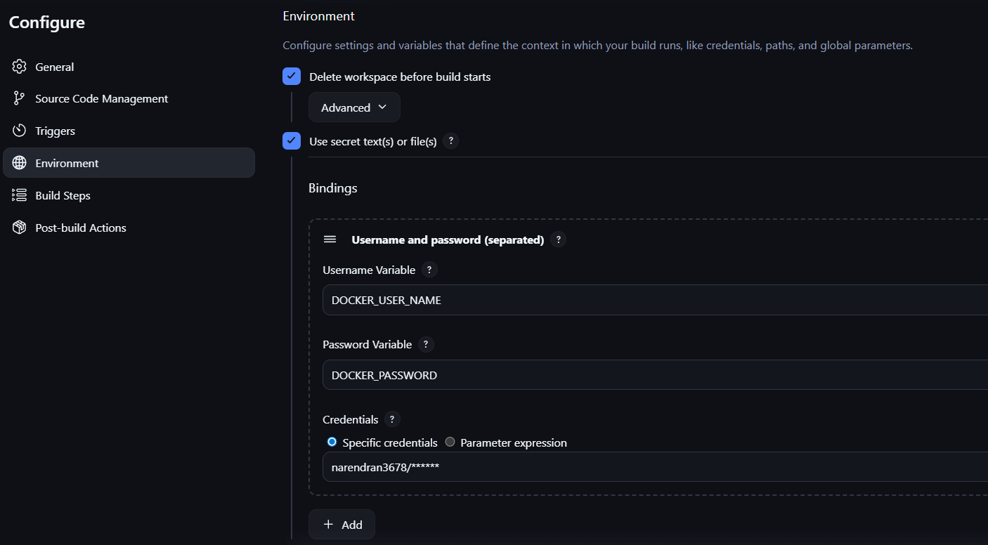
  - Command to login:
    - docker login -u %DOCKER_USER_NAME% -p %DOCKER_PASSWORD%
    - docker login -u narendran3678 -p dckr_pat_AcdI31S3eCJndmil2QzyL4bUdIc
- Configuration Setup
  - 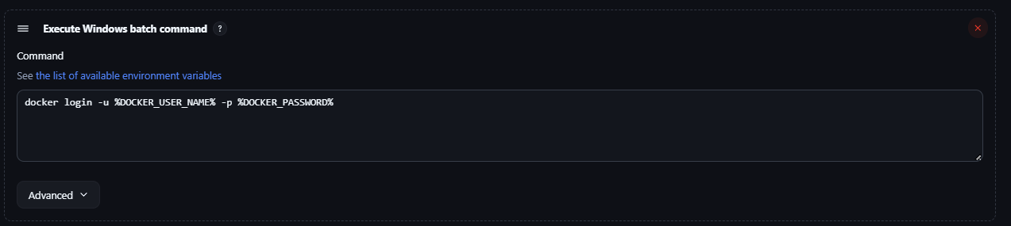
- Post Build, Add Docker publish
  - 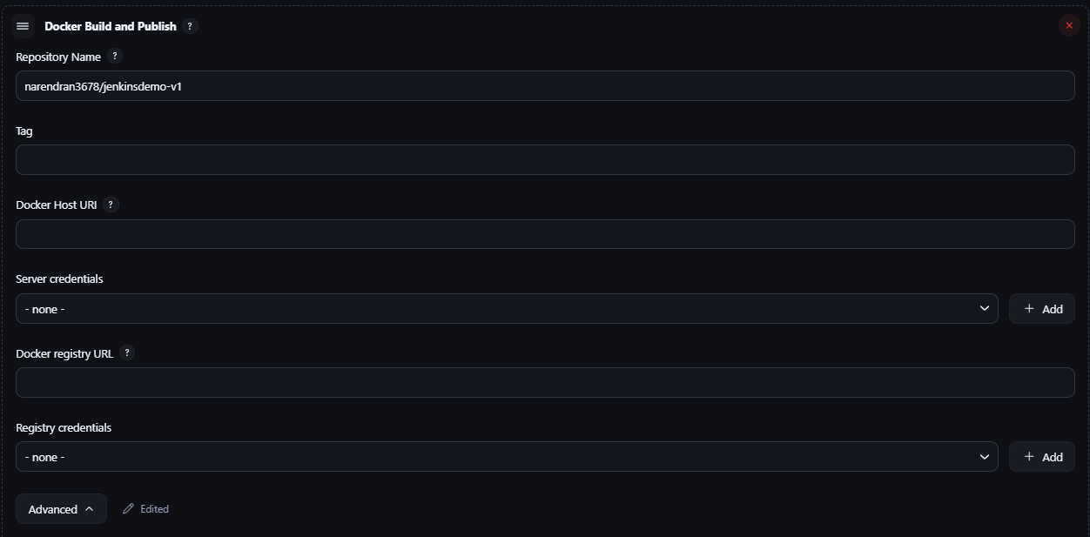

  - 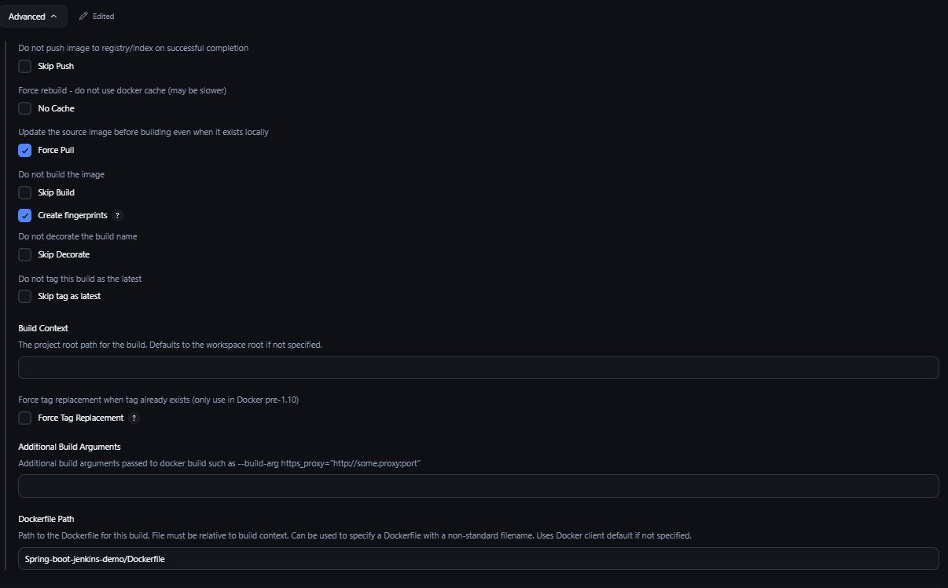

JENKINS CUSTOM PLUGIN GENERATION:
- mvn -U archetype:generate -Dfilter="io.jenkins.archetypes:"

