JENKINS

- Jenkins:
  - Jenkins is an open-source Continuous Integration server written in Java for orchestrating a chain of actions to achieve the Continuous Integration process in an automated fashion.
  - Jenkins supports the complete development life cycle of software
  - from building, testing, deploying the software.
  - 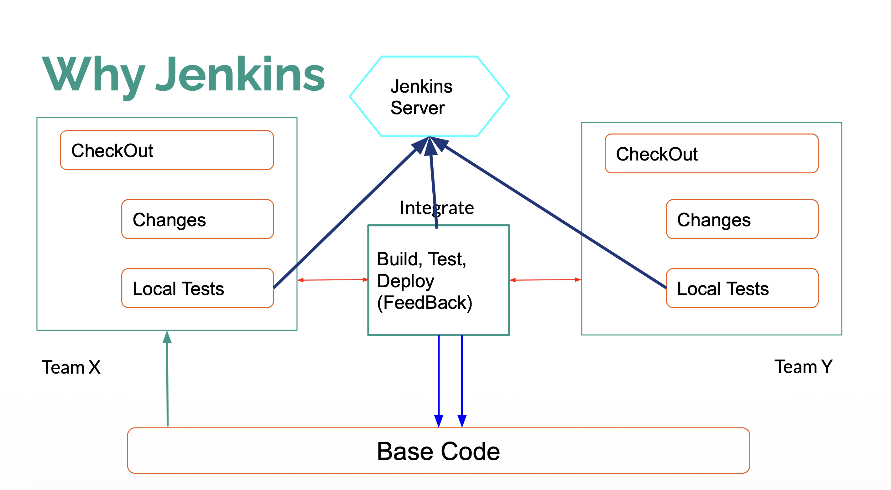
- Continuous Integration with Jenkins:
  - Code Built and Test as soon as Developer Commit the Changes.
  - Auto Deployment on Successful Software Build and Notify Stakeholders.
  - Notify Errors to Development team on Build Failure.
  - Automating Build Process saving the Delivery Time and reduce the Defects.
- Digital Ocean Virtual Server:
  - Referral Link: https://m.do.co/c/98ed549bfab5 - Sign Up to get your $200 credit.
- Jenkins Architecture:
  - 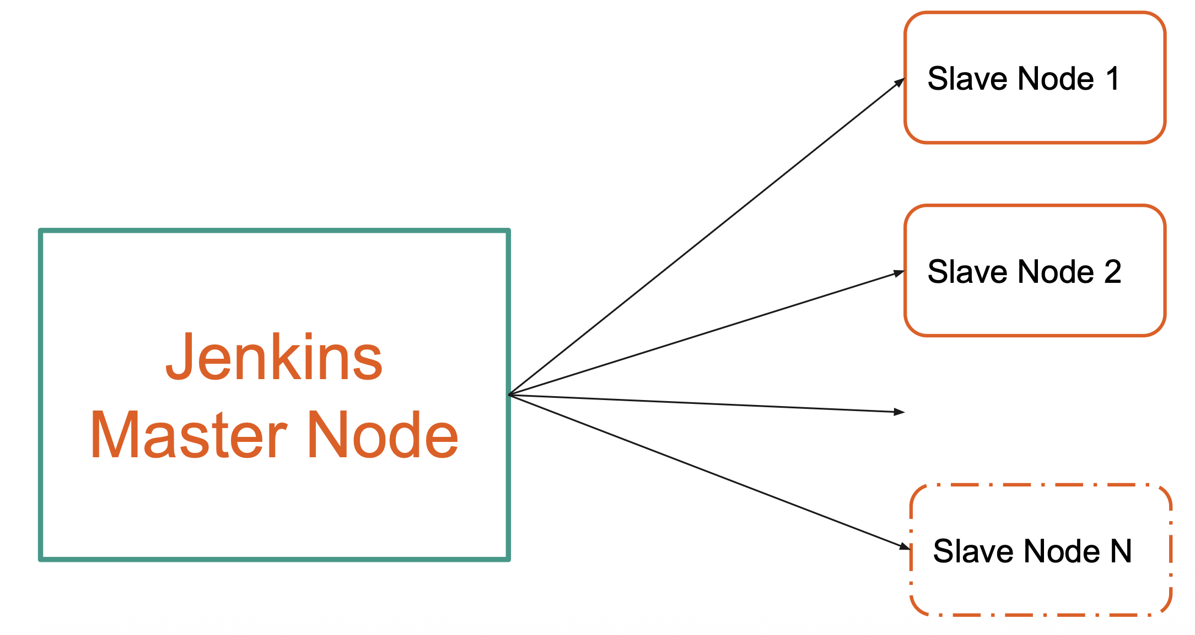
  - Jenkins follow the master slave architecture.
  - Master Node - Work like a Controller
  - Worker Node - Slave/Worker node will work as a Execution Node
  - Single Master Node can have Multiple Worker Node.
  - Master Controls the Load Distribution on Slave Nodes.

  - Master Node
    - Schedule Build Job
    - Dispatch Build Execution to Slave Node
    - Monitor Slave and Record the Build Result
  - Slave Node :
    - Execute Build dispatched by Master

- Job in Jenkins:
  - Job is runnable task that is controlled by Jenkins.
- CI and CD Automation:
  - Continuous Integration (CI) is a software development practice where team members frequently merge (integrate) their code changes into a shared repository—often several times a day. Each integration automatically triggers a build and testing process.
  - 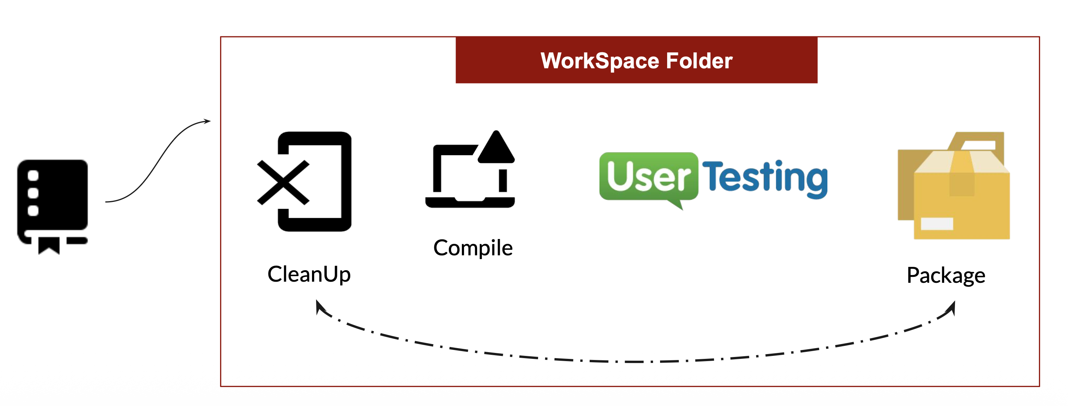
  - Sample Git : https://github.com/anshulc55/jenkins_Upgradev3.git

