**19CCE203**

**COMPUTATIONAL ELECTROMAGNETICS**

**ASSIGNMENT 1 – ERROR CONVERGENCE**

Narendran S

CB.EN. U4CCE20036

**MATLAB CODE:**

l = 10; i = 1;a = 0:20;

sinx = zeros(10,20); cosx = zeros(10,20); tanx = zeros(10,20);

angle = [0,0.5233,0.785,1.046,1.57,2.093,3.14,6.28,1.347,2.144];

while i<=l

angle1 = angle(i);

c = 1;c1 = 1;n = 0;pres = 0;prev = 0;count = 0;prev1 = 0;pres1 = 0;count1 = 0;

while n<21

term = mytermsin(n,angle1); term1 = mytermcos(n,angle1);

pres = prev + term;

c = round(pres - prev,6);

prev = pres;

pres1 = prev1 + term1;

c1 = round(pres1 - prev1,6);

prev1 = pres1;

if count1 == 0

if c1 == 0

count1 = n;

end

end

if count == 0

if c == 0

count = n;

end

end

n = n + 1;

sinx(i,n) = prev;cosx(i,n) = prev1;

end

fprintf("\n The sin of %.2f is %.8f, and convergent value if %f", angle1, prev,count);

fprintf("\n The cos of %.2f is %.8f, and convergent value is %f \n", angle1, prev1, count1);

i = i+1;

end

for i = 1:10

for n = 1:21

tanx(i,n) = sinx(i,n)/cosx(i,n); %calculating tan x (i.e) tanx = sinx/cosx

end

end

figure;%ploting first 5 terms of sin x

hold on

grid on

plot(a,sinx(1,:),'b');

plot(a,sinx(2,:),'k');

plot(a,sinx(3,:),'r');

plot(a,sinx(4,:),'m');

plot(a,sinx(5,:),'g');

xlabel('No. of terms')

ylabel('Sin Values for each x values')

title('Sinx values:')

legend('x=0','x=π/6','x=π/4','x=π/3','x=π/2')

figure;%ploting last 5 terms of sin x

hold on

grid on

plot(a,sinx(6,:),'b');

plot(a,sinx(7,:),'k');

plot(a,sinx(8,:),'r');

plot(a,sinx(9,:),'m');

plot(a,sinx(10,:),'g');

xlabel('No. of terms ')

ylabel('Sin Values for each x values')

title(' Sinx values :')

legend('x=2π/3','x=π','x=2π','x=0.429π','x=0.683π')

figure;%ploting first 5 terms of cosx

hold on

grid on

plot(a,cosx(1,:),'b');

plot(a,cosx(2,:),'k');

plot(a,cosx(3,:),'r');

plot(a,cosx(4,:),'m');

plot(a,cosx(5,:),'g');

xlabel('No. of terms ')

ylabel('Cos Values for each x values')

title(' Cosx values :')

legend('x=0','x=π/6','x=π/4','x=π/3','x=π/2')

figure;

hold on

grid on

plot(a,cosx(6,:),'b');

plot(a,cosx(7,:),'k');

plot(a,cosx(8,:),'r');

plot(a,cosx(9,:),'m');

plot(a,cosx(10,:),'g');

xlabel('No. of terms ')

ylabel('Cos Values for each x values')

title(' Cosx values:')

legend('x=2π/3','x=π','x=2π','x=0.429π','x=0.683π')

figure;%ploting first 5 terms of tan x

hold on

grid on

plot(a,tanx(1,:),'b');

plot(a,tanx(2,:),'k');

plot(a,tanx(3,:),'r');

plot(a,tanx(4,:),'m');

plot(a,tanx(5,:),'g');

xlabel('No. of terms ')

ylabel('Tan Values for each x values')

title(' Tanx values :')

legend('x=0','x=π/6','x=π/4','x=π/3','x=π/2')

figure;%ploting last 5 terms of tan x

hold on

grid on

plot(a,tanx(6,:),'b');

plot(a,tanx(7,:),'k');

plot(a,tanx(8,:),'r');

plot(a,tanx(9,:),'m');

plot(a,tanx(10,:),'g');

xlabel('No. of terms ')

ylabel('Tan Values for each x ')

title(' Tanx values :')

legend('x=2π/3','x=π','x=2π','x=0.429π','x=0.683π')

function [term] = mytermsin(n,angle) %sinx tylor series formula

term = ( ((-1)^n) / (factorial((2*n) + 1)) ) * ( angle ^ ((2*n) + 1) );

end

function [term1] = mytermcos(n,angle) %cos x tylor series formula

term1 = ( ((-1)^n) / (factorial((2*n))) ) * ( angle ^ ((2*n) ) );

end

function fact = factorial(a)

if (a <= 0)

fact = 1;

else

fact = factorial(a-1) * a;

end

end

**OUTPUT:**

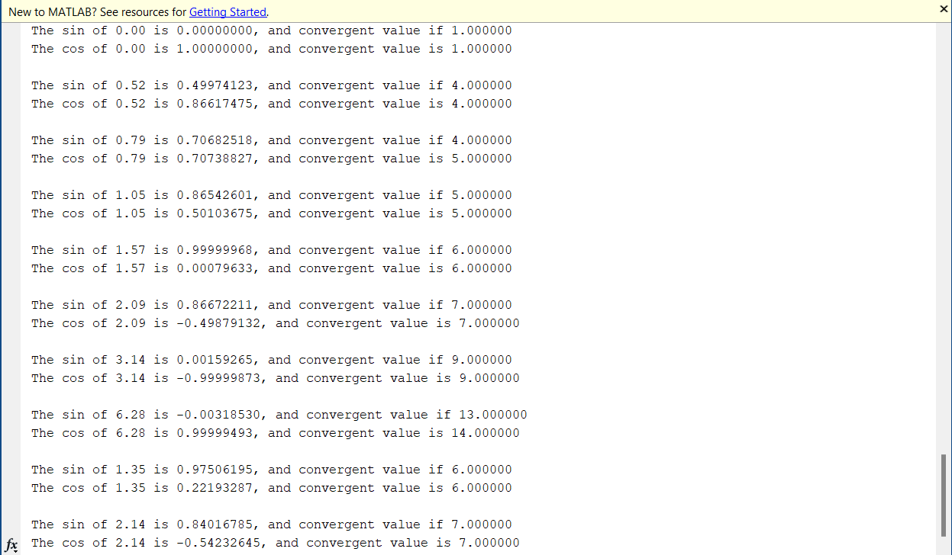

**GRAPHS:**

1. First 5 terms of sin x (0, π/6, π/4, π/3, π/2)

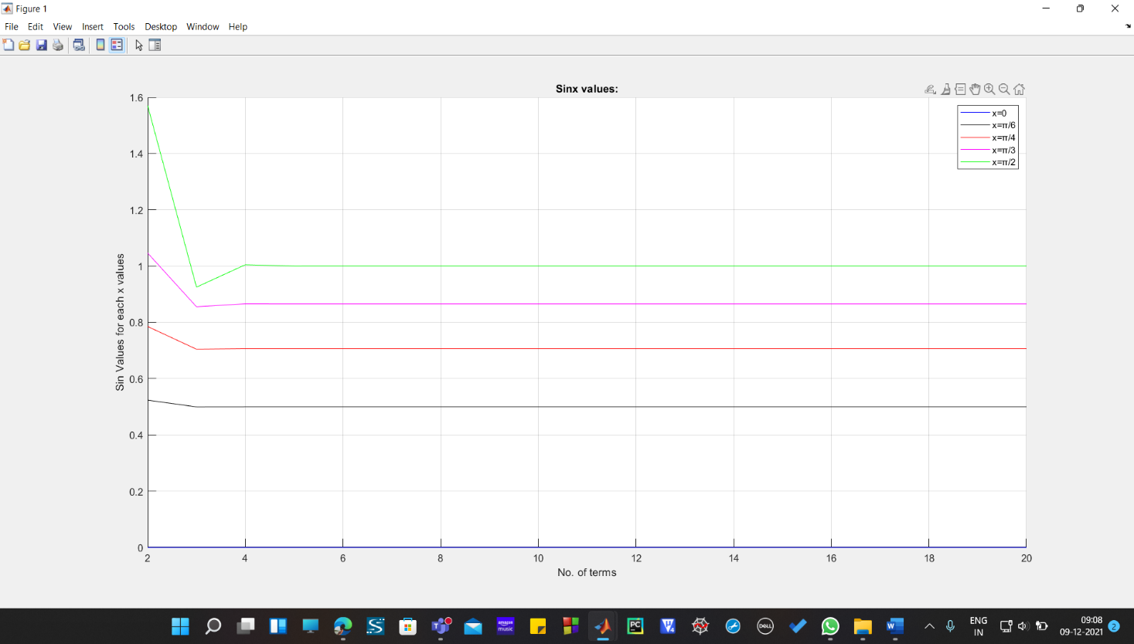

1. Last 5 terms of sin x (2π/3, π, 2π, 0.429π, 0.683π)

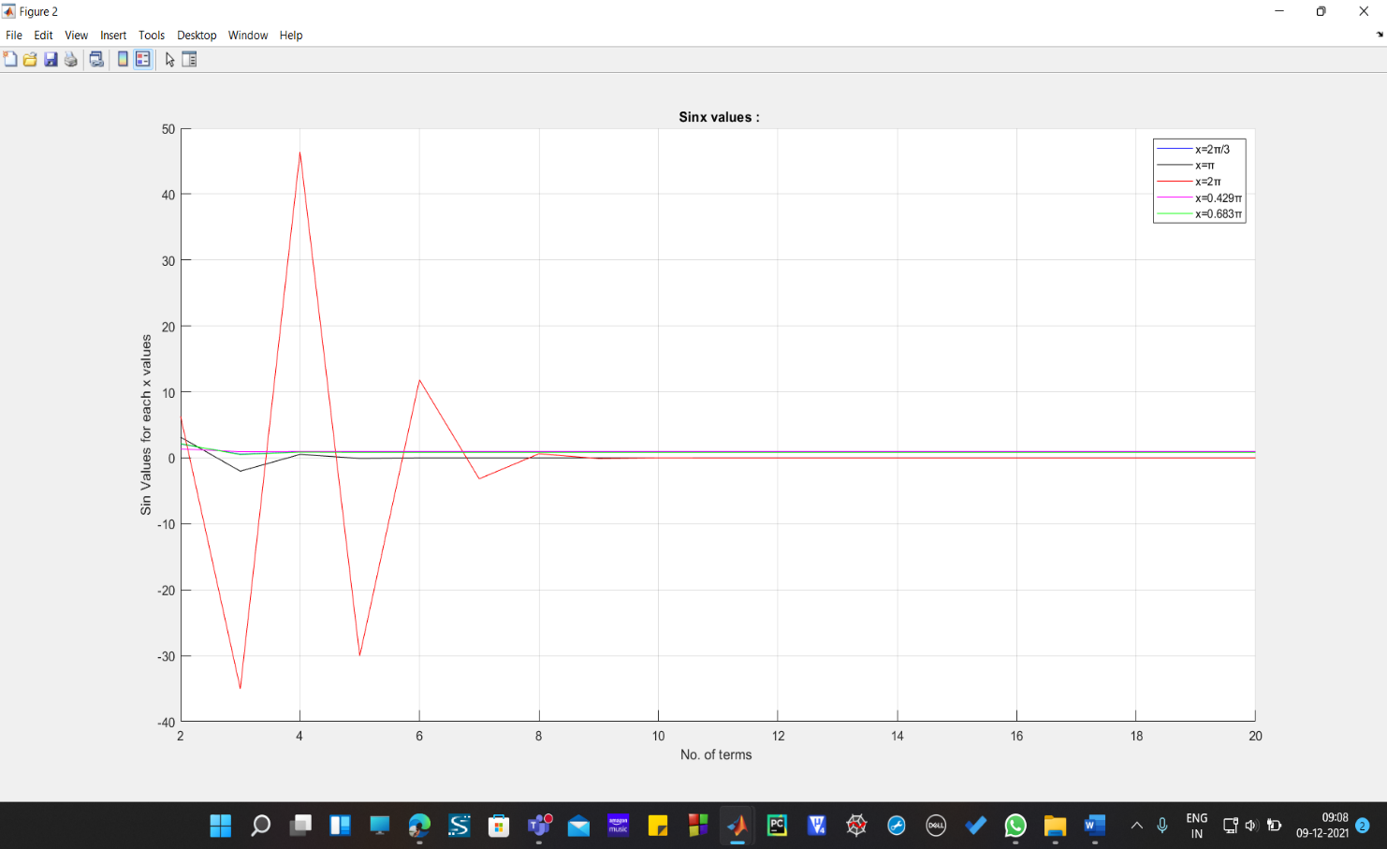

1. First 5 terms of cos x (0, π/6, π/4, π/3, π/2)

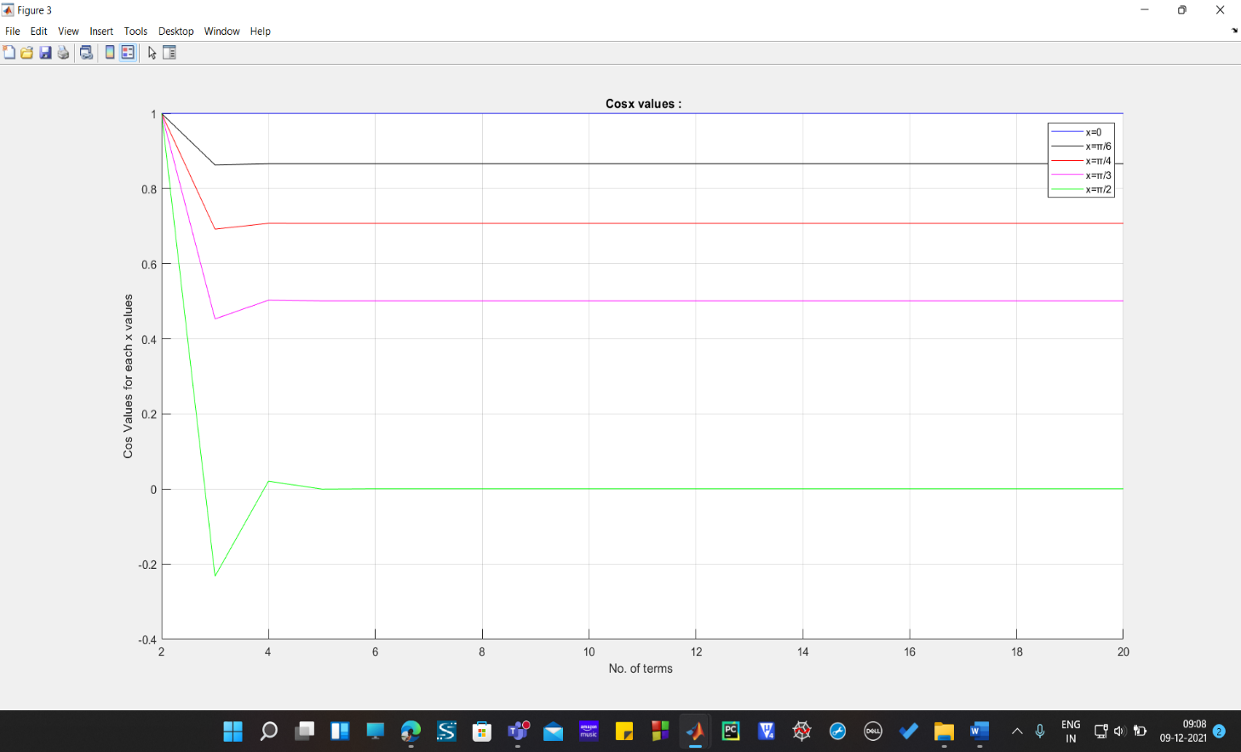

1. last 5 terms of cos x (2π/3, π, 2π, 0.429π, 0.683π)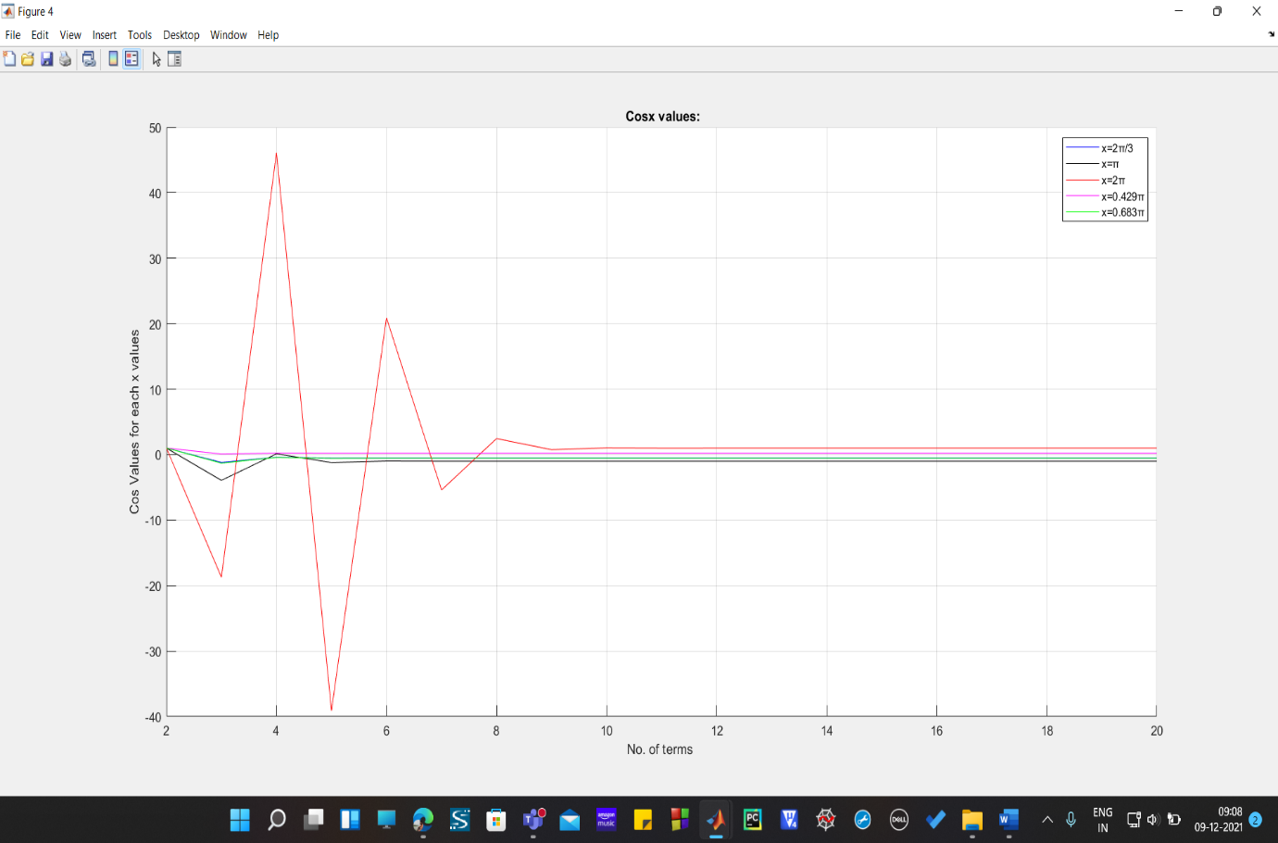
2. First 5 terms of tan x (0, π/6, π/4, π/3, π/2)

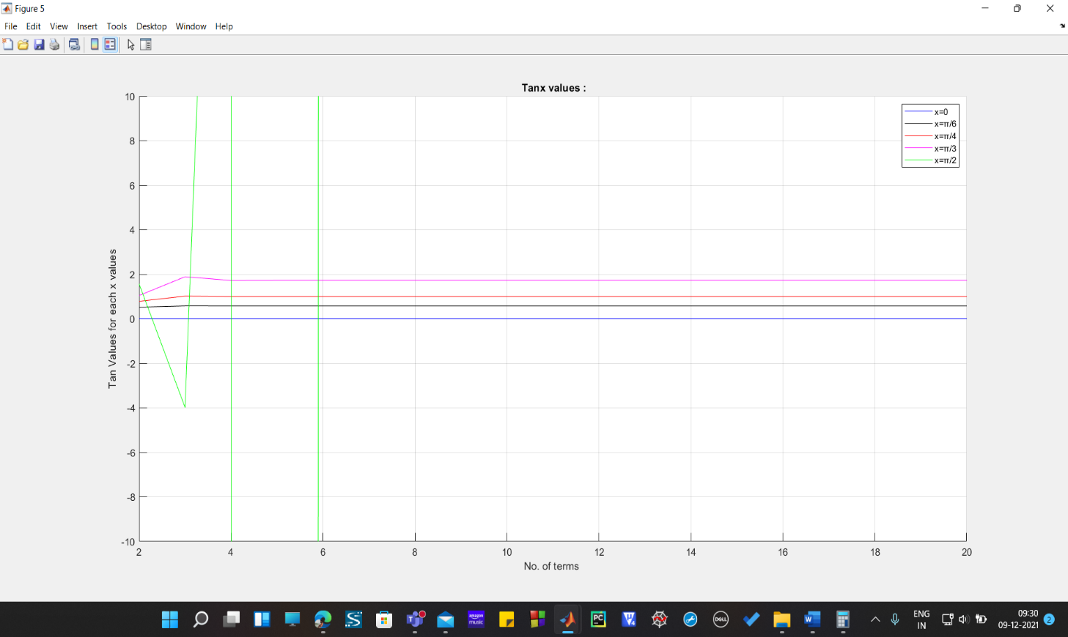

1. Last 5 terms of tan x (2π/3, π, 2π, 0.429π, 0.683π)

