**19CCE203**

**COMPUTATIONAL ELECTROMAGNETICS**

**Matlab Assignment -3**

**Trapizoidal rule, Simpson 1/3 rule and Simpson 3/8 rule**

Narendran S

CB.EN. U4CCE20036

**MATLAB CODE:**

a1 = input('enter the lower limit: ');

b1 = input('enter the upper limit: ');

a = (a1*3.14)/180;

b = (b1*3.14)/180;

axis = 1:20;

integral = 0; integral1 = 0; integral2 = 0; integral_cosx = 0; integral_cosx1 = 0; integral_cosx2 = 0; index = 1;

interval = [b,(a+b)/2,(a+b)/3,(a+b)/4,(a+b)/5,(a+b)/6,(a+b)/7,(a+b)/8,(a+b)/9,(a+b)/10,(a+b)/11,(a+b)/12,(a+b)/13,(a+b)/14,(a+b)/15,(a+b)/16,(a+b)/17,(a+b)/18,(a+b)/19,(a+b)/20,(a+b)/21,(a+b)/22,(a+b)/23,(a+b)/24,(a+b)/25,(a+b)/26,(a+b)/27,(a+b)/28,(a+b)/29,(a+b)/30];

sinx = zeros(3,20); cosx = zeros(3,20);

while index <= 20

for i = a:+interval(index):b

angle1 = i;angle2 = i+interval(index);anglemid = (angle1+angle2)/2;anglesim1 = (angle1+anglemid)/2;anglesim2 = (angle2+anglemid)/2;

for j = 0:+1:4

n = 0;new = 0;old = 0;new1 = 0;old1 = 0;

while n<20

if j == 0

term = myterm(n,angle1); term1 = myterm1(n,angle1);

elseif j == 1

term = myterm(n,angle2); term1 = myterm1(n,angle2);

elseif j == 2

term = myterm(n,anglemid); term1 = myterm1(n,anglemid);

elseif j == 3

term = myterm(n,anglesim1); term1 = myterm1(n,anglesim1);

elseif j == 4

term = myterm(n,anglesim2); term1 = myterm1(n,anglesim2);

end

new = old + term; old = new;

new1 = old1 + term1; old1 = new1;

n = n + 1;

end

if j == 0

temp1 = old;flag1 = old1;

elseif j == 1

temp2 = old;flag2 = old1;

elseif j == 2

tempmid = old;flagmid = old1;

elseif j == 3

tempsim1 = old;flagsim1 = old1;

elseif j == 4

tempsim2 = old; flagsim2 = old1;

end

end

temp = ((temp1+temp2)/2)*(angle2-angle1); %trapizoidal rule

integral = integral + temp;

sinx(1,index) = integral;

tempsim = ((temp1+ (4*tempmid) +temp2)/3)*((angle2-angle1)/2); %simson 1/3 rule

integral1 = integral1 + tempsim;

sinx(2,index) = integral1;

tempsim2 = ((temp1 + (3*tempsim1) + (3*tempsim2) + temp2)/4)*((angle2-angle1)/2);

integral2 = integral2 + tempsim2; %simson 3/8 rule

sinx(3,index) = integral2;

flag = ((flag1+flag2)/2)*(angle2-angle1); %trapizoidal rule

integral_cosx = integral_cosx + flag;

cosx(1,index) = integral_cosx;

flagsim = ((flag1+ (4*flagmid) +flag2)/3)*((angle2-angle1)/2); %simson 1/3 rule

integral_cosx1 = integral_cosx1 + flagsim;

cosx(2,index) = integral_cosx1;

flagsimpson2 = ((flag1 + (3*flagsim1) + (3*flagsim2) + flag2)/4)*((angle2-angle1)/2);

integral_cosx2 = integral_cosx2 + flagsimpson2; %simson 3/8 rule

cosx(3,index) = integral_cosx2;

end

fprintf('integral sinx value is %.3f with interval %d using trapizoidal rule\n', integral, index);

fprintf('integral sinx value is %.3f with interval %d using simpson 1/3 rule\n', integral1, index);

fprintf('integral sinx value is %.3f with interval %d using simpson 3/8 rule\n', integral2, index);

fprintf('integral cosx value is %.3f with interval %d using trapizoidal rule\n', integral_cosx, index);

fprintf('integral cosx value is %.3f with interval %d using simpson 1/3 rule\n', integral_cosx1, index);

fprintf('integral cosx value is %.3f with interval %d using simpson 3/8 rule\n\n', integral_cosx2, index);

index = index + 1;

integral = 0;integral1 = 0; integral2 = 0; integral_cosx = 0; integral_cosx1 = 0; integral_cosx2 = 0;

end

figure;

grid on

plot(axis,sinx(1,:));

xlabel('No. of terms')

ylabel('integral Sin x Values ')

title('Sinx integral trapizoidal rule:')

figure;

grid on

plot(axis,sinx(2,:));

xlabel('No. of terms')

ylabel('integral Sin x Values ')

title('Sinx integral using simpson 1/3 rule:')

figure;

grid on

plot(axis,sinx(3,:));

xlabel('No. of terms')

ylabel('integral Sin x Values ')

title('Sinx integral using simpson 3/8 rule:')

figure;

grid on

plot(axis,cosx(1,:));

xlabel('No. of terms')

ylabel('integral cos x Values ')

title('cosx integral trapizoidal rule:')

figure;

grid on

plot(axis,cosx(2,:));

xlabel('No. of terms')

ylabel('integral cos x Values ')

title('cosx values simpson 1/3 rule:')

figure;

grid on

plot(axis,cosx(3,:));

xlabel('No. of terms')

ylabel('integral cos x Values ')

title('cosx values simpson 3/8 rule:')

function [term] = myterm(n,angle)

term = ( ((-1)^n) / (factorial((2*n) + 1)) ) * ( angle ^ ((2*n) + 1) );

end

function [term1] = myterm1(n,angle)

term1 = ( ((-1)^n) / (factorial((2*n))) ) * ( angle ^ ((2*n)) );

end

function fact = factorial(a)

if (a <= 0)

fact = 1;

else

fact = factorial(a-1) * a;

end

end

**OUTPUT:**

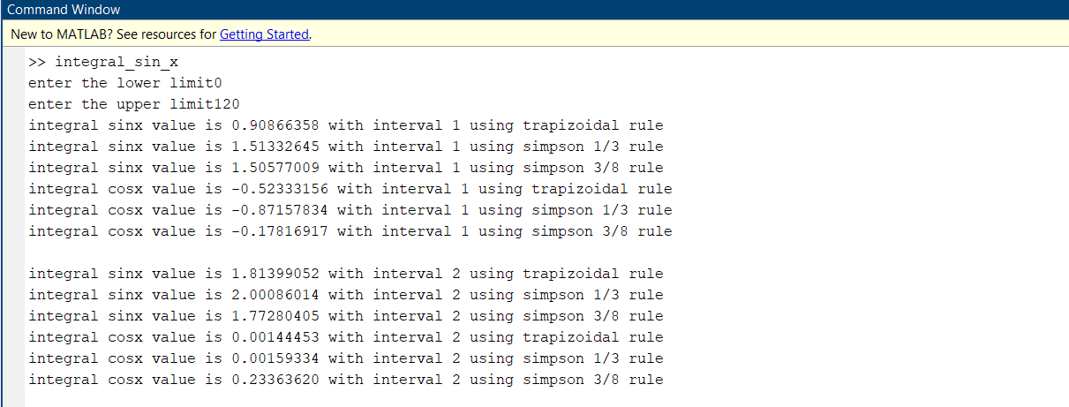

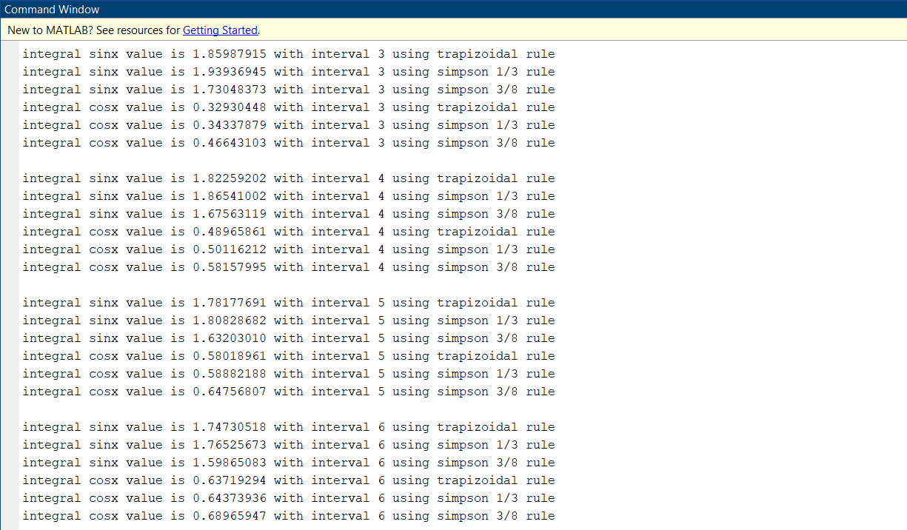

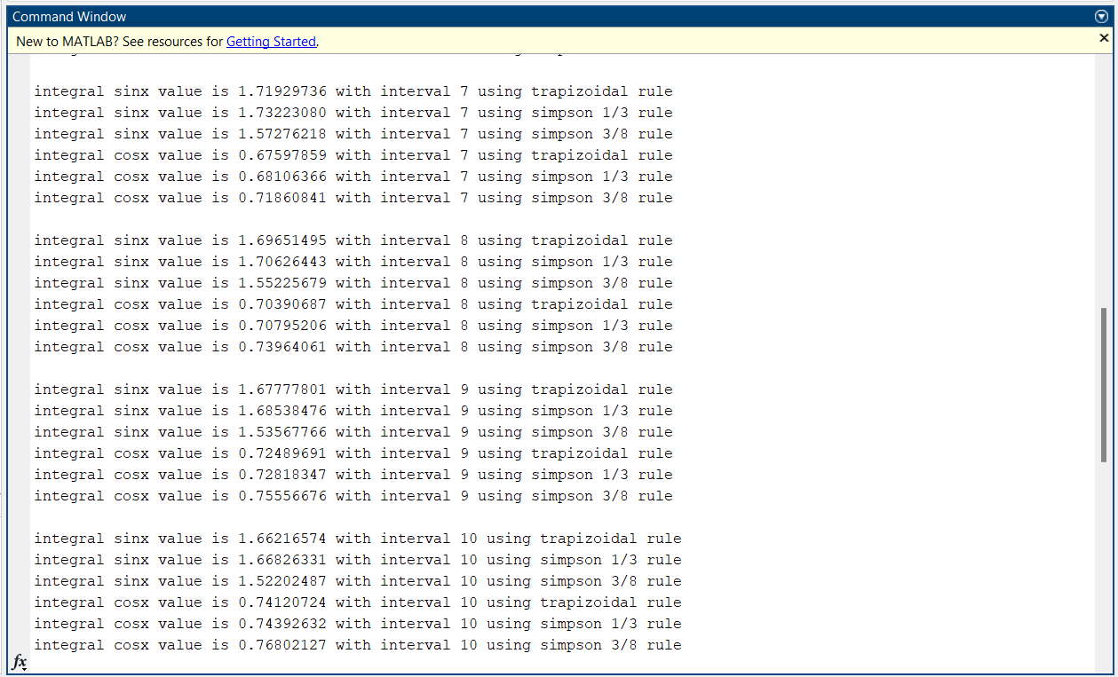

**GRAPHS:**

Integral sinx using trapizoidal rule:

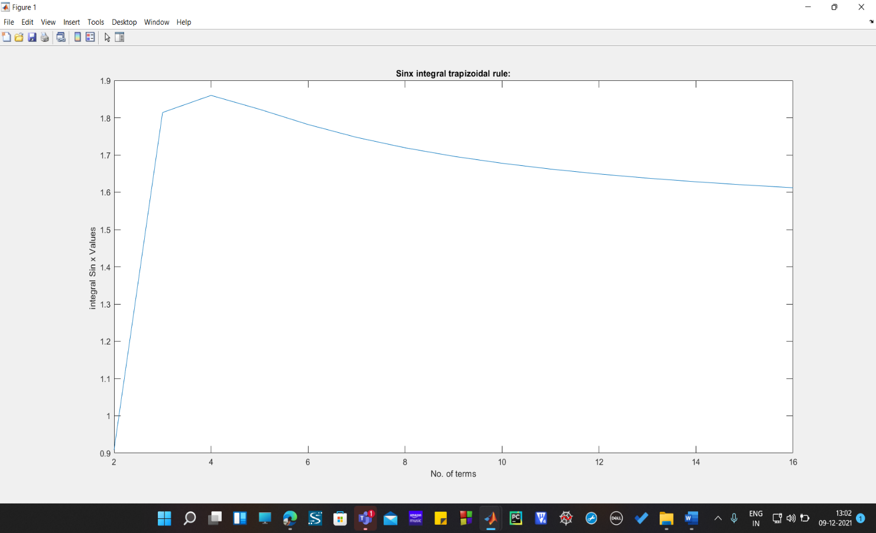

Integral sinx using simson 1/3 rule:

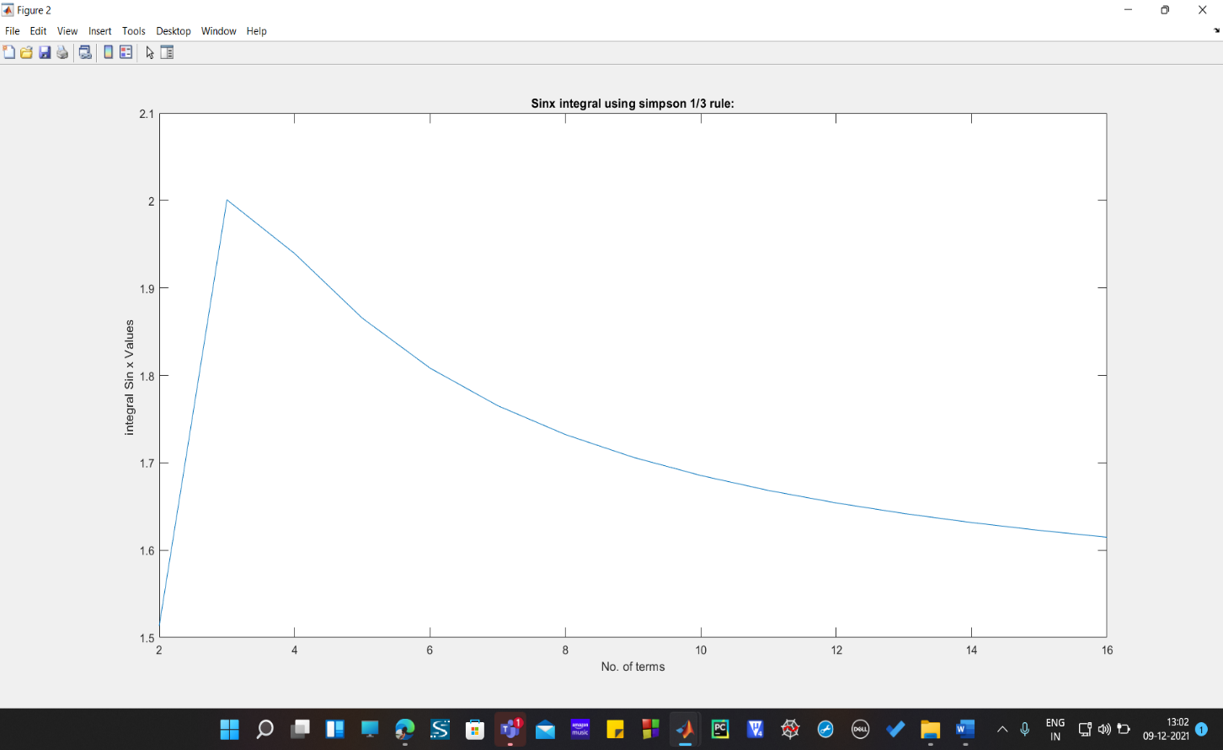

Integral sinx using simson 3/8 rule:

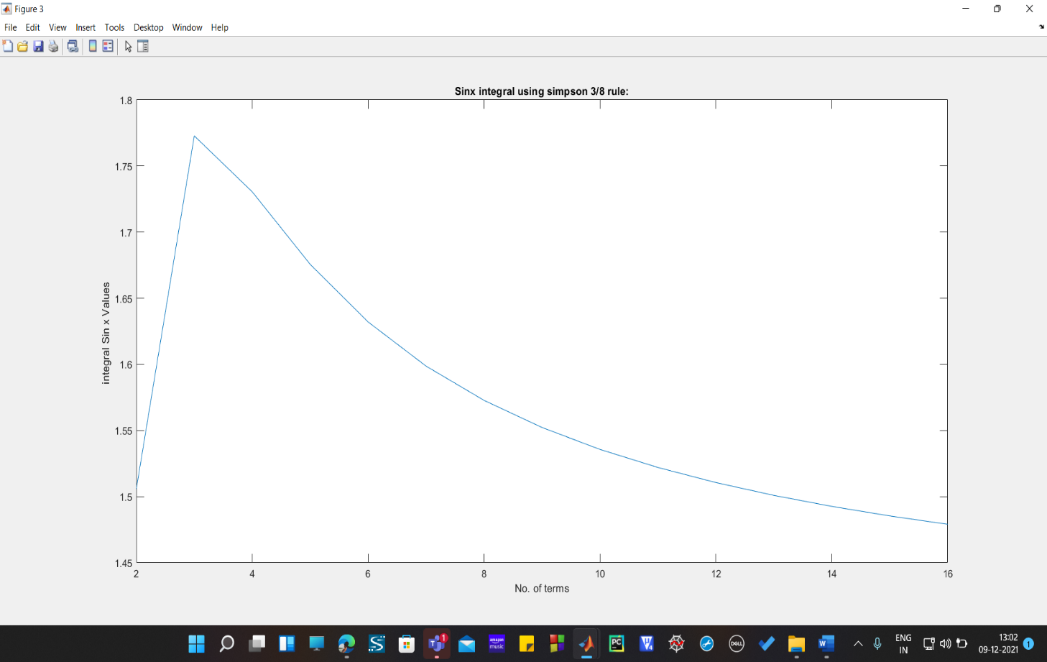

Integral cosx using trapizoidal rule: 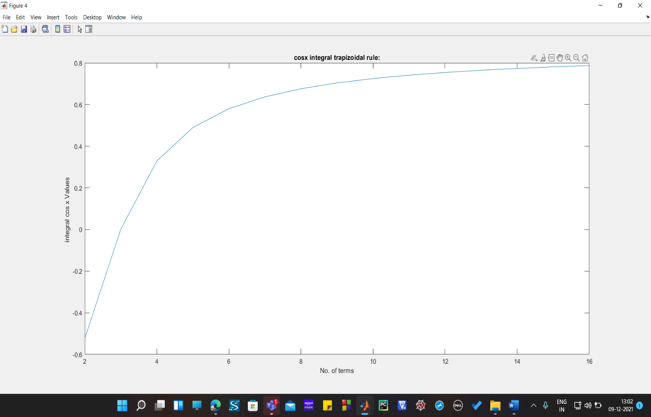

Integral cosx using simson 1/3 rule: 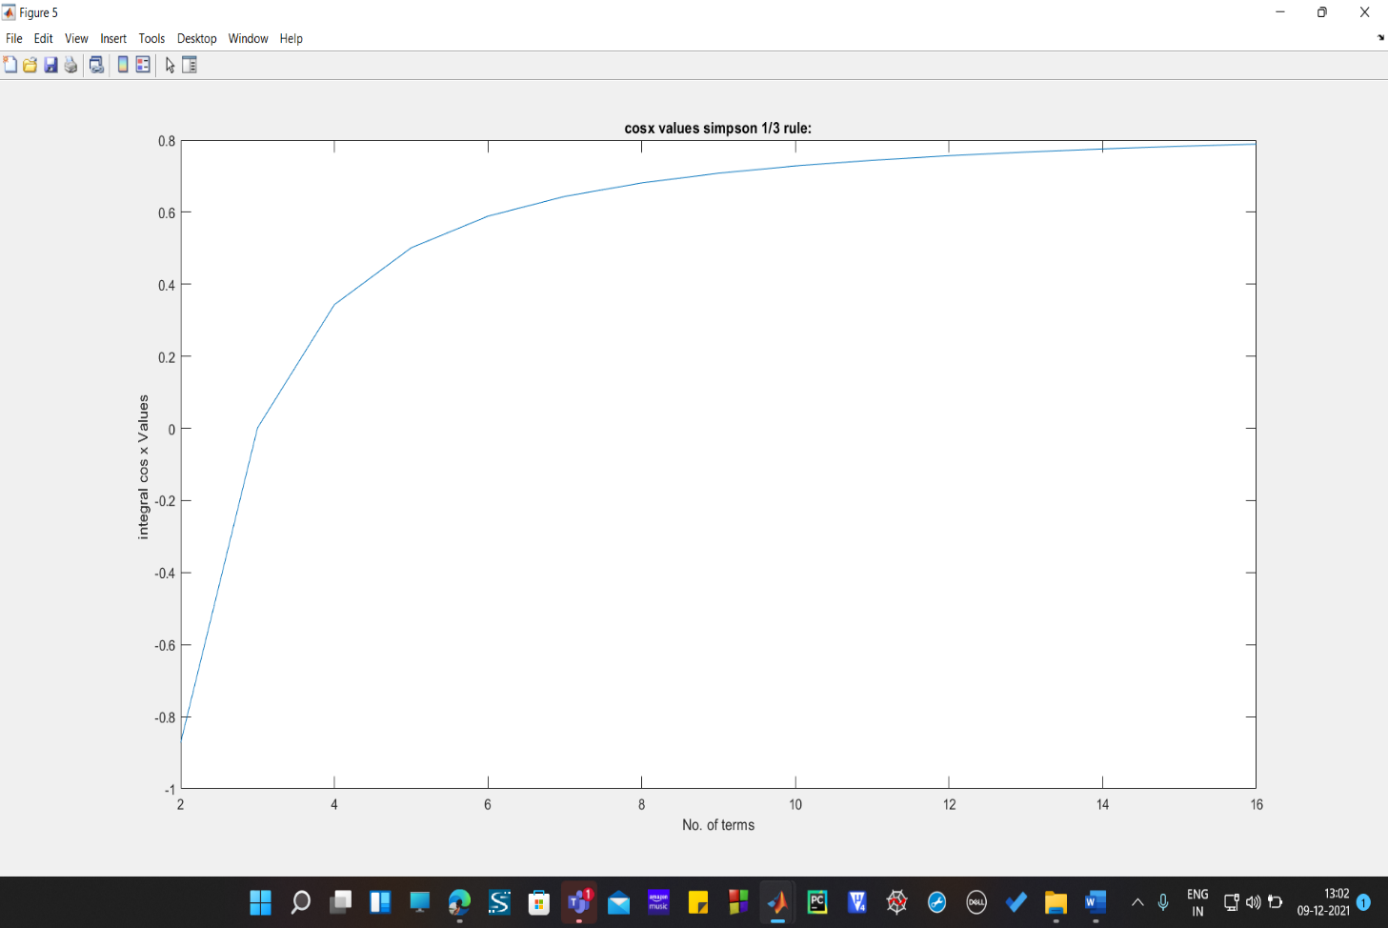

Integral cosx using simson 3/8 rule:

