Bank Marketing Funnel Analysis
Analytics Project Report
Prepared by: Narendra Kumar
Tools used: Python (pandas), Power BI, DAX
Dataset: UCI Bank Marketing (bank-full.csv, 45,211 records)

1. Executive Summary
A Portuguese bank ran a telemarketing campaign to sell term deposits to its customers. This project analyses 45,211 calls to understand where customers drop off in the funnel, which channels and customer segments convert best, and what the bank should do to improve results.
The overall conversion rate is 11.7%. The biggest single opportunity is re-contacting customers who said yes in a previous campaign, since they convert at 64.7% — more than five times the average.
Total Calls  45,211 | Converted  5,289 | Conversion Rate  11.7% | Engaged Rate  89.5% | Warm Lead Rate  64.7%

2. Problem Statement
The bank does not know:
- Where customers drop off between being contacted and making a deposit
- Which contact channel brings the highest-quality leads
- Which months and customer segments convert best
- Whether repeated call attempts help or hurt conversion
The goal of this project is to answer these questions using the call data and recommend concrete actions to improve conversion.

3. Data Source
The dataset is the UCI Bank Marketing dataset. Two files were provided: bank.csv (a 4,521-row sample, used only for quick testing) and bank-full.csv (all 45,211 records, used for the actual analysis). The data has 17 columns covering customer demographics, loan status, and details of the marketing calls.

Key columns
Column | Meaning
age, job, marital, education | Customer demographics
housing, loan, default | Existing loans / credit status
contact, month, day, duration | Details of the last call in this campaign
campaign | Number of times contacted in this campaign
pdays, previous, poutcome | Details of the previous campaign
y | Target: did the customer subscribe? (yes/no)

4. Methodology
- Cleaned the data in Python (pandas): converted y to a 1/0 converted flag, ordered months chronologically, and kept "unknown" values as their own category instead of dropping them.
- Built a three-stage funnel: Contacted → Engaged (call longer than 60 seconds) → Converted.
- Compared conversion rate across channel, month, job, marital status, housing loan, number of attempts, and previous campaign outcome.
- Imported the cleaned data into Power BI and built DAX measures for Total Calls, Converted Customers, Conversion Rate %, Engaged Rate %, and Warm Lead Conversion %.
- Built an interactive Power BI dashboard across two pages with slicers for month, job, contact, poutcome, and number of attempts.

5. Funnel Analysis
Stage | Customers | % of Contacted | Drop-off
Contacted | 45,211 | 100% | —
Engaged (>60s) | 40,445 | 89.5% | 10.5%
Converted | 5,289 | 11.7% | 86.9%
Almost 9 in 10 calls are long enough to count as "engaged", but only 1 in 10 of all calls converts. This means the biggest drop-off happens after the call connects, not during the opening — the pitch itself needs improvement, not the greeting.

6. Key Findings

6.1 Channel
Channel | Calls | Conversion Rate
cellular | 29,285 | 14.9%
telephone | 2,906 | 13.4%
unknown | 13,020 | 4.1%
Cellular is the best-performing channel. Calls with an unrecorded channel convert four times worse, which may partly reflect a data-quality gap rather than a true difference in channel effectiveness.

6.2 Month
Month | Conversion Rate | Calls
March | 52.0% | 477
September | 46.5% | 579
December | 46.7% | 214
October | 43.8% | 738
May | 6.7% | 13,766
May alone accounts for 30% of all calls but converts at only 6.7%, while March, September, October and December convert at 40–52% on much smaller volumes. This is the clearest sign of a resource-allocation problem in the campaign.

6.3 Customer segment
Segment | Best | Worst
Job | Student — 28.7% | Blue-collar — 7.3%
Marital status | Single — 14.9% | Married — 10.1%
Housing loan | No loan — 16.7% | Has loan — 7.7%

6.4 Repeated attempts
Attempts | Conversion Rate
1 | 14.6%
2 | 11.2%
3 | 11.2%
4–5 | 8.6%
6–10 | 6.5%
10+ | 3.9%
Conversion falls steadily with each additional attempt. Calling the same customer more than 5 times rarely pays off.

6.5 Previous campaign outcome
Previous Outcome | Conversion Rate
Success | 64.7%
Other | 16.7%
Failure | 12.6%
Unknown | 9.2%
This is the single strongest predictor in the dataset. Customers who said yes before are far more likely to say yes again.

7. Power BI Dashboard
The dashboard has two pages. Page 1 covers the funnel, channel, month, and top job segments. Page 2 covers marital status, housing loan, number of attempts, and previous campaign outcome.

Page 1: Overview, Channel & Time
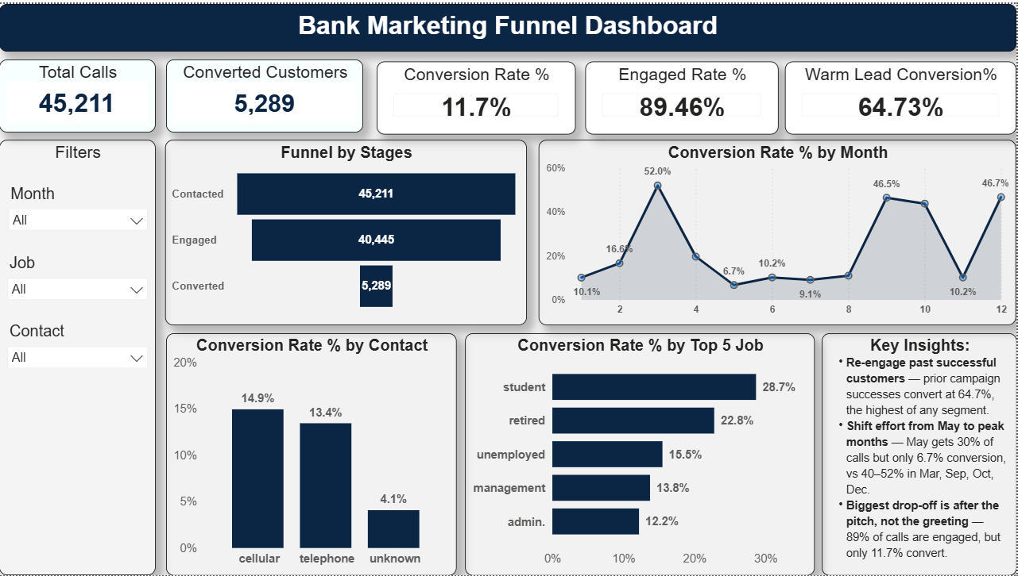

Page 2: Segments & Effort
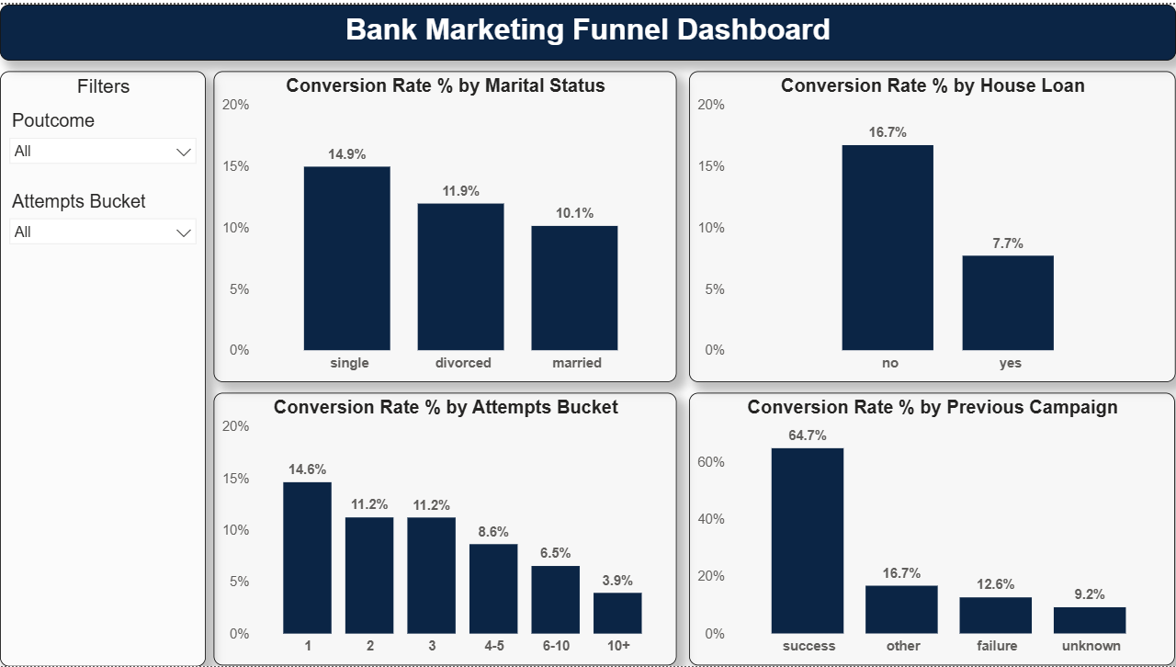

8. Recommendations
- Re-contact customers with a successful previous campaign outcome first — they convert at 64.7%, the highest of any segment.
- Shift call volume away from May (6.7% conversion on 30% of all calls) toward March, September, October and December (40–52% conversion).
- Prioritise the cellular channel and start recording the channel for every call, since 29% of calls currently have no channel recorded.
- Cap outreach at 3–5 attempts per customer — conversion falls steadily beyond that point.
- De-prioritise customers who already hold a housing loan (7.7% conversion vs 16.7% for those without one).
- Review and strengthen the sales pitch used after the call connects, since 89% of calls are engaged but only 11.7% convert — the drop-off happens after the greeting, not during it.

9. Conclusion
The campaign's overall 11.7% conversion rate hides large, addressable differences by month, channel, and customer history. Re-engaging past successful customers and reallocating effort away from low-converting months like May are the two highest-leverage, lowest-cost changes the bank can make. Longer-term, capturing channel data consistently and revisiting the call script would close the remaining gaps identified in this analysis.

