**Noise Classification**

1. Run main.m file by typing main in command window (figure 1).

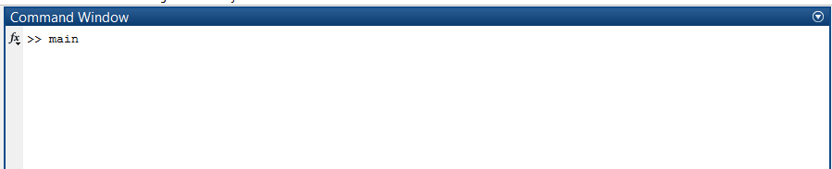

figure 1

2. Select anyone out of four classifier(figure 2)

a) Neural Network Classifier

b) K Nearest Neighbor Classifier

c) Support Vector Machine Classifier

d) Gaussian Mixture Model Classifier.

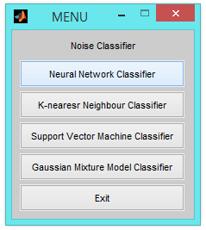

figure 2

3. After selecting appropriate classifier, select option 1 'choose Dataset' (figure 3) then choose anyone dataset out of four dataset from the next dialogue box (figure 4) and then press Exit (figure 5).

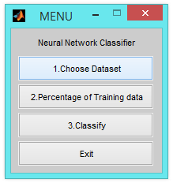 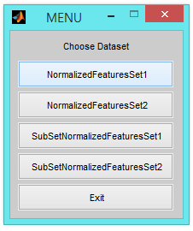

figure 3 figure 4

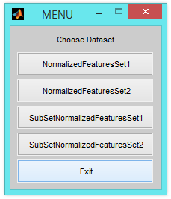

figure 5

4. Press option 2 'percentage of training data ' (figure 6) then enter percentage value in command window (e.g. 70% then type 0.7) (figure 7).

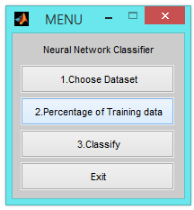

figure 6

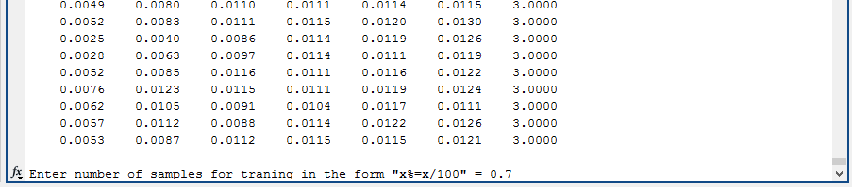

figure 7

5. Select option 3 ' Classify ' (figure 8) then classifier output (Confusion Matrix and Error ) will be display on command window screen (figure 9).

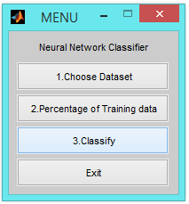

figure 8

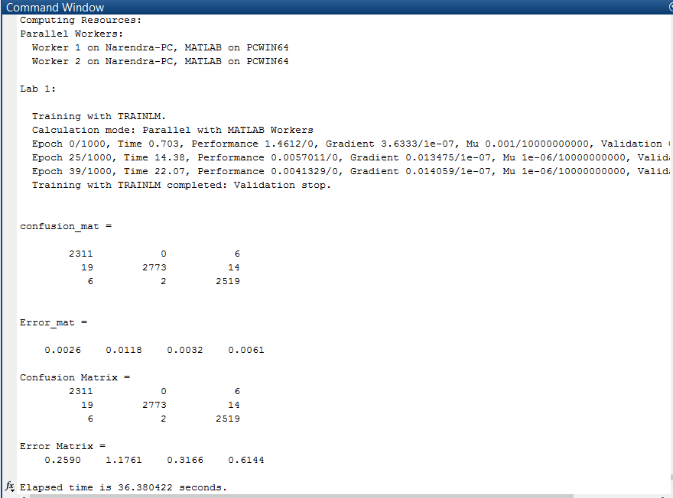

figure 9

6. Press Exit (figure 10) for return to main menu (figure 1).

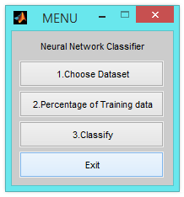

figure 10