TELECOM CUSTOMER CHURN PREDICTION
A Industrial/Practical Training project report

Submitted to the Faculty of Engineering of
JAWAHARLAL NEHRU TECHNOLOGICAL UNIVERSITY KAKINADA,
KAKINADA

In partial fulfillment of the requirements for the award of the Degree of

BACHELOR OF TECHNOLOGY
In
COMPUTER SCIENCE AND ENGINEERING

By

M.MANASA M.NARENDRA REDDY
(16481A05D6) (16481A05C4)

M.LEELA SAHITHI P.YASWANTH KUMAR
(16481A05C0) (16485A05H6)

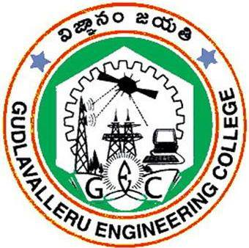

DEPARTMENT OF COMPUTER SCIENCE AND ENGINEERING

GUDLAVALLERUENGINEERINGCOLLEGE
(An Autonomous Institute with Permanent Affiliation to JNTUK, Kakinada)
SESHADRIRAOKNOWLEDGEVILLAGE
GUDLAVALLERU – 521356
ANDHRA PRADESH
2019-2020

GUDLAVALLERU ENGINEERING COLLEGE
(An Autonomous Institute with Permanent affiliation to JNTUK, Kakinada)

SESHADRIRAO KNOWLEDGE VILLAGE::GUDLAVALLERU

DEPARTMENT OF
COMPUTER SCIENCE AND ENGINEERING


certificate

This is to certify that the Industrial/Practical Training project Report entitled “TELECOM CUSTOMER CHURN PREDICTION” is a bonafide record of work carried out by M.MANASA, M.NARENDRA REDDY, M.LEELA SAHITHI and P.YASWANTH KUMAR in partial fulfillment of the requirements for the award of the degree of Bachelor of Technology in Computer Science and Engineering of Jawaharlal Nehru Technological University Kakinada, Kakinada during the academic year 2019-2020.

SK.SALMA BEGUM
(Industrial/Practical Training Coordinator)

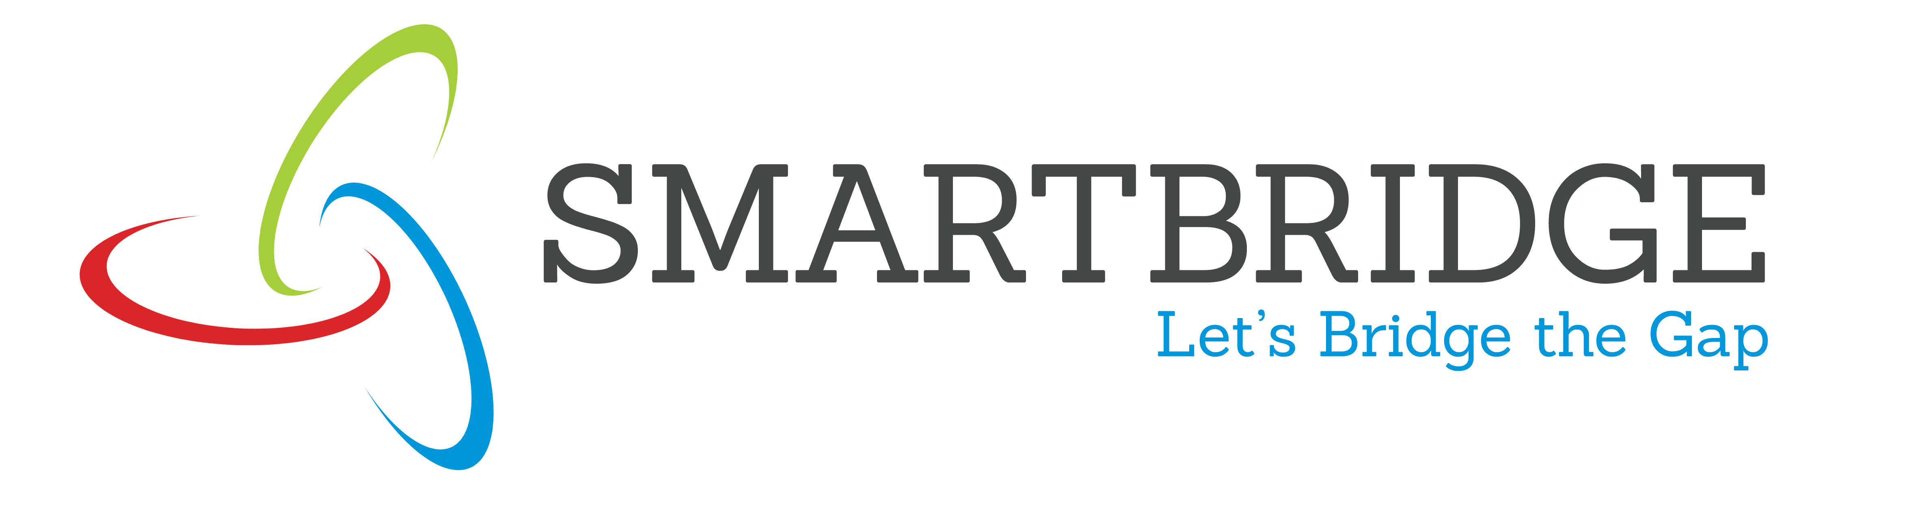
INTERNSHIP REPORT APPROVAL FORM

May 24, 2019

With immense pleasure, this is to approve that the students of Gudlavalleru Engineering College i.e,

Manasa Morla(16481A05D6),
Narendra Reddy Mangunuru(16481A05C4),
Leela Sahithi Maddula(16481A05C0) and
Yaswanth Kumar Pirati(16481A05H6)

successfully completed their Project and Project Report on “Loan Risk Prediction” under our guidance.
We are highly impressed with the work that they have done and commend them on their quick grasping skills. They have shown good intent to learn and have put the knowledge gained into application in the from of this project. We appreciate the hard work and commitment shown by them.
We, hereby approve that this document is completely checked and accepted by SmartBridge Technical Team. Its been an absolute pleasure to educate and mentor these students. We hope that this document will also serve as a Letter of Recommendation, to whomsover applied.

We wish them success in all future endeavors and a great career ahead.

Mahankali Surya Tej
AI and IOT Developer

ACKNOWLEDGEMENT

The satisfaction that accompanies the successful completion of any task would be incomplete without the mention of people who made it possible and whose constant guidance and encouragements crown all the efforts with success.

We feel elated to express our floral gratitude and sincere thanks to Dr.S.Narayana, Head of the Department, Computer Science and Engineering for his encouragements all the way during analysis of the project. His annotations, insinuations and criticisms are the key behind the successful completion of the project work.

We would like to take this opportunity to thank our beloved principal Dr.P.Ravindra Babufor providing a great support for us in completing our project and giving us the opportunity for doing project.

We would like to take this opportunity to thank Smart Bridge Educational Services PVT Ltd. for providing this training program and support for us in completing our project.

Our Special thanks to the faculty of our department and programmers of our computer lab. Finally, we thank our family members, non-teaching staff, attendants and our friends, who had directly or indirectly helped and supported us in completing our project in time.

Team members
M.Manasa (16481A05D6)
M.Narendra Reddy (16481A05C4)
M.Leela Sahithi (16481A05C0)
P.Yaswanth Kumar(16485A05H6)

ABSTRACT
With the rapid development of telecommunication industry, the service providers are inclined more towards expansion of the subscriber base. To meet the need of surviving in the competitive environment, the retention of existing customers has become a huge challenge. In the survey done in the Telecom industry, it is stated that the cost of acquiring a new customer is far more that retaining the existing one. Therefore, by collecting knowledge from the telecom industries can help in predicting the association of the customers as whether or not they will leave the company. The required action needs to be undertaken by the telecom industries in order to initiate the acquisition of their associated customers for making their market value stagnant. Our paper proposes a new framework for the churn prediction model. The efficiency and the performance of Decision tree and Random forest techniques have been compared.

INDEX
TITLE PAGE NO
ABSTRACT 1
CHAPTER 1: TITLE OF THE PROJECT 1
  - INTRODUCTION 1
  - OBJECTIVES OF RESEARCH 1
  - PROBLEM STATEMENT 1
CHAPTER 2: REVIEW OF LITERATURE 2
CHAPTER 3: DATA COLLECTION 2
CHAPTER 4: METHODOLOGY 2
4.1 EXPLORATORY DATA ANALYSIS 4
4.1.1 FIGURES AND TABLES 4
4.2 STATISTICAL TECHNIQUES AND DATA VISUALIZATION 7
4.3 DATA MODELING USING SUPERVISED ML TECHNIQUES 8
CHAPTER 5: FINDINGS AND SUGGESTIONS 9
CHAPTER6: CONCLUSION 10

