TASK:2

i)creating images in docker using Jenkins from git hub repo index.html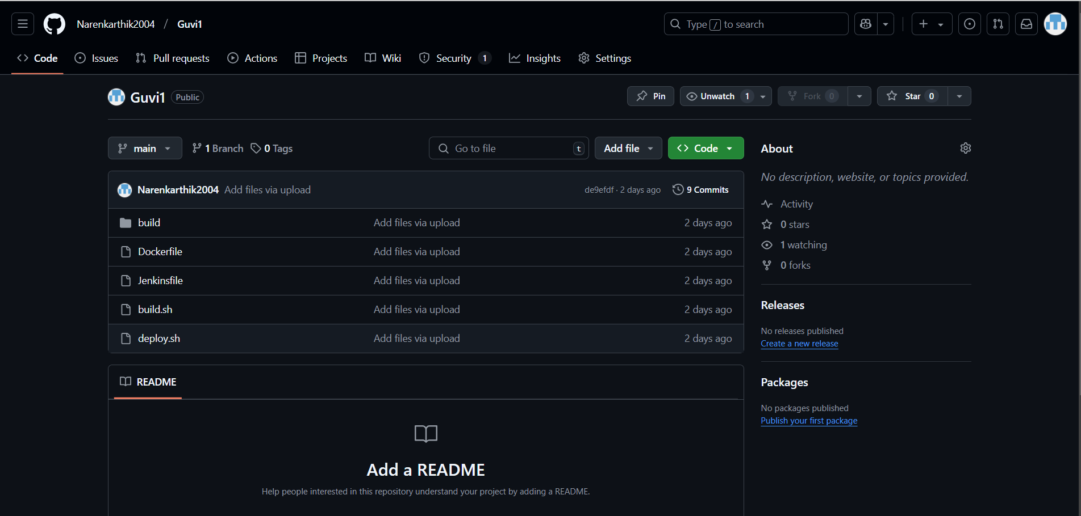

Dockerfile

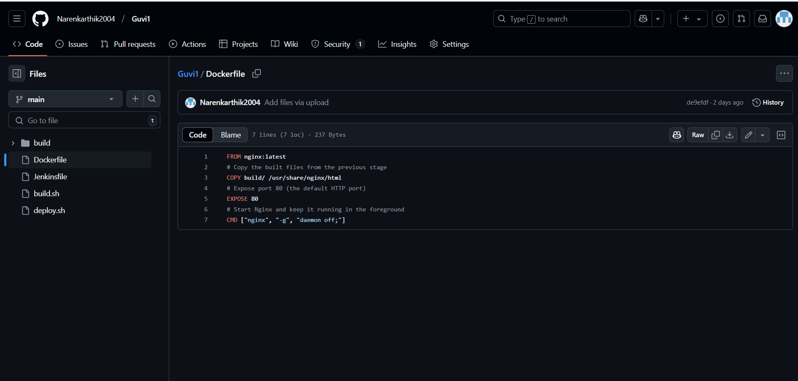

Jenkinsfile

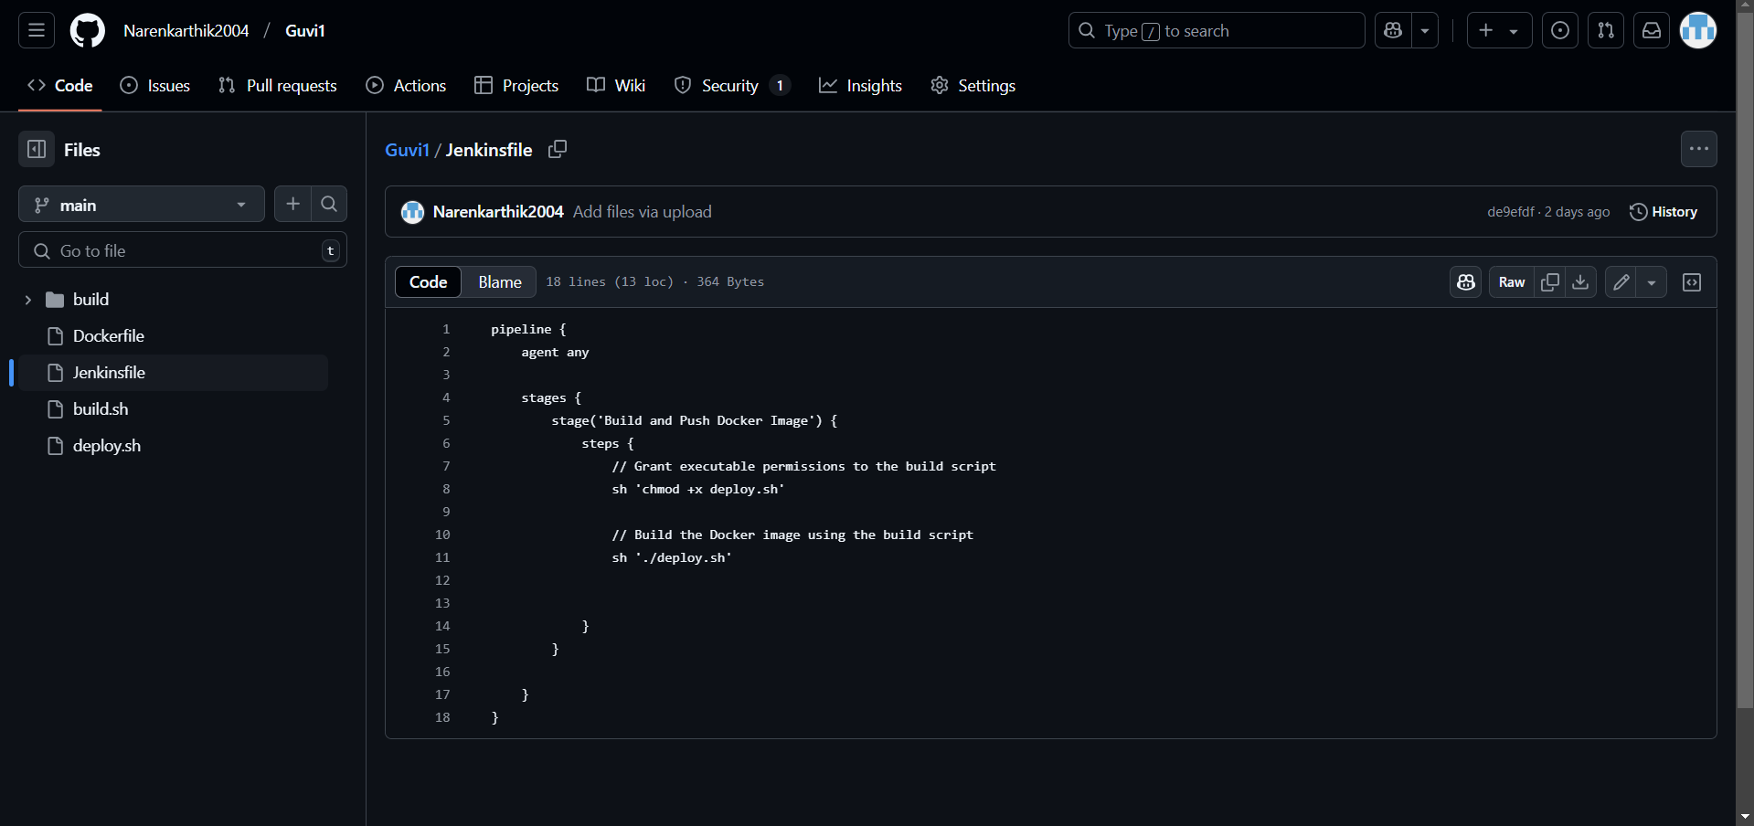

Build.sh

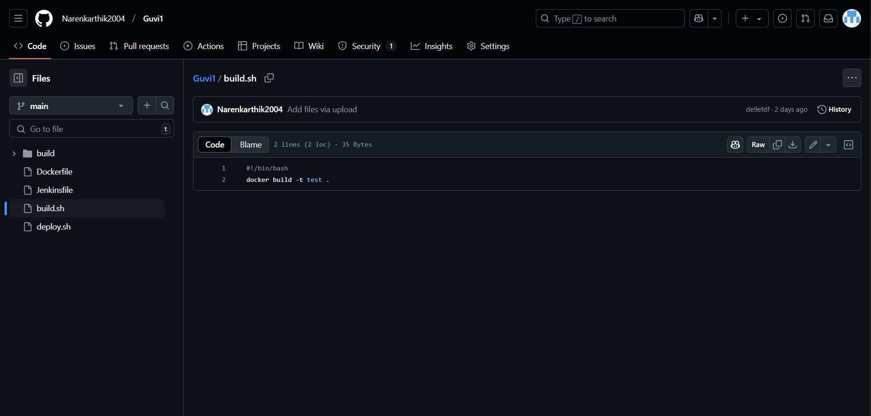

Deploy.sh

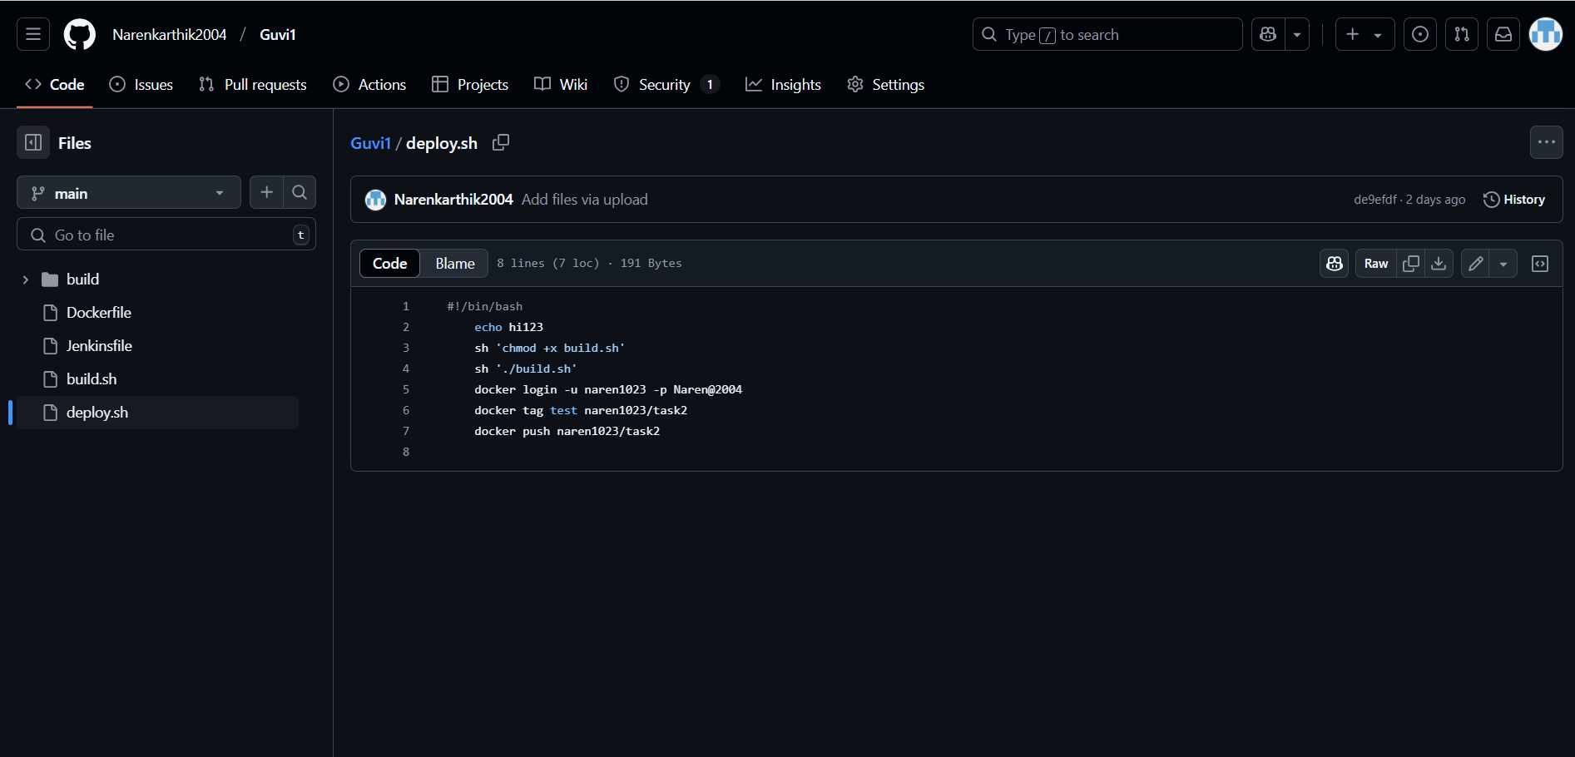

OUTPUT IN JENKINS CONSOLE

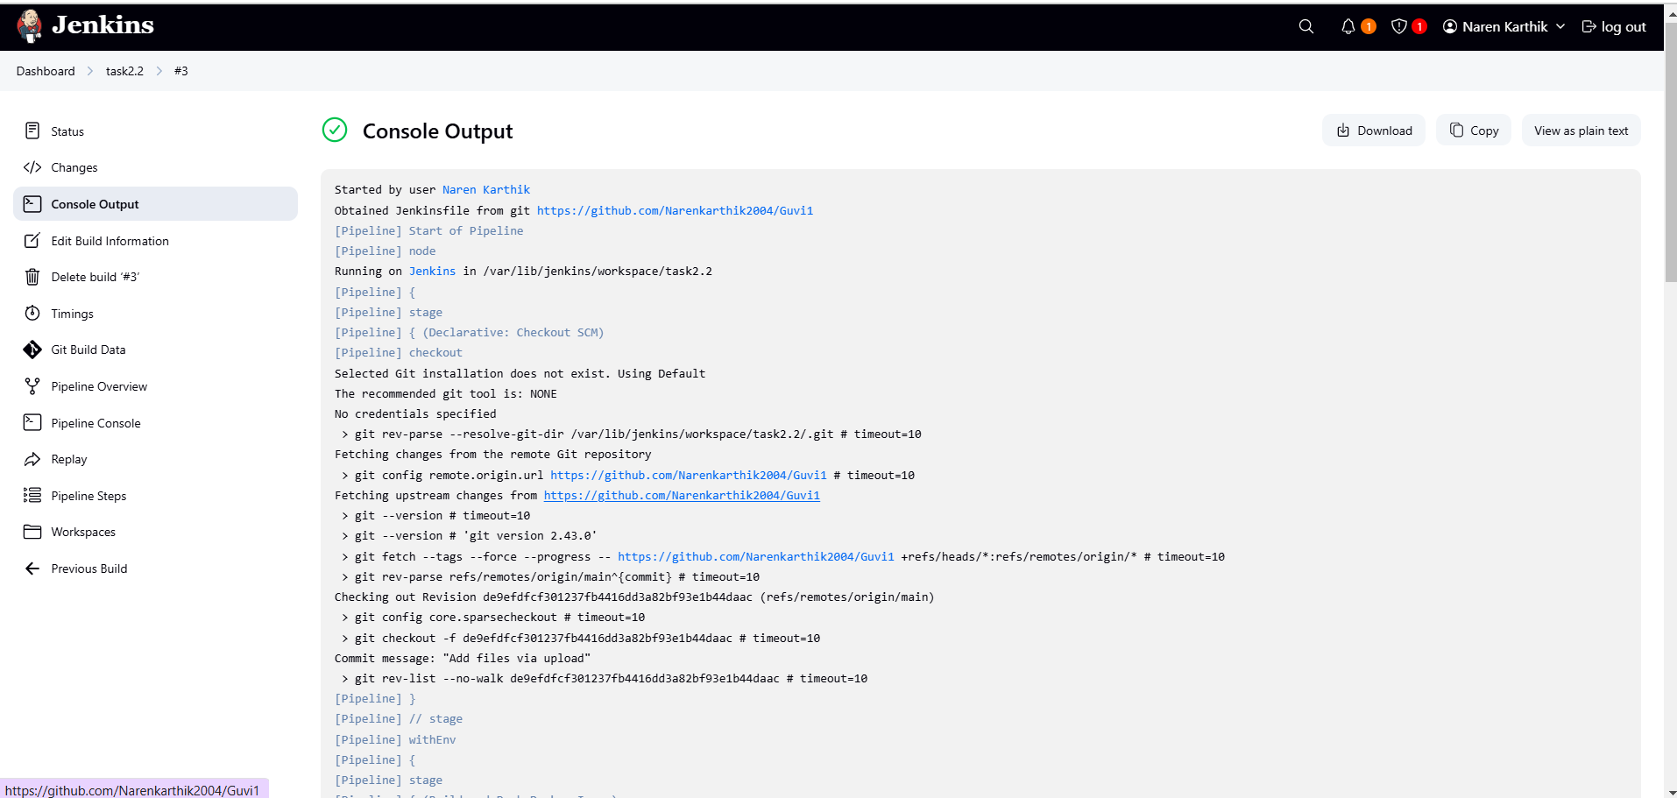

OUTPUT OF INDEX.HTML PAGE

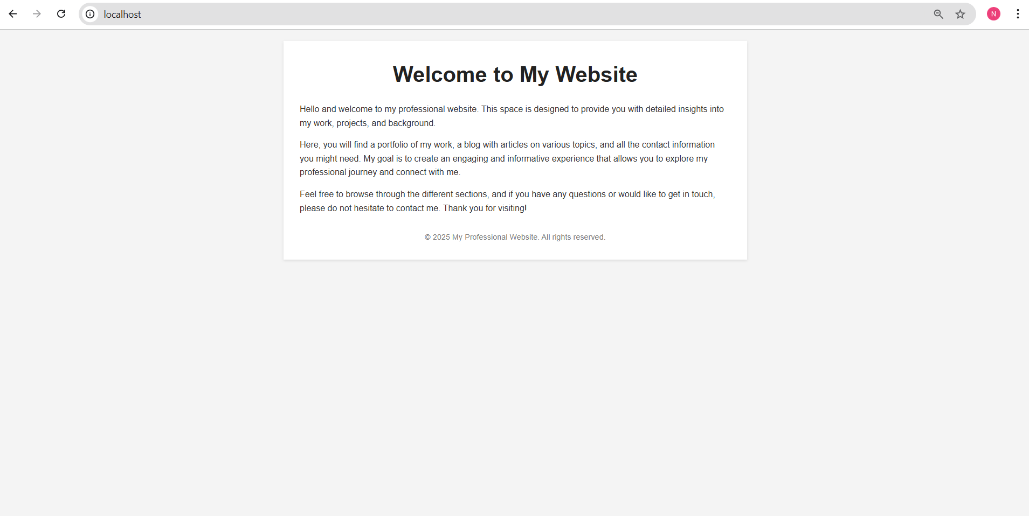

REPOSITORY ADDED IN DOCKER HUB

