TASK:3

CREATING A MINIKUBE SERVICE TO HANDLE CINTAINERS

I.creating a deployment

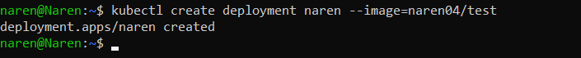

II.exposing the deployment

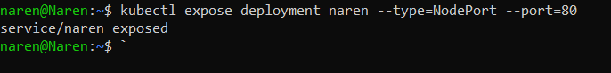

III.checking for pod

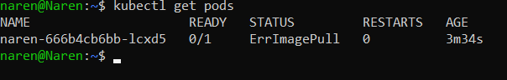

IV.opening the minikube service

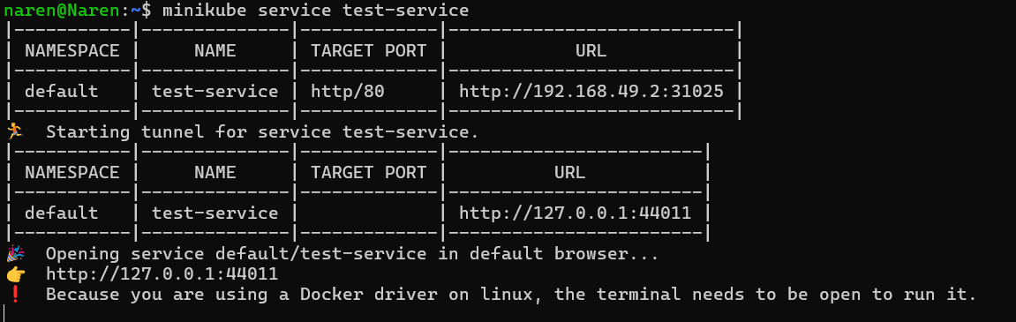

VI.output

