HACKUP TECHNOLOGY PVT. LTD. | AI-POWERED SOC & DIGITAL FORENSICS
MINI PROJECT 1- SOC ALERT
WEEK 1: Foundations and SOC Thinking

NAME : R.NARESH

SOC Incident Analysis Report

Project Title
Detection of Multiple Failed Login Attempts Using Event Viewer

Aim
To investigate suspicious login activities by analyzing failed authentication events in Windows Security logs.

Incident Overview
A review of the Windows Security logs revealed several failed login attempts recorded on the system. These events were detected through Event Viewer using Event ID 4625, which represents unsuccessful account login activity.
The repeated login failures suggest possible unauthorized access attempts or incorrect credential usage.

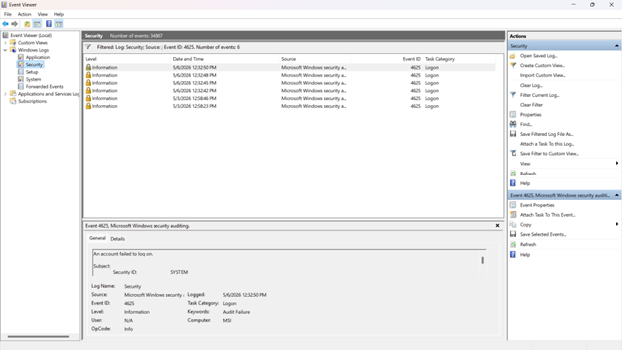

Tools Used
- Windows Event Viewer
- Windows Security Logs

Log Information
Field | Value
Event ID | 4625
Event Category | Logon Failure
Source | Microsoft Windows Security Auditing
Machine Name | MSI
Log Type | Security
Monitoring Tool | Event Viewer

Analysis Performed
The Security logs were checked for suspicious authentication activities. Multiple entries with the same Event ID were observed within a short duration.
The following points were analyzed:
- Number of failed login attempts
- Time and date of the events
- Event category and source
- Target system information

Security Concern
Frequent failed login attempts may indicate:
- Password guessing attempts
- Brute-force attack behavior
- Unauthorized user access attempts
- Invalid user credential usage

Recommended Actions
- Monitor authentication logs regularly.
- Configure account lockout settings.
- Enforce strong password policies.
- Enable multi-factor authentication.
- Restrict access to authorized users only.
- Investigate suspicious IP addresses or user accounts.

Final Outcome
The investigation confirmed repeated failed authentication attempts on the monitored Windows system. By analyzing Event ID 4625 in Event Viewer, suspicious login activity was successfully identified. Continuous log monitoring and proper security measures are essential to reduce potential security risks.

