HACKUP TECHNOLOGY PVT. LTD.

SOC Monitoring & Log Investigation Report

Mini Project-2– SSH Authentication Analysis

NAME : R.NARESH

Candidate Details
Field | Information
Project Type | Log Monitoring & Investigation
Investigation Topic | SSH Login Failure Analysis
Platform Used | Kali Linux
Log File Examined | /var/log/auth.log

1. Introduction
This project focuses on monitoring and analyzing SSH authentication logs to detect suspicious login activities. The investigation was performed to identify repeated login failures, suspicious access behavior, and successful user authentication events.

2. Investigation Setup
Component | Details
Operating System | Kali Linux
Virtual Environment | Oracle VirtualBox
Service Monitored | OpenSSH
Log Source | Authentication Log
Analysis Technique | Linux Command-Line Investigation

3. Commands Used During Investigation

View Failed SSH Login Attempts



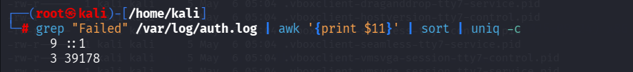
Calculate Number of Failed Attempts

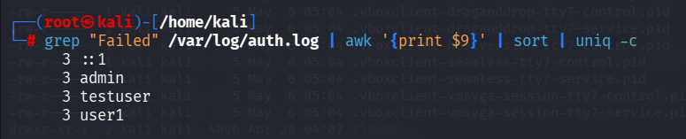
Extract Login Source Address

Identify Attempted User Accounts


Detect Successful Login Events

4. Investigation Results
Analysis Area | Observation
Authentication Failures | Several failed SSH logins identified
User Accounts Targeted | admin, testuser, user1
Login Source | localhost (::1)
Successful Authentication | kali account login detected
Session Activity | SSH session creation confirmed

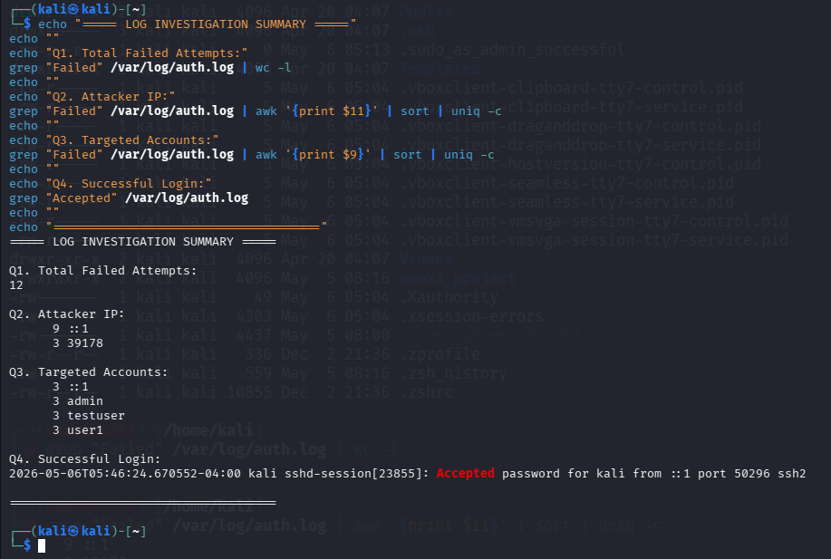
5. Threat Analysis

The logs indicate repeated authentication failures occurring over a short period. Multiple usernames were targeted sequentially, which is commonly associated with brute-force attack behavior.
After multiple failed attempts, a successful login was observed for one account, followed by the opening of an SSH session. This confirms that valid credentials were eventually used to access the system.

6. Event Timeline
Timestamp | Activity Detected | Priority
05:40 AM | First failed SSH login attempt | Medium
05:41 AM | Multiple invalid login attempts | High
05:42 AM | Continued authentication failures | High
05:46 AM | Successful SSH login | Critical
05:46 AM | User session established | Critical

7. Security Improvements Suggested
- Implement account lockout mechanisms.
- Use complex and unique passwords.
- Enable SSH key-based authentication.
- Restrict SSH access using firewall rules.
- Deploy intrusion prevention tools such as Fail2Ban.
- Configure continuous SOC monitoring for login anomalies.

8. Final Summary
The authentication log investigation successfully identified suspicious SSH login activity on the system. By analyzing the authentication logs, repeated failed login attempts and a confirmed successful access event were detected.
This investigation highlights the importance of real-time monitoring, proper access control, and log analysis in cybersecurity operations.

