A
PROJECT REPORT
ON
FARWEST TECH STORE


In the partial fulfillment of requirements for the Bachelor's Degree in Computer Science and Information Technology

Department of Computer Science and Information Technology
Far Western University, Kailali Multiple Campus

SUBMITTED BY:
Naresh Bohara [Reg. No.: Sc-2022-1-16-3041]
Pawan Bdr. Bhul [Reg. No.: Sc-2022-1-16-3045]
Pradeep Badu [Reg. No.: Sc-2022-1-16-3046]
Santosh Bhatta [Reg. No.: Sc-2022-1-16-3051]

Date: 20 February, 2026

STUDENTS’ DECLARATION
We, the undersigned, hereby declare that the project report entitled "FARWEST TECH STORE" has been prepared and submitted as part of the course Minor Project II (CSIT.412) in the Seventh Semester of the Bachelor of Science in Computer Science and Information Technology (B.Sc. CSIT) program at Far-Western University, Kailali Multiple Campus, Dhangadhi, Nepal.
We confirm that this project is our original work, carried out with sincerity, dedication, and teamwork. It has not been submitted previously, either in whole or in part, for any academic or professional qualification. All references and sources of information have been properly acknowledged, and any external contributions have been duly credited.
We take full responsibility for any errors or shortcomings in this work.
Team Members:

………………………………………  Naresh Bohara  Reg. No.: SC-2022-1-16-3041 | ………………………………………  Pawan Bdr. Bhul  Reg. No.: SC-2022-1-16-3045
………………………………………  Pradeep Badu  Reg. No.: SC-2022-1-16-3046 | ………………………………………  Santosh Bhatta  Reg. No.: SC-2022-1-16-3051

Department of Computer Science and Information Technology
Far-Western University
Kailali Multiple Campus, Dhangadhi-Kailali
Date: 20 February, 2026

SUPERVISOR'S RECOMMENDATION
It is my pleasure to recommend that a report on "Farwest Tech Store" has been prepared under my supervision by Naresh Bohara, Pawan Bdr. Bhul, Pradeep Badu, and Santosh Bhatta in partial fulfillment of the requirements for the Bachelor of Science (B.Sc.) in Computer Science and Information Technology at Kailali Multiple Campus, Far Western University, Nepal.
To the best of my knowledge, this report is original work carried out by the team and is recommended for final approval and acceptance.

........................................
Mr. Bibek Joshi
Head of Department (HOD)
Department of Computer Science and Information Technology
Kailali Multiple Campus
Far Western University, Nepal

LETTER OF APPROVAL
This is to certify that the project entitled "FARWEST TECH STORE" submitted by Naresh Bohara, Pawan Bdr. Bhul, Pradeep Badu, and Santosh Bhatta to the Department of Computer Science & Information Technology, Far Western University, Kailali Multiple Campus, Dhangadhi, Nepal, has been thoroughly examined and evaluated.
This submission fulfills the requirements for the course Minor Project II (CSIT.412) in the seventh semester of the Bachelor of Science in Computer Science and Information Technology (B.Sc. CSIT) program.
Based on our review, we hereby recommend this project for acceptance and approval.

…………………………..  Mr. Bibek Joshi  Project Supervisor  Department of CSIT  Kailali Multiple Campus  Far Western University | …………………………...  Mr. Bibek Joshi  Head of Department (HOD)  Department of CSIT  Kailali Multiple Campus  Far Western University
…………………………..  ___________________  Internal Examiner  Department of CSIT  Kailali Multiple Campus  Far Western University | …………………………..  ___________________  External Examiner  Department of CSIT  Central Campus  Far Western University

ACKNOWLEDGEMENT
We would like to express our heartfelt gratitude to our respected supervisor, Mr. Bibek Joshi, Head of the Department of Computer Science and Information Technology, Kailali Multiple Campus, Far-Western University, for his invaluable guidance, continuous support, and thoughtful suggestions throughout our project work. His encouragement and mentorship have been a constant source of inspiration in successfully completing this project.
We are equally thankful to all our teachers and the project evaluation committee of the Department of CSIT for their constructive feedback, cooperation, and encouragement, which greatly helped us improve the quality of our work.
Our sincere appreciation also goes to our team members for their dedication, effort, and excellent teamwork. The successful completion of this project, titled "Farwest Tech Store", would not have been possible without the collective contribution of each member.
Finally, we extend our gratitude to everyone who supported us, directly or indirectly, in bringing this project to completion.

ABSTRACT
Farwest Tech Store is a specialized e-commerce platform dedicated exclusively to STEM and Robotics products, lab solutions, and innovation support in Nepal. Unlike general e-commerce platforms, our platform focuses only on educational technology tools—making it easier for students, schools, colleges, and innovators to find everything in one place.
Built using the MERN stack (MongoDB, Express.js, React.js, Node.js), the system features a responsive frontend developed with Tailwind CSS and Flowbite, and a secure backend implementing JWT authentication and role-based access control. Key functionalities include product categorization, brand management, promotional banners, order processing, and real-time chat using Socket.io.
The platform addresses the critical need for accessible STEM education resources in Nepal by empowering local sellers and providing students and educators with a secure, scalable, and user-friendly marketplace tailored to the regional market.

Table of Contents

STUDENTS’ DECLARATION i
SUPERVISOR'S RECOMMENDATION ii
LETTER OF APPROVAL iii
ACKNOWLEDGEMENT iv
ABSTRACT v
LIST OF FIGURES ix
LIST OF TABLES x
LIST OF ABBREVIATIONS xi
CHAPTER 1: INTRODUCTION 1
1.1 Introduction 1
1.2 Problem Statement 1
1.3 Objectives 2
1.4 Project Scope 2
1.5 Project Limitations 3
CHAPTER 2: LITERATURE REVIEW 4
2.1 Background Study 4
2.2 Related Works 4
2.3 Summary 5
CHAPTER 3: SYSTEM ANALYSIS 6
3.1 Introduction 6
3.2 Existing System 6
3.3 Proposed System 7
3.4 Feasibility Study 7
3.4.1 Technical Feasibility 7
3.4.2 Economic Feasibility 8
3.4.3 Operational Feasibility 9
3.4.4 Schedule Feasibility 9
3.5 Requirement Analysis 11
3.5.1 Functional Requirements 11
3.5.2 Non-Functional Requirements 11
CHAPTER 4: SYSTEM DESIGN 12
4.1 Introduction 12
4.2 Choice of Methodology – Agile Model 12
4.3 Development Phases 12
4.3.1 Requirement Gathering & Analysis 12
4.3.2 System Design 12
4.3.3 Implementation & Development 13
4.3.4 Testing & Quality Assurance 13
4.3.4 Deployment & Maintenance 13
4.4 Data Flow Diagram (DFD) 14
4.4.1 Level 0 (Context Diagram) 14
4.4.2 Level 1 DFD 15
4.4.3 Level 2 DFD 15
4.5 Use Case Diagram 17
4.6 Database Schema 18
4.7 ER Diagram 19
CHAPTER 5: SYSTEM TESTING 22
5.1 Coding 22
5.2 Testing Approach 22
5.3 Testing Techniques 22
5.4 Test Cases 23
CHAPTER 6: IMPLEMENTATION PHASE 24
6.1 Introduction 24
6.2 Hardware and Software Setup 24
6.3 Data Migration 24
6.4 User Training 25
6.5 Documentation 25
CHAPTER 7: CONCLUSIONS AND RECOMMENDATIONS 27
7.1 Conclusion 27
7.2 Recommendation 27
7.3 Final Word 28
REFERENCES 30
APPENDIX 31
APPENDIX A – USER INTERFACE (FRONTEND) 31
A.1 Signup Page 31
A.2 Login Page 32
A.3 Homepage – Top Header 32
A.4 Homepage – Middle Section (Courses) 33
A.5 Homepage – Reviews Section 33
A.6 Homepage + Footer 34
A.7 All Products Page (All Courses Listing) 34
A.8 Contact Page 35
A.9 Products by Category Page 35
A.10 Checkout Page 36
APPENDIX B – ADMIN INTERFACE (BACKEND DASHBOARD) 36
B.1 Admin Dashboard (Main Overview) 36
B.2 Create Product Page 37
B.3 Create Category Page 37
B.4 Create Banner Page 38
B.5 Order Page 38
APPENDIX C – DEVELOPMENT & DATABASE 39
C.1 Postman – Login API Test 39
C.2 VS Code – Frontend (Login Component) 39
C.3 VS Code – Backend Code (index.js) 40
C.4 MongoDB Compass – Database Collections 40

LIST OF FIGURES
Figure 1: Gantt Chart 10
Figure 2: Agile Methodology 13
Figure 3: Level 0 DFD 14
Figure 4: Level 1 DFD 15
Figure 5: Level 2 DFD 16
Figure 6: Use Case Diagram 17
Figure 7: Database Schema 19
Figure 8: ER Diagram 21
Figure 9: Signup Page 31
Figure 10: Login Page 32
Figure 11: Homepage – Top Header 32
Figure 12: Homepage – Middle Section (Courses) 33
Figure 13: Homepage – Reviews Section 33
Figure 14: Homepage + Footer 34
Figure 15: All Products Page (All Courses Listing) 34
Figure 16: Contact Page 35
Figure 17: Products by Category Page 35
Figure 18: Checkout Page 36
Figure 19: Admin Dashboard (Main Overview) 36
Figure 20: Create Product Page 37
Figure 21: Create Category Page 37
Figure 22: Create Banner Page 38
Figure 23: Order Page 38
Figure 24: Postman – Login API Test 39
Figure 25: VS Code – Frontend (Login Component) 39
Figure 26: VS Code – Backend Code (index.js) 40
Figure 27: MongoDB Compass – Database Collections 40

LIST OF TABLES
Table I: List of Abbreviations xi
Table II:Hardware Specifications 8
Table III: Software Specifications 8
Table IV: Test Cases (System Testing – Black Box Testing) 23

LIST OF ABBREVIATIONS
Table I: List of Abbreviations

Abbreviation | Full Form
API | Application Programming Interface
CRUD | Create, Read, Update, Delete
DFD | Data Flow Diagram
ERD | Entity Relationship Diagram
JWT | JSON Web Token
MERN | MongoDB, Express.js, React.js, Node.js
RBAC | Role-Based Access Control
SRS | Software Requirement Specification
UAT | User Acceptance Testing
UI | User Interface
URL | Uniform Resource Locator
UX | User Experience

CHAPTER 1: INTRODUCTION

1.1 Introduction
The digital transformation of technology and education has significantly changed how students, institutions, and innovators access learning resources. In Nepal, particularly in the Far Western region, there is a growing demand for STEM and Robotics tools to support practical learning, innovation, and technical skill development. However, a dedicated platform focused exclusively on STEM education products and lab solutions has been limited, creating challenges for students and institutions seeking reliable and specialized resources.
Farwest Tech Store is a modern, specialized platform designed exclusively for STEM and Robotics innovation. Unlike general e-commerce platforms, it focuses solely on educational technology tools such as robotics kits, Arduino and microcontroller boards, sensors, IoT devices, drone training equipment, and STEM experiment kits. The platform enables customers to explore products, place orders, and receive expert technical guidance, while also supporting institutions with complete lab setup solutions, training programs, and project development assistance.
Built using the MERN stack (MongoDB, Express.js, React.js, and Node.js), the system provides a responsive and user-friendly interface powered by Tailwind CSS and Flowbite. The backend ensures secure authentication through JWT, role-based access control, structured APIs, and real-time communication using Socket.io for instant customer support. Farwest Tech Store is not just an online store — it is a technology-driven platform committed to empowering innovation and advancing STEM education in Nepal.

1.2 Problem Statement
The Far Western region of Nepal, as well as the country overall, faces significant challenges in accessing quality STEM and Robotics educational resources. Students, schools, colleges, and independent innovators often struggle to obtain authentic robotics kits, Arduino boards, sensors, IoT devices, and other essential educational technology components from reliable and specialized sources. The lack of a centralized and dedicated platform focused solely on STEM products makes it difficult to acquire appropriate tools required for practical learning, experimentation, and innovation.
Although general e-commerce platforms such as Daraz and Sastodeal operate in Nepal, they primarily focus on consumer goods rather than educational technology. These platforms lack structured STEM categories, detailed technical specifications, and educational guidance tailored to academic institutions and learners. Furthermore, they do not provide technical consultation, project assistance, or comprehensive lab setup services, which are crucial for effective implementation of STEM education.
In addition, users frequently lack access to real-time technical support when selecting complex electronic components, leading to confusion and incorrect purchases. Local STEM educators and small-scale suppliers also face challenges in reaching their targeted audience due to limited visibility and absence of specialized infrastructure. As a result, the absence of an integrated platform that combines authentic products, expert guidance, lab setup support, and real-time communication creates a substantial gap in Nepal’s evolving STEM and innovation ecosystem.

1.3 Objectives
The primary objective of Farwest Tech Store is to design and develop a specialized, secure, and user-friendly online platform dedicated to STEM and Robotics education in Nepal, with a focus on supporting students, institutions, and innovators.
Specific Objectives:
- To develop a multi-role system (Admin, Seller, Customer) with appropriate access control and permissions for effective platform management.
- To implement a structured product management system with STEM-specific categories such as Robotics Kits, Arduino boards, Sensors, IoT devices, and electronic components.
- To design a secure shopping cart and order processing system suitable for both individual learners and educational institutions.
- To integrate real-time chat functionality to provide instant technical support and product guidance.
- To incorporate WhatsApp integration for seamless communication and project consultation support.
- To develop an admin dashboard for managing products, categories, sellers, lab setup services, and training programs.
- To design a responsive and intuitive user interface that presents STEM products in an organized and user-friendly manner.
- To support additional services such as STEM lab setup assistance, hands-on training programs, and project development guidance.

1.4 Project Scope
The scope of Farwest Tech Store encompasses the following key areas:
- Specialized STEM Product Catalog: Robotics kits, Arduino and microcontroller boards, sensors, drone equipment, STEM experiment kits, and IoT tools.
- User Management: Registration, login, and profile management for students, educators, sellers, and administrators.
- Product Browsing: Advanced search and filtering by category, skill level (beginner to advanced), and price.
- Shopping Cart & Orders: Add/remove items, checkout, order placement, and order tracking.
- Real-time Communication: Instant messaging with sellers for technical queries via chat and WhatsApp integration.
- Lab Setup Services: Consultation and product bundles for complete STEM lab setup in schools and colleges.
- Training Programs: Information, registration, and participation support for hands-on STEM and Robotics training sessions.
- Seller Dashboard: Product management, order tracking, and customer communication for local STEM suppliers.
- Admin Dashboard: User management, product moderation, category and brand management, banner management, and overall platform oversight.
- Responsive Design: Optimized interface for desktops, tablets, and mobile devices.

1.5 Project Limitations
The initial version of Farwest Tech Store has the following limitations:
- No Integrated Payment Gateway: Payments are simulated; future integration with eSewa and Khalti is planned.
- Limited to STEM Products: Focused exclusively on educational technology tools such as robotics kits, Arduino boards, and sensors.
- No Online Training Delivery: Training information is provided, but hands-on sessions are conducted offline.
- Basic Inventory Management: Only simple stock tracking is available; advanced features are planned for future versions.
- No Multi-language Support: Currently English only; Nepali language support is planned.
- Internet Dependent: Real-time features require a stable internet connection.
- Limited Product Catalog: Initial offerings depend on available local suppliers; expansion planned over time.

CHAPTER 2: LITERATURE REVIEW

2.1 Background Study
STEM (Science, Technology, Engineering, and Mathematics) education plays a critical role in fostering innovation, economic growth, and technological self-sufficiency in developing countries [1]. In Nepal, there is an increasing emphasis on promoting STEM education from schools to higher education institutions. Access to quality educational tools, such as robotics kits, Arduino boards, sensors, and IoT devices, is essential for hands-on learning, skill development, and project-based innovation.

The digital transformation of commerce has revolutionized how products and educational resources are accessed and distributed. Globally, e-commerce platforms have evolved from simple online catalogs to complex ecosystems offering secure payments, user accounts, personalized recommendations, and real-time communication [2]. However, in Nepal, specialized platforms for STEM and Robotics products remain largely absent, leaving students, educators, and local suppliers underserved. General e-commerce sites like Daraz and Sastodeal provide a mix of consumer products but lack technical guidance, detailed specifications, educational categories, and real-time support tailored for STEM learning.

The MERN stack (MongoDB, Express.js, React.js, Node.js) is widely used for modern web application development due to its scalability, flexibility, and full-stack JavaScript environment [3]. MongoDB enables flexible handling of diverse product specifications, Express.js supports robust API and backend services, React.js facilitates dynamic and responsive user interfaces, and Node.js ensures high performance for concurrent requests. Real-time communication technologies, such as Socket.io, are particularly valuable for STEM platforms, allowing instant guidance, technical support, and clarification on product usage, which enhances user experience and reduces purchasing hesitation [4].

2.2 Related Works
Several existing e-commerce platforms and educational initiatives provide valuable insights for developing a specialized STEM and Robotics marketplace in Nepal:
- Daraz Nepal: Offers a wide product range, including some electronics, but lacks specialization in STEM education tools. It does not provide technical guidance, structured educational categories, or support for learning projects [5].
- Sastodeal: Popular general e-commerce platform in Nepal with limited STEM product categories. It does not offer real-time technical support or educational resources for students and institutions [6].
- Hamrobazar: Classified-style marketplace where some STEM products are listed. However, it lacks structured categorization, secure transactions, seller verification, and integrated support for educational buyers [7].
- Amazon: Provides extensive STEM product categories with high-quality specifications, but it is not localized for Nepal, involves high shipping costs, and offers no local technical assistance [8].
- SparkFun Electronics (USA) & Adafruit Industries (Global): Specialized platforms for electronics and robotics education. They provide detailed documentation, learning resources, and project guidance, serving as exemplary models for combining products with educational content, though they are not accessible to Nepali users [9][10].
- Research Insights: Studies indicate that access to quality STEM resources is a major barrier in developing countries. Platforms integrating product sales with technical guidance, real-time support, and local training can significantly enhance learning outcomes [11][12][13].

2.3 Summary
The literature review confirms that Farwest Tech Store addresses a critical gap in Nepal's educational technology and STEM ecosystem:
- Specialized STEM & Robotics Focus: Caters specifically to students, educators, and institutions seeking authentic educational technology tools.
- Modern Web Technologies: Enables a scalable, high-performance platform capable of handling growing user demand.
- Real-time Communication: Essential for providing technical guidance, project support, and building customer confidence.
- Localization: Addresses Nepal’s unique educational context, regional needs, and resource constraints.
- Integration of Products and Services: Combines product sales with lab setup consultation, training programs, and hands-on project support, creating comprehensive value.
Building on these insights, Farwest Tech Store has been developed as a specialized platform that merges e-commerce with educational support, leveraging the MERN stack to deliver a secure, user-friendly, and locally-relevant online marketplace for STEM education in Nepal.

CHAPTER 3: SYSTEM ANALYSIS

3.1 Introduction
System analysis involves examining the existing landscape, identifying limitations, and defining requirements for an improved solution. For Farwest Tech Store, this phase focused on understanding the challenges faced by students, educators, and institutions in accessing STEM and Robotics resources in Nepal. The goal was to design a specialized platform that not only provides products but also supports educational needs, technical guidance, and STEM lab setup services.
The analysis considered the current methods used to obtain STEM products, the issues associated with these methods, and the features required in a comprehensive solution tailored to the local context.

3.2 Existing System
Currently, students and educators in Nepal access STEM products through multiple channels, each with notable limitations:
- General E-commerce Platforms (Daraz, Sastodeal): Offer a wide range of products but lack specialization for STEM education. These platforms do not provide technical guidance, structured educational categories, or verified sellers for STEM products.
- Local Electronics Shops: Limited inventory, no online presence, high prices, and no educational focus make access to STEM resources challenging.
- International Websites (Amazon, AliExpress): While they offer specialized products, high shipping costs, long delivery times, customs complications, and lack of local support make them impractical for most Nepali users.
- Social media (Facebook Marketplace): Listings are unverified, security risks exist, and there is no structured catalog or buyer protection.
- Direct from Suppliers (Kathmandu): Accessing suppliers requires travel, and there is no option for online ordering for users in the Far Western region.
Key Problems Identified:
- No Specialized STEM Platform: There is no centralized platform focusing exclusively on educational technology tools.
- Limited Technical Information: Product listings often lack tutorials, project ideas, or educational context.
- No Post-Purchase Support: Buyers receive no guidance on how to effectively use products for learning or projects.
- Geographic Disadvantage: Students and institutions in the Far Western region face additional barriers in accessing resources.
- Absence of Lab Setup Services: Schools and colleges have no unified solution for establishing complete STEM labs.

3.3 Proposed System
Farwest Tech Store is proposed as a specialized, multi-vendor e-commerce platform for STEM and Robotics products. The system is designed to be educational, supportive, and locally relevant, combining e-commerce functionality with guidance, consultation, and training services.
Key Features:
- Specialized STEM Catalog: Robotics kits, Arduino boards, sensors, drone equipment, STEM experiment kits, and IoT tools.
- Educational Focus: Each product includes tutorials, project ideas, and learning resources to support practical STEM education.
- Multi-Role System: Roles for Students, Educators, Sellers, and Admins with appropriate permissions.
- Real-Time Chat: Instant messaging via Socket.io for technical queries and project guidance.
- WhatsApp Integration: Direct connection for implementation support and consultation.
- Lab Setup Services: Complete consultation and product bundles for schools, colleges, and innovation labs.
- Training Programs: Information and registration for hands-on STEM workshops and training sessions.
- Seller Verification: Ensures only trusted local suppliers list authentic STEM products.
- Technical Blog: Articles, tutorials, and project ideas for self-learning and innovation.
This system addresses the limitations of existing solutions by combining a centralized STEM product marketplace with educational support, technical guidance, and institutional services, ensuring a secure, user-friendly, and regionally relevant platform for Nepal.

3.4 Feasibility Study
A feasibility study evaluates whether developing and implementing Farwest Tech Store is practical, beneficial, and achievable within the available resources. It examines technical, economic, operational, and schedule aspects to ensure the system can be successfully developed, deployed, and maintained.

3.4.1 Technical Feasibility
The technical feasibility assesses whether the required technologies and infrastructure are available to support Farwest Tech Store. The platform will be built using modern, open-source, and well-documented technologies that ensure reliability, scalability, and security.

Component | Specification
Operating System | Windows 10/11, Linux
Front-End | React.js, Tailwind CSS, Flowbite
Backend | Node.js, Express.js
Database | MongoDB
Real-Time | Socket.io
File Storage | Cloudinary with Multer
Table II:Hardware Specifications

Table III: Software Specifications

Component | Specification
Processor | Intel Core i5 (11/12th Generation)
RAM | 8GB
Storage | 512GB SSD
Input Devices | Standard Keyboard, Mouse

All technologies are readily available, cost-effective, and suitable for the project scope. Cloud-based services such as MongoDB Atlas and Cloudinary provide free tiers, which minimize initial costs while enabling future scalability.

3.4.2 Economic Feasibility
The economic feasibility considers the financial practicality of developing Farwest Tech Store:
- No Licensing Fees: Open-source software eliminates software acquisition costs.
- Low Hardware Investment: Existing computers meet the system requirements.
- Free Cloud Services: MongoDB Atlas, Cloudinary, and other services offer free tiers for initial deployment.
- Scalable Architecture: The system can be expanded without major additional costs.
- Revenue Potential: Income can be generated via commissions on sales, lab setup consultations, and training program fees.
These factors indicate that the project is economically viable for small teams or individual developers.

3.4.3 Operational Feasibility
Operational feasibility evaluates whether the system can be used effectively by its intended users:
- Intuitive Interface: Easy navigation for students, educators, and sellers.
- Educational Focus: Product listings include tutorials, project guides, and learning resources, not just sales information.
- Technical Support: Real-time chat and WhatsApp integration provide instant guidance for users.
- Local Relevance: Products are selected according to Nepal’s curriculum and regional context.
- Seller Onboarding: Simple tools enable local STEM suppliers to list products efficiently.
The system is designed to be user-friendly, locally relevant, and supportive of STEM education initiatives in Nepal.

3.4.4 Schedule Feasibility
Schedule feasibility determines whether the project can be completed on time using available resources. The project is divided into clear development phases:
- Requirement Gathering
- System Design
- Development
- Testing
- Deployment
- Maintenance
- Phase Durations: Each phase has a defined timeline to track progress.
- Realistic Timeline: Suitable for a small development team or individual developer.
- Future Updates: Additional features, such as advanced teacher/admin roles or multi-language support, can be integrated without delaying the main deployment.
This structured approach ensures that Farwest Tech Store can be delivered on schedule, meeting both functional and educational requirements.

 | Month-1 |  |  |  | Month-2 |  |  |  | Month-3
Project  Phase | Week-1 | Week-2 | Week-3 | Week-4 | Week-5 | Week-6 | Week-7 | Week-8 | Week-9 | Week-10 | Week-11
Planning & Requirement Analysis
Literature Review & Problem Statement
UI/UX Design
Coding
Testing & Debugging
Deployment
Documentation
Final Review & Handover

Figure 1: Gantt Chart

3.5 Requirement Analysis

3.5.1 Functional Requirements
Functional requirements describe the main features of the system:
- User Management – Registration, login, profile management, and password recovery for students, educators, and sellers.
- Product Management – Add, edit, or delete STEM products with categories (Robotics Kits, Arduino, Sensors, etc.), skill levels, and project ideas.
- Browsing & Search – Product listing, search, and filtering by category, skill level, price, and product compatibility.
- Shopping Cart – Add, update, or remove items; support bulk orders for educational institutions.
- Order Processing – Checkout, order placement, and status tracking for both individual and institutional orders.
- Real-time Chat – Instant messaging for technical queries and project guidance between buyers and sellers.
- WhatsApp Integration – Direct connection for implementation support and consultation.
- Training Programs – Course listings, registration, and schedule information for hands-on STEM workshops.
- Admin Panel – User management, product moderation, and content management for blogs and resources.
- Seller Panel – Product management, order fulfillment, and customer communication.

3.5.2 Non-Functional Requirements
Non-functional requirements describe how the system performs:
- Usability – Intuitive and educational interface; mobile-responsive for students and educators.
- Performance – Page load < 3 seconds; API response < 500ms.
- Security – JWT authentication, bcrypt password hashing, input validation to prevent attacks.
- Reliability – 99% uptime, regular backups, and order data integrity.
- Scalability – Can handle increasing users, products, and institutional orders.
- Maintainability – Modular code and comprehensive documentation for future enhancements.

CHAPTER 4: SYSTEM DESIGN

Introduction
System design provides the blueprint for how Farwest Tech Store will operate. The design follows a three-tier architecture:
- Presentation Layer: React.js frontend with user-friendly and educational-focused UI components.
- Application Layer: Node.js/Express backend handling business logic for STEM product management, orders, and user interactions.
- Data Layer: MongoDB database for persistent storage of products, orders, user accounts, and educational content.

Choice of Methodology – Agile Model
The Agile methodology was chosen for its flexibility and iterative approach, allowing the platform to evolve based on customer and seller feedback.
Why Agile is Suitable for Farwest Tech Store:
- Iterative development – Features are built and tested incrementally to ensure smooth buying/selling experience.
- Adaptability – Requirements can change as more STEM products, sellers, or services are added.
- User involvement – Regular feedback from buyers, sellers, and admins ensures the platform meets real marketplace needs.
- Continuous testing – Each iteration ensures platform reliability, security, and performance.

Development Phases

Requirement Gathering & Analysis
- Surveyed potential buyers (students, educators, tech enthusiasts) about product needs.
- Interviewed local STEM suppliers and robotics trainers to understand seller requirements.
- Analyzed global and regional e-commerce platforms specialized in technology products.
- Documented functional and non-functional requirements for both buyers and sellers.

System Design
- Created UI wireframes emphasizing easy product browsing, STEM product details, and educational resources.
- Designed database schema for multi-category STEM products, users, and orders.
- Developed DFDs, use case diagrams, and ER diagrams for the platform workflow.

Implementation & Development
- Backend: Node.js/Express with modular architecture for scalable e-commerce functionality.
- Frontend: React components with responsive and intuitive design.
- Database: MongoDB with Mongoose for structured product and order storage.
- Real-time support: Socket.io for instant buyer-seller communication.
- Media storage: Cloudinary for product images, tutorials, and videos.
- WhatsApp integration: Direct support and consultation for buyers.

4.3.4 Testing & Quality Assurance
- Unit testing for individual components (frontend and backend).
- Integration testing for APIs, real-time chat, and payment simulation.
- User acceptance testing with buyers, sellers, and admins.
- Security, performance, and load testing to ensure platform stability.
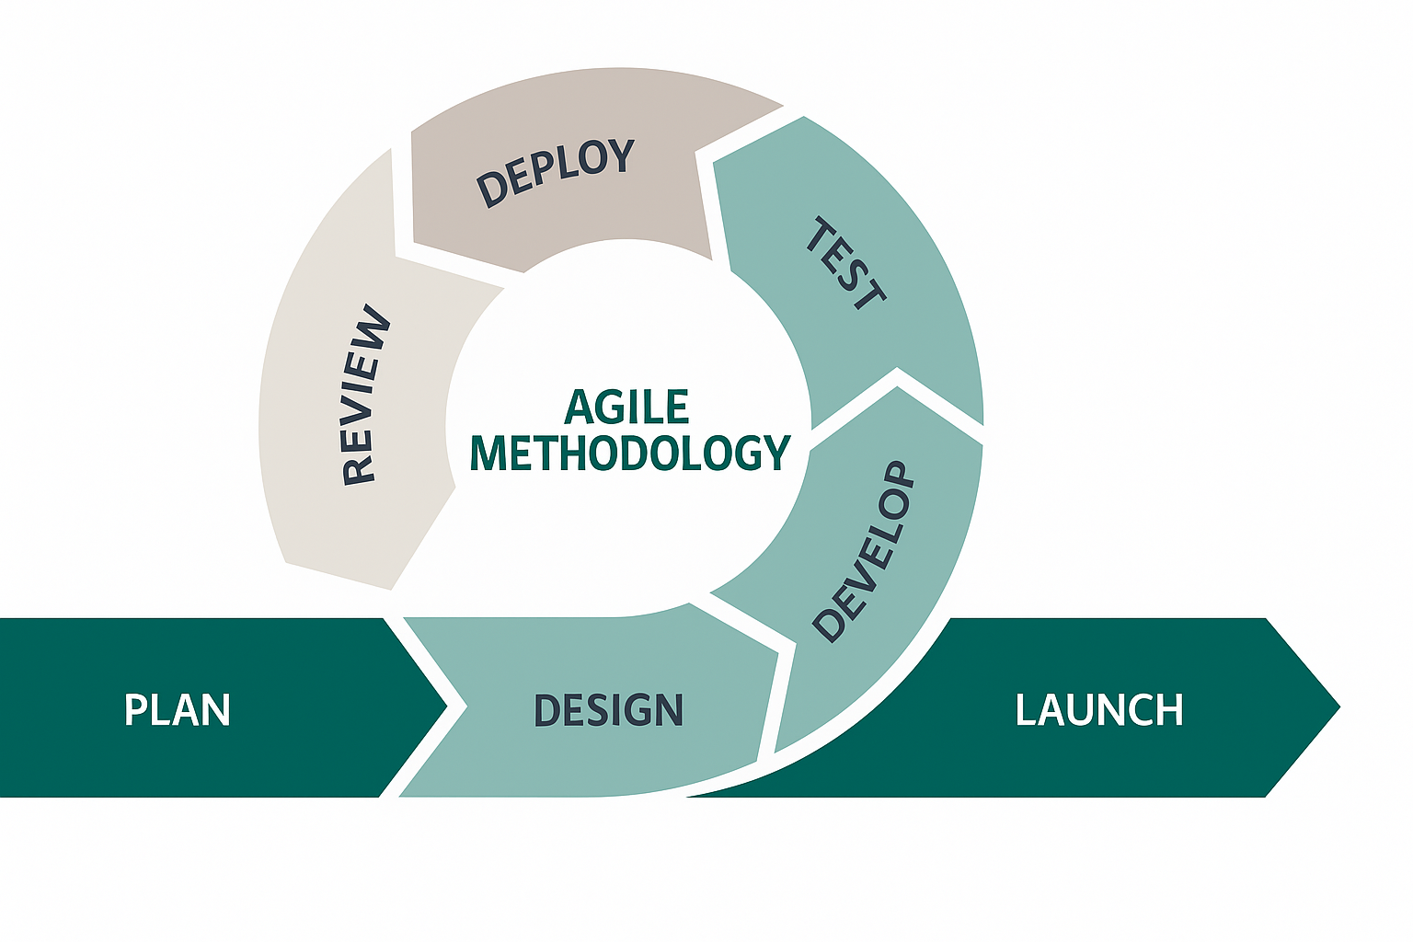

Figure 2: Agile Methodology

Deployment & Maintenance
- Frontend: Deployed on Netlify or Vercel.
- Backend: Deployed on Render or Heroku.
- Database: MongoDB Atlas.
- Regular updates based on user feedback to improve product listings, chat features, and platform usability.

4.4 Data Flow Diagram (DFD)
A Data Flow Diagram (DFD) explains how information moves through the Farwest Tech Store system and how different parts interact. It helps in understanding the flow of data between users, processes, and external systems.

4.4.1 Level 0 (Context Diagram)
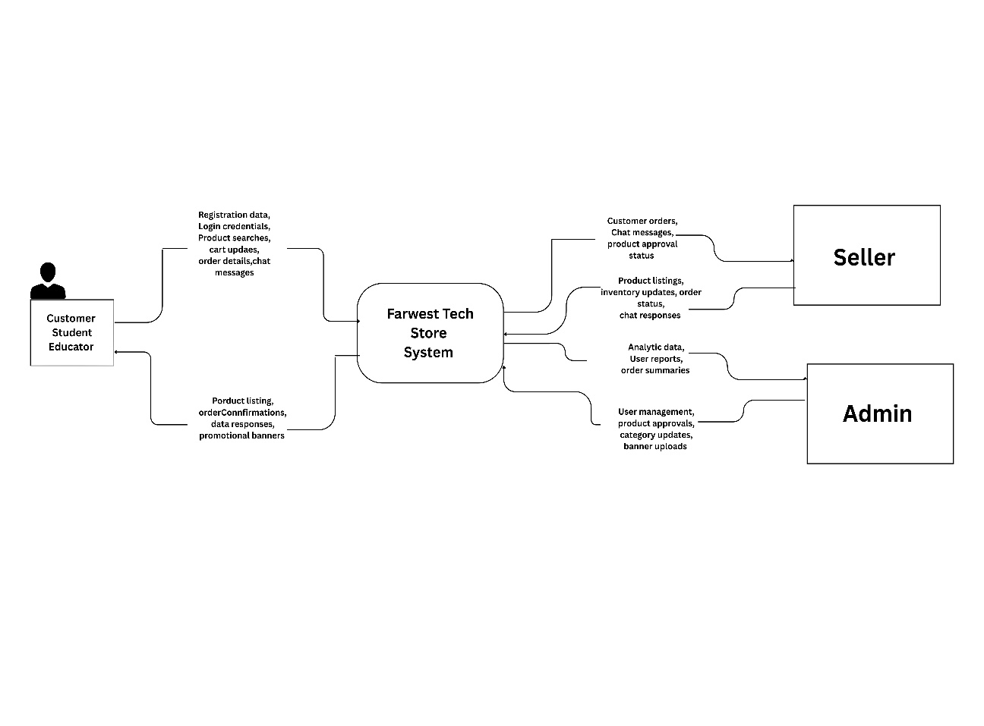

Figure 3: Level 0 DFD

The Level 0 DFD shows Farwest Tech Store as a single system interacting with three external entities: Customer, Seller, and Admin. Customers browse products, manage cart, place orders, and chat. Sellers manage product catalog and respond to queries. Admins manage users, products, categories, brands, and banners. Data flows include registration, login, searches, orders, and chats from customers; product listings and inventory from sellers; and user management and approvals from admin. The system returns product listings, confirmations, and analytics to respective entities

4.4.2 Level 1 DFD
The Level 1 DFD
breaks the system into five main processes. User Management handles registration, login, and profiles using Users DB. Product Management manages product catalog with Products, Categories, and Brands DB. Shopping & Order Processing handles cart, checkout, and orders using Cart and Orders DB. Chat System manages real-time communication using Chats DB. Admin Panel oversees all platform functions with access to all databases. These processes connect to form complete e-commerce functionality.
Figure 4: Level 1 DFD
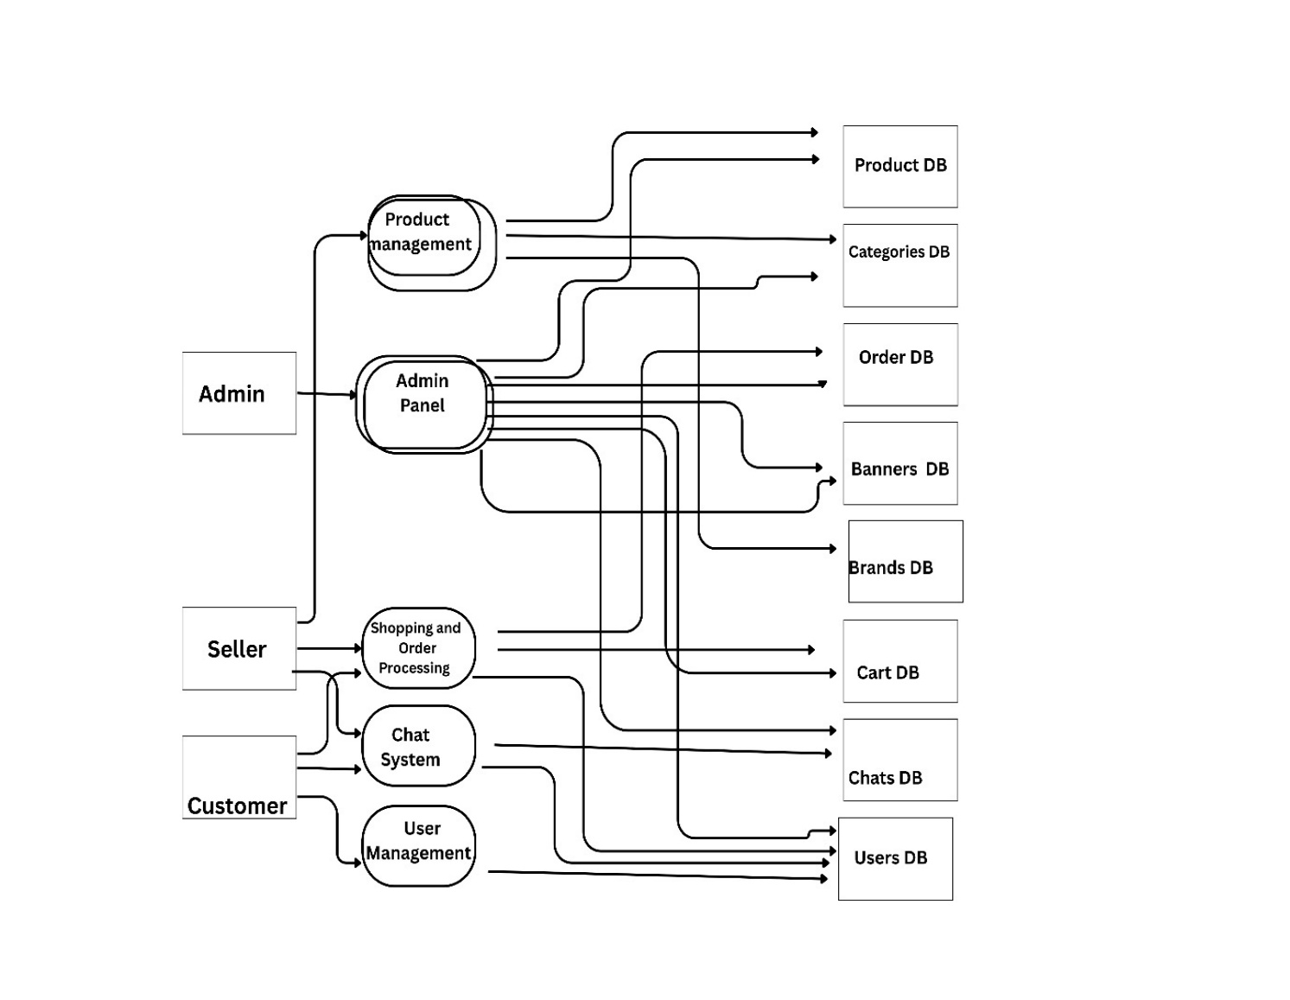
Figure 4. 3: Level 1 DFD

4.4.3 Level 2 DFD
The Level 2 DFD shows detailed workflows. In Order Processing, customers browse products, add to cart, checkout, generate orders, update inventory, and track status using Products, Cart, Orders, and Chats DB. In Real-time Chat, users connect via Socket.io, send messages stored in Chats DB, and receive instant responses. WhatsApp Integration allows customers to click icon and directly contact admin via WhatsApp for external support.

Figure 5: Level 2 DFD
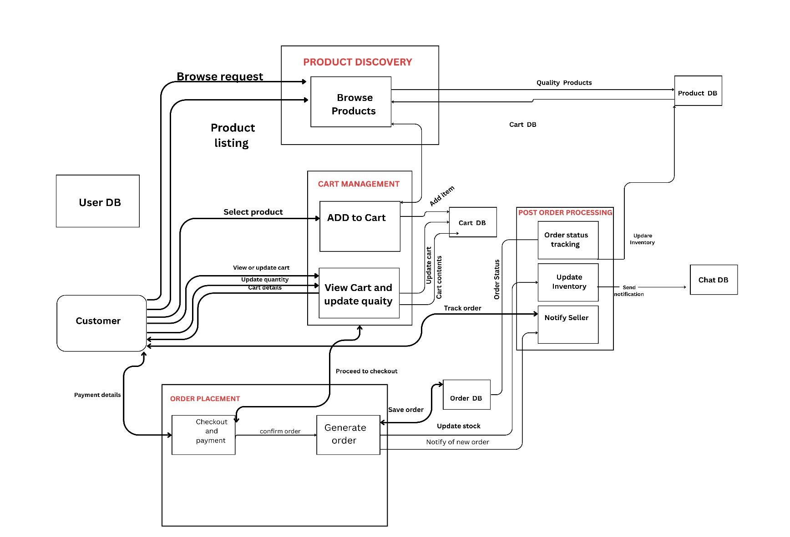

4.5 Use Case Diagram
The Use Case Diagram shows how different users interact with Farwest Tech Store and what actions they can perform.
- Actors:
  - Customer/Student/Educator – register, login, browse STEM products, filter by category, view product details, add to cart, update cart, remove from cart, checkout and place orders, view order history, track order status, chat with sellers/admin in real-time, and contact via WhatsApp support.
  - Seller– register, login, browse STEM products, filter by category, view product details, add to cart, update cart, remove from cart, checkout and place orders, view order history, track order status, chat with sellers/admin in real-time, and contact via WhatsApp support.
  - Admin– login to admin dashboard, manage all users, verify sellers, approve/reject products, create/edit categories, create/edit brands, upload banners, view all orders, access platform analytics, and chat with customers and sellers.
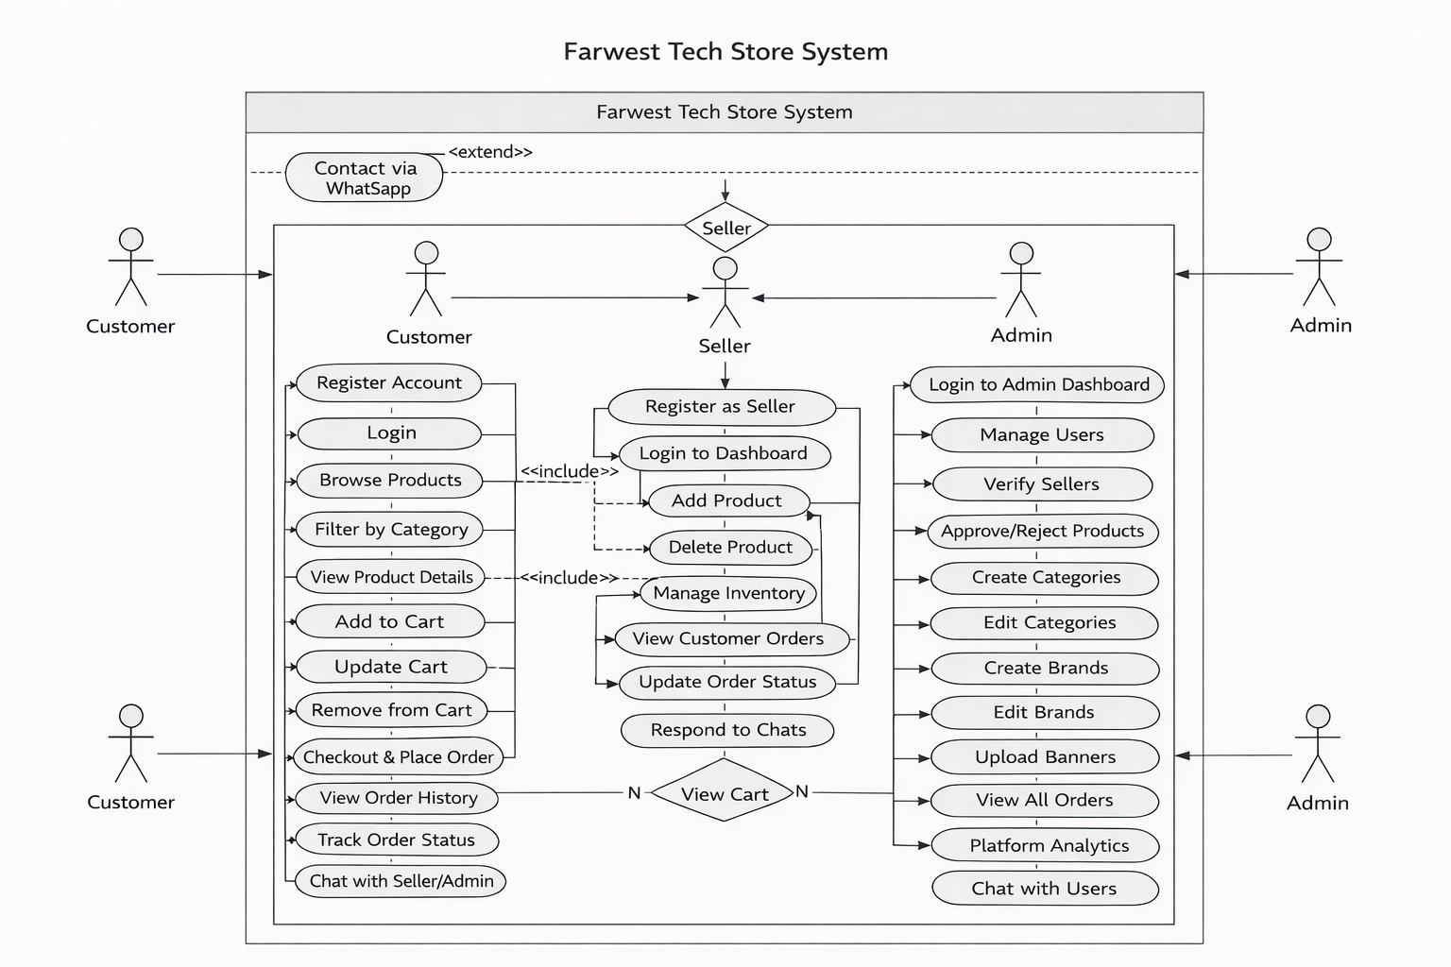
- Use Cases: The use cases define the tasks each actor performs, focusing on user interaction without showing internal system details. Customers focus on product discovery and purchasing, sellers manage their product catalog and orders, while admins oversee platform operations and content management.

Figure 6: Use Case Diagram

4.6 Database Schema
The database schema defines how data is organized in MongoDB. MongoDB uses collections (similar to tables) and documents (similar to records) to store information.
Main Collections
- Users – Stores user accounts with name, email, password, role (admin, customer, seller), address, phone, and status.
- Products – Stores STEM product details with title, price, discount, images, and references to category, brand, and seller.
- Categories – Stores product categories with title, slug, image, and self-reference for subcategories.
- Brands – Stores product brands with title, slug, and image.
- Orders – Stores customer orders with buyer reference, total amount, status, and references to cart items.
- Carts – Stores temporary cart items with user reference, product reference, and quantity.
- Chats – Stores real-time messages with sender, receiver, message content, and seen status.
- Banners – Stores promotional banners with title, image, start date, end date, and status.
Main Relationships
- Users ↔ Products – One-to-Many (A seller can list multiple products).
- Users ↔ Orders – One-to-Many (A customer can place multiple orders).
- Users ↔ Chats – One-to-Many (A user can send and receive multiple messages).
- Users ↔ Carts – One-to-Many (A user can have multiple items in cart).
- Users ↔ Banners – One-to-Many (An admin can create multiple banners).
- Categories ↔ Products – One-to-Many (A category can contain multiple products).
- Categories ↔ Categories – One-to-Many (Self-reference for subcategories).
- Brands ↔ Products – One-to-Many (A brand can have multiple products).
- Orders ↔ Carts – One-to-Many (An order can contain multiple cart items).
- Products ↔ Carts – One-to-Many (A product can appear in multiple carts).

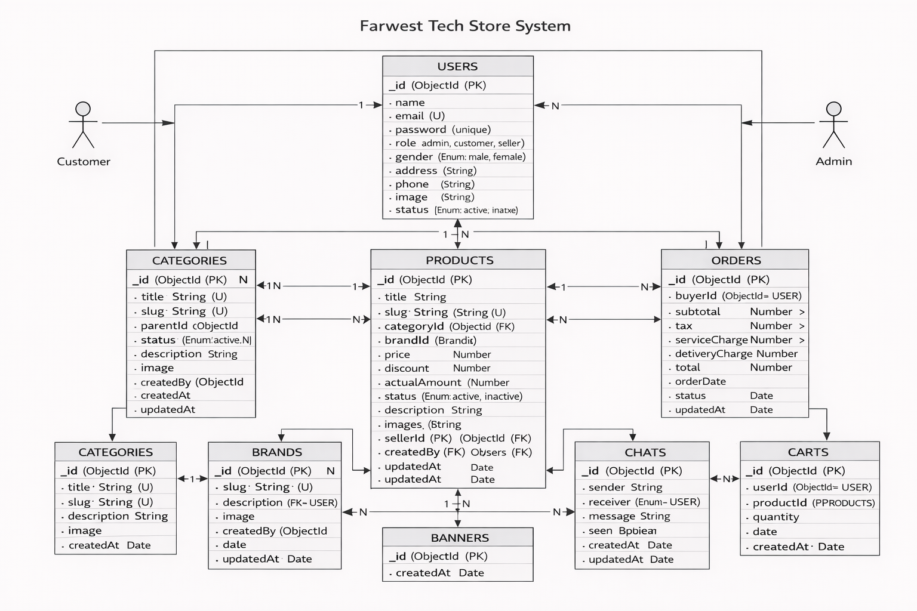

Figure 7: Database Schema

4.7 ER Diagram
The Entity Relationship Diagram illustrates how data is organized and linked in Farwest Tech Store. It shows eight main entities with their attributes and relationships.
- User entity contains userId, name, email, password, role, phone, address, and status. Users can be customers, sellers, or admins.
- Product entity includes productId, title, price, discount, actualAmount, description, and references to seller, category, and brand.
- Category entity has categoryId, title, slug, description, image, and self-referencing parentId for subcategories.
- Brand entity contains brandId, title, slug, description, and image.
- Order entity tracks orderId, buyerId, subtotal, total, orderDate, and status.
- Cart entity stores cartId, userId, productId, and quantity for temporary shopping items.
- Chat entity manages chatId, senderId, receiverId, message, seen status, and timestamp for real-time conversations.
- Banner entity handles bannerId, title, image, link, startDate, endDate, and status for promotions.
Key Relationships
- User → Product: One-to-Many (seller lists many products)
- User → Order: One-to-Many (buyer places many orders)
- User → Chat: One-to-Many (user sends/receives many messages)
- User → Banner: One-to-Many (admin creates many banners)
- User → Cart: One-to-Many (user maintains many cart items)
- Category → Product: One-to-Many (category contains many products)
- Category → Category: One-to-Many (self-reference for subcategories)
- Brand → Product: One-to-Many (brand has many products)
- Order → Cart: One-to-Many (order contains many cart items)
- Product → Cart: One-to-Many (product appears in many carts)

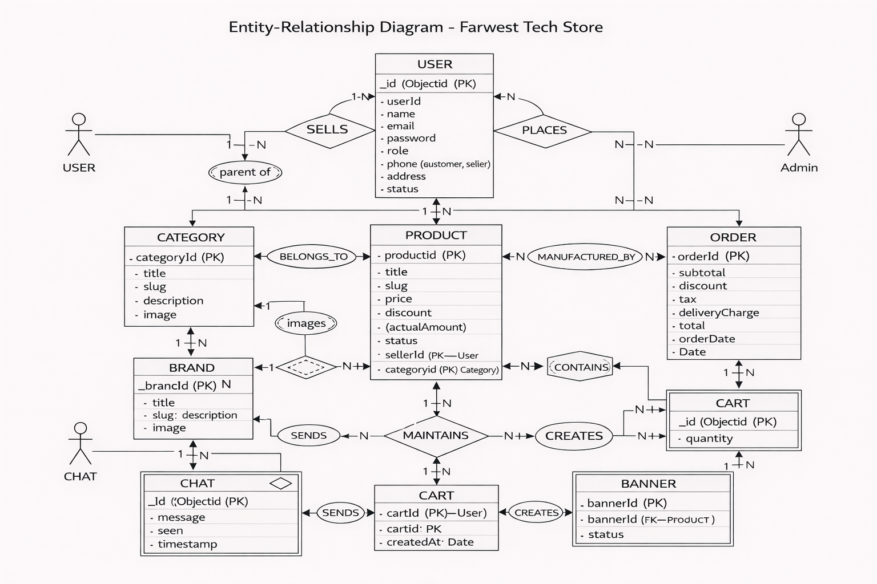
Figure 8: ER Diagram

CHAPTER 5: SYSTEM TESTING

5.1 Coding
After completing the design, Farwest Tech Store was developed following modern coding practices and standards.
- Frontend Development: Implemented using React functional components with hooks, Redux Toolkit for state management, Tailwind CSS for responsive design, and Formik with Yup for form validation.
- Backend Development: Developed following the MVC architecture with route-controller-service structure, JWT-based authentication, Joi request validation, Mongoose schemas with validation, and centralized error handling.
- Development Tools: Used VS Code with ESLint and Prettier, Git for version control, Postman for API testing, and MongoDB Compass for database management.

5.2 Testing Approach
A structured testing strategy was followed to ensure system reliability, security, and performance. Testing was conducted throughout the development lifecycle to identify and resolve issues early. The following testing approaches were applied:
- Unit Testing – Individual components, controllers, and services were tested independently to verify correct functionality. (Frontend: Vitest, Backend: Jest)
- Integration Testing – Interaction between frontend, backend, and database was tested to ensure proper data flow and API communication. (Postman, Supertest)
- System Testing – Complete workflows such as registration, login, product browsing, cart management, and order placement were tested to validate overall system behavior.
- User Acceptance Testing (UAT) – End-users evaluated usability, functionality, and overall experience, and feedback was collected for improvements.
- Security Testing – Authentication, authorization, and role-based access control mechanisms were tested to ensure secure system access.
Testing was performed iteratively during development to detect defects early and maintain system stability.

5.3 Testing Techniques
- Black Box Testing: Verified system functionalities such as registration, login, product browsing, cart, checkout, and chat without examining internal code.
- White Box Testing: Tested backend logic, API routes, database queries, and authentication flow to ensure accuracy, security, and performance.

5.4 Test Cases
Test Case ID | Module | Scenario | Expected Result
TC01 | User | User registers with valid details | Account created successfully
TC02 | User | Login with correct credentials | Redirect to dashboard
TC03 | Product | Seller adds new STEM product | Product saved successfully
TC04 | Product | Filter products by skill level | Filtered products displayed
TC05 | Cart | Add item to cart | Cart count increases
TC06 | Cart | Update quantity | Price updates correctly
TC07 | Order | Place order | Order created
TC08 | Chat | Send real-time message | Message delivered instantly
TC09 | Admin | Change user role | Role updated
TC10 | Security | Access without token | Redirect to login
Table IV: Test Cases (System Testing – Black Box Testing)

Conclusion
The testing phase confirmed that Farwest Tech Store operates correctly across all modules. Functional, security, and performance requirements were successfully validated. The system is stable, secure, and ready for deployment, with future scalability for additional features.

CHAPTER 6: IMPLEMENTATION PHASE

6.1 Introduction
The Implementation Phase transformed the design of Farwest Tech Store into a fully functional web application. After successful testing, the system was deployed for real-world use. This phase ensured that the platform is stable, secure, and user-friendly for all stakeholders.

6.2 Hardware and Software Setup
The following tools and technologies were used to set up and develop the system:
- Frontend Development: React 18.3.1 with Vite, Redux Toolkit for state management, Tailwind CSS & Flowbite for styling, React Router DOM for routing, Axios for HTTP requests, Formik + Yup for forms, Socket.io-client for real-time chat, and Font Awesome / React Icons for icons. Notifications implemented using React Toastify and SweetAlert2.
- Backend Development: Node.js with Express.js, MongoDB with Mongoose for database operations, JWT & bcryptjs for authentication, Joi for request validation, Multer + Cloudinary for file uploads, Nodemailer for email, and Socket.io for real-time communication. Security handled with CORS and Helmet.
- Development Tools: Visual Studio Code with ESLint & Prettier, Git & GitHub for version control, Postman for API testing, MongoDB Compass for local database management, and MongoDB Atlas for cloud database.
- Testing & Deployment: Tested on desktops, tablets, and smartphones for responsiveness and compatibility. Frontend deployed on Netlify, backend on Render, and media stored on Cloudinary.

6.3 Data Migration
To ensure a smooth transition from development to the production environment, a structured data migration process was carried out:
- Essential data such as the admin account, default categories, brands, skill levels, and sample products were created using automated seed scripts.
- Duplicate, incomplete, or inconsistent records were identified and removed to maintain data accuracy and consistency.
- Data formats were standardized, and referential integrity between collections (users, products, categories, orders) was verified.
- The development database was exported, cleaned, and securely imported into MongoDB Atlas for production deployment.
- Product images were uploaded to Cloudinary, and database records were updated with secure image URLs.
- Backups were created before and after migration to prevent data loss and ensure recovery capability.

6.4 User Training
To ensure effective use of the Farwest Tech Store platform, structured training sessions were conducted for different user roles.
Student / Educator Training:
- Registration and profile setup
- Browsing STEM products by category and skill level
- Accessing tutorials, project ideas, and educational resources
- Adding items to cart and completing checkout
- Using real-time chat for technical support
- Submitting lab setup consultation requests
- Registering for STEM training programs and workshops
Seller Training:
- Seller registration and verification process
- Adding STEM products with detailed specifications and educational content
- Managing inventory and updating product information
- Responding to customer technical queries via chat
- Processing and fulfilling orders
Admin Training:
- Managing users (students, educators, sellers)
- Product moderation and category management
- Reviewing and handling lab setup requests
- Managing training programs and workshop registrations
- Updating tutorials, blog content, and educational resources
Training Methods:
- Live system demonstrations
- Step-by-step user manuals (PDF format)
- Video tutorials
- Hands-on practice sessions
- Frequently Asked Questions (FAQ) support

6.5 Documentation
Comprehensive documentation was prepared to support both users and system administrators.:
- User Documentation: Separate user manuals were prepared for Students/Educators, Sellers, and Admins. These manuals include step-by-step instructions, screenshots, FAQs, and troubleshooting guides to help users efficiently navigate the platform and resolve common issues.
- Technical Documentation: Comprehensive technical documentation was developed, including system architecture design, API documentation, database schema details, deployment procedures, environment configuration setup, and well-commented source code with structured README files for future maintenance and scalability.
- Project Documentation: Project plan, requirement specifications, design diagrams (DFD, ERD, Use Cases), test plans, and meeting records.

CHAPTER 7: CONCLUSIONS AND RECOMMENDATIONS

7.1 Conclusion
The development of Farwest Tech Store has been a valuable and enriching experience that allowed the practical application of theoretical knowledge to a real-world educational e-commerce platform. Throughout the project lifecycle—ranging from requirement analysis and system design to implementation, testing, and deployment—the team gained comprehensive exposure to modern software development practices.
Farwest Tech Store successfully fulfills its primary objective of creating a specialized STEM-focused marketplace that goes beyond traditional online selling. Unlike general e-commerce platforms, this system integrates educational value with product distribution by providing tutorials, project ideas, skill-level categorization, and technical guidance.
The key accomplishments of the project include:
- Successful development of a dedicated STEM marketplace featuring robotics kits, Arduino boards, sensors, IoT tools, and related educational technologies.
- Integration of educational features such as project-based learning resources and skill-level filtering.
- Implementation of real-time technical support using chat functionality and WhatsApp integration.
- Development of lab setup consultation services tailored for schools and colleges.
- Inclusion of training program management to support hands-on STEM education.
- Secure authentication using JWT with role-based access control for Admin, Seller, and Customer roles.
- Responsive and user-friendly interface designed using React and Tailwind CSS.
Beyond technical implementation, the project contributed significantly to personal and professional growth. It enhanced proficiency in MERN stack development, strengthened understanding of educational technology markets, improved collaborative teamwork practices using version control systems, and reinforced the importance of user-centered design.
Most importantly, the project demonstrates how technology can bridge educational resource gaps and support STEM education accessibility in Nepal. Farwest Tech Store represents a meaningful step toward building an integrated educational technology ecosystem rather than a simple online store.

7.2 Recommendation
While the system achieves its core objectives, several enhancements are recommended to further improve functionality, scalability, and educational impact.
Short-term Enhancements
- Integration of Nepali payment gateways such as eSewa, Khalti, and ConnectIPS for secure digital transactions.
- Development of an expanded tutorial library including structured learning paths from beginner to advanced levels.
- Introduction of a student project gallery where learners can showcase their completed projects.
- Automation of common support queries through WhatsApp bot integration.
Medium-term Enhancements
- Development of an online training platform offering live and recorded STEM sessions with certification.
- Creation of a dedicated institutional dashboard for schools and colleges to manage bulk orders and lab requirements.
- Alignment of products with the Nepali curriculum to support grade-specific recommendations.
- Implementation of a community forum to encourage collaboration, mentorship, and knowledge sharing.
Long-term Enhancements
- Development of a mobile application using React Native for wider accessibility and push notifications.
- Implementation of AI-based learning recommendations tailored to user skill levels and interests.
- Introduction of “STEM Lab-in-a-Box” curated packages for complete laboratory setups.
- Establishment of regional STEM support centers for physical workshops and demonstrations.
- Addition of multi-language support, including a Nepali interface and localized educational resources.
These improvements will help Farwest Tech Store evolve into a scalable, innovative, and nationally impactful educational technology platform.

7.3 Final Word
Farwest Tech Store represents more than an academic project—it reflects a vision to democratize access to STEM education in Nepal. By combining e-commerce capabilities with structured educational support, the platform creates a holistic ecosystem that supports learners, educators, and institutions alike.
The successful completion of this project demonstrates the potential of modern web technologies when applied with a clear educational purpose. It highlights how thoughtful system design, secure architecture, and user-centered development can create sustainable impact in communities.
This project not only fulfilled its academic objectives but also laid the foundation for a platform capable of inspiring innovation, creativity, and technological advancement among students across Nepal.
Farwest Tech Store stands as a testament to the idea that technology, when guided by educational goals, can drive meaningful and lasting change.

REFERENCES
[1] UNESCO, STEM Education for Sustainable Development, 2023.
[2] World Bank, Digital Transformation in Education: E-learning and Resource Access, 2024.
[3] MongoDB Inc., MongoDB Documentation. [Online]. Available: https://www.mongodb.com/docs/
[4] React Team, React Documentation. [Online]. Available: https://reactjs.org/
[5] Node.js Foundation, Node.js Documentation. [Online]. Available: https://nodejs.org/
[6] Express.js Team, Express.js Documentation. [Online]. Available: https://expressjs.com/
[7] Socket.io, Real-time Engine Documentation. [Online]. Available: https://socket.io/docs/
[8] Cloudinary, Image and Video Management. [Online]. Available: https://cloudinary.com/documentation
[9] J. Smith, E-commerce for Educational Products: Best Practices, Educational Technology Journal, 2024.
[10] M. Karki, STEM Education in Nepal: Challenges and Opportunities, Nepal Education Review, 2025.
[11] SparkFun Electronics, Educational Electronics Platform. [Online]. Available: https://www.sparkfun.com/
[12] Adafruit Industries, Learning System. [Online]. Available: https://learn.adafruit.com/
[13] S. Poudel, Technology Access in Rural Nepal, Journal of Development Informatics, 2024.
[14] Redux Toolkit, Redux Toolkit Documentation. [Online]. Available: https://redux-toolkit.js.org/
[15] Tailwind CSS, Tailwind CSS Documentation. [Online]. Available: https://tailwindcss.com/docs

APPENDIX

APPENDIX A – USER INTERFACE (FRONTEND)

A.1 Signup Page
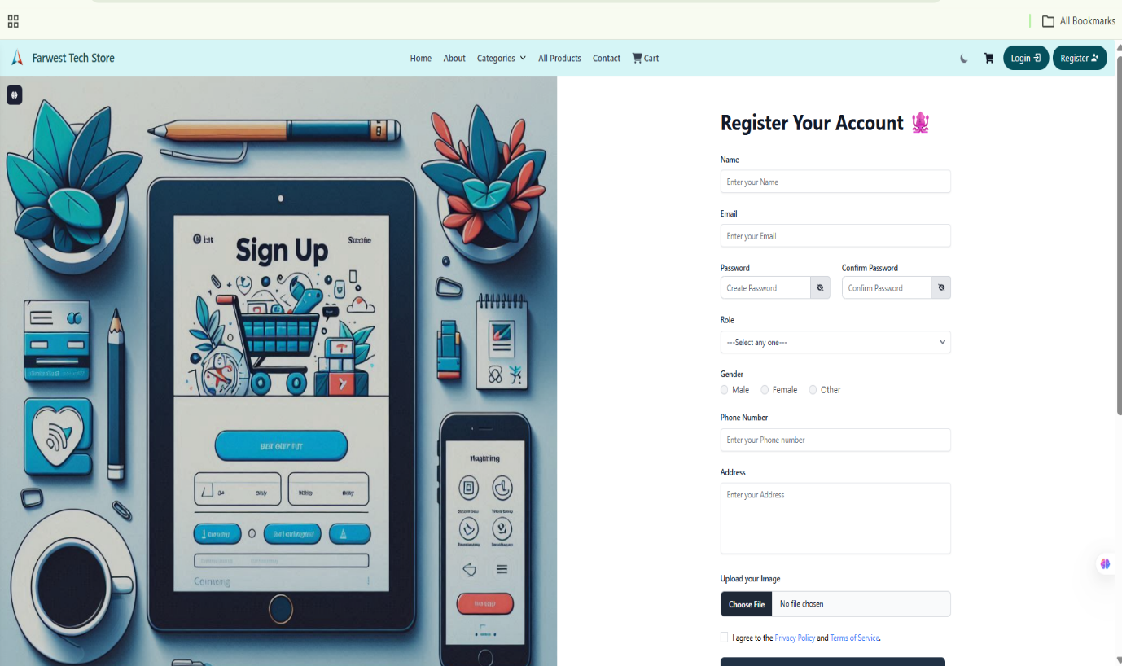
Figure 9: Signup Page

A.2 Login Page
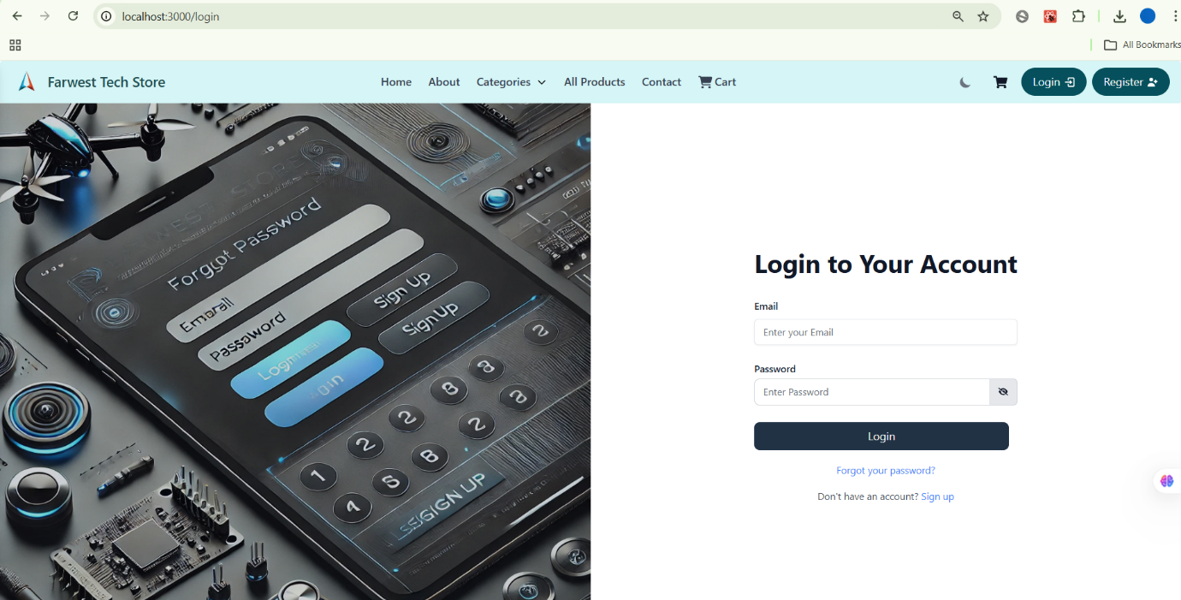
Figure 10: Login Page

A.3 Homepage – Top Header
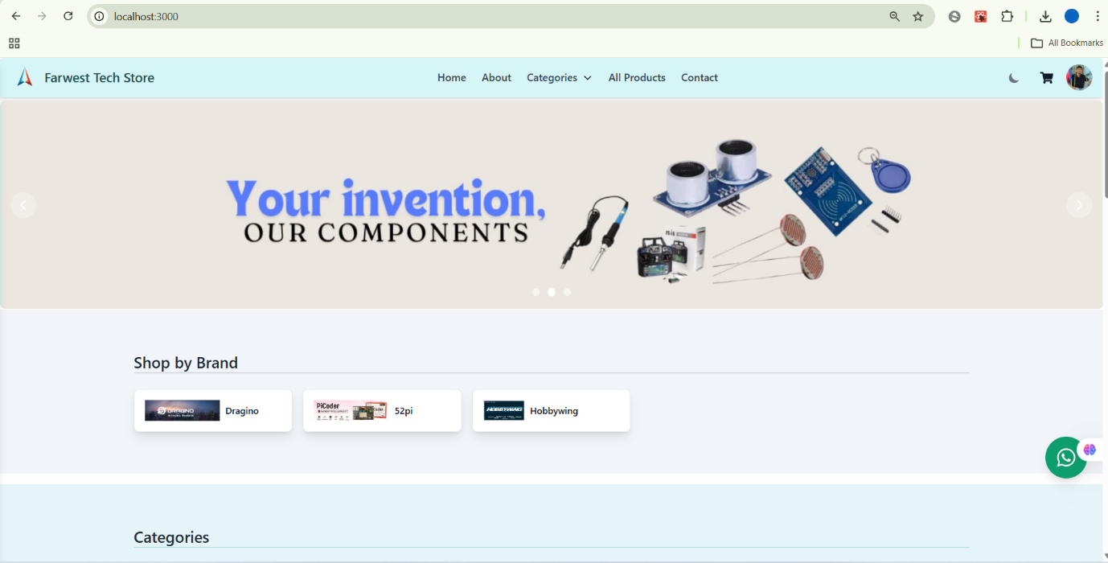
Figure 11: Homepage – Top Header

A.4 Homepage – Middle Section (Courses)
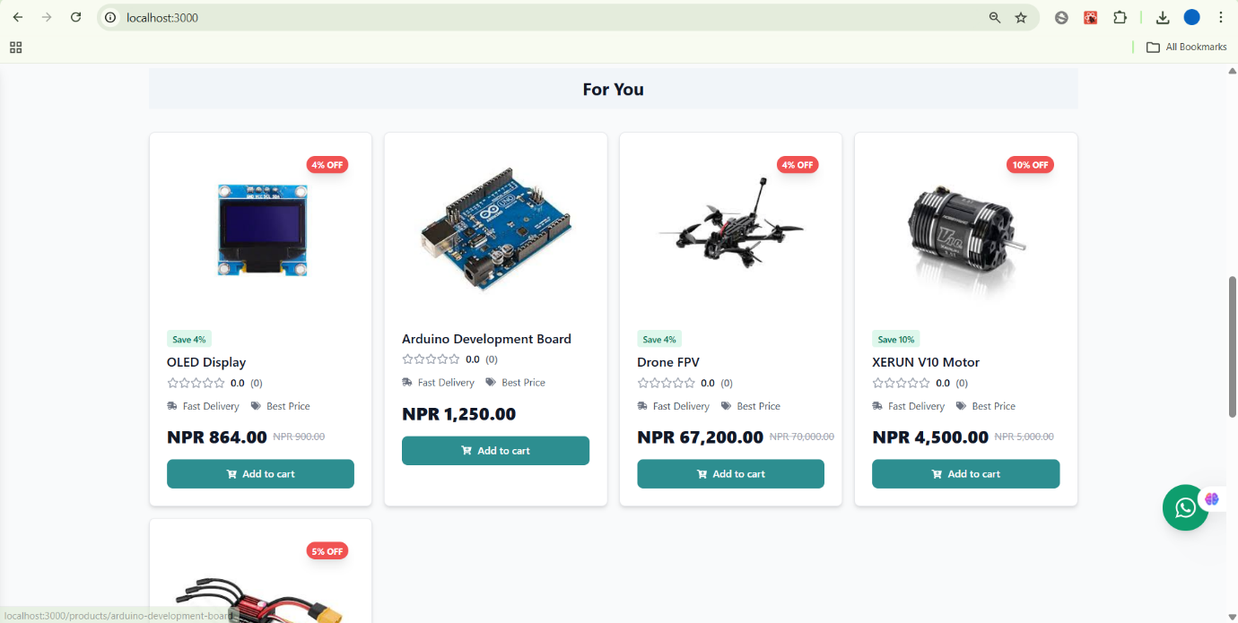
Figure 12: Homepage – Middle Section (Courses)

A.5 Homepage – Reviews Section
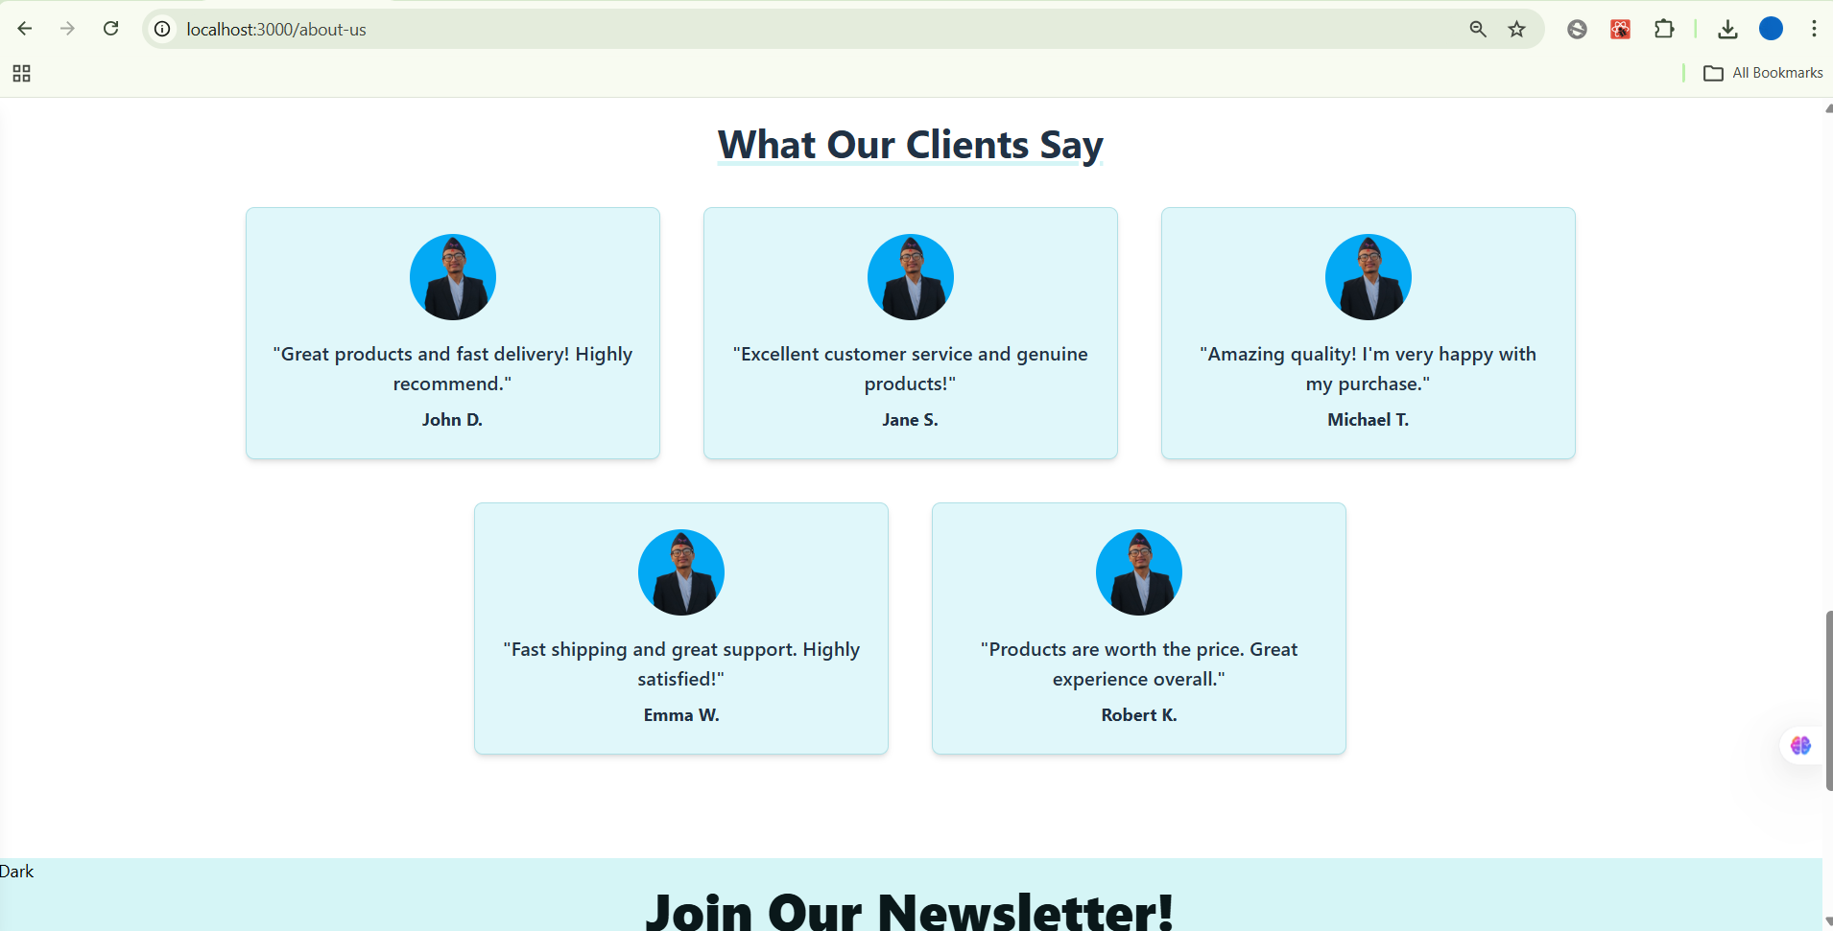
Figure 13: Homepage – Reviews Section

A.6 Homepage + Footer
Figure 14: Homepage + Footer
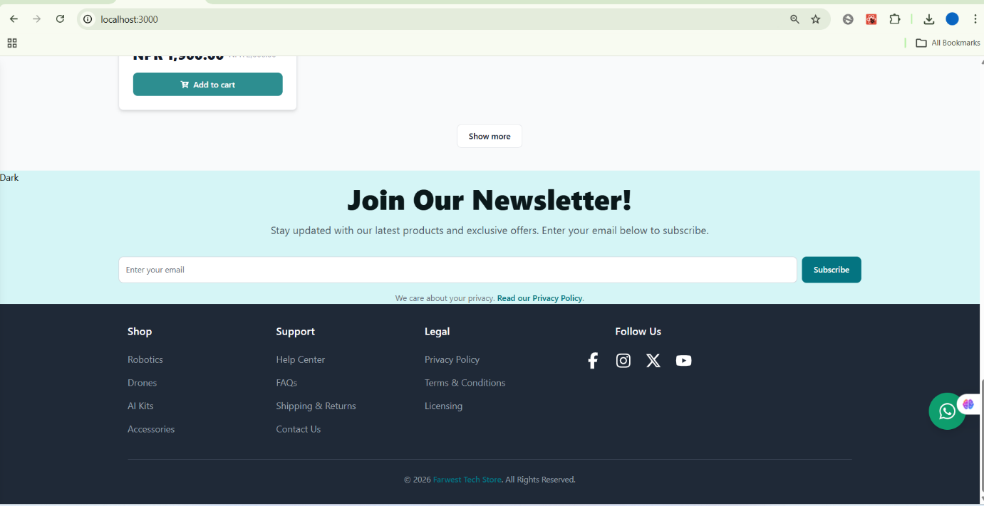

A.7 All Products Page (All Courses Listing)
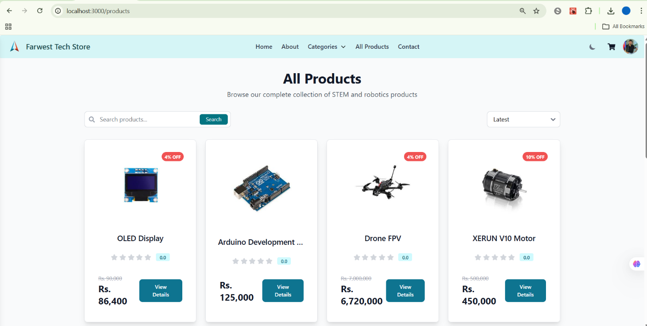
Figure 15: All Products Page (All Courses Listing)

A.8 Contact Page
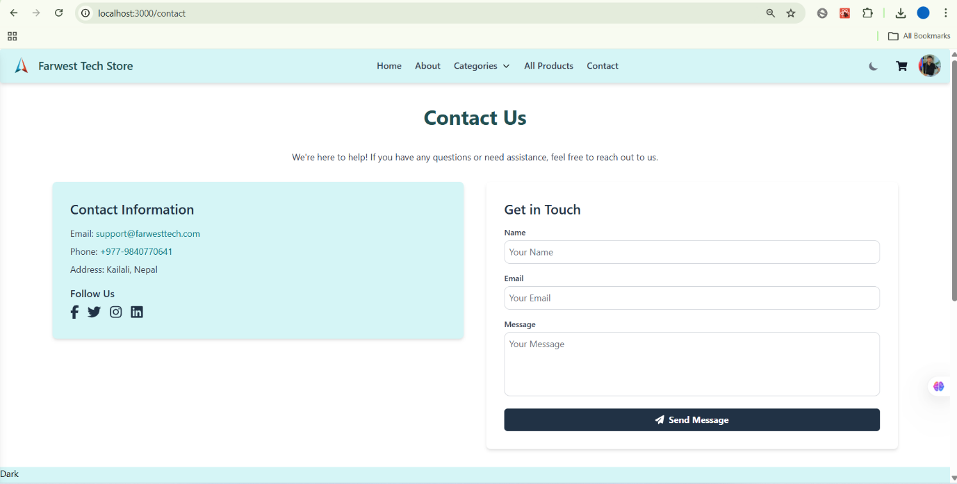

Figure 16: Contact Page

A.9 Products by Category Page
Figure 17: Products by Category Page
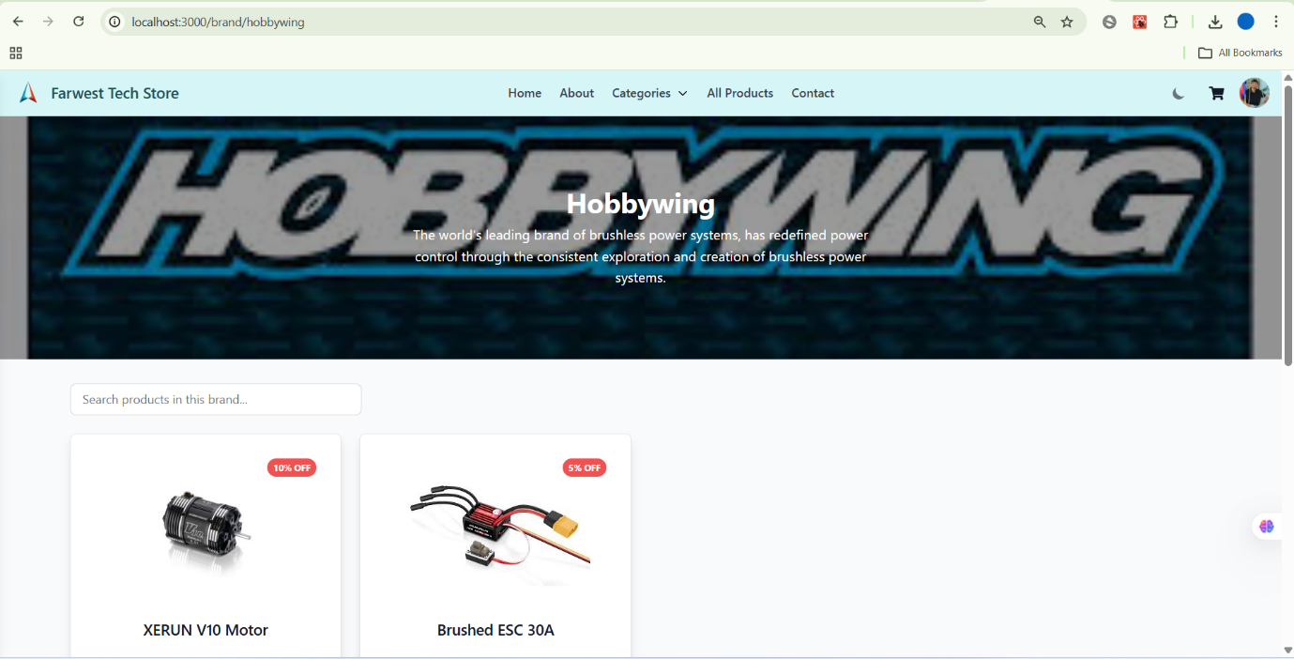

A.10 Checkout Page
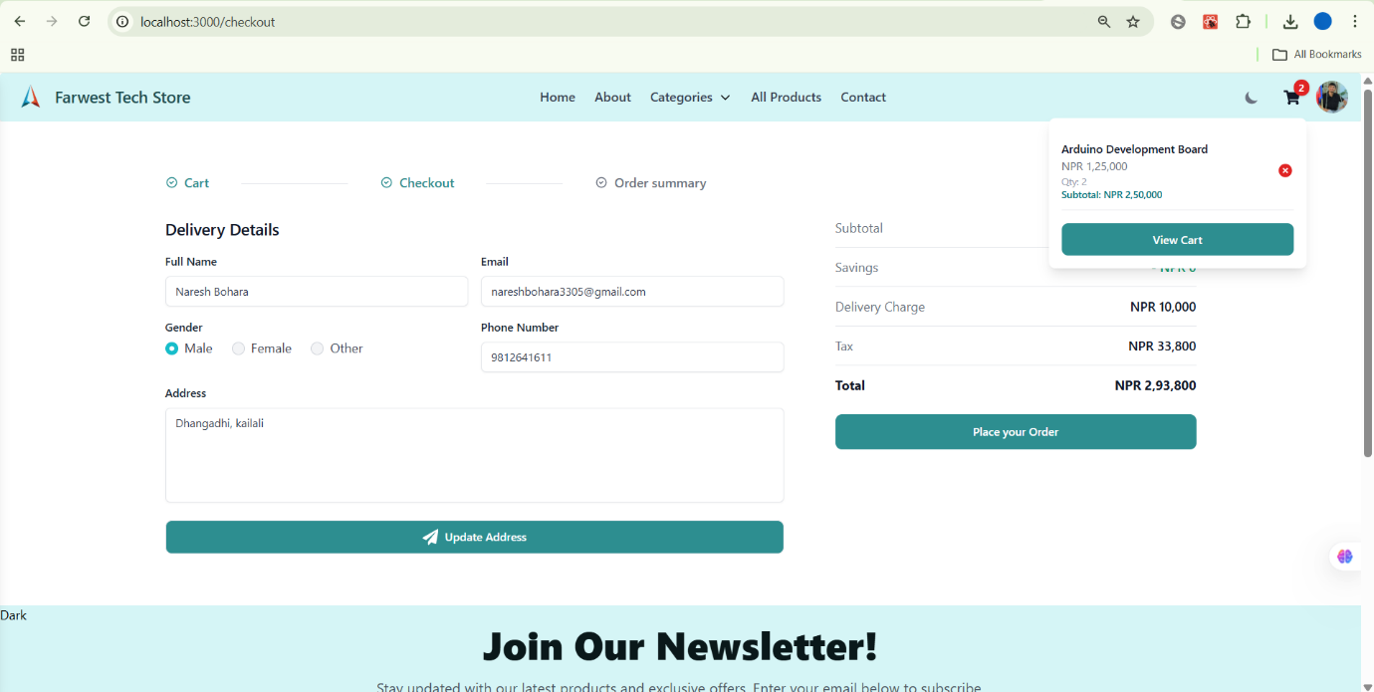

Figure 18: Checkout Page

APPENDIX B – ADMIN INTERFACE (BACKEND DASHBOARD)

B.1 Admin Dashboard (Main Overview)
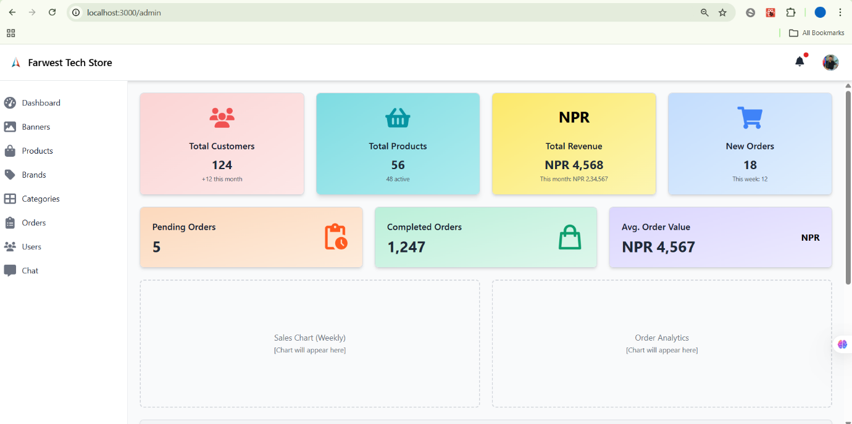
Figure 19: Admin Dashboard (Main Overview)

B.2 Create Product Page
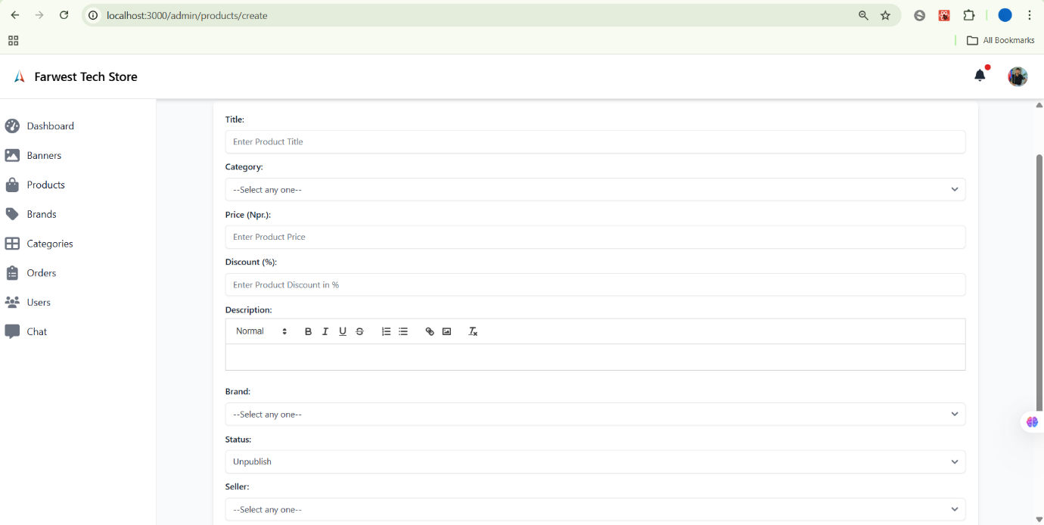
Figure 20: Create Product Page

B.3 Create Category Page
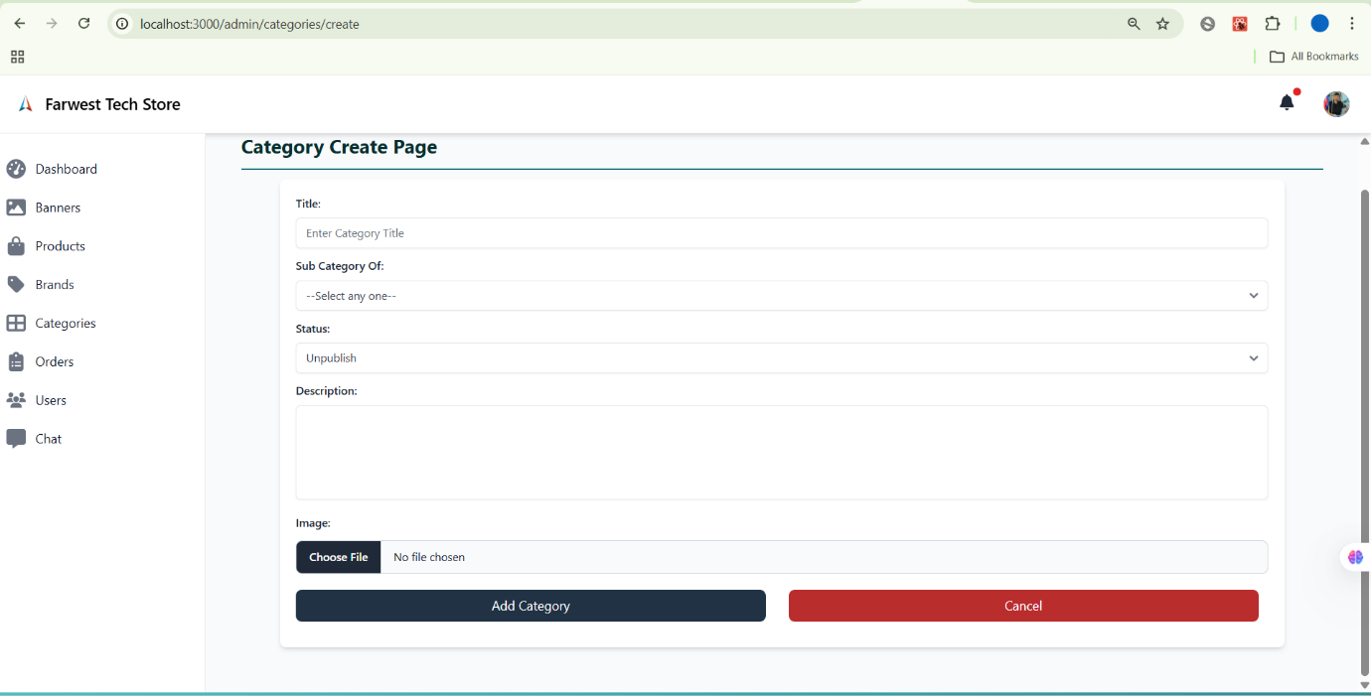
Figure 21: Create Category Page

B.4 Create Banner Page
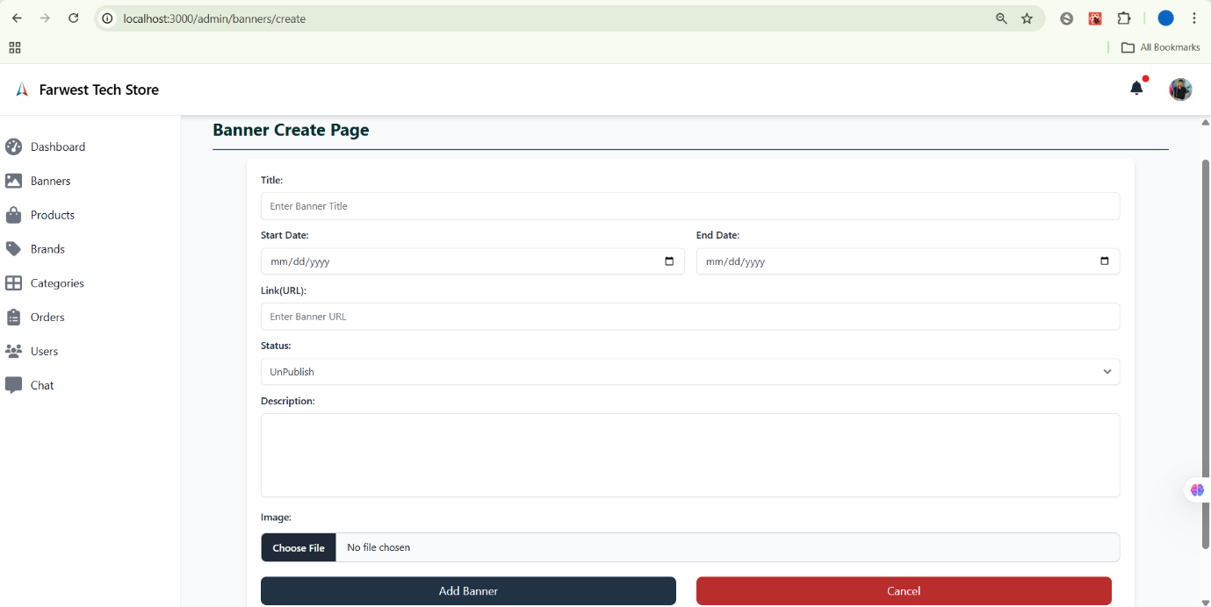

Figure 22: Create Banner Page

B.5 Order Page
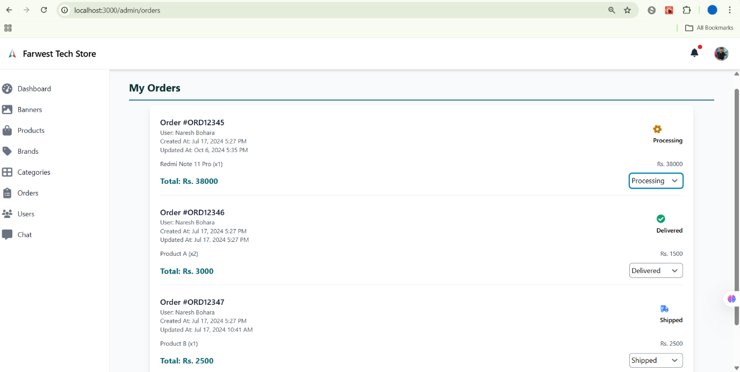
Figure 23: Order Page

APPENDIX C – DEVELOPMENT & DATABASE

C.1 Postman – Login API Test
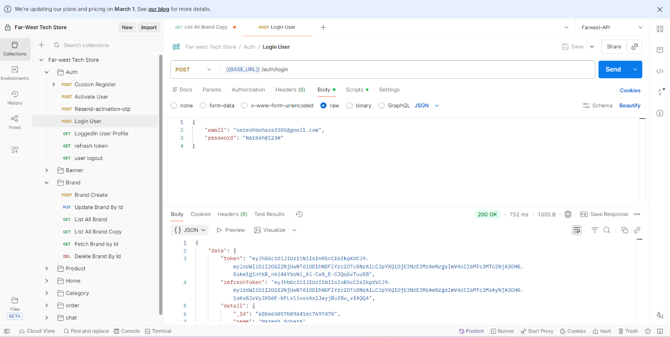

Figure 24: Postman – Login API Test

C.2 VS Code – Frontend (Login Component)
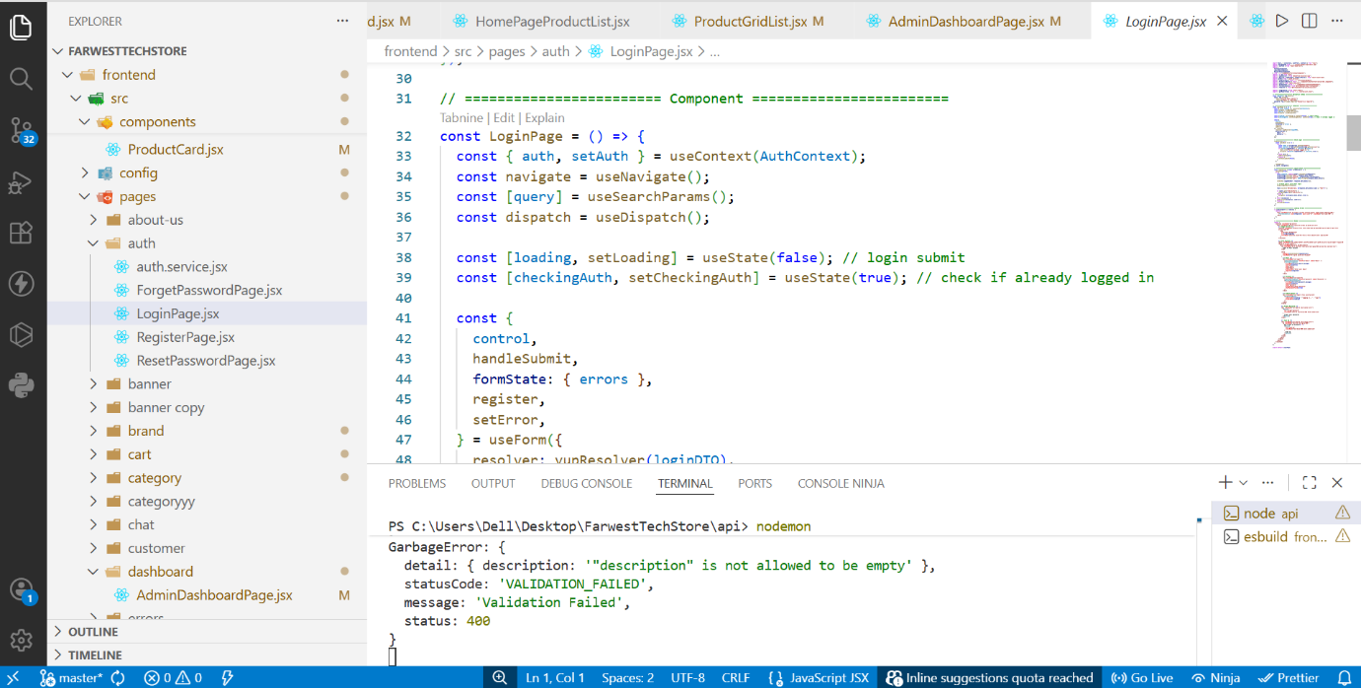
Figure 25: VS Code – Frontend (Login Component)

C.3 VS Code – Backend Code (index.js)
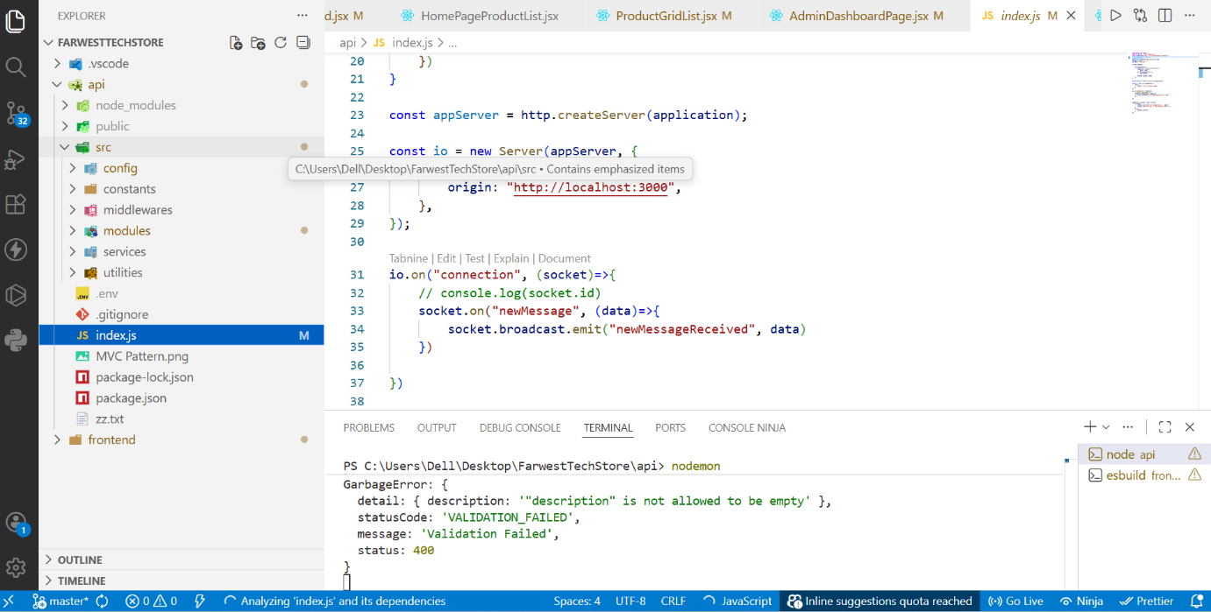
Figure 26: VS Code – Backend Code (index.js)

C.4 MongoDB Compass – Database Collections
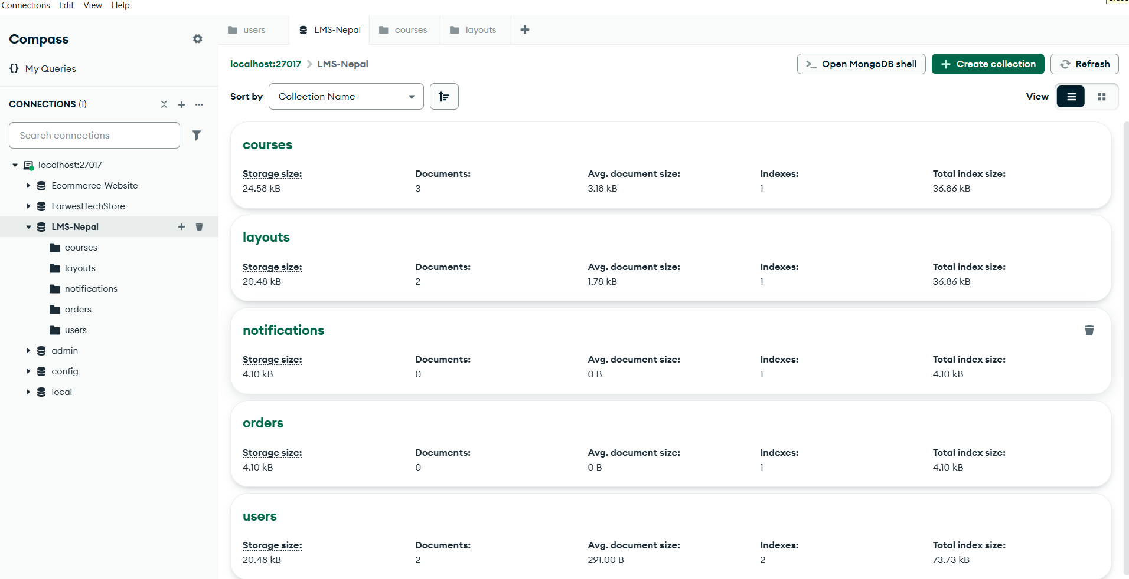
Figure 27: MongoDB Compass – Database Collections

