**Shiva: - Java Script :**

**Na – Limitations of JavaScript.**

* **Can’t Access DB, File systems using JavaScript.**
* **Can’t Access hardware such as USB.**

**Manipulates Web Pages - Java Script is client side language. It is sent to users computer and run on client machines. PHP,Ruby on Rails,ASP.Net run on server side deliver results to client.**

**Java Script is Case sensitive .**

**Variables :**

**var Year;**

**var customerEmail;**

**var x;**

**var foo;**

**variable is undefined till you set value to variable.**

**var year = 2015;**

**var myvariable = “Hello”;**

**var myboolean = true;**

**var mybolean = false;**

**if(condition)**

**{**

**// codes go here**

**}**

**Else**

**{**

**}**

**== 🡪 Equality**

**=== 🡪 Strict Equality**

**Demo:**

**var a = 5; 🡪 number**

**var b = “5”; 🡪 string**

**if(a==b) 🡪 returns true;**

**if(a===b) 🡪 returns false ;**

**&& 🡪 and**

**|| 🡪 or**

**Rest all loops are same as C#.**

**Functions :**

**function createMessage()**

**{//code goes here**

**}**

**createMessage();**

**Functions can return value;**

**You can return multiple values, and function need not have type defined. A single function can return all kind of data types.**

**Variable scope is same as other. Variable inside func is local else its global.**

**(isNaN) - is not a number .**

**Math.round(x);**

**Math.max, Math.min,Math.pi,Math.Sqrt**

**Retreiving Elements:**

**var MyElement =document.GetElementById(“someID”);**

**var MylistItems[] = document.GetElementsByTagName(“li”);**

**Changing Elements:**

**MyElement.setAttribute(“allign”,”right”);**

**mainTittle = document.GetElementById(“mainTittle”);**

**mainTittle**

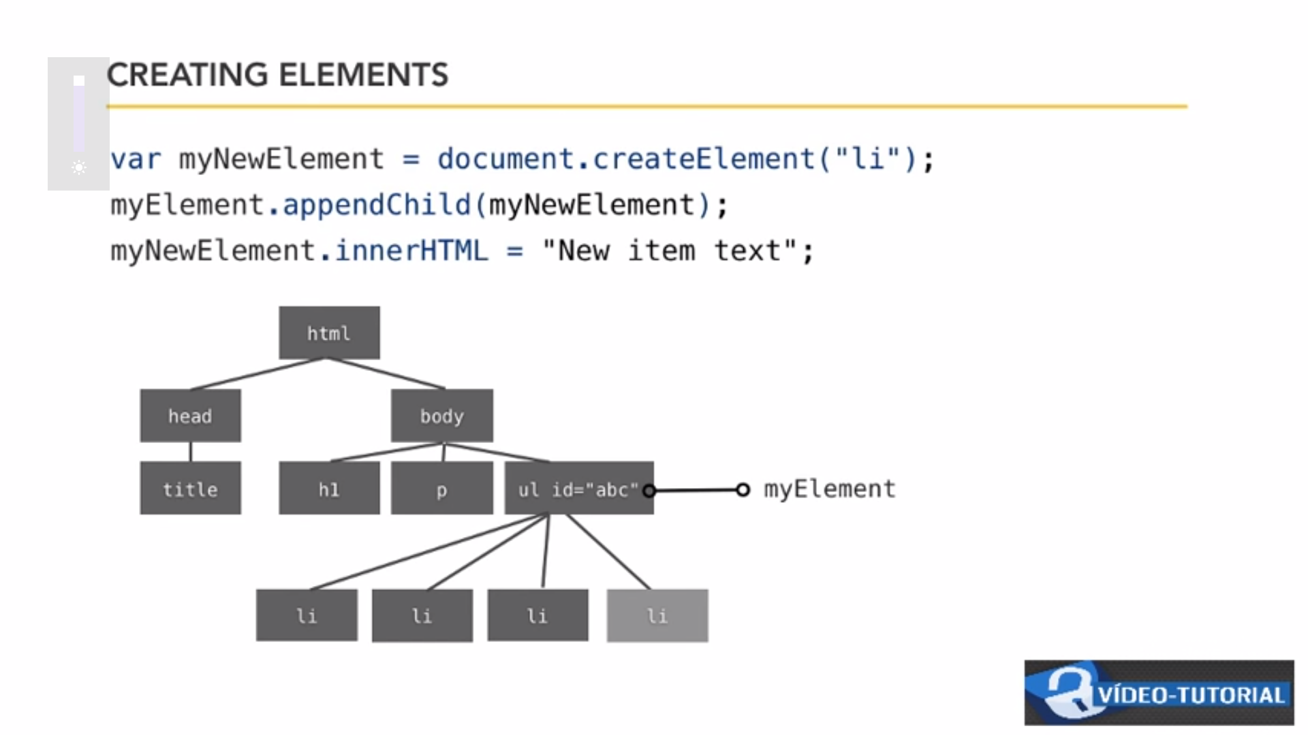

**Step 2**

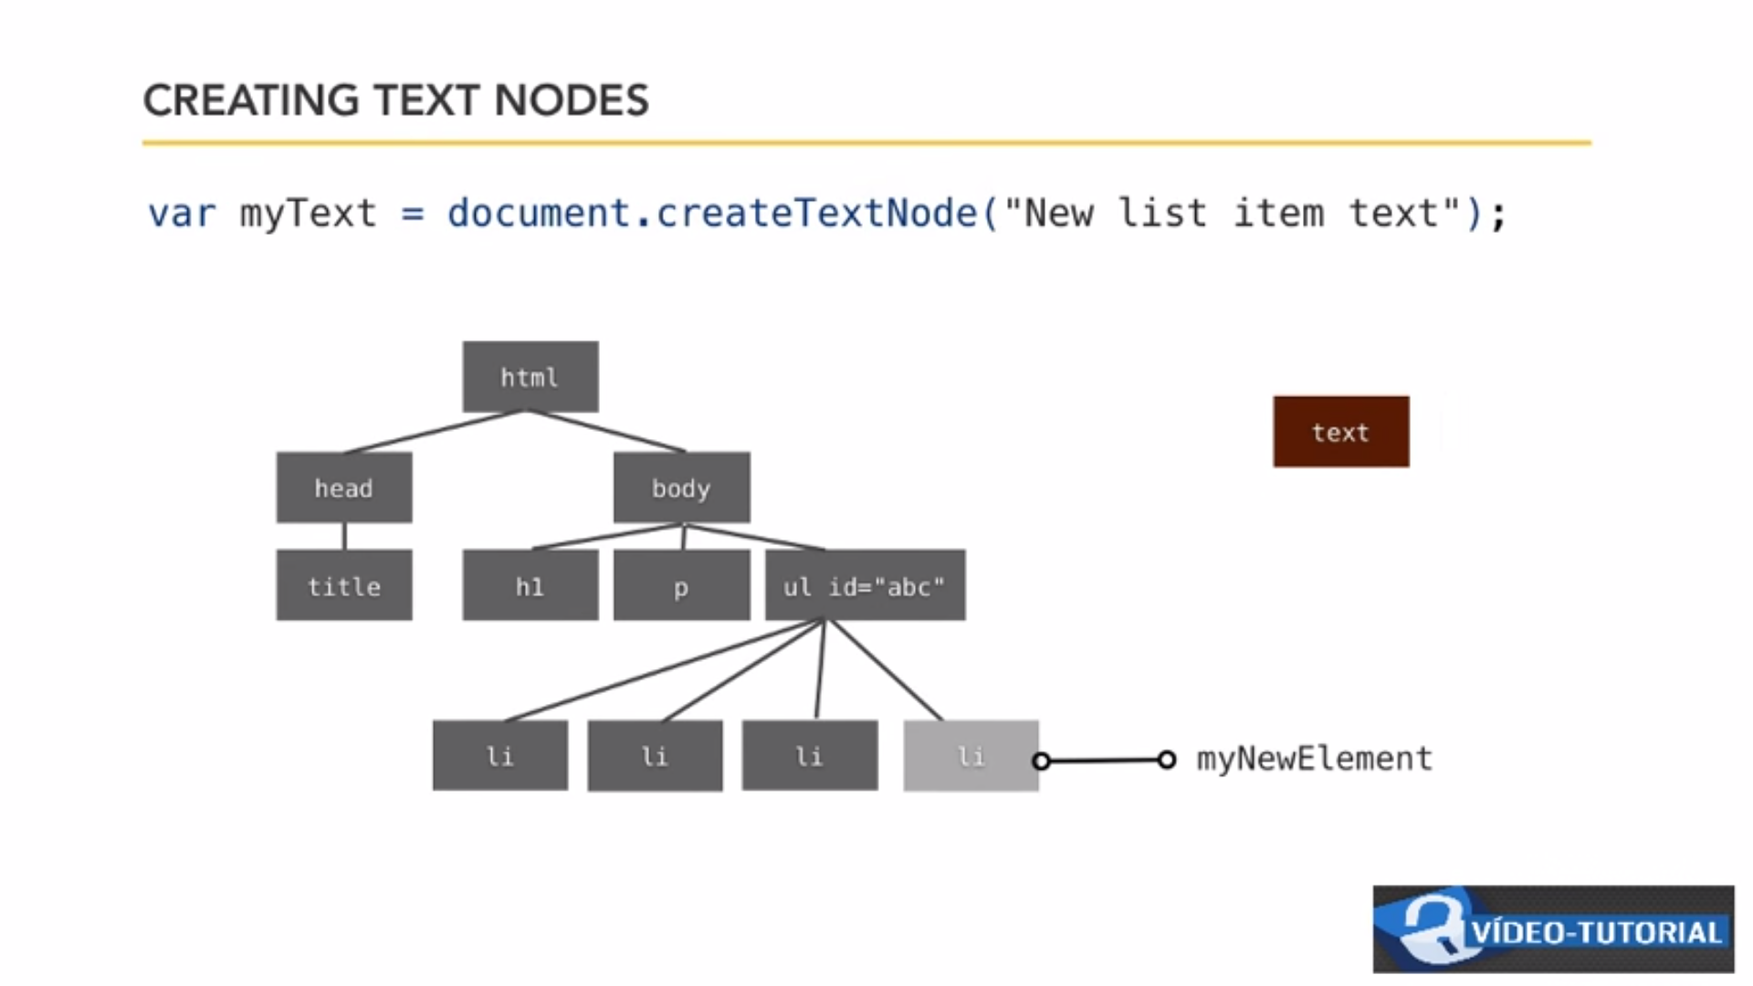

**To change/add new element follow below steps.**

1. **Create the element. 🡪 document.CreateElement(“li”); if paragraph p, etc..**
2. **Create a text Nodes = document.createTextNode(“New List Item Text”);**

**MyNewElement.appendChild(myText);**

**EVENTS and EVENTLISTENER:**

**EveryThing is a Event.**

**Onload**

**Onclick**

**Onmouseover**

**Onblur**

**Onfocus**

**Write a function for each of event.**

**Myelement.onclick = function (){}; 🡪 as it’s a single statement.**

**Another type.**

**Document.addEventListener(‘click’,myfunction,false);**

**Use JQuery for cross browser functions – Because AddEventLister will not work in IE8 but it has function AttachEvent, So there are many other like this. SO we use jQuery to cross browser fucntions. Its like common platform.**

**You should use only windows.onload event.**

[**https://www.youtube.com/watch?v=iE3tGbarTtk&list=PL5bVh07ELMxTQQzn7Qhi_4u4fq2JlxV8r&index=6&spfreload=1**](https://www.youtube.com/watch?v=iE3tGbarTtk&list=PL5bVh07ELMxTQQzn7Qhi_4u4fq2JlxV8r&index=6&spfreload=1)

**setTimeout 🡪 to set the time out.**

**setInterval 🡪**

**ClearTimeout 🡪**

**ClearInterval 🡪**

**lets say to change the image every 5000 millisecond. Store the images in array and use function to**