1.Install nginx and run nginx on port number 81

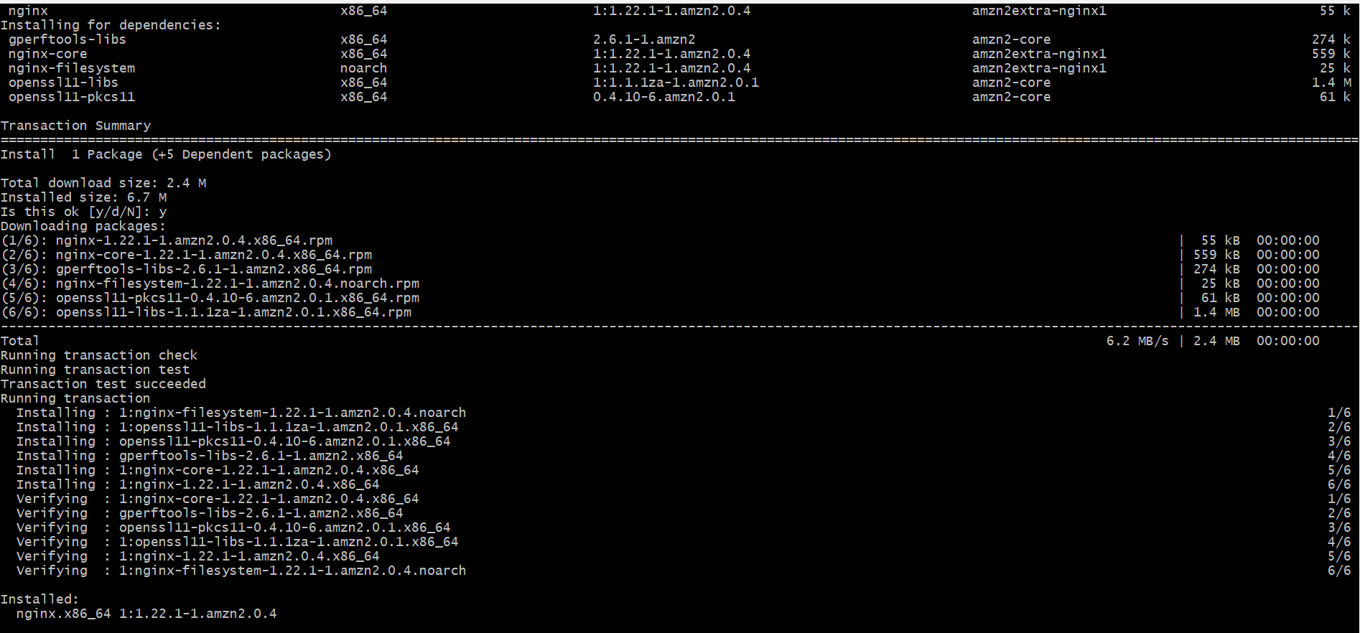

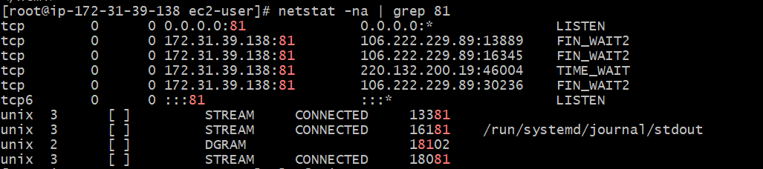

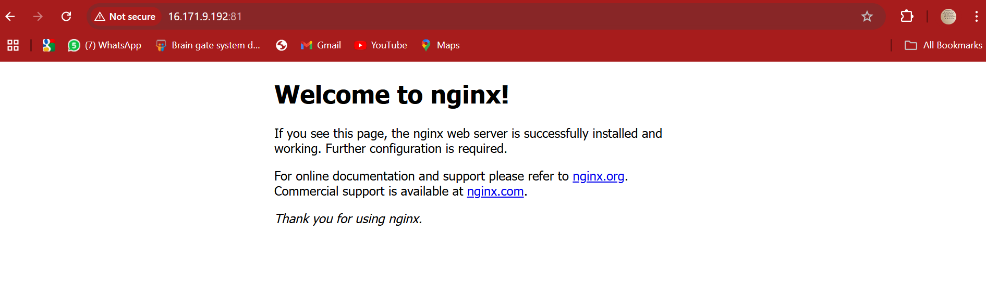

2.Deploy a sample index.html file on nginx.

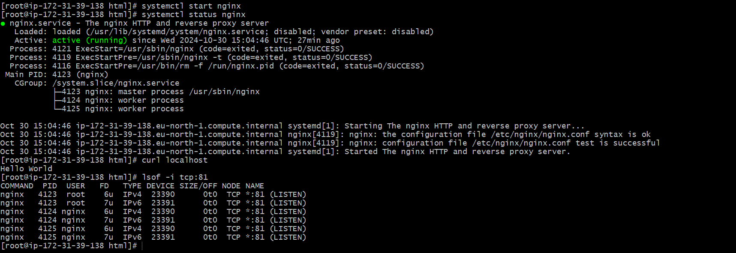

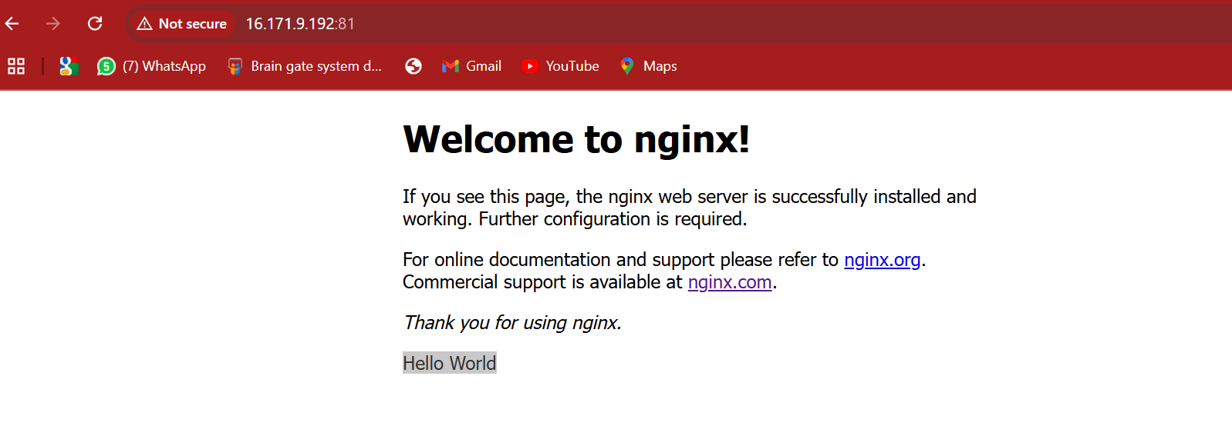

3.Install Apache and run Apache on port number 82

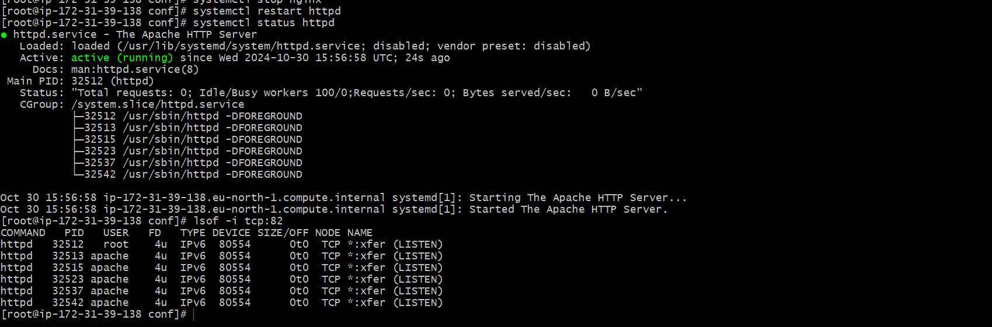



4.Deploy a sample index.html file on Apache

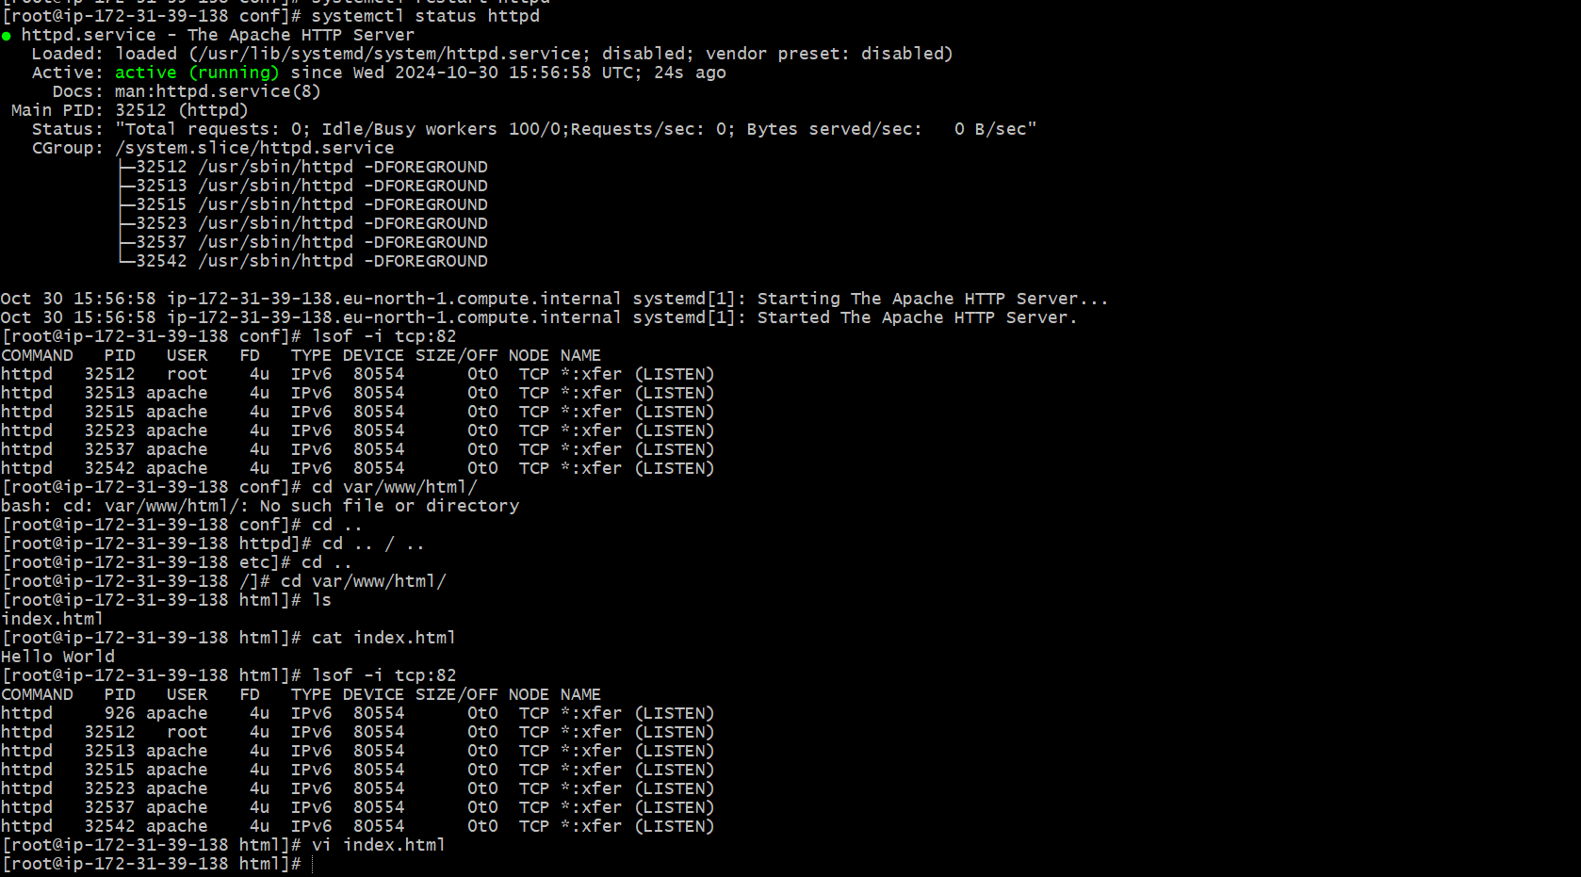

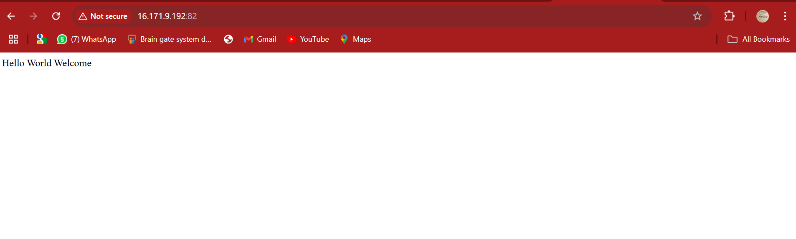

5.Install Apache tomcat on port number 8082

