INCIDENT LIFE CYCLE AUTOMATION

Functional System Design (FSD) Documentation
Implementation-oriented design for Incident Life Cycle Automation
━━━━━━━━━━━━━━━━━━━━━━━━━━━━━━━━━━━━━━━━━━━━━━━━━━━━━━━━━━━━━━━━━━━━━━
STUDENT NAME  Nareshkumar S | PROJECT  Incident Life Cycle Automation
DOCUMENT DATE  08 October 2026 | SCOPE  Incident lifecycle workflow & automation only

1. Introduction
Project Title: Incident Life Cycle Automation
Student Name: Nareshkumar S

2. Project Overview
The system manages operational incidents as a continuous workflow from intake to closure. The design focuses on visibility, ownership, SLA control and traceable history.
- Incident intake and unique identification
- Classification and priority
- Assignment and reassignment
- SLA monitoring and escalation
- Lifecycle status and work notes
- Resolution and closure
- Search, dashboard and audit history

3. Architecture
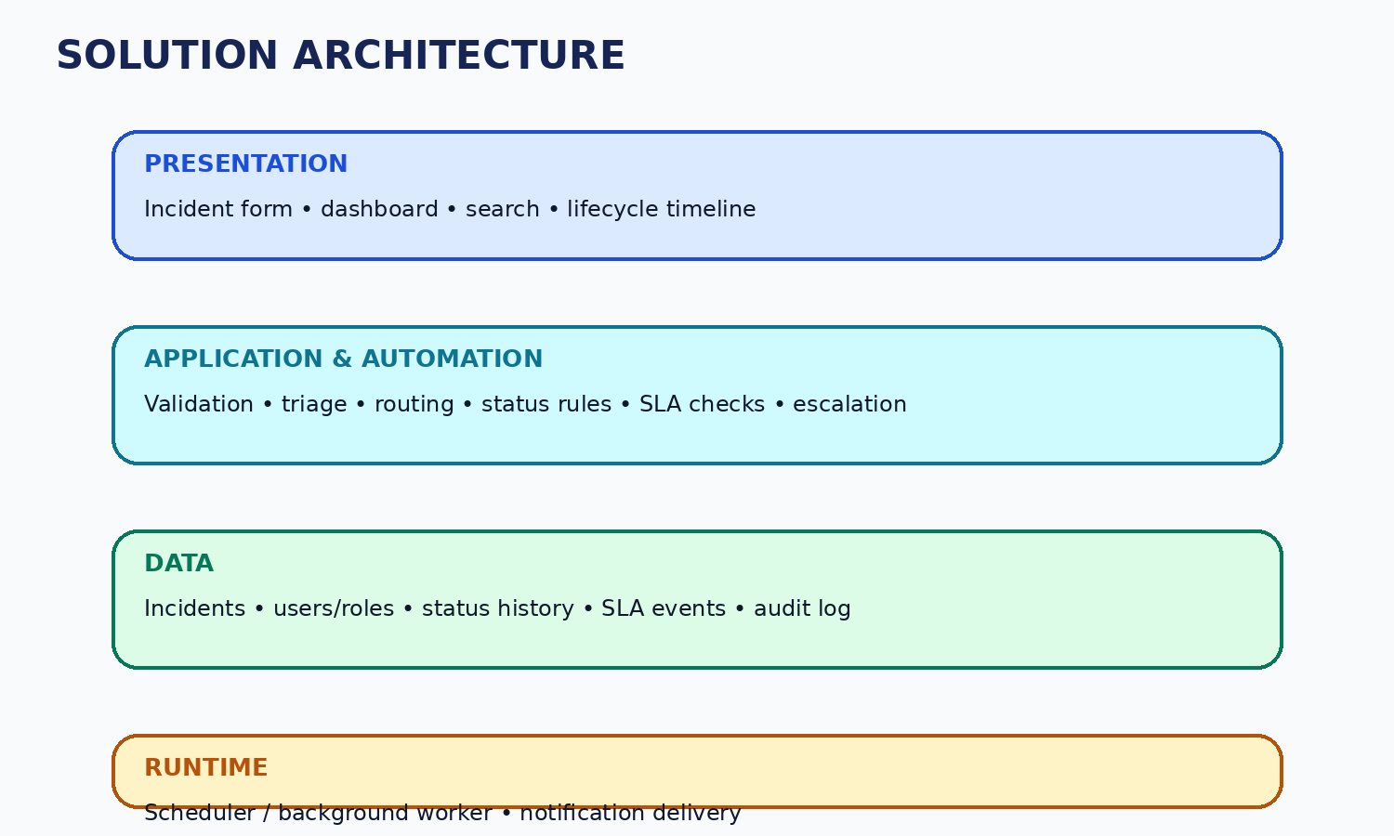

4. Logical Data Model
Entity | Key Data | Relationship
Incident | ID, title, description, source, category, impact, urgency, priority, status, owner, timestamps | Central record linked to users, history, SLA events and resolution.
User / Role | User ID, name, role, access scope | Controls who can view or modify incidents.
Status History | Incident ID, old/new status, actor, timestamp, note | One-to-many relationship with Incident.
SLA Event | Incident ID, due time, event type, triggered time, state | Tracks SLA and escalation lifecycle.
Audit Entry | Actor, action, entity, timestamp, context | Provides traceability for key changes.

5. Service Responsibilities
Service | Responsibility
Incident Service | Create, retrieve, update and close incidents.
Triage Service | Apply classification and priority rules.
Assignment Service | Resolve queue/owner and handle reassignment.
SLA Worker | Check due times and trigger escalation events.
Notification Service | Deliver assignment, status and SLA messages.
Audit Service | Store lifecycle and administrative history.

6. Testing
Functional, UAT and performance testing should be performed against the actual implementation. Results should be recorded from execution rather than assumed.

7. Known Limitations
The initial design focuses only on core incident lifecycle automation. Advanced integrations and analytics are not required for the baseline project.

8. Future Enhancements
Additional service-specific SLA policies, deeper reporting and selected external integrations can be considered after the core lifecycle is stable.

