Advanced Shell Simulation With Integrated OS Concepts:
Deliverable 2: CPU Scheduling and Process Management

Department of Computer Science, University of the Cumberlands
MSCS-630-M20: Advanced Operating Systems
Sean Perryman

Group Members:
Naresh Landam
Nikitha Desam
Subhash Kalal

Day 1 Git Repository: https://github.com/Nani-Nari/Advanced-Shell-Simulation-With-Integrated-OS-Concepts
October 24, 2026

Advanced Shell Simulation With Integrated OS Concepts

Introduction
This project extends the Python-based Unix-like command shell developed in Deliverable 1 by adding two CPU scheduling simulations: Round-Robin Scheduling and Preemptive Priority Scheduling. The existing shell continues to accept built-in commands, launch external programs, and support basic foreground and background job management. Deliverable 2 focuses on demonstrating how a scheduler chooses processes, responds to arrivals, handles interruptions, and reports process-level performance.

Design and Implementation
The implementation uses myshell.py as the interactive command interface and scheduler.py for the scheduling logic. Each simulated process has a name, burst time, priority, and arrival time. The shell exposes the sched add, sched list, sched reset, sched demo rr, sched demo priority, sched rr, and sched priority commands. Execution advances in discrete simulated ticks, with event messages for arrival, dispatch, quantum expiration, preemption, and completion. The simulator does not replace the operating system’s actual CPU scheduler.

Round-Robin Scheduling
Round-Robin Scheduling maintains a first-in, first-out ready queue. Each ready process receives a configurable time quantum. When its quantum expires and it still has work remaining, the process is returned to the end of the queue. Completed processes are removed. The Ubuntu demonstration used sched demo rr, sched list, and sched rr 2 with three processes: P1 (burst 5, arrival 0), P2 (burst 3, arrival 0), and P3 (burst 2, arrival 2). The output shows P1 running from time 0 to 2, P2 from 2 to 4, P3 from 4 to 6, followed by the remaining turns until time 10.

Preemptive Priority Scheduling
Preemptive Priority Scheduling selects the highest-priority ready process, using smaller numeric values to indicate higher priority. A newly arrived process can interrupt a running process when its priority is higher. The demonstration used sched demo priority, sched list, and sched priority. P1 initially ran with priority 3. At time 2, P2 and P3 arrived with priority 1; the scheduler printed “PREEMPT P1 -> P2 (higher priority).” P2 executed before P3, illustrating the tie-breaking behavior for equal-priority processes in this example.

Performance Measurements
For each process, turnaround time equals finish time minus arrival time; waiting time equals turnaround time minus CPU burst time; and response time equals first execution time minus arrival time. The following results were recorded from the actual Ubuntu output.
Run | Avg. waiting | Avg. turnaround | Avg. response
Round-Robin, quantum 2 | 4.33 | 7.67 | 1.33
Priority demo | 3.25 | 6.50 | 1.50
Custom priority | 2.33 | 5.33 | 0.67
Round-Robin, quantum 1 | 4.33 | 7.67 | 0.67
All measurements are in simulated time units. The built-in Round-Robin and priority examples have different workloads, so their averages should not be treated as a controlled head-to-head performance comparison.

Continuity With Deliverable 1
The Day 1 submission established the Shell and Job classes, command parsing with shlex, built-in file commands, subprocess.Popen() for external execution, and POSIX signal-based job control. Day 2 retains these capabilities and adds a separate simulated scheduling queue accessed through the sched command family. This distinction matters: foreground and background job management uses actual operating-system processes, while Round-Robin and priority runs model CPU execution in simulated time units.

Reproducible Ubuntu Commands
From Ubuntu WSL: cd ~/Residency_Day2; python3 test_scheduler.py; python3 myshell.py. Within myshell, use: sched demo rr; sched list; sched rr 2; sched demo priority; sched list; sched priority; sched reset; sched add A 4 3 0; sched add B 3 1 1; sched add C 2 2 2; sched list; sched priority; sched demo rr; sched rr 1. The actual terminal commands and outputs are documented in the figures below.

Testing and Execution Evidence
The following figures are original, unaltered Ubuntu WSL screenshots from the project execution. They are presented in the order of testing, with the figure labels above the images, consistent with the format used in Deliverable 1. The screenshots document actual terminal commands, scheduling events, Gantt timelines, and reported metrics.

Figure 1. Ubuntu project setup, file listing, and four passing automated tests
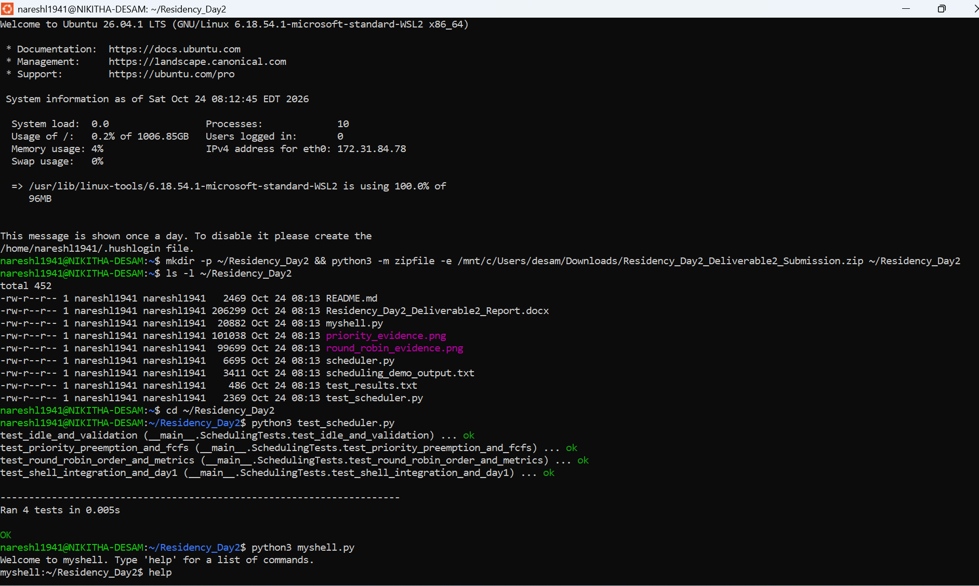

Figure 2. Shell help and Round-Robin commands with quantum = 2
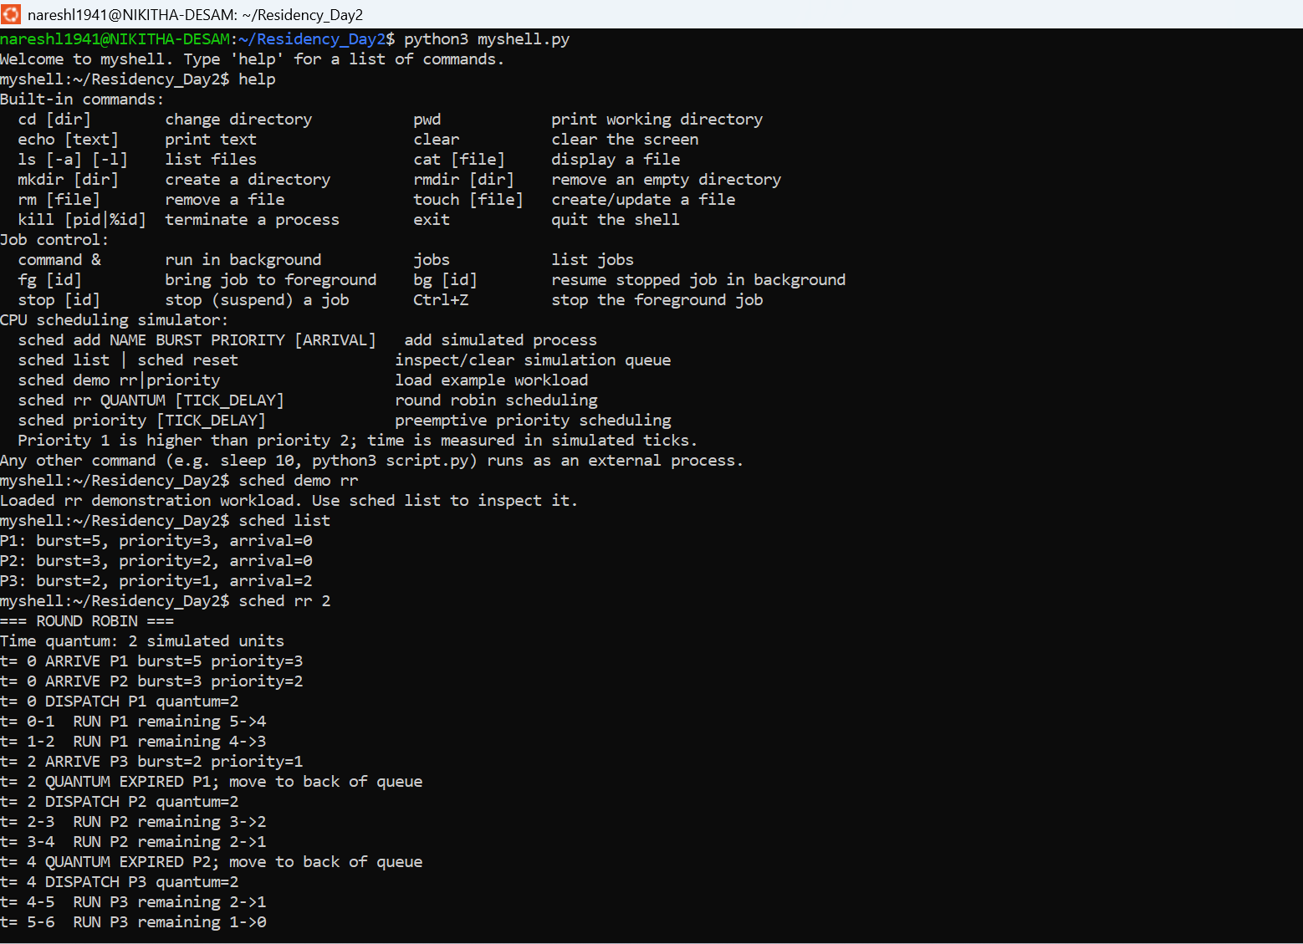

Figure 3. Round-Robin Gantt timeline and process metrics; Priority Scheduling begins
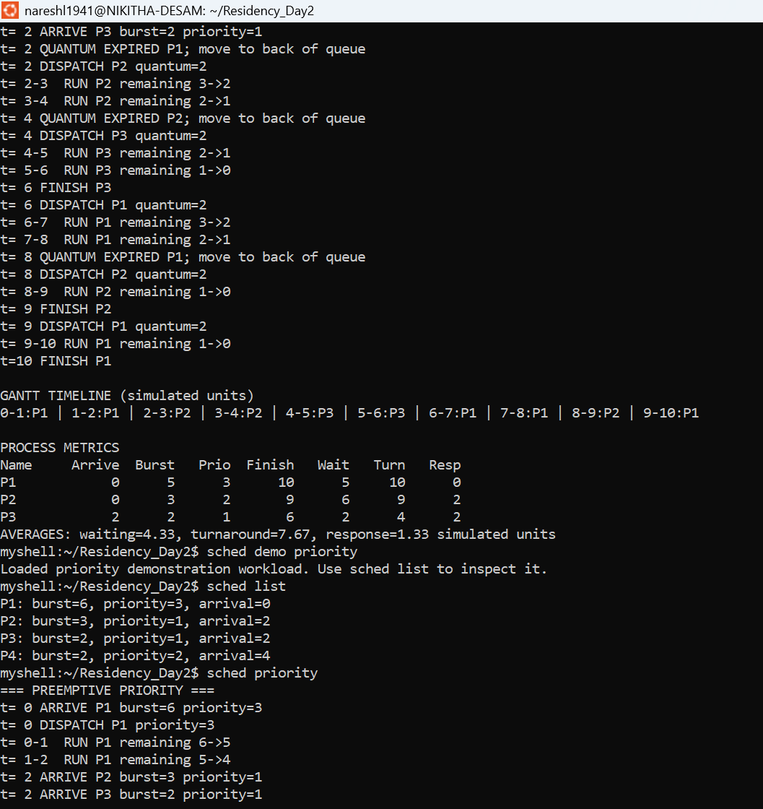

Figure 4. Preemptive Priority Scheduling, including the preemption event and final metrics
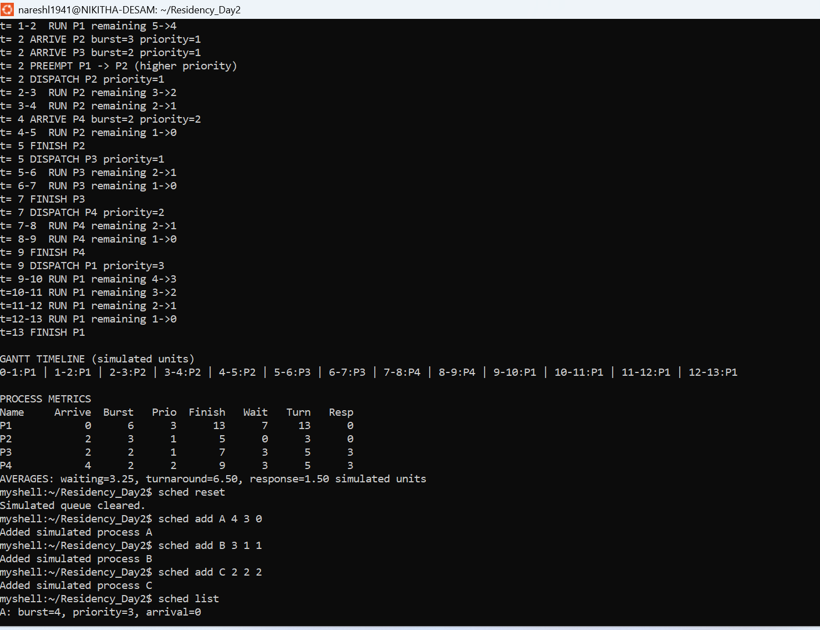

Figure 5. Custom processes A, B, and C: priority scheduling and verified results
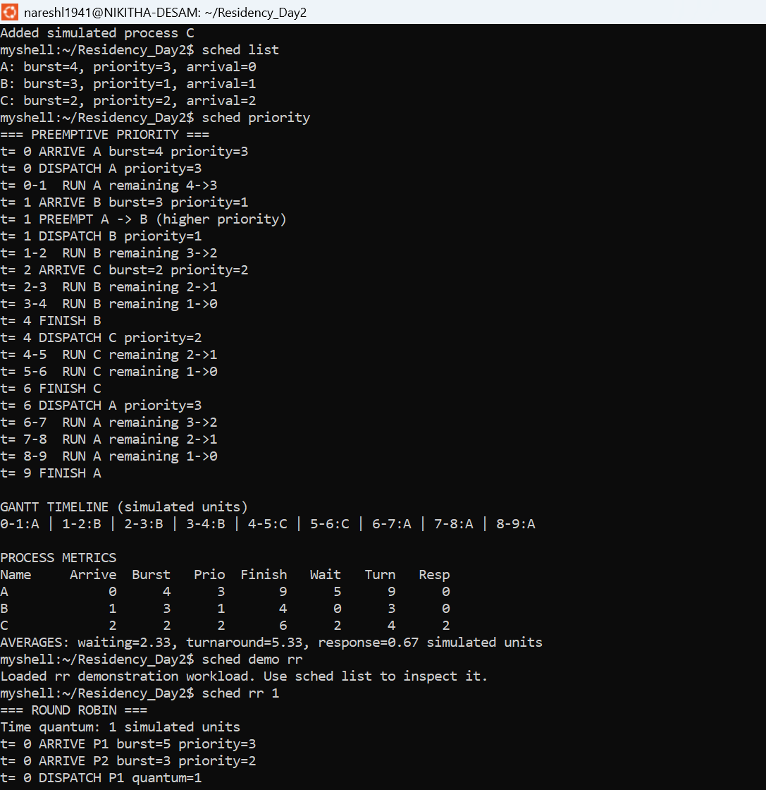

Figure 6. Round-Robin Scheduling with quantum = 1 and process metrics
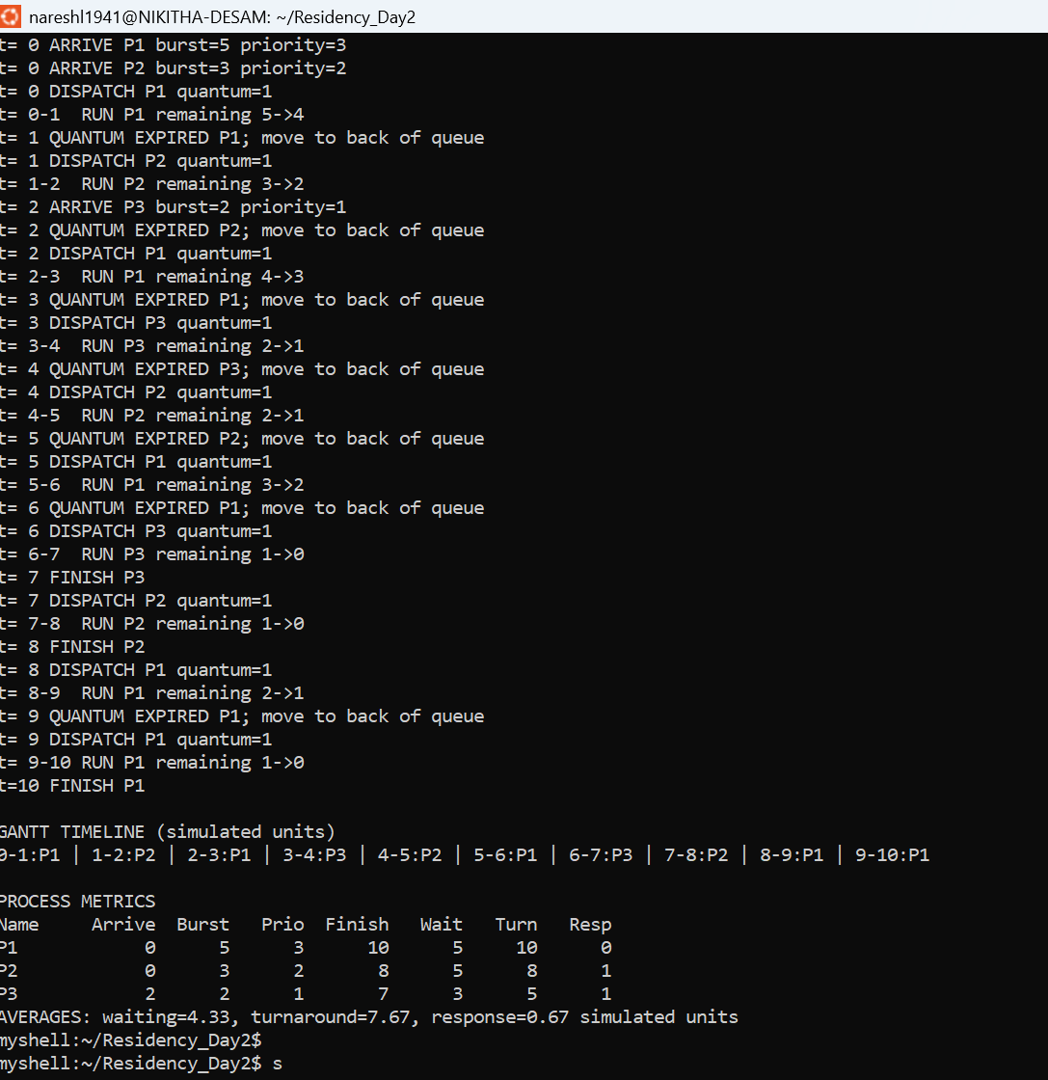

Custom Workload and Quantum Comparison
The custom priority test reset the simulation queue and added three processes with the commands sched add A 4 3 0, sched add B 3 1 1, and sched add C 2 2 2. Running sched priority produced the sequence A (0–1), B (1–4), C (4–6), and A (6–9). Process B interrupted A at time 1 because its priority was higher. The average waiting, turnaround, and response times were 2.33, 5.33, and 0.67 simulated ticks, respectively.
To demonstrate that the time quantum is configurable, the original Round-Robin workload was reloaded and run using sched rr 1. The resulting average response time was 0.67 ticks, compared with 1.33 ticks using quantum 2. Average waiting time remained 4.33 ticks and average turnaround time remained 7.67 ticks. A smaller quantum increased the frequency of scheduling decisions; this simulator does not report real operating-system context-switch overhead.

Validation and Error Handling
The Ubuntu test suite was executed with python3 test_scheduler.py. Four tests passed: idle time and validation, priority preemption and first-come-first-served tie handling, Round-Robin order and metrics, and shell integration with Deliverable 1. The screenshot in Figure 1 records the “Ran 4 tests” and “OK” messages. The shell’s help output also documents the supported scheduling command syntax.

Challenges and Improvements
A key challenge was preserving accurate ready-queue behavior while new processes arrive and unfinished processes are rescheduled. The simulator also needs to distinguish the first response time from total waiting time, especially after preemption. Future improvements could include modeling context-switch cost, adding other scheduling policies, supporting larger benchmark workloads, and displaying a more compact Gantt chart directly in the shell.

Conclusion
Deliverable 2 extends the Day 1 shell with two working CPU scheduling algorithms. Actual Ubuntu tests demonstrate quantum-based rotation, preemption when higher-priority work arrives, equal-priority ordering, custom process definitions, and performance measurements. The screenshots and four passing automated tests provide reproducible evidence that the simulated scheduler performs the expected operations.

References
Arpaci-Dusseau, R. H., & Arpaci-Dusseau, A. C. (2023). Operating systems: Three easy pieces (Version 1.10). Arpaci-Dusseau Books. https://pages.cs.wisc.edu/~remzi/OSTEP/
Tanenbaum, A. S., & Bos, H. (2023). Modern operating systems (5th ed.). Pearson.

Appendix A: Source Code Submission
The complete executable source code is supplied separately in myshell.py and scheduler.py, with automated validation in test_scheduler.py. In Ubuntu, enter the Residency_Day2 directory and run python3 myshell.py. The original screenshot files and scheduling demonstration output are also included in the project submission package.

Appendix B: Scheduling Data Structures and Time Simulation
The implementation uses collections.deque as the Round-Robin ready queue. Processes are dispatched in queue order, and an unfinished process is appended to the queue after its configured quantum expires. The quantum is supplied through the sched rr QUANTUM command. New arrivals are inserted at the appropriate simulated time, and completed processes are not returned to the queue.
For Preemptive Priority Scheduling, scheduler.py imports heapq and stores ready processes in a min-heap ordered by (priority, arrival, sequence, process). Lower numeric priority values are scheduled first. Arrival time and original insertion sequence provide deterministic first-come-first-served ordering for equal priorities. When the ready heap contains a process with a strictly higher priority than the current process, the current process is preempted and returned to the heap.
The simulation advances one discrete tick at a time. The optional TICK_DELAY argument is implemented using time.sleep(tick_seconds), with a permitted delay from 0 to 2 seconds per simulated tick. A delay of zero runs immediately; a positive delay makes scheduling transitions easier to observe without changing simulated waiting, turnaround, or response time calculations.
Optional demonstrations: sched rr 2 0.1 and sched priority 0.1. These commands illustrate the supported timing feature; the submitted screenshots document the default no-delay runs, not these optional demonstrations.

Submission Contents
The accompanying ZIP archive includes this report, myshell.py, scheduler.py, test_scheduler.py, README.md, scheduling_demo_output.txt, test_results.txt, and the available scheduling evidence images. Complete executable source code is supplied as separate Python files rather than reproduced in the body of the report.

