Residency Day 1 – Project Deliverable 1
Advanced Shell Simulation with Integrated OS Concepts
Basic Shell Implementation and Process Management
Course: Advanced Operating Systems (MSCS-630)
Student: __________________________
Date: October 23, 2026

1. Project Overview
For Deliverable 1, I implemented a command-line shell in Python. The program accepts user input, identifies commands that are handled internally, and starts external programs when needed. It also keeps track of background jobs and allows a user to inspect, resume, or bring them into the foreground. The scope is intentionally limited to the shell and process management requirements for this deliverable.

2. Implementation and Built-in Commands
The shell uses a read–execute loop. Python shlex.split() separates command arguments while respecting quotation marks. A command dispatcher handles built-in operations directly; all other commands are located using shutil.which() and started through subprocess.Popen(). The following commands are implemented:
Command | Function
cd | Change current directory
pwd | Show working directory
exit | Close shell
echo | Print text
clear | Clear interactive terminal
ls | List directory entries
cat | Read file contents
mkdir / rmdir | Create / remove empty directory
rm | Remove a file
touch | Create file or update timestamp
kill | Send SIGTERM to PID
jobs / fg / bg | Inspect, foreground, and resume background jobs

3. Process Creation and Management
External commands are started using subprocess.Popen(), which delegates process creation to the host operating system. Each new external process receives its own process session using start_new_session=True. The shell displays the operating system PID so the process can be observed and terminated. This implementation uses the host OS for real process creation and signaling; it does not claim to implement an independent kernel.
Foreground commands block the shell until the command finishes or is stopped. The shell checks process state with waitpid() and wait-related status flags. A foreground Ctrl+C is handled by sending SIGINT to the child process group while leaving the shell alive. For a command ending in &, the shell starts the child without waiting, assigns an internal job number, and returns to the prompt. A job table records the job number, PID, original command, and state (Running, Stopped, or Done).
The jobs command prints tracked background jobs. The fg command resumes a stopped job if necessary and waits for it to finish. The bg command sends SIGCONT to a stopped job so it can continue in the background. The kill command sends SIGTERM to a supplied PID. These controls are based on POSIX signals, so this version runs on Linux or macOS, including Linux through Windows Subsystem for Linux (WSL).

4. Execution Evidence
The figures below display terminal-style renderings of actual output captured by the included verify.py test script. Process IDs and working directories depend on the machine running the test. These images are reproducible test evidence, not photographs of an interactive desktop terminal.

4.1 Built-in Commands
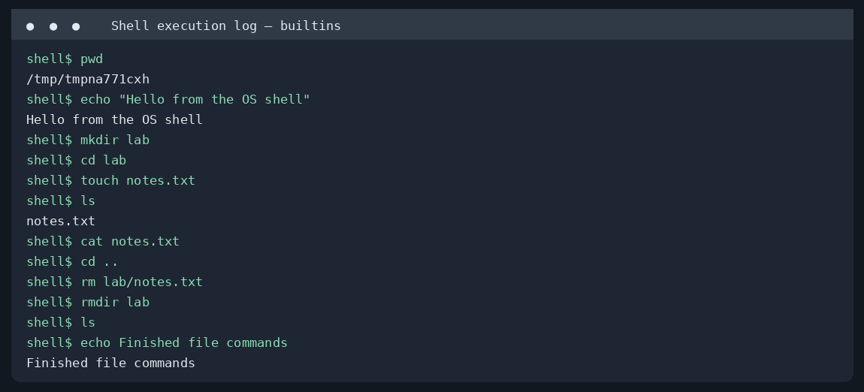
Figure 1. File and directory commands, current directory, and echo.

4.2 Foreground and Background Job Control
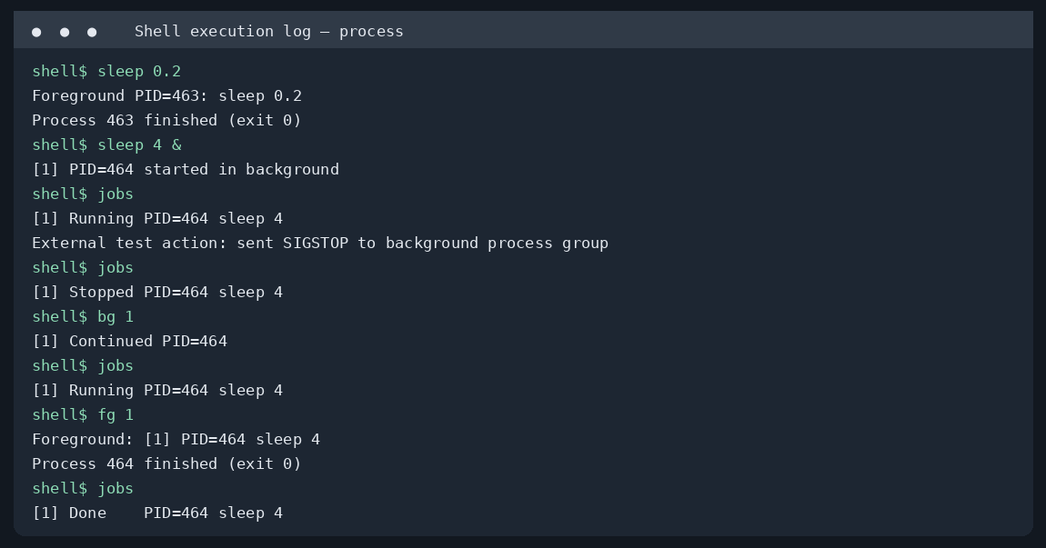
Figure 2. Foreground wait, background job creation, externally stopped job, bg resume, and fg completion.

4.3 Error Handling
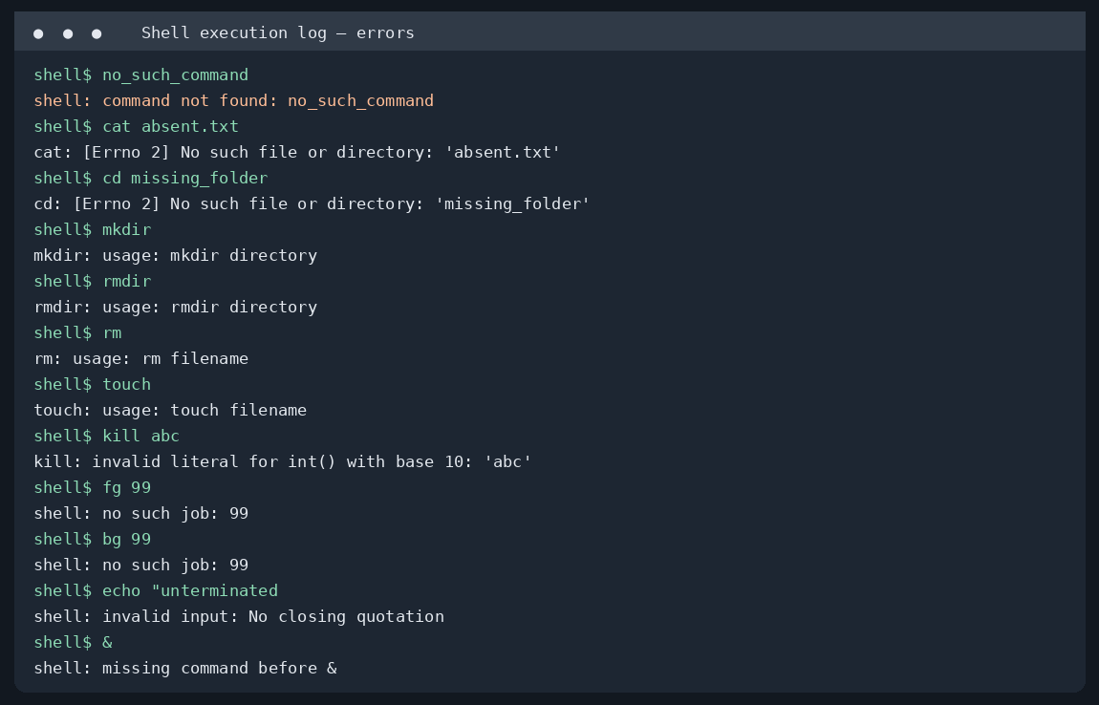
Figure 3. Invalid command, missing file, missing arguments, invalid job IDs, and unmatched quotation marks.

4.4 Terminating a Process
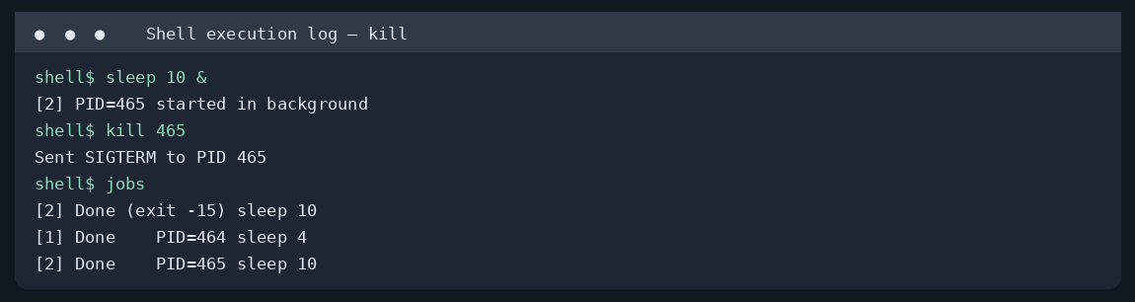
Figure 4. SIGTERM sent to a real background process; its termination appears in the job table.

5. Error Handling
The command parser catches malformed quotation marks before execution. Unknown external commands produce a “command not found” message. File and directory operations catch operating system errors, such as missing files, missing directories, or attempts to remove a nonempty directory. Built-ins check required argument counts and print usage instructions. The job-control commands validate numeric job IDs and report missing or already completed jobs. Process-start failures are caught and displayed without crashing the command loop.

6. Challenges and Improvements
A key design challenge is that commands such as cd must run in the shell process itself. Running cd as an external child would not change the shell’s own working directory. I therefore separated built-ins from external commands. A second challenge is allowing the prompt to return immediately for background commands while retaining enough information to manage them later. A job table and periodic status checks address this. A third challenge is distinguishing a stopped process from a finished one; POSIX wait flags and SIGCONT provide a basic solution.
There are limitations. The shell currently supports a single external process per command, not pipelines or redirection. It uses POSIX signals and is not a native Windows shell. Its job control is basic rather than full terminal job control; for example, it does not implement complete terminal foreground-process-group handoff or a shell-level stop shortcut. A later improvement would add terminal control with tcsetpgrp(), richer command history, redirection, and a more complete asynchronous job-state monitor. Scheduling, memory management, synchronization, and security remain outside the scope of Deliverable 1.

7. How to Run and Verify
Requirements: Python 3.9 or later on Linux/macOS (or WSL on Windows). Open a terminal in the folder containing shell.py. Run “python3 shell.py”. Try “pwd”, “mkdir lab”, “cd lab”, “touch file.txt”, “ls”, “cd ..”, and “sleep 5 &”. Use “jobs”, “fg 1”, and “kill PID” to demonstrate process control. Type “exit” to close the shell. For repeatable verification, run “python3 verify.py” from the same folder; it creates the four text execution logs.
Submission contents: shell.py (main source), verify.py (repeatable tests), four execution-output images, and this report. The Python source is the authoritative implementation; the output images document observed test behavior.

