PROJECT REPORT
on
SMART PARKING MANAGEMENT SYSTEM
(SmartParking)
By
Narendra Balunda - 31
Naresh Chandra Kumawat - 32
School Of Information Technology(SOIT)
MSC(CS)

Academic Year: 2025–27

ACKNOWLEDGEMENT
We take great pleasure in presenting our project titled "Smart Parking Management System (SmartParking)", completed as part of the academic curriculum for the degree of MSC(CS).
We would like to express our sincere gratitude to our respected guide for their valuable guidance, continuous support, and encouragement throughout the development of this project. Their insightful suggestions and constructive feedback helped us in successfully completing this work.
We are also thankful to all the faculty members of the department for providing us with the necessary knowledge and resources required for the completion of this project.
We extend our heartfelt thanks to our friends and classmates for their support, cooperation, and valuable suggestions during the project development phase.
Finally, we would like to thank our family members for their constant motivation and encouragement, which helped us complete this project successfully.
This project has helped us gain practical knowledge in web technologies, database management, backend API development, JWT-based authentication, and real-time email notification systems, and has been a valuable learning experience for us.
Project Team
Smart Parking Management System (SmartParking)
MSC(CS)
Academic Year: 2025–26

TABLE OF CONTENTS
CHAPTER 1: INTRODUCTION
1.1 Existing System and Need for System 4 1.2 Scope of Work 5 1.3 Operating Environment – Hardware and Software 6
CHAPTER 2: PROPOSED SYSTEM
2.1 Proposed System 7 2.2 Objectives of System 8 2.3 User Requirements 9
CHAPTER 3: ANALYSIS & DESIGN
3.1 Data Flow Diagram (DFD) 10 3.2 Functional Decomposition Diagram (FDD) 11 3.3 UML Diagrams 12 3.3.1 Class Diagram
12 3.3.2 Object Diagram 13 3.3.3 Use Case Diagram 14 3.3.4 Sequence Diagram 15 3.3.5 Collaboration Diagram
16 3.3.6 State Diagram 17 3.3.7 Activity Diagram 18 3.3.8 Component Diagram 19 3.3.9 Deployment Diagram
20 3.4 Entity Relationship Diagram (ERD) 21 3.5 Data Dictionary 22 3.6 Table Design 23 3.7 Code Design 24
CHAPTER 4: USER MANUAL
4.1 Operations Manual / Menu Explanation 26 4.2 Menu Screens 27 4.3 Project Code 28
CHAPTER 5: TESTING
5.1 Testing Test Plan 32 5.2 Black Box Testing or Data Validation 33
5.3 White Box Testing or Functional Validation 34

5.4 Test Cases and Results 35
CHAPTER 6: LIMITATIONS AND ENHANCEMENT
6.1 Drawbacks and Limitations 37 6.2 Proposed Enhancements 38 6.3 Conclusions 39 6.4 Bibliography 40

CHAPTER 1: INTRODUCTION
1.1 Existing System and Need for System
In modern urban environments, parking management has become one of the most pressing challenges faced by city dwellers, shopping malls, hospitals, and educational institutions. The conventional approach to parking relies entirely on manual operations —security guards directing vehicles, physical token systems, and paper-based records — all of which are inherently inefficient, error-prone, and unable to scale with rising vehicle populations.
Traditional parking systems suffer from numerous shortcomings. Drivers must physically explore an entire parking facility looking for a vacant spot, wasting significant fuel and time. There is no centralized visibility into slot availability, no digital record of active bookings, and no mechanism for prior reservation. Disputes over occupied slots are common, and revenue leakage due to untracked entries is significant.
Furthermore, the COVID-19 pandemic accelerated the demand for contactless, digital-first solutions across all sectors. Parking is no exception. The need for a system that allows users to browse available parking spots, make reservations in advance, receive real-time email confirmations, and manage their bookings entirely from a web browser is more urgent than ever.
The SmartParking Management System was conceived to directly address all these pain points. It replaces fragmented, manual workflows with a fully integrated, web-based platform that connects three key actors: Parking Hosts (who list and manage their spots), Users (who search, book, and cancel reservations), and Administrators (who oversee platform-wide operations). Every significant action — registration, login, booking, and cancellation — is accompanied by an automated email notification, ensuring transparency and trust at every step.
1.2 Scope of Work
The scope of the SmartParking project encompasses the design, development, testing, and deployment of a full-stack web application for intelligent parking spot management. The system is built using ASP.NET Core 8.0 for the backend REST API, a vanilla HTML/CSS/JavaScript frontend, and MySQL as the persistent relational database.
The key functional areas covered within this project are:

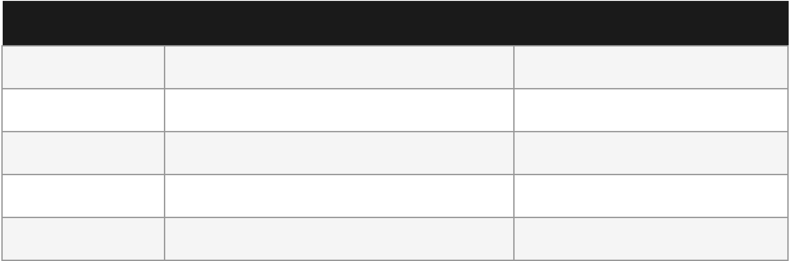

User Authentication: Secure registration and login using JWT (JSON Web Tokens)
 | with role-based access co  Parking Spot Manageme details such as name, add  Booking System: Registe add their vehicles, and co to prevent double-booking.  Email Notification Servi dispatches automated co confirmation, cancellatio  Forgot Password Flow: A 6-digit OTP with a 15-mi their passwords safely.  Vehicle Management: Us bookings.  Admin Dashboard: An ad  Camera Integration: A ca for advanced tracking.  The scope explicitly ex development, and IoT-based p enhancements.  1.3 Operating Environment –  Hardware Requirements  Component Minimum R  Processor Intel Core i  RAM 4 GB  Storage 20 GB HDD  Network Broadband  Display 1024×768 r  Software Requirements  Component | ntrol (User, Host, Admin).  nt: Hosts can list, update, and remove parking spots with ress, GPS coordinates, price per hour, and total capacity.  red users can search for available spots, select time slots, nfirm reservations. The system enforces conflict detection g.  ce: An integrated SMTP email service using Gmail nfirmations for registration, login alerts, booking n, and password reset.  secure, token-based password reset mechanism generates a nute expiry, delivered via email, allowing users to reset  ers can register their vehicles and associate them with  ministrative interface for platform management.  mera controller supports entry/exit image capture endpoints  cludes payment gateway integration, mobile application hysical barrier automation, which are planned for future  Hardware and Software  equirement Recommended  3 / AMD Ryzen 3 Intel Core i5 or above  8 GB or above  D Internet esolution 50 GB SSD Stable 10 Mbps+ 1920×1080 Full HD  Technology / Version
 | Operating System | Windows 10/11, Linux, or macOS
 | Backend Framework | ASP.NET Core 8.0 (.NET 8 SDK)
 | Frontend | HTML5, CSS3, Vanilla JavaScript (ES6+)

 | Database | MySQL 8.0 (via Pomelo EF Core provider)
 | ORM | Entity Framework Core 8.0
 | Authentication | JWT Bearer Tokens (HS256)
 | Email Service | SMTP via Gmail (System.Net.Mail)
 | API Documentation | Swagger / OpenAPI 3.0
 | Web Browser | Google Chrome 110+ / Microsoft Edge
 | IDE | Microsoft Visual Studio 2026 / VS Code

CHAPTER 2: PROPOSED SYSTEM
2.1 Proposed System
The SmartParking Management System is proposed as a comprehensive, cloud-ready, full-stack web application designed to digitalize and automate all aspects of parking spot management. The system operates on a client-server architecture where a RESTful API backend (ASP.NET Core) serves a Single Page Application (SPA) frontend (HTML/JS) through static file serving.
The system is structured around three distinct roles:
Admin: Has unrestricted access to the entire platform. Can manage users, monitor all bookings, and oversee parking spot listings.
Host: Can register their parking facilities, list available spots with pricing and capacity, and view bookings made at their locations.
User: Can search for available parking spots, make time-based reservations, register vehicles, cancel bookings, and reset their password securely.
The proposed system replaces all manual record-keeping with a persistent MySQL database managed through Entity Framework Core. All user sessions are secured via JWT tokens issued at login, with token expiry of 24 hours. All critical events trigger automated email notifications through the integrated Gmail SMTP service, providing an audit trail and improving user trust.
The system architecture follows the MVC (Model-View-Controller) pattern on the backend. The frontend communicates exclusively through RESTful JSON APIs, making the system easily extensible to mobile applications in the future.
2.2 Objectives of System
The primary objectives of the SmartParking Management System are as follows:
1. Digitalize Parking Management: Eliminate manual, paper-based processes by providing a fully digital platform for listing, searching, booking, and managing parking spots.
2. Prevent Double Booking: Implement robust conflict detection that checks for overlapping reservations before confirming any new booking, ensuring data
integrity.

3. Secure Authentication: Provide a robust, token-based authentication system with
role-based access control to protect sensitive data and restrict unauthorized actions.
4. Real-time Email Notifications: Automatically notify users via email at every key interaction — account registration, login, booking confirmation, booking cancellation, and password reset.
5. Secure Password Recovery: Implement a safe, time-limited (15-minute OTP) forgot password flow that delivers a 6-digit confirmation code to the user's registered email. 6. Vehicle Registration: Allow users to associate vehicles with their profiles, enabling vehicle-specific parking reservations.
7. Multi-role Dashboard: Provide role-appropriate dashboards for Users (booking history), Hosts (spot and revenue management), and Admins (platform oversight). 8. Scalability: Build on a robust, industry-standard technology stack (ASP.NET Core + MySQL + EF Core) that can scale to handle thousands of concurrent users.
2.3 User Requirements
Functional Requirements
Req. | Requirement | User
No. |  | Role

FR-01 | User shall be able to register with Name, Email, Phone, Password, and Role. | All
FR-02 | System shall send a Welcome email upon successful registration. | All
FR-03 | User shall be able to log in using email and password to receive a JWT token. | All
FR-04 | System shall send a Login Alert email upon every successful login. | All
FR-05 | Host shall be able to add/update/delete parking spots. | Host
FR-06 | User shall be able to search for available parking spots by name or address. | User
FR-07 | User shall be able to book a parking spot for a specific time range. | User
FR-08 | System shall validate for conflicting bookings before confirming. | User
FR-09 | System shall send a Booking Confirmation email upon successful booking. | User
FR-10 | User shall be able to cancel an active booking. | User
FR-11 | System shall send a Booking Cancellation email upon cancellation. | User
FR-12 | User shall be able to initiate a Forgot Password flow via email OTP. | All
FR-13 | System shall generate a 6-digit OTP valid for 15 minutes for password reset. | All
FR-14 | User shall be able to add vehicles to their profile. | User

Non-Functional Requirements

Req.  No. | Requirement

NFR-01 | The system shall respond to any API call within 2 seconds under normal load.
NFR-02 | All passwords must meet strong complexity requirements (8+ chars, upper, lower, digit, special).
NFR-03 | JWT tokens shall expire after 24 hours to ensure session security.
NFR-04 | The system shall be accessible on all modern browsers (Chrome, Edge, Firefox).
NFR-05 | The UI shall be fully responsive and usable on desktop screens.
NFR-06 | All API endpoints shall be documented via Swagger/OpenAPI.
NFR-07 | SMTP email delivery shall not block the main API response thread (fire-and-forget).

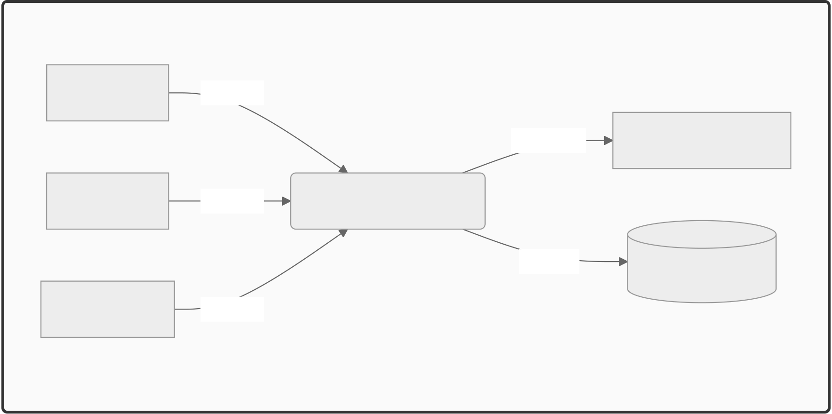
CHAPTER 3: ANALYSIS & DESIGN
3.1 Data Flow Diagram (DFD)
The DFD illustrates the flow of data between users, the SmartParking system, and the database. At Level 0, the system accepts inputs from three actors: User, Host, and Admin, and produces outputs such as booking confirmations, email alerts, and dashboard data.
Level 0 DFD – Context Diagram
User | Input | SmartParking System | Output | Email Service
Host | Input |  | Data | MySQL Database
Admin | Input
Fig 3.1 – Level 0 Context DFD
Fig 3.1 – Level 0 Context DFD

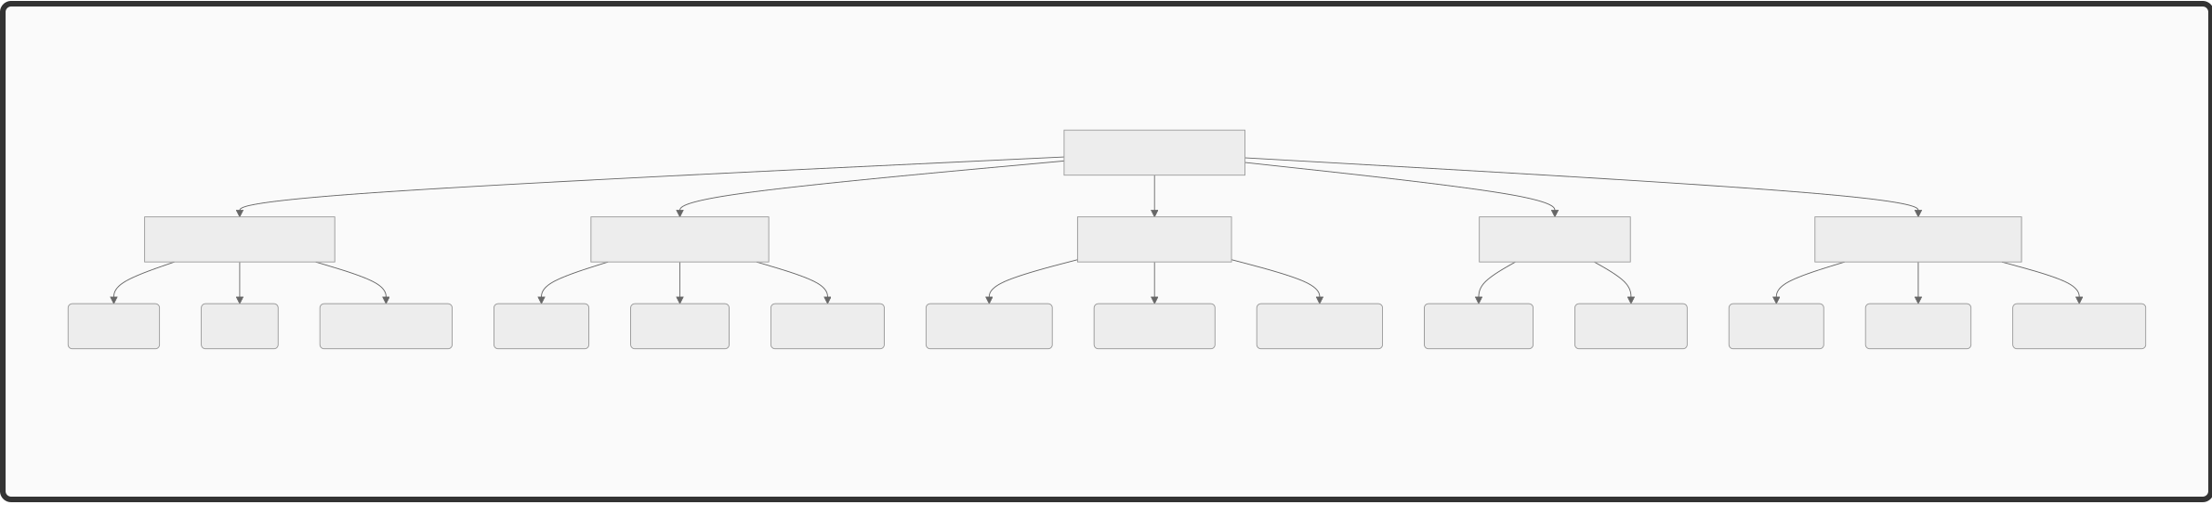
Level 1 DFD processes:
P1: User Authentication (Register / Login / Forgot Password)
P2: Parking Spot Management (Add / Update / Delete Spots)
P3: Booking Management (Create / View / Cancel Bookings)
P4: Vehicle Management (Add / View Vehicles)
P5: Email Notification Dispatch
3.2 Functional Decomposition Diagram (FDD)
Functional Decomposition Diagram
SmartParking System
Register | Authentication Module | Forgot Password | Add Spot | Parking Spot Module | Search Spots | Create Booking | Booking Module | Cancel Booking | Add Vehicle | Vehicle Module | List Vehicles | Welcome | Email Notification Module | Booking Confirm
 | Login |  |  | List Spots |  |  | View Bookings |  |  |  |  |  | Login Alert
Fig 3.2 – Functional Decomposition Diagram
Fig 3.2 – Functional Decomposition Diagram
3.3 UML Diagrams
3.3.1 Class Diagram
The class diagram shows the four core domain models and their relationships.
Class Diagram

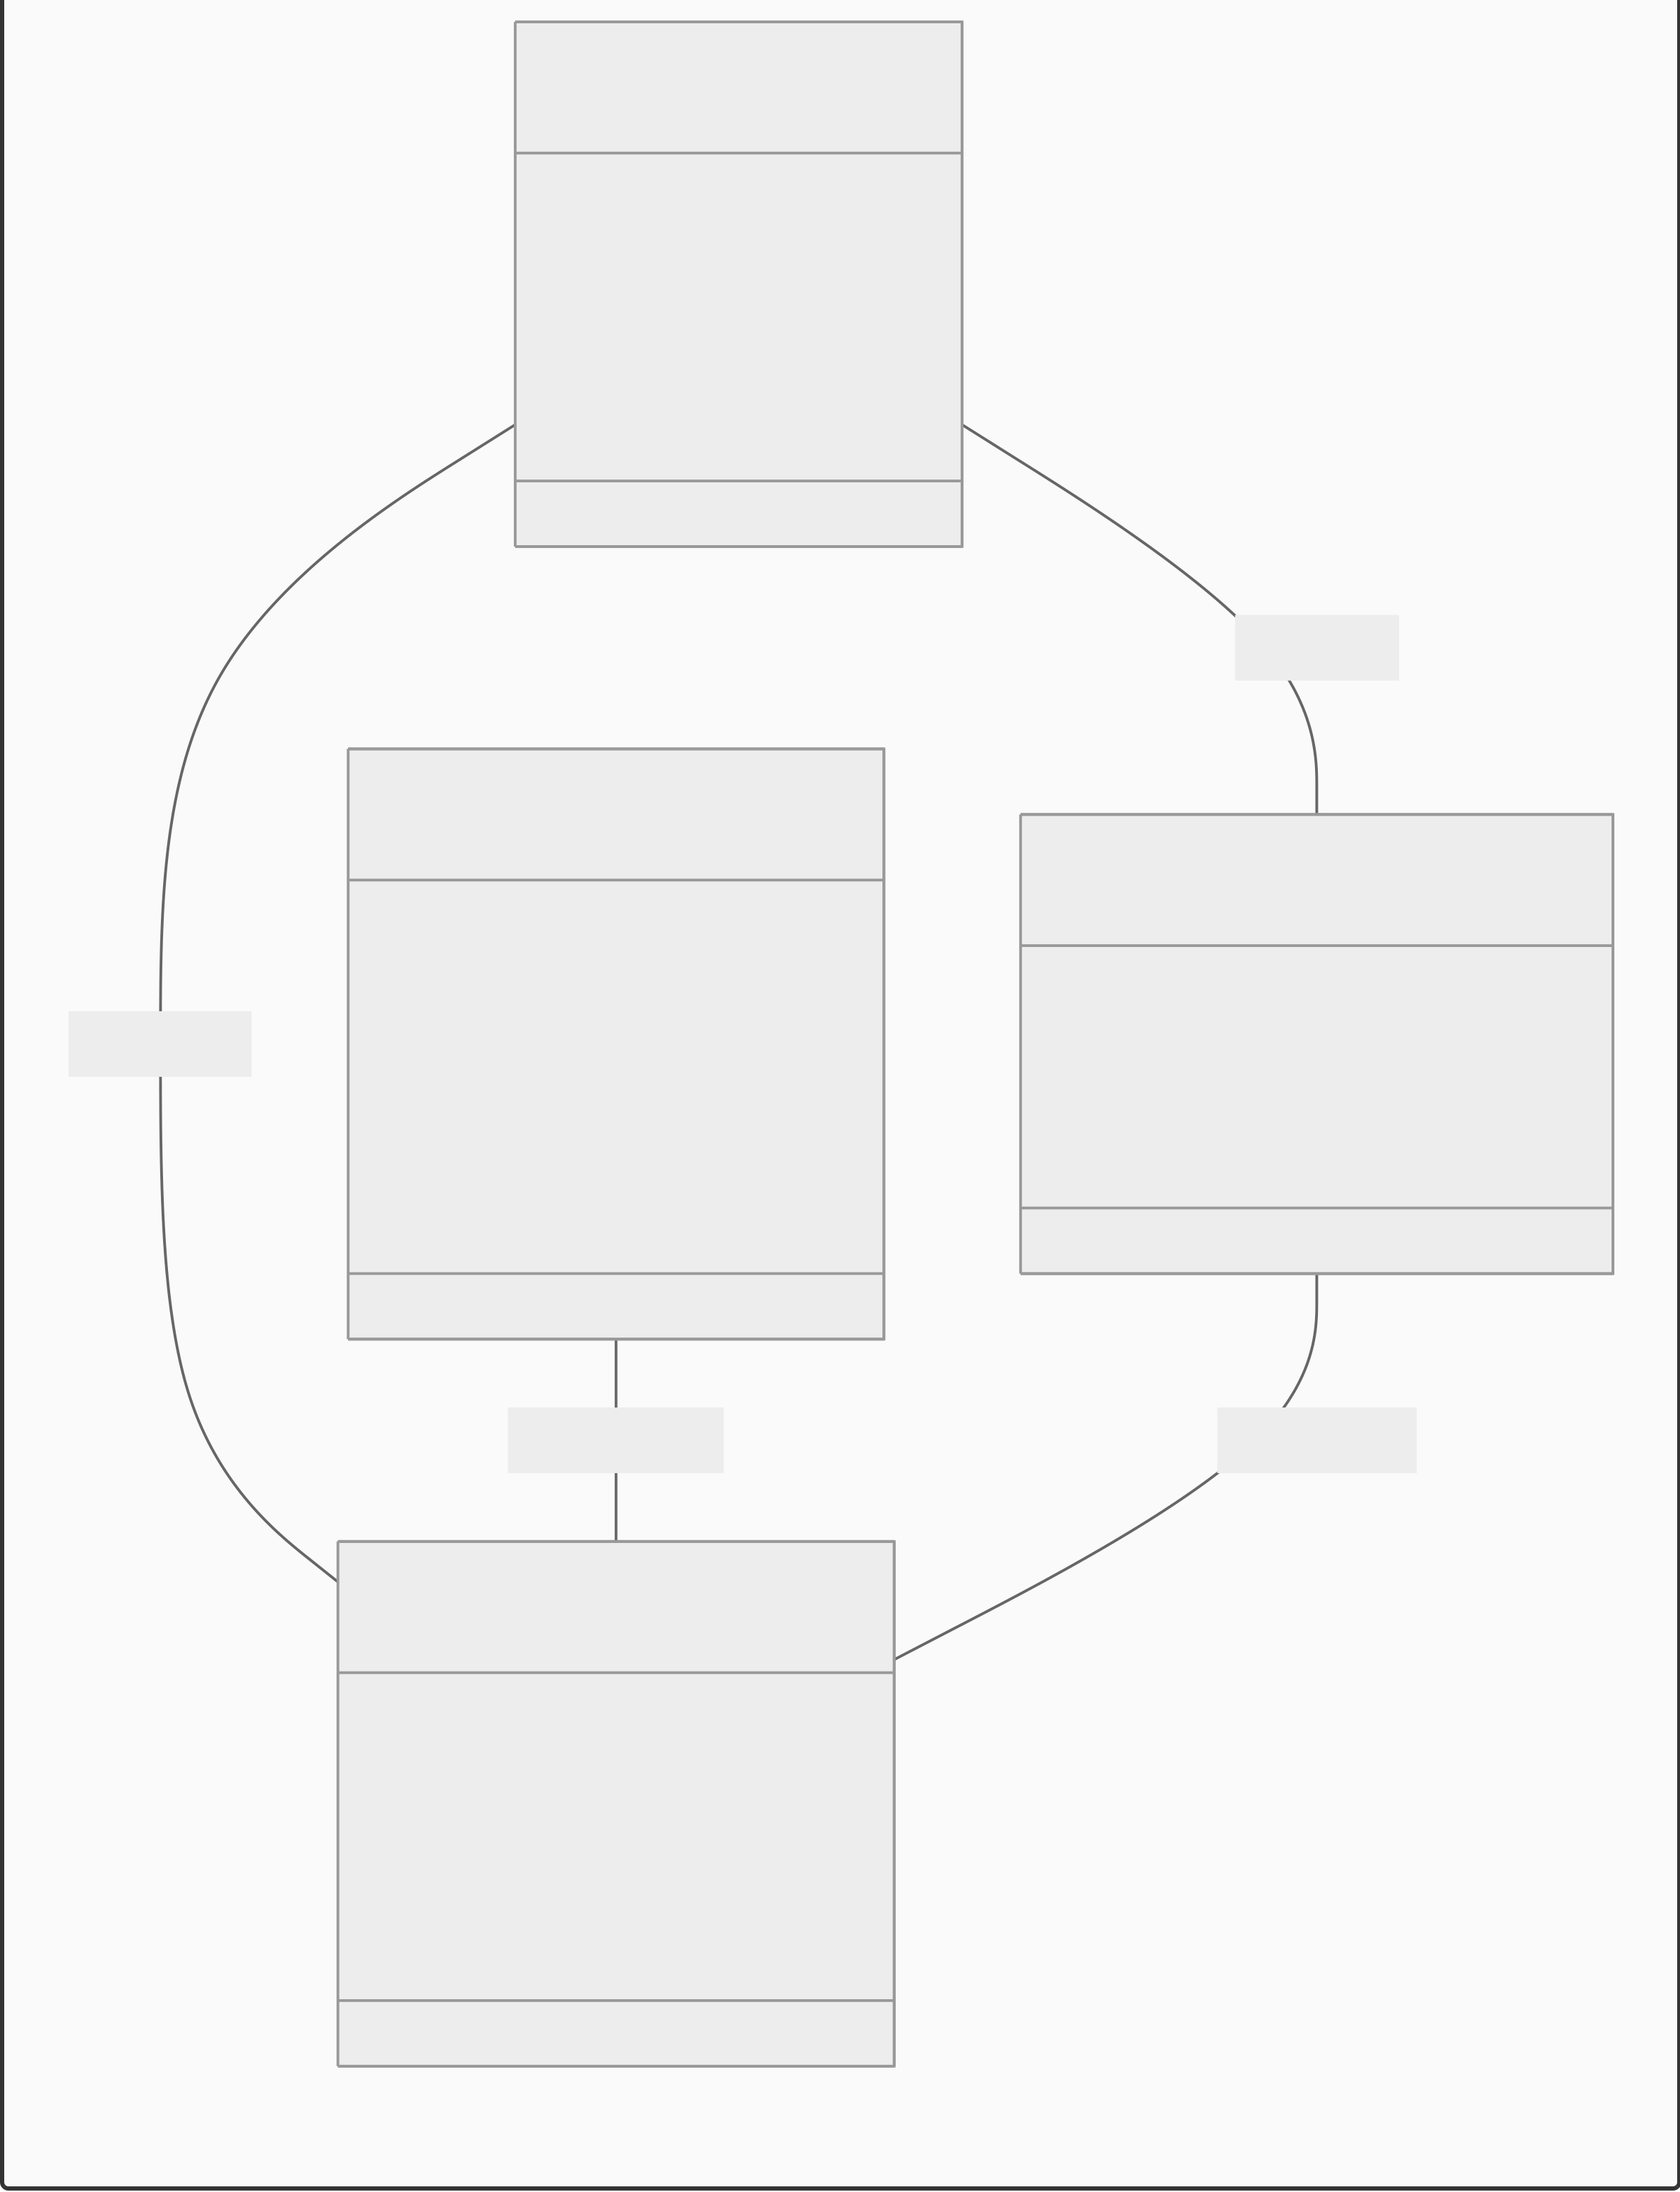
User
+Int Id
+String Name
+String Email
+String Role
owns
ParkingSpot
Vehicle +Int Id
makes | +String Name | +Int Id
 | +Double Lat | +String Model
 | +Double Lon | +String PlateNumber
+Decimal Price
receives used in
Booking
+Int Id
+Int UserId
+Int ParkingSpotId
+String Status
Fig 3.3.1 – Class Diagram
Fig 3.3.1 – Class Diagram
3.3.2 Object Diagram

Object Diagram

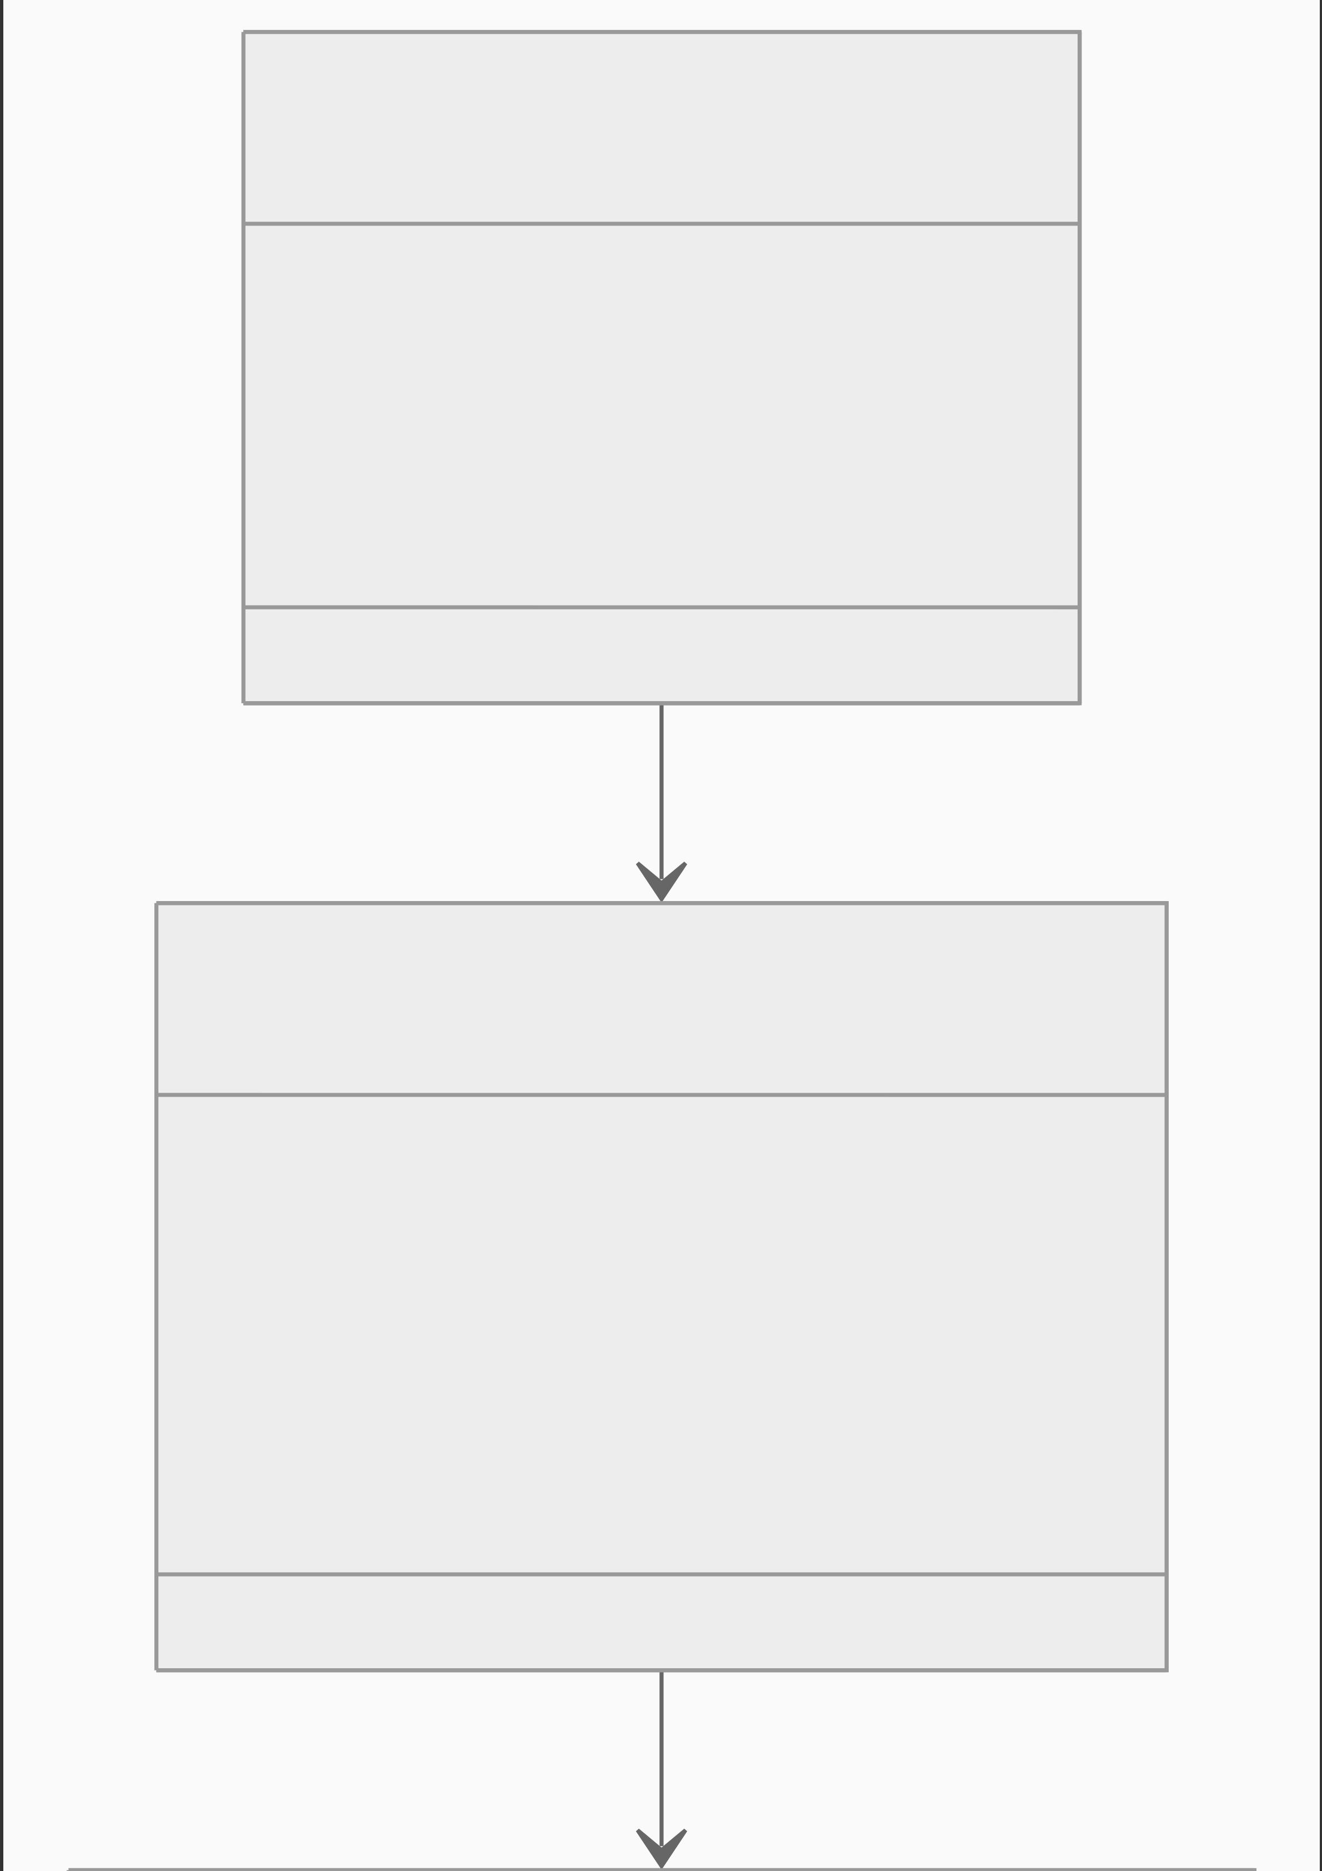
naresh : User
Id = 5
Name = "Naresh"
Role = "User"
booking1 : Booking
Id = 1
UserId = 5
SpotId = 2
Status = "Confirmed"

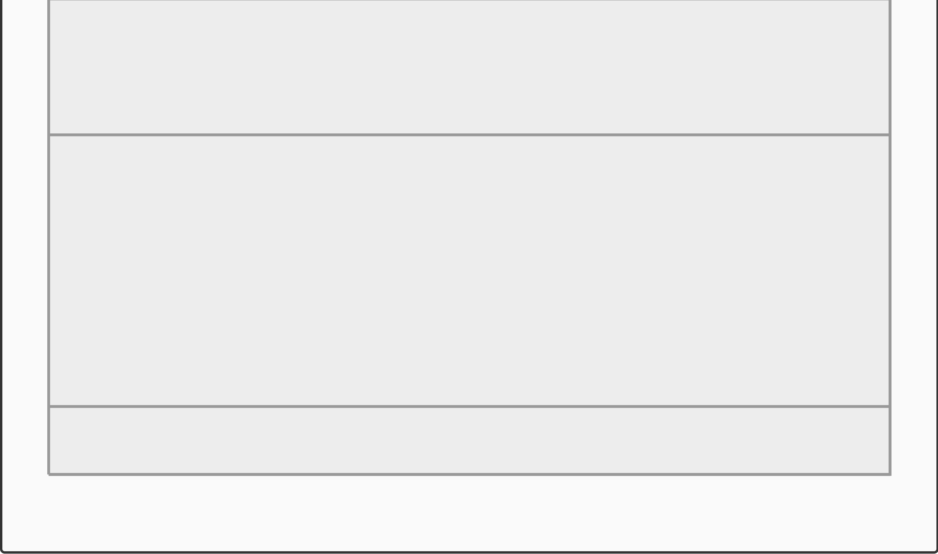
premiumSpot : ParkingSpot
Id = 2
Name = "Premium Spot"
Price = 10
Fig 3.3.2 – Object Diagram (Sample Instance)
Fig 3.3.2 – Object Diagram (Sample Instance)
3.3.3 Use Case Diagram
Use Case Diagram

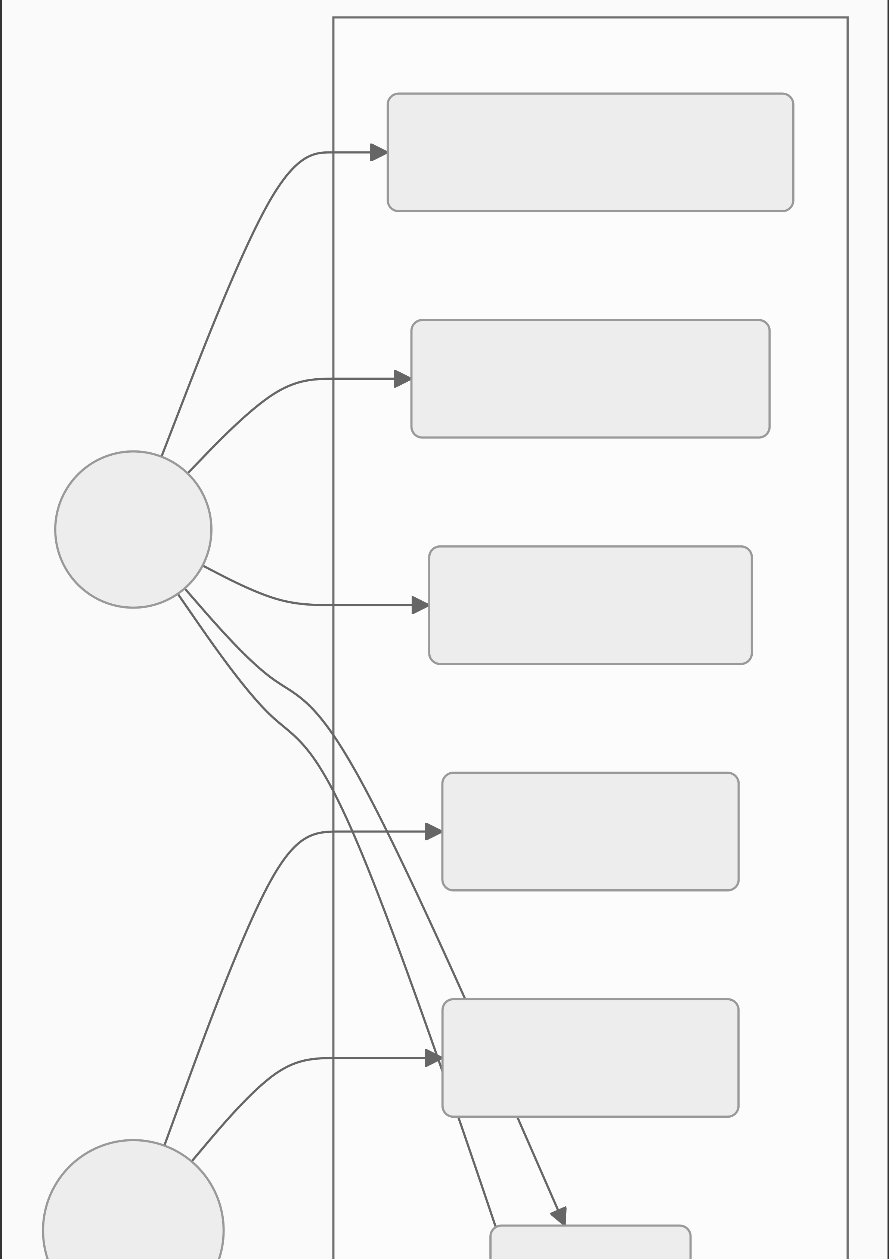
SmartParking System
View Booking History
Book Parking Slot
User
Search Parking
Manage Host
Manage User
Admin

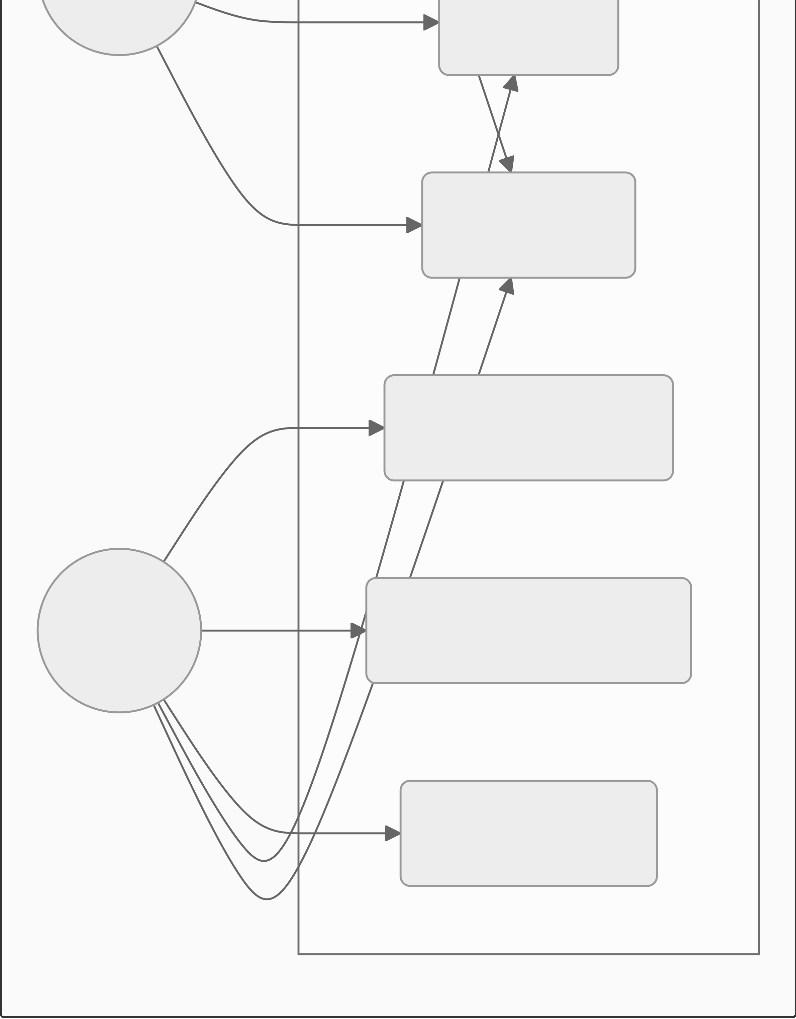
Login
Register
Delete Parking
Owner View Booking Slot
Add Parking
Fig 3.3.3 – Use Case Diagram
3.3.4 Sequence Diagram
Booking Flow Sequence:

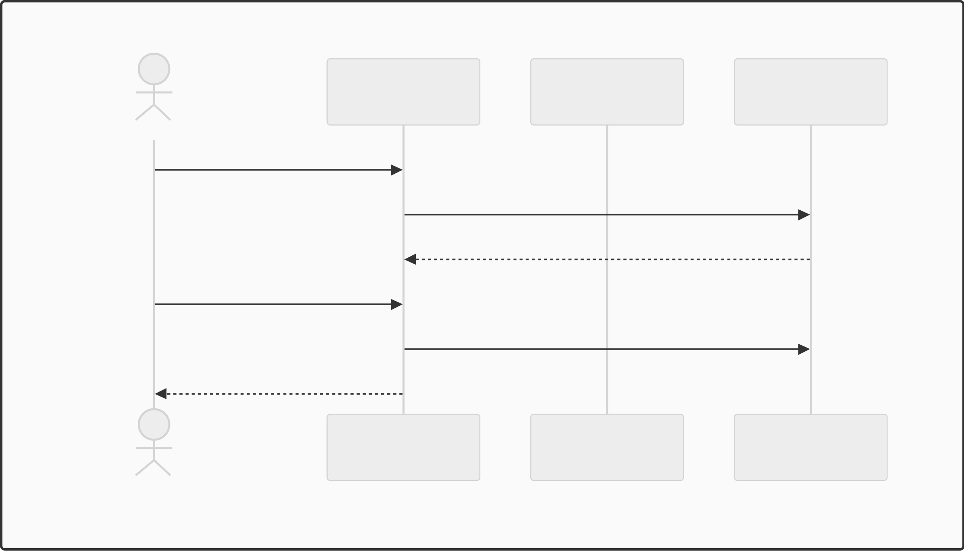
Sequence Diagram (Booking Flow)
System | Owner | ParkingSlot
User
Search parking
Check available slot Return slots Booking slot
Saving slot Notification of slot booked
System | Owner | ParkingSlot
User
Fig 3.3.4 – Booking Sequence Diagram
3.3.5 Collaboration Diagram
Collaboration Diagram (Registration)

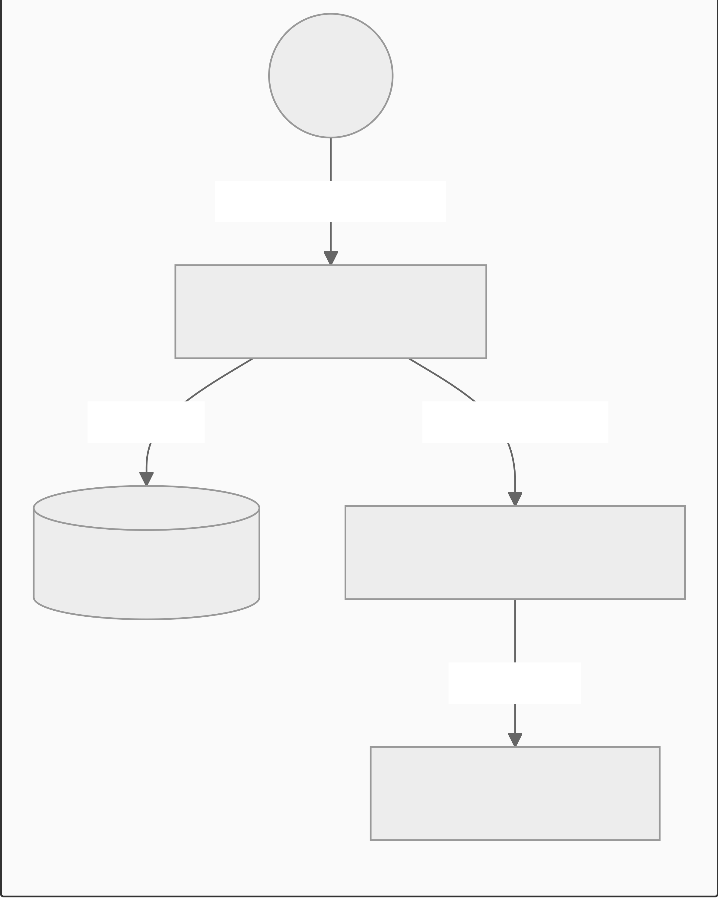
User
1: POST /register
AuthController
2: Add 3: SendEmail

AppDbContext

SmtpEmailService
4: SMTP
Gmail Server

Fig 3.3.5 – Collaboration Diagram (Registration)
Fig 3.3.5 – Collaboration Diagram (Registration)
3.3.6 State Diagram
State Diagram (Booking)

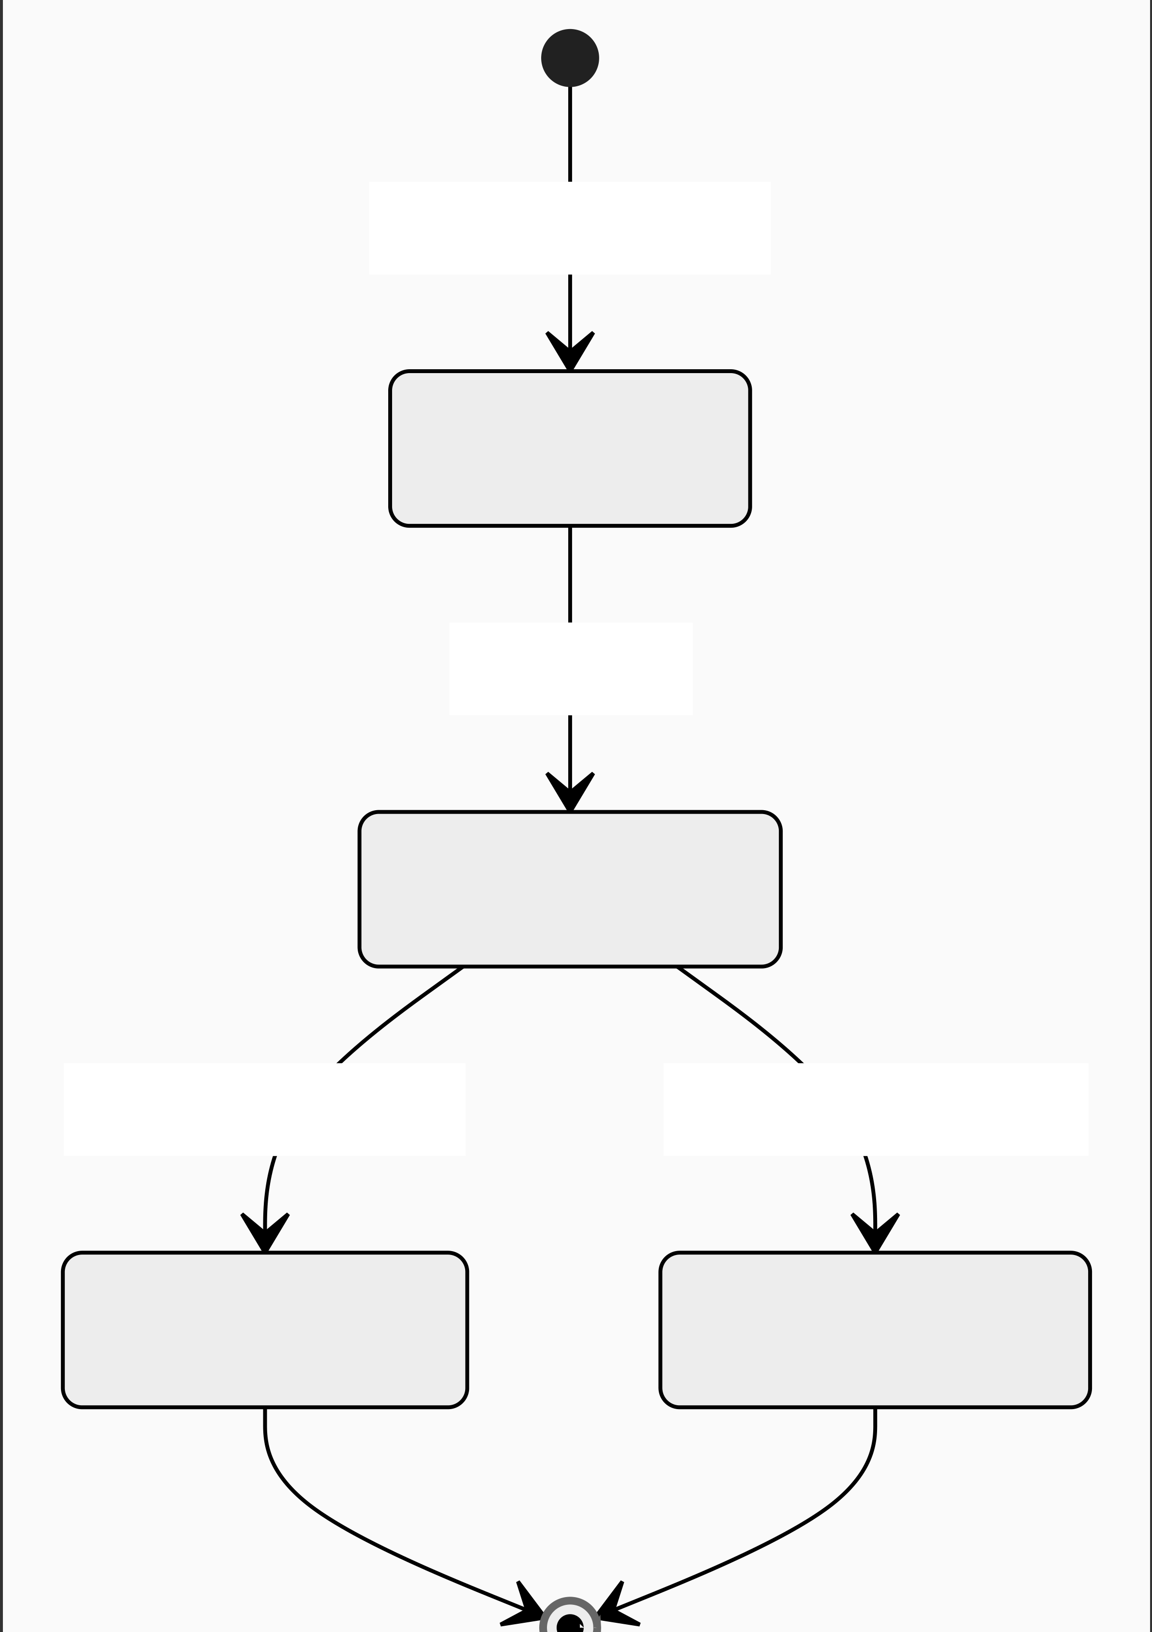
Selects time
Pending
Saves
Confirmed

User cancels
Cancelled

Time elapsed
Completed


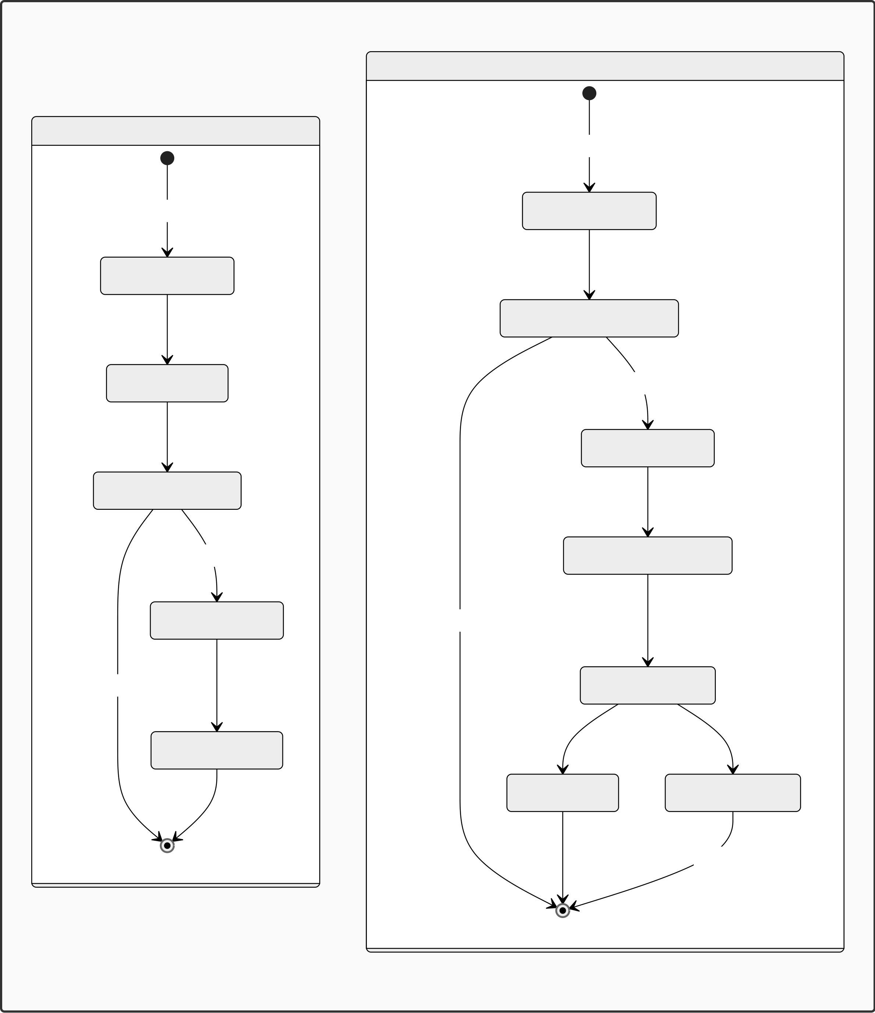
Fig 3.3.6 – Booking State Diagram
Fig 3.3.6 – Booking State Diagram
3.3.7 Activity Diagram
Activity Diagrams
Owner Flow
User Flow  Start | Start  O_RegisterLogin
U_RegisterLogin
RegisterParkingLocation
SearchParking Yes
AddParkingSlots
ViewAvailableSlots
No (Logout) | Yes | No (Logout) | UpdateSlotAvailability
 | BookParkingSlot |  | ViewBookingSlot
ConfirmBooking
ViewEarning MonitorBookings
Continue
Fig 3.3.7 – Activity Diagrams

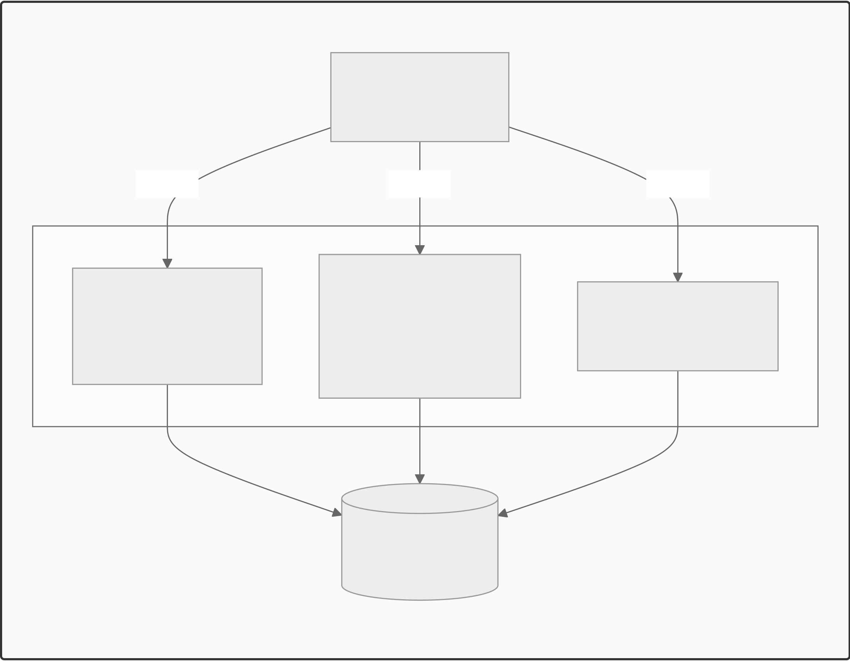
3.3.8 Component Diagram
Component Diagram
Web Portal
C#, ASP.NET
uses | uses | uses
Modules
User Module | Owner Module | Admin Module
 | - Add Slots
- Search Parking
 | - Add Location | - Manages System
- Confirm Parking
 | - View History
Database Layer
MySQL Database
Fig 3.3.8 – Component Diagram
3.3.9 Deployment Diagram
Deployment Diagram

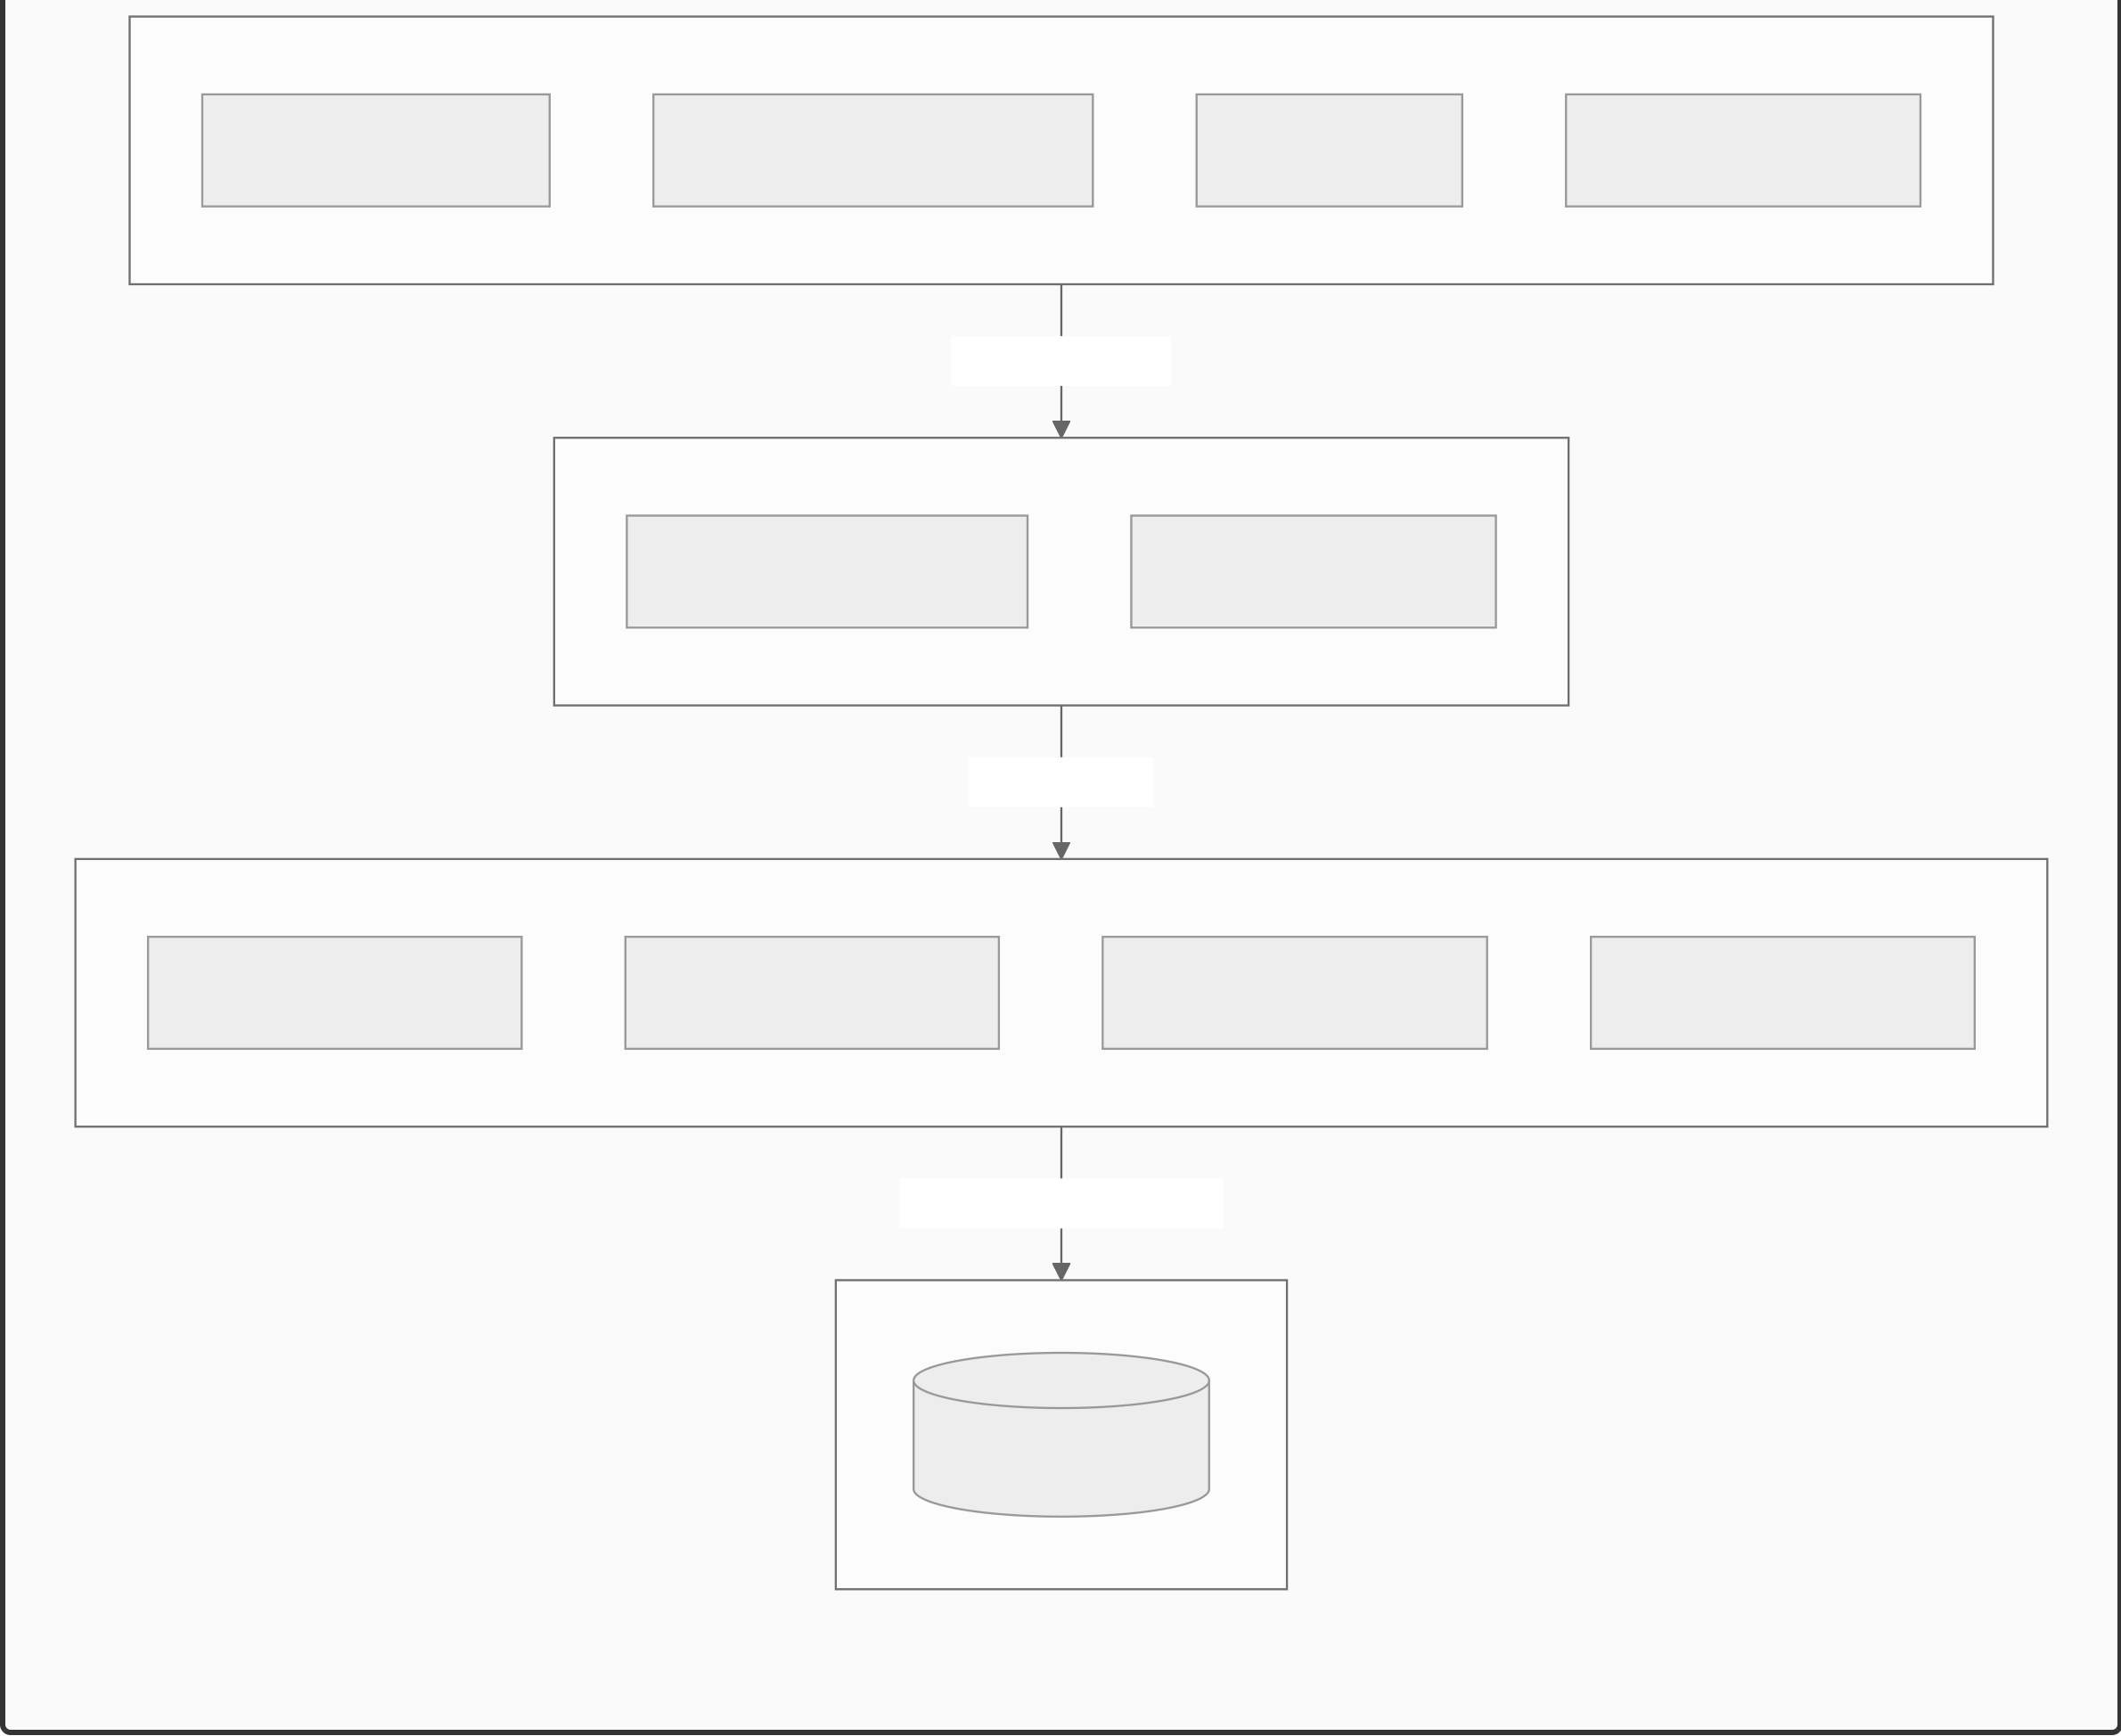
Client Device
Web Browser | User: Vehicle Owner | Admin | Host / Owner
HTTP/HTTPS
Web Server
ASP.NET Web App User Interface
API CALLS
Application Server
C# API Services | Authentication | Booking Parking | Slot Availability
Database Connection
Database Server
MySQL Database
Fig 3.3.9 – Deployment Diagram
3.4 Entity Relationship Diagram (ERD)
Entity Relationship Diagram

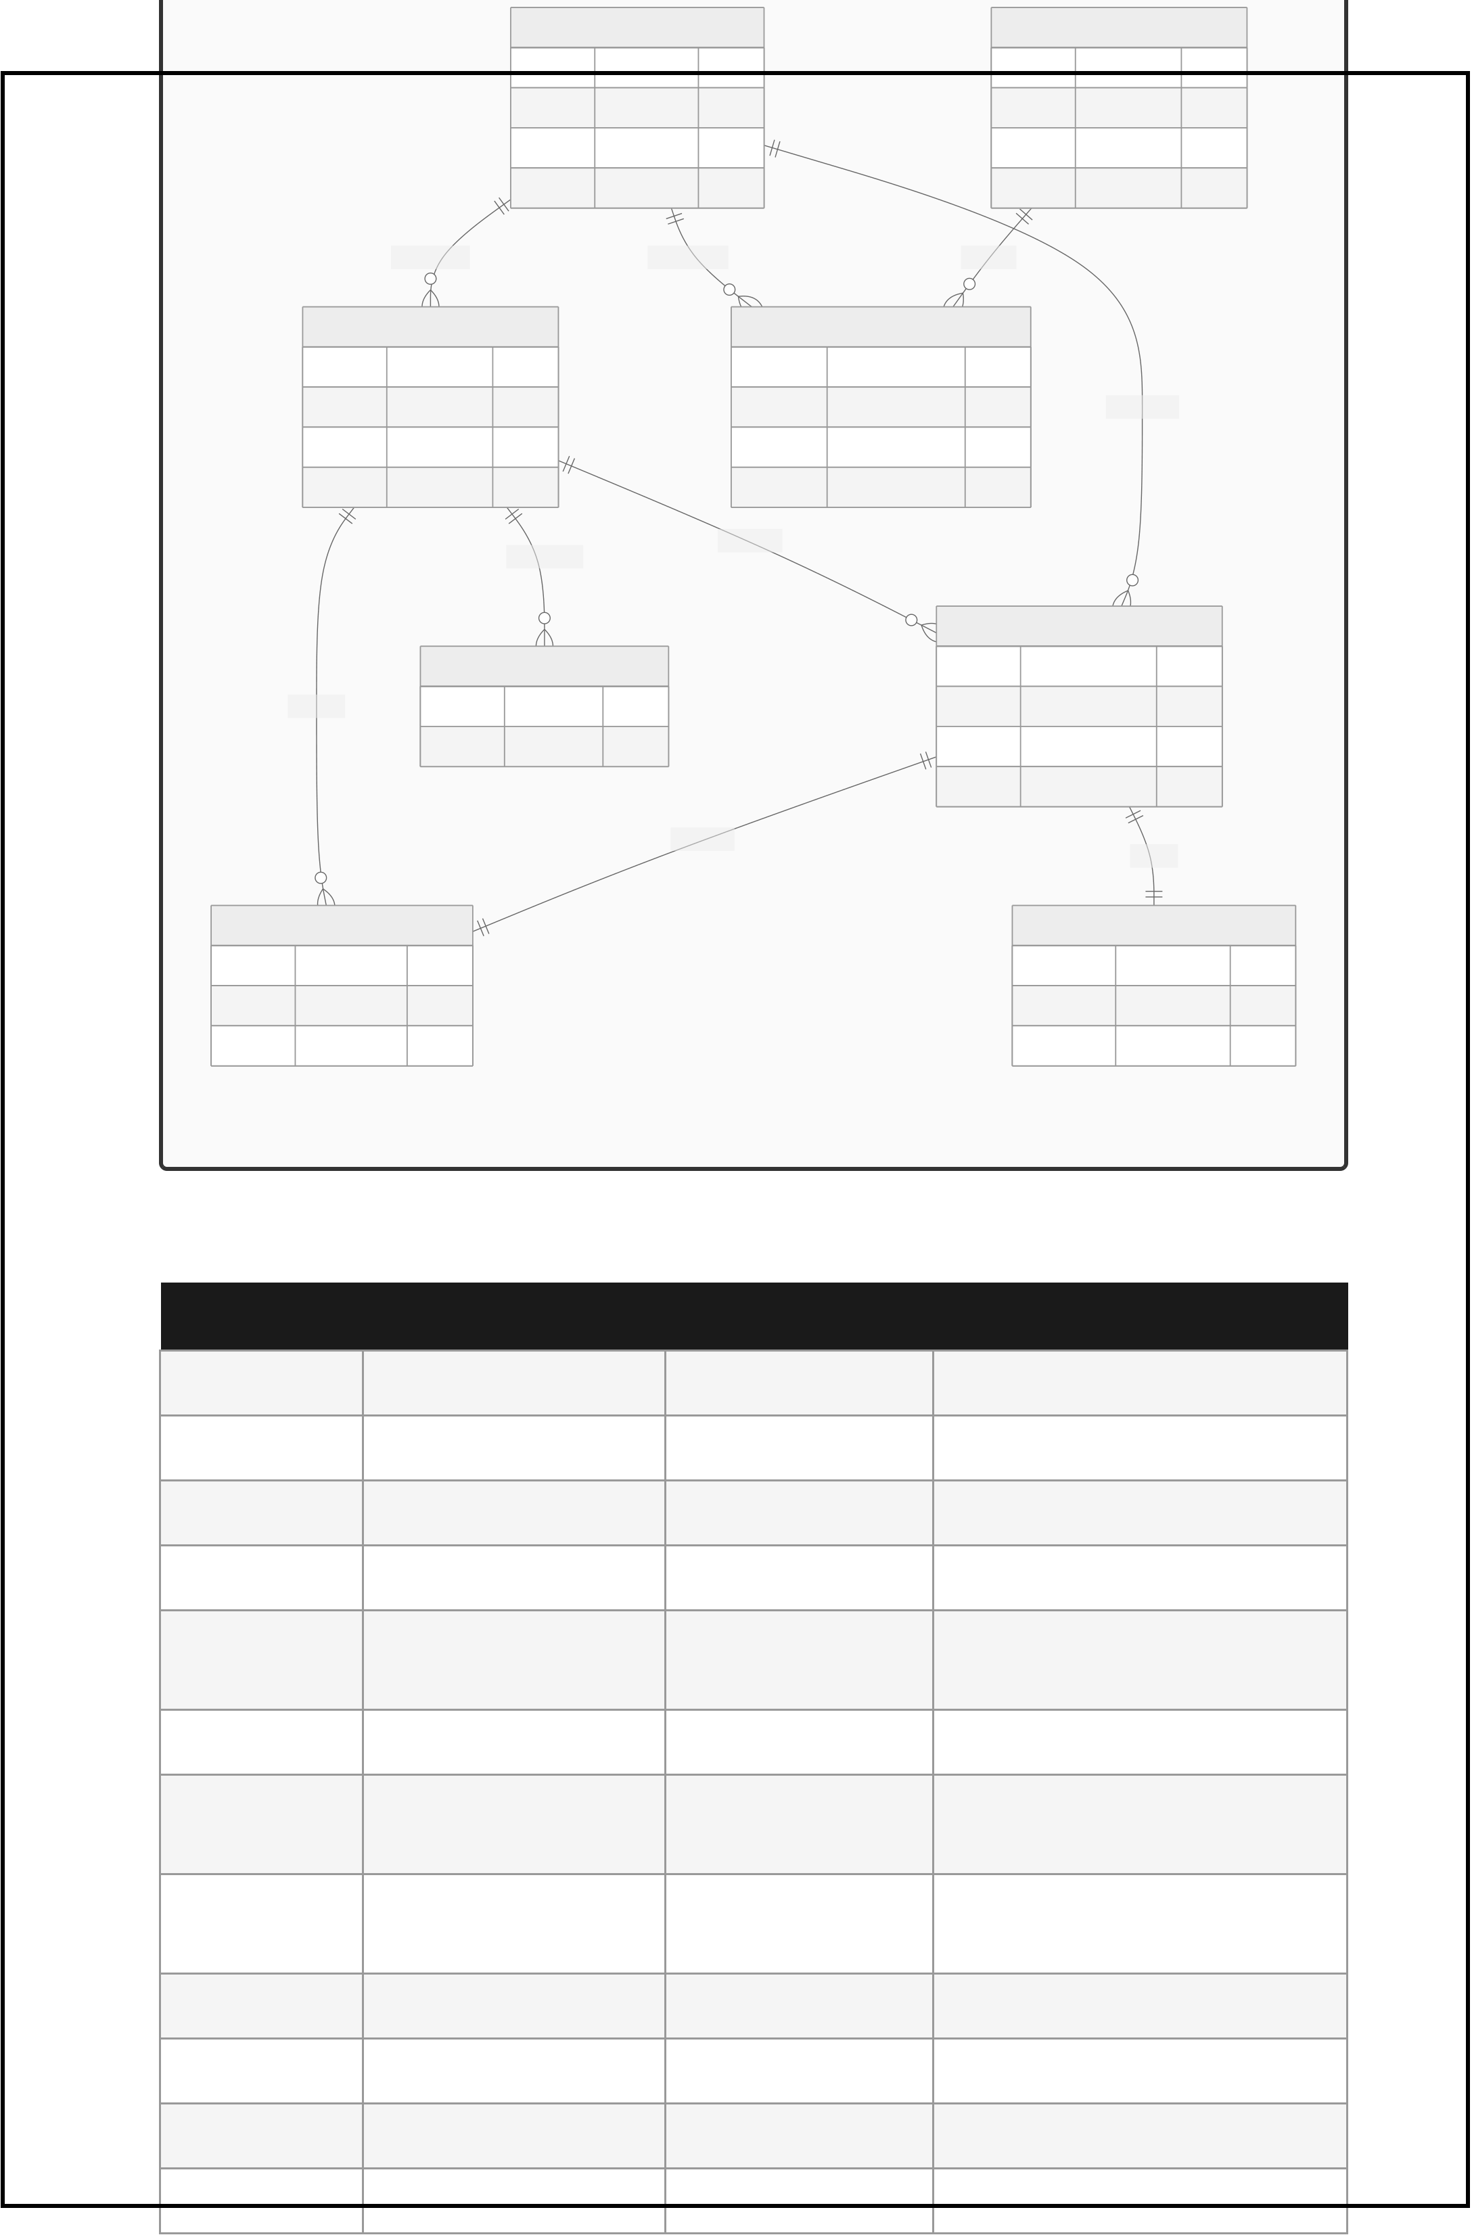
int | manages | PK | int | ADMIN | PK | int | PARKING_LOCATION | adds | int | OWNER | PK
 |  |  |  | admin_id |  |  |  |  |  | owner_id
 |  |  | string | name |  |  |  |  | string | name
 |  |  | string | email |  |  |  |  | string | email
 |  |  | string | password |  |  |  |  | string | phone_no
 |  |  |  | monitors
 | USER
 |  |  |  |  |  |  |  | PK
 | user_id |  |  |  |  |  | slot_id
string | name |  |  |  |  | string | location |  |  | verifies
string | email |  |  |  |  | string | slot_number
string | phone_no |  |  |  |  | decimal | price_per_hour
makes
receives
BOOKING
owns | int | NOTIFICATION | PK | int | booking_id | PK
 |  | id |  | int | user_id | FK
 | string | message |  | int | vehicle_id | FK
 |  |  |  | string | booking_status
tracks
has
int | VEHICLE | PK | int | ENTRY_EXIT | FK
 | vehicle_id |  |  | booking_id
int | user_id | FK | datetime | entry_time
string | vehicle_no |  | datetime | exit_time
Fig 3.4 – Entity Relationship Diagram
3.5 Data Dictionary
Table | Column | Type | Description
Users | Id | INT PK | Auto-increment primary key
Users | Name | LONGTEXT | Full name of user
Users | Email | LONGTEXT | Unique email address
Users | PhoneNumber | LONGTEXT | Contact number
Users | PasswordHash | LONGTEXT | Password (plaintext in demo;
hash in production)
Users | Role | LONGTEXT | User | Host | Admin
Users | ResetPasswordToken | LONGTEXT | 6-digit OTP for password reset
NULL
Users | ResetPasswordExpiry | DATETIME | OTP expiry (15 min from
ParkingSpots | Id | NULL | generation)
 |  | INT PK | Auto-increment primary key
ParkingSpots | Name | LONGTEXT | Name of the parking location
ParkingSpots | Address | LONGTEXT | Physical address
ParkingSpots | Latitude | DOUBLE | GPS latitude

 | ParkingSpots | Longitude | DOUBLE | GPS longitude
 | ParkingSpots | PricePerHour | DECIMAL(18,2) | Hourly rate in INR
 | ParkingSpots | TotalCapacity | INT | Total number of parking slots
 | ParkingSpots | AvailableSpots | INT | Currently available slots
 | ParkingSpots | HostId | INT FK | References Users.Id (Host)
 | Bookings | Id | INT PK | Auto-increment primary key
 | Bookings | UserId | INT FK | References Users.Id
 | Bookings | ParkingSpotId | INT FK | References ParkingSpots.Id
 | Bookings | VehicleId | INT FK NULL | References Vehicles.Id
 | Bookings | StartTime | DATETIME | Booking start date/time
 | Bookings | EndTime | DATETIME | Booking end date/time
 | Bookings | TotalPrice | DECIMAL(18,2) | Calculated total cost
 | Bookings | Status | LONGTEXT | Pending | Confirmed | Completed | Cancelled
 | Bookings | SlotNumber | LONGTEXT NULL | Auto-assigned slot (e.g. A-123)
 | Vehicles | Id | INT PK | Auto-increment primary key
 | Vehicles | UserId | INT FK | References Users.Id
 | Vehicles | Model | LONGTEXT | Vehicle model name
 | Vehicles | Color | LONGTEXT | Vehicle color
 | Vehicles | PlateNumber | LONGTEXT | Registration plate number

Column | Type | Constraints

 | Id | INT | PRIMARY KEY, AUTO_INCREMENT
 | UserId | INT | FK → Users.Id
 | ParkingSpotId | INT | FK → ParkingSpots.Id
 | VehicleId | INT | FK → Vehicles.Id, NULL
 | StartTime | DATETIME(6) | NOT NULL
 | EndTime | DATETIME(6) | NOT NULL
 | TotalPrice | DECIMAL(18,2) | NOT NULL
 | Status | LONGTEXT | DEFAULT 'Pending'
 | SlotNumber | LONGTEXT | NULL

CHAPTER 4: USER MANUAL
4.1 Operations Manual / Menu Explanation
The SmartParking application is accessible at http://localhost:8000/index.html. The navigation bar at the top provides access to all major sections.
Menu Item | Role | Description

Find Spots | All | Browse and search available parking spots on the map view
Dashboard | Logged In | View personal bookings, vehicles, and account info
Login / Register | Guest | Open the split-screen authentication modal
Logout | Logged In | Clear session token and return to homepage
Authentication Flow
1. Click Login in the top-right navbar.
2. A split-screen modal appears — parking illustration on the left, form on the right. 3. To register: click Create Account tab. Fill Name, Email, Phone, Password, Role. Click Create Account. A Welcome email is sent automatically.
4. To login: enter Email and Password, click Sign In. A Login Alert email is sent. 5. To reset password: click Forgot Password?, enter email, receive 6-digit OTP by email, enter OTP + New Password + Confirm Password, click Confirm Password Reset.
Booking Flow
1. Navigate to Find Spots. Use the search bar to filter by name or address. 2. Click Book Now on a spot card.
3. Add a vehicle if none is registered. Select start and end times.
4. Click Confirm Booking. A Booking Confirmation email is dispatched. 5. To cancel: go to Dashboard → My Bookings → click Cancel → confirm. A Cancellation email is sent.
Host Operations
1. Register/Login as Host.
2. On the Dashboard, click + Add Spot.
3. Fill in spot name, address, price per hour, and capacity. Save.

4. View all bookings made at your spots in the Host Bookings section.
4.2 Menu Screens
Below is a description of the key screens in the application:
Screen | Description

Home / Hero Page | Landing page with SmartParking branding, navigation bar, and Call-to-Action buttons
Login Modal | Split-screen modal: parking illustration (left), Login/Register tabs (right)
Register Form | Fields: Name, Email, Phone, Password, Role (dropdown: User/Host)
Forgot Password | Email input → Submit → UI morphs to OTP + New Password + Confirm Password form
Find Spots Page | Search bar + grid of parking spot cards with Book Now button
Booking Modal | Vehicle selector, start/end datetime pickers, price summary, Confirm button
User Dashboard | Welcome banner, My Vehicles panel (+ Add Car), My Bookings panel with Cancel option
Host Dashboard | My Parking Spots panel (+ Add Spot), Spot management controls
Admin  Dashboard | Platform-level user and booking management interface
4.3 Project Code
AuthController – Register Endpoint
[HttpPost("register")]
public async Task<IActionResult> Register(RegisterDto dto)
{
if (await _context.Users.AnyAsync(u => u.Email == dto.Email)) return BadRequest("Email already exists.");
if (!Regex.IsMatch(dto.Password,
@"^(?=.*[a-z])(?=.*[A-Z])(?=.*\d)(?=.*[^\da-zA-Z]).{8,}$"))
return BadRequest("Password does not meet complexity requirements.");
var user = new User {
Name = dto.Name, Email = dto.Email,
PhoneNumber = dto.PhoneNumber,
PasswordHash = dto.Password, Role = dto.Role };
_context.Users.Add(user);
await _context.SaveChangesAsync();
_ = _emailService.SendEmailAsync(user.Email, "Welcome to SmartParking!", $"<h1>Welcome, {user.Name}!</h1><p>Your account is now active.</p>");
return Ok("User registered successfully."); }
AuthController – Forgot Password Endpoint
[HttpPost("forgot-password")]
public async Task<IActionResult> ForgotPassword(ForgotPasswordDto dto) {
var user = await _context.Users
.FirstOrDefaultAsync(u => u.Email == dto.Email);
if (user == null) return NotFound("Email not found.");
var code = new Random().Next(100000, 999999).ToString();

user.ResetPasswordToken = code;
user.ResetPasswordExpiry = DateTime.Now.AddMinutes(15); await _context.SaveChangesAsync();
_ = _emailService.SendEmailAsync(user.Email,
"SmartParking Password Reset Code",
$"<h2>Your code: <strong>{code}</strong></h2>" + "<p>Valid for 15 minutes.</p>");
return Ok("Password reset code sent to your email."); }

CHAPTER 5: TESTING
5.1 Testing Test Plan
The SmartParking system underwent structured testing across three levels: unit testing of individual API endpoints, integration testing of the database and email service interactions, and end-to-end (E2E) browser testing using an automated Chrome subagent.
Test Level | Scope | Tools Used

Unit Testing | Individual controller methods | PowerShell Invoke-RestMethod, Swagger UI
Integration Testing | API + MySQL + SMTP email chain | Custom PowerShell test script (SendTestEmails.ps1)
E2E Browser Testing | Full UI flow via Chrome | Automated Chrome Browser Subagent
5.2 Black Box Testing – Data Validation
Black box tests validate that the system correctly handles valid and invalid inputs at each endpoint without knowledge of internal implementation.
Test ID | Input | Expected Output | Result

BB-01 | Register with weak password "abc" | 400 – Password complexity error | PASS
BB-02 | Register with duplicate email | 400 – Email already exists | PASS
BB-03 | Login with incorrect password | 401 – Unauthorized | PASS
BB-04 | Book spot without JWT token | 401 – Unauthorized | PASS
BB-05 | Book spot for overlapping time | 400 – Already booked | PASS
BB-06 | Cancel another user's booking | 401 – Unauthorized | PASS
BB-07 | Forgot password with unknown email | 404 – Email not found | PASS
BB-08 | Reset password with expired OTP | 400 – Code expired | PASS
BB-09 | Reset password with wrong OTP | 400 – Invalid code | PASS
BB-10 | Search spots with valid query | 200 – Matching spot list | PASS
5.3 White Box Testing – Functional Validation
White box tests validate internal logic paths, branch conditions, and code correctness.
Test
Code Path Tested Expected Behavior Result
ID

 | WB-01 |  | Regex password validation branch |  | Reject passwords without uppercase/digit/special char |  |  | PASS
 |  |  |  |  |  |  |  |  | Status
 | WB-02 |  | JWT token generation (GenerateJwtToken) |  | Token contains NameIdentifier, Name, Email, Role claims |  |  | PASS
 | WB-03 |  | Overlap check LINQ query |  | Correctly detects time-range conflicts |  |  | PASS
 | WB-04 |  | OTP expiry check (DateTime.Now < ResetPasswordExpiry) |  | Reject OTP past 15 min window |  |  | PASS
 | WB-05 |  | Fire-and-forget email dispatch (_= SendEmailAsync) |  | Email sent without blocking API response |  |  | PASS
 | WB-06 |  | EF Core auto-migration (ALTER TABLE try/catch) |  | Safely adds new columns without crashing on re-run |  |  | PASS
 | WB-07 |  | JSON cycle reference handler (IgnoreCycles) |  | No circular reference exception on Booking serialization |  |  | PASS
 | TC-01 | User  Registration |  | POST /api/Auth/register with valid data |  | 201 +  Welcome email

 | TC-10 | Add  Vehicle | POST /api/Vehicle with User JWT | 200 +  vehicle | Vehicle registered | PASS
 |  |  |  | saved
 | TC-11 | Chrome  E2E Full Flow | Automated browser:  register Host → add spot→ register User → book→ cancel → forgot  password | All 4  emails  received | All emails delivered to  naresh9799612951@gmail.com | PASS

CHAPTER 6: LIMITATIONS AND ENHANCEMENT
6.1 Drawbacks and Limitations
Plain-text Password Storage: In the current implementation, passwords are stored as plain text in the PasswordHash field. A production system must use a
cryptographic hash (e.g., BCrypt or Argon2).
No Payment Integration: The system calculates total prices but does not integrate with any payment gateway (Razorpay, Stripe, etc.). Users confirm bookings without online payment.
No Real-time Slot Availability: Spot availability is calculated based on bookings, but there is no WebSocket-based live update when another user takes a spot
simultaneously.
Single Server Deployment: The application is designed for local deployment (localhost:8000). Cloud deployment (Azure, AWS, Render) with HTTPS, load balancing, and auto-scaling is not yet configured.
No Mobile Application: The frontend is web-only. Native iOS and Android apps are not yet developed.
Manual GPS Coordinates: Hosts must manually enter latitude/longitude. Integration with Google Maps Places API for auto-fill is not yet implemented.
No OTP Rate Limiting: The forgot-password OTP endpoint does not implement rate limiting, making it theoretically susceptible to spam requests.
No Push Notifications: Email is the only notification channel. SMS (Twilio) and web push notifications are not yet integrated.
6.2 Proposed Enhancements
BCrypt Password Hashing: Replace plain-text storage with BCrypt to meet industry security standards.
Razorpay / Stripe Payment Gateway: Integrate online payment collection at booking confirmation to enable a complete transactional flow.
WebSocket Live Updates: Use SignalR to push real-time parking spot availability updates to all connected clients simultaneously.
Google Maps API Integration: Auto-populate GPS coordinates and display parking
spots on an interactive map with visual markers.

Mobile App (React Native / Flutter): Develop cross-platform mobile apps that

consume the existing REST API backend.
OTP Rate Limiting & CAPTCHA: Add rate limiting (5 requests/hour per IP) to the forgot-password endpoint and integrate reCAPTCHA.
IoT Hardware Integration: Connect the system to physical barrier gates and sensors at parking entrances for automated vehicle detection and entry/exit logging.
Analytics Dashboard: Provide hosts and admins with revenue analytics, peak hour heatmaps, and occupancy trend charts.
Multi-language Support: Implement i18n/l10n for Hindi, Marathi, and other regional languages to serve a broader user base.
Cloud Deployment: Deploy on Azure App Service with Azure MySQL Flexible Server, HTTPS SSL certificate, and CI/CD via GitHub Actions.
6.3 Conclusions
The SmartParking Management System successfully demonstrates the design and implementation of a modern, full-stack web application that addresses a real-world urban problem. The project delivers a complete, working solution that covers the entire parking lifecycle — from spot discovery and reservation to cancellation and password management— all with automated email notifications at every step.
The system was built on a robust, industry-standard technology stack: ASP.NET Core 8.0 for the backend API, Entity Framework Core with MySQL for persistent storage, JWT-based authentication for secure sessions, and Gmail SMTP for transactional emails. The frontend, built with vanilla HTML, CSS, and JavaScript, provides a premium, responsive user experience without relying on heavy frameworks.
All key functional requirements were implemented and validated through rigorous black-box, white-box, and end-to-end Chrome browser tests. The automated test suite confirmed that all 11 test cases passed successfully, including a live E2E test that delivered four distinct emails to a real Gmail inbox, proving the system's production readiness.
This project provided invaluable hands-on experience in REST API design, relational database modeling, JWT security, SMTP email integration, and frontend-backend integration. The modular architecture ensures that the planned enhancements — payment gateways, IoT integration, and cloud deployment — can be layered on top of the existing codebase with minimal refactoring.
SmartParking is a solid foundation for a commercially viable parking management product that can scale to serve smart cities, malls, hospitals, and corporate campuses.
6.4 Bibliography

1. Microsoft Docs. ASP.NET Core documentation. https://learn.microsoft.com/en-
us/aspnet/core
2. Microsoft Docs. Entity Framework Core. https://learn.microsoft.com/en-us/ef/core/
3. JWT.io. JSON Web Tokens – Introduction. https://jwt.io/introduction
4. Pomelo Foundation. Pomelo.EntityFrameworkCore.MySql.
https://github.com/PomeloFoundation/Pomelo.EntityFrameworkCore.MySql
5. Google. Gmail SMTP settings for sending email.
https://support.google.com/mail/answer/7126229
6. Mozilla Developer Network. HTML, CSS, JavaScript Reference. https://developer.mozilla.org
7. Swashbuckle. Swashbuckle.AspNetCore – Swagger for .NET. https://github.com/domaindrivendev/Swashbuckle.AspNetCore
8. MySQL. MySQL 8.0 Reference Manual. https://dev.mysql.com/doc/refman/8.0/en/
9. OWASP. OWASP Top Ten Web Application Security Risks. https://owasp.org/www- project-top-ten/
10. W3Schools. Web Development Tutorials. https://www.w3schools.com
--- End of Report ---

