Secure Chit System - System Diagrams

1. Context Level Diagram (Level 0 DFD)
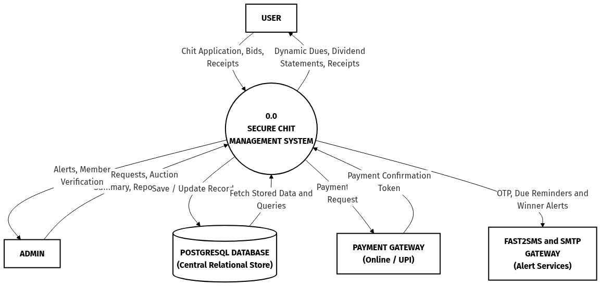

2. System Overview & Subsystem Decomposition (Level 1 DFD)
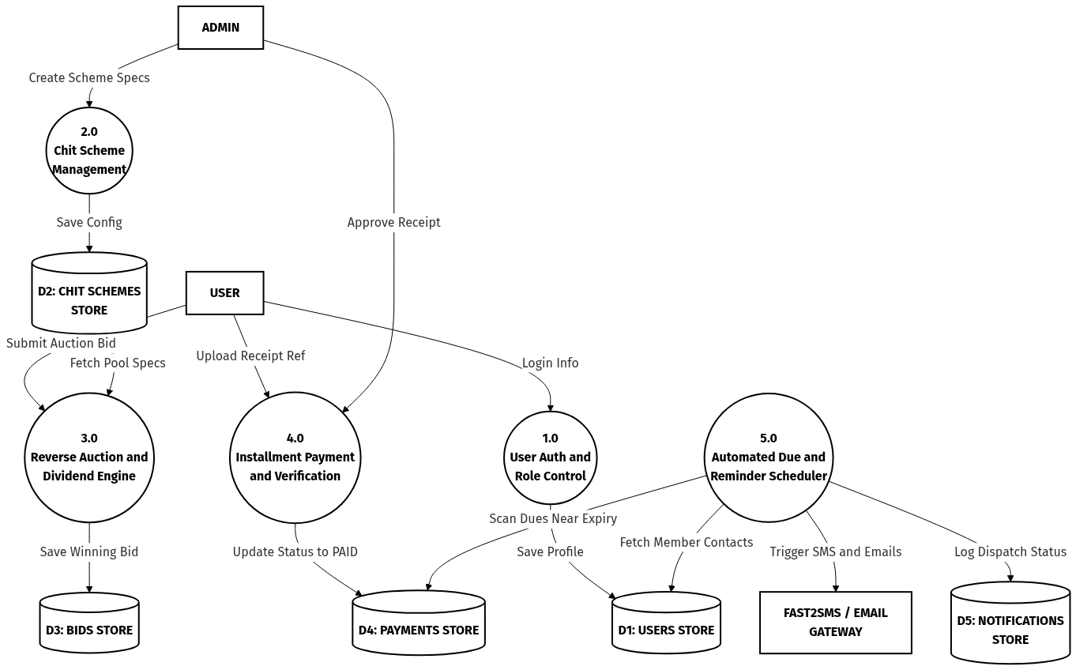

3. Auction Bidding & Workflow (Level 2 DFD)
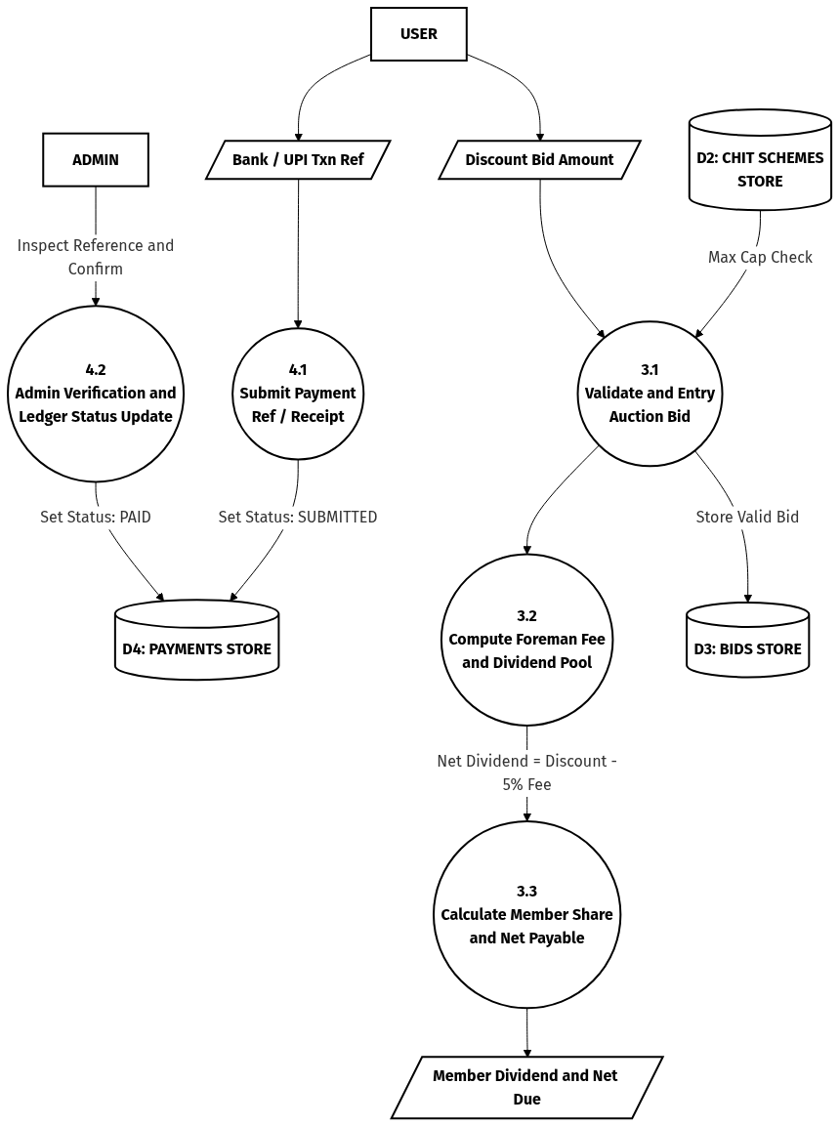

4. Behavioral Model - Use Case Design (Digital Version)
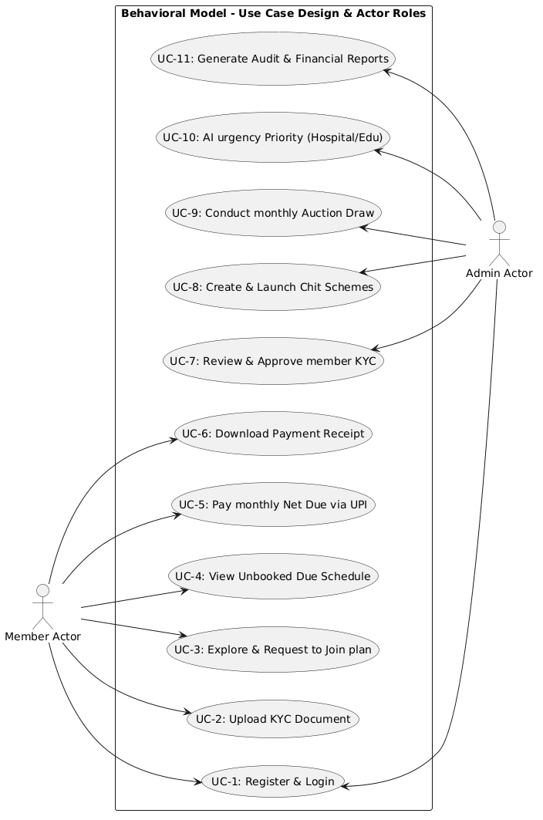

5. Original Hand-Drawn Use Case Sketch
