SECURE CHIT: DIGITAL CHIT FUND MANAGEMENT SYSTEM
Submitted in partial fulfilment of the requirements for the award of the degree of
Bachelor of Science in Computer Science
Submitted By
R. NARESHKUMAR (24UCS08)
APR. JEGATHEESH VARSHAN (24UCS06)
Under the Guidance of
Mrs. SM. VALLI B.E., M.C.A., M.Phil

DEPARTMENT OF COMPUTER SCIENCE
THIAGARAJAR COLLEGE (AUTONOMOUS)
(Affiliated to Madurai Kamaraj University)
Re-accredited with 'A++' Grade by NAAC | Ranked 20th in NIRF 2026
Madurai – 625009
October - 2026

THIAGARAJAR COLLEGE (AUTONOMOUS)
(Affiliated to Madurai Kamaraj University)
Re-Accredited with 'A++' Grade by NAAC | Ranked 20th in NIRF 2026
DEPARTMENT OF COMPUTER SCIENCE
BONAFIDE CERTIFICATE
This is to certify that the project work entitled "SECURE CHIT: DIGITAL CHIT FUND MANAGEMENT SYSTEM" is a bonafide work done by R. NARESHKUMAR (24UCS08) and APR. JEGATHEESH VARSHAN (24UCS06) in partial fulfilment of the requirements for the award of the degree of Bachelor of Science in Computer Science during the academic year 2026.
Submitted for the final Viva-Voce Examination held on _____________________ at Department of Computer Science, Thiagarajar College (Autonomous), Madurai - 625009.
Project Guide Head of the Department
(Mrs. SM. Valli) (Mrs. SM. Valli)
Internal Examiner: _________________________ Date: _______________
External Examiner: _________________________ Date: _______________

DECLARATION
Name & Address:
R. NARESHKUMAR (24UCS08)
B.Sc. Computer Science
Department of Computer Science
Thiagarajar College (Autonomous), Madurai - 625009
I hereby declare that the project work entitled "SECURE CHIT: DIGITAL CHIT FUND MANAGEMENT SYSTEM", submitted to Thiagarajar College (Autonomous), Madurai, in partial fulfilment of the requirements for the award of the degree of Bachelor of Science in Computer Science, is a record of original work done by me under the guidance of Mrs. SM. VALLI B.E., M.C.A., M.Phil, Department of Computer Science, Thiagarajar College, Madurai.
To the best of my knowledge, this report has not formed the basis for the award of any degree, diploma, associateship, fellowship, or similar title in any other University or Institution.
Place: Madurai
Date: Signature: _______________________
(R. NARESHKUMAR)

DECLARATION
Name & Address:
APR. JEGATHEESH VARSHAN (24UCS06)
B.Sc. Computer Science
Department of Computer Science
Thiagarajar College (Autonomous), Madurai - 625009
I hereby declare that the project work entitled "SECURE CHIT: DIGITAL CHIT FUND MANAGEMENT SYSTEM", submitted to Thiagarajar College (Autonomous), Madurai, in partial fulfilment of the requirements for the award of the degree of Bachelor of Science in Computer Science, is a record of original work done by me under the guidance of Mrs. SM. VALLI B.E., M.C.A., M.Phil, Department of Computer Science, Thiagarajar College, Madurai.
To the best of my knowledge, this report has not formed the basis for the award of any degree, diploma, associateship, fellowship, or similar title in any other University or Institution.
Place: Madurai
Date: Signature: _______________________
(APR. JEGATHEESH VARSHAN)

ACKNOWLEDGEMENT
We extend our sincere thanks to the Almighty for blessing us with the physical strength, mental ability, and determination that enabled us to complete this project effectively.
We are grateful to our respected Principal, Dr. D. PANDIARAJA, M.Sc., M.Phil., P.G.D.C.A., B.Ed., Ph.D., Thiagarajar College, Madurai, for granting us the opportunity to carry out this project work under the esteemed guidance of our department.
We wish to express our profound gratitude to the Head of the Department of Computer Science, Mrs. SM. VALLI, B.E., M.C.A., M.Phil. We sincerely thank her for her valuable guidance, constant encouragement, and support throughout the progress of this work.
We are especially indebted to our Project Guide Mrs. SM. VALLI, B.E., M.C.A., M.Phil., for her patient guidance, constructive suggestions, and for having faith in our ability. Her keen interest and valuable feedback at every stage greatly contributed to the successful completion of this project.
We also extend our heartfelt thanks to all the faculty members of the Department of Computer Science for their constant support, academic guidance, and encouragement during the course of our project.
Finally, we express our deep sense of gratitude to our family members and friends for their unwavering encouragement, moral support, and understanding, which have been a pillar of strength throughout our work.

TABLE OF CONTENTS
Sl. No. | Section / Topic Title | Page No.
1 | 1. Intro & Overview  1.1 Abstract  1.2 Project Description  1.3 Purpose & Objectives  1.4 Project Scope | 1
2 | 2. System Analysis  2.1 Existing System & Disadvantages  2.2 Proposed System & Advantages  2.3 Feasibility Study | 4
3 | 3. System Configuration  3.1 Hardware Specifications  3.2 Software Specifications  3.3 Language & Technologies | 7
4 | 4. System Design  4.1 DFD Symbols Dictionary  4.2 Graphical Data Flow Diagrams (Levels 0-3)  4.3 Database Schema & ER Design  4.4 Module Descriptions | 11
5 | 5. System Implementation  5.1 Requirements & Version Specs  5.2 Sample Coding Implementation | 17
6 | 6. System Testing  6.1 Testing Overview  6.2 Unit Testing & Calculation Verification  6.3 Performance Testing  6.4 Integration & End-to-End Testing | 21
7 | 7. Screenshots & Interface Walkthrough | 25
8 | 8. Conclusion | 28
9 | 9. Future Enhancements | 29
10 | 10. Bibliography & References | 30

1. Intro & Overview
1.1 ABSTRACT
The Secure Chit Fund Management System is a web based financial management application designed to automate traditional chit fund operations with complete transparency and security. The system features a Razorpay payment gateway for online installment payments with instant printable Digital Receipts, an AI-powered smart winner allocation engine that evaluates emergency priorities to select auction winners fairly, and Role-Based Access Control (RBAC) web portals for members and administrators with full ledger auditability.
Built using a modern full-stack web architecture leveraging React 18, Tailwind CSS, Python FastAPI REST services, and PostgreSQL database persistence, the system digitizes member onboarding, KYC validation, live reverse auction bidding, and automated dividend distribution. A core highlight of the platform is the integrated Promissory Note (Pronote) Management module. When an auction winner is announced, the system automatically generates an official legal Promissory Note (PRN-YYYY-XXXX) in pending status and requires the winner to draw their digital signature using an interactive HTML5 Canvas touch/mouse pad before the note is activated and revealed in the Administrator portal.
To ensure operational reliability and zero payment defaults, SecureChit incorporates an automated multi-channel communication engine featuring Fast2SMS Bulk SMS and Nodemailer SMTP email integration for pre-due installment reminders and win declarations. Comprehensive security is maintained through bcrypt password encryption, JWT bearer session tokens, strict input validations, and immutable database audit trails. Overall, the platform eliminates physical paperwork, prevents bid collusion and ledger discrepancies, and delivers a transparent, automated, and legally auditable ROSCA solution for contemporary financial management.
1.2 PROJECT DESCRIPTION
Chit funds represent a unique indigenous financial institution in India that combines savings and credit. A group of individuals agrees to contribute a fixed amount of money periodically into a single pool for a specified duration. In every cycle, the collected pool is auctioned to the subscriber willing to accept the highest discount, with the remaining balance (minus foreman commission) distributed equally among all members as a dividend.
- User Registration & Identity Verification: Onboarding subscribers with identity proof validation and role assignment.
- Chit Pool Builder: Enabling foremen to define pool value, tenure (months), member capacity, and bid floor discount limits.
- Live Reverse Bidding Console: Facilitating transparent real-time bidding where members enter discount offers digitally.
- Automated Dividend Algorithm: Instant calculation of 5% foreman commission, net dividend pool, individual dividend shares, and net payable monthly installments.
- Promissory Note & Canvas Digital Signature: Auto-generation of official loan Promissory Notes for draw winners with HTML5 canvas touch/mouse signature capture.
- Installment Ledger & Approval Workflow: Digital logging of payment references, receipt screenshot submission, and one-click admin verification.
1.3 PURPOSE & OBJECTIVES
- Eliminate Paperwork: Replace physical registers, paper receipts, and handwritten passbooks with an encrypted relational database.
- 100% Financial Transparency: Provide real-time visibility into pool value, bid discounts, foreman commission, and individual dividend payouts.
- Promissory Note Automation: Generate legal Promissory Notes automatically upon auction win, forcing canvas-based digital signatures before admin activation.

2. System Analysis
2.1 EXISTING SYSTEM ANALYSIS
Currently, most traditional chit fund organizations rely on manual or semi-automated processes. Members are required to physically attend monthly auction meetings, submit handwritten bid slips, and sign physical paper promissory notes.
2.2 PROPOSED SYSTEM ANALYSIS
The proposed SecureChit system transforms traditional chit operations into a secure web application. Subscribers can register online, view active schemes, bid in live reverse auctions, digitally sign auto-generated Promissory Notes, and track their savings history from any device.
2.3 FEASIBILITY STUDY
Feasibility Dimension | Evaluation Parameters & Criteria | Feasibility Status
Technical Feasibility | Uses open-source React 18, FastAPI, PostgreSQL. Low server demands, runs on standard Web infrastructure. | HIGHLY FEASIBLE
Operational Feasibility | Clean responsive UI tailored for non-technical users. Automated notifications simplify workflow. | HIGHLY FEASIBLE
Economic Feasibility | Zero software licensing costs. Reduces paper printing, passbooks, and manual collection expenses. | HIGHLY FEASIBLE
Schedule Feasibility | Designed and deployed within the fifth semester academic timeline. | HIGHLY FEASIBLE

3. System Configuration
3.1 HARDWARE SPECIFICATIONS
- Processor: Intel Core i5-1235U / AMD Ryzen 5 5500U (2.0 GHz - 4.4 GHz)
- RAM: 8 GB DDR4 / DDR5
- Storage: 512 GB NVMe Solid State Drive (SSD)
- Display: 15.6" Full HD (1920 x 1080) Color Display
3.2 SOFTWARE SPECIFICATIONS
- Operating System: Windows 11 64-bit / Linux Ubuntu 22.04 LTS
- Frontend Framework: React 18, Vite, Tailwind CSS, Canvas API, Lucide React Icons
- Backend Framework: Python 3.11 (FastAPI) / Uvicorn Server
- Database Engine: PostgreSQL 16 / SQLAlchemy 2.0 ORM

4. System Design
4.1 DFD SYMBOLS DICTIONARY
Symbol Name | Graphic Notation | Functional Description in SecureChit
Data Flow | ---> (Arrow) | Represents movement of bid data, payment receipts, or alerts.
Process | Circle / Ellipse | Transforms data (e.g., Compute Dividend, Verify Payment).
External Entity | Rectangle | External actor (Subscriber, Chit Foreman, Fast2SMS API).
Data Store | Open Cylinder | Database tables (Users DB, Schemes DB, Payments DB).
4.1 DATA FLOW DIAGRAM

Context Level Diagram (Level 0 DFD)
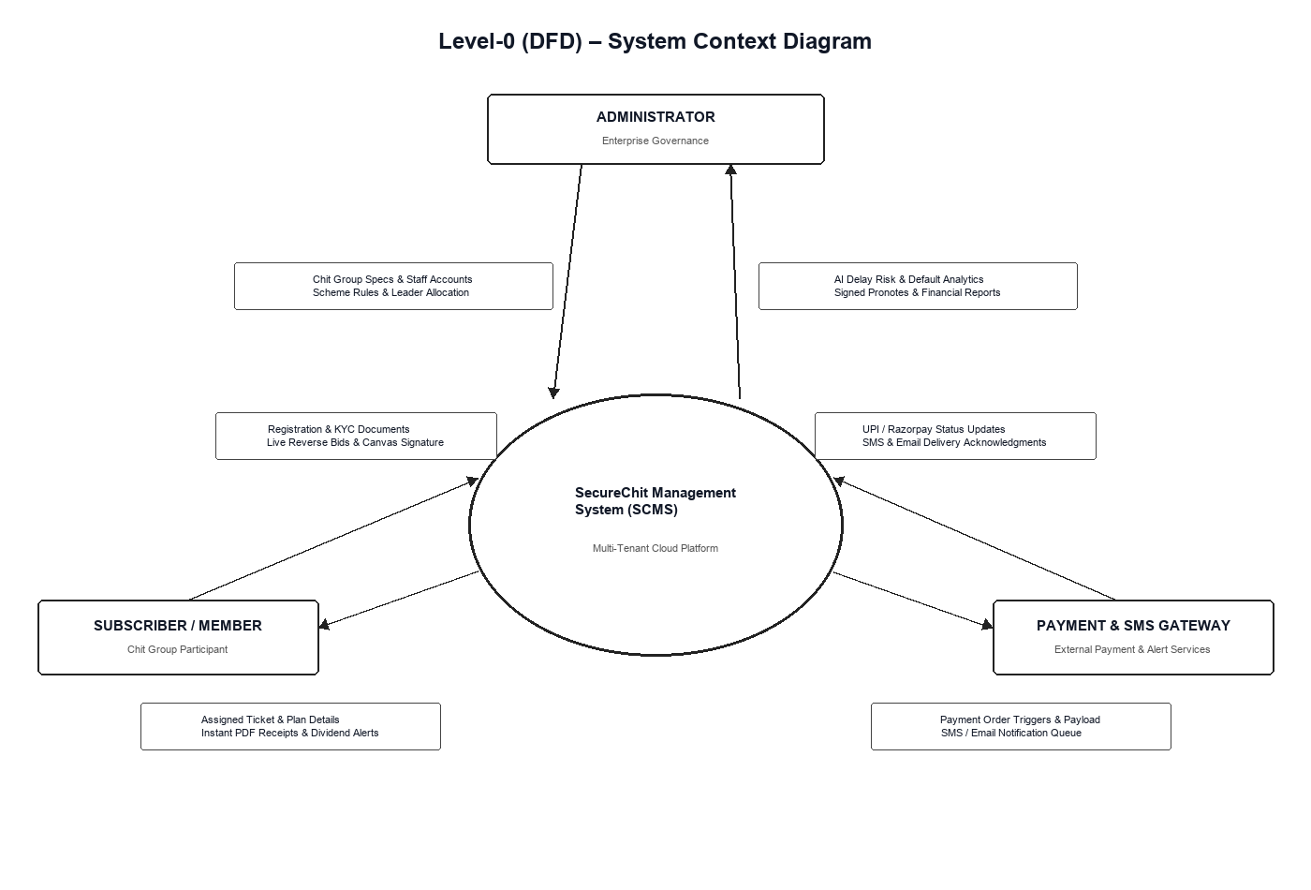
Figure : Level 0 Context Diagram showing Member User, Admin Foreman, Central System, and PostgreSQL Database.

System Overview & Subsystem Decomposition (Level 1 DFD)
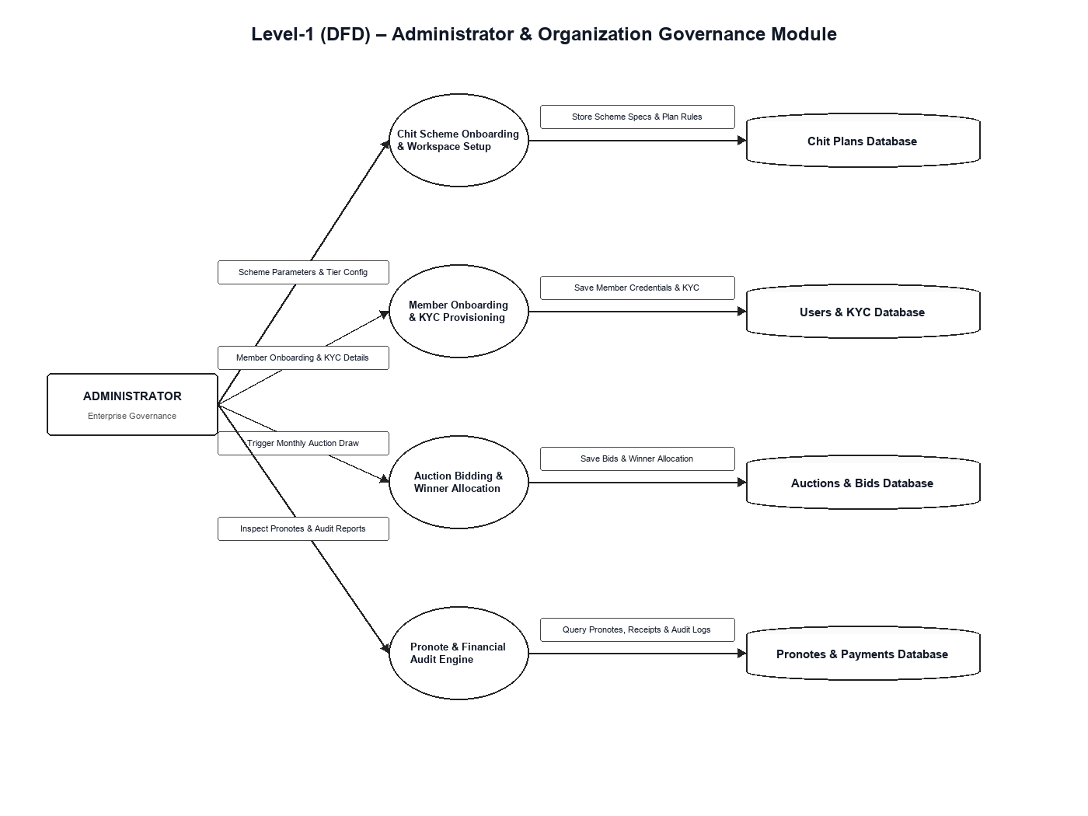
Figure : Level 1 DFD (Decomposition Diagram)

Auction Bidding & Workflow (Level 2 DFD)
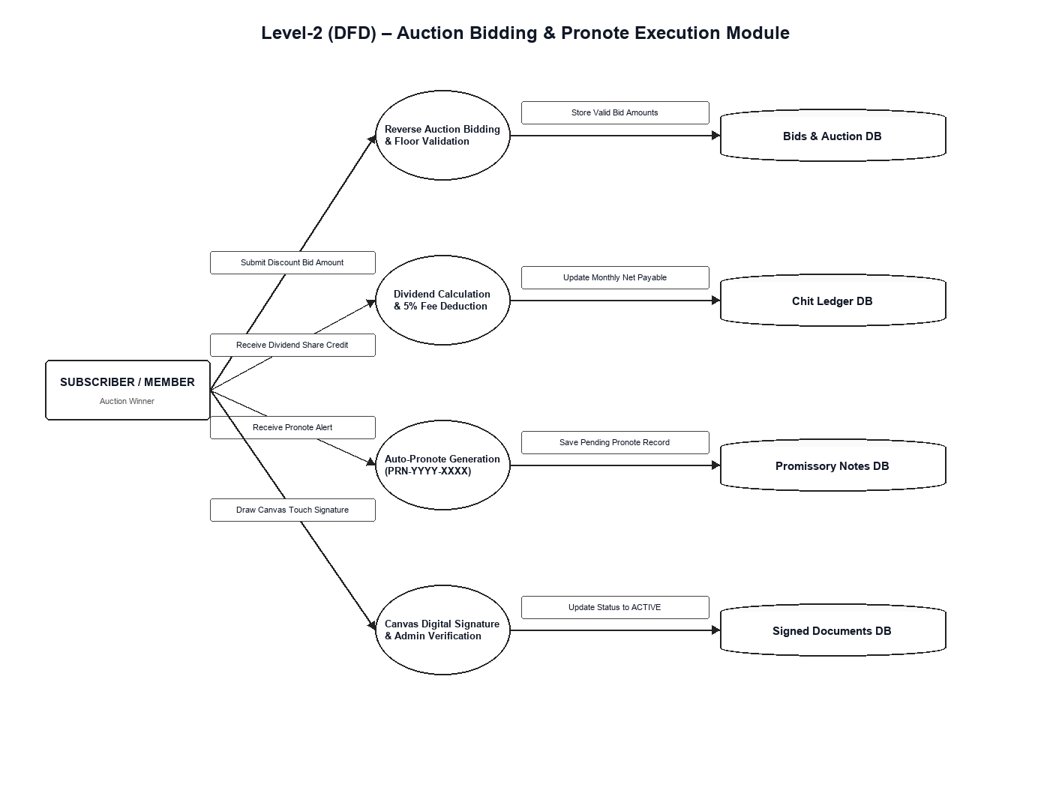
Figure : Level 2 DFD - Auction Bidding and Workflow

4.3 DATABASE SCHEMA DICTIONARY
Table 1: users (Subscriber & Admin Accounts)
Column Name | Data Type | Constraints | Description
user_id | INTEGER | PRIMARY KEY, AUTOINC | Unique identifier for user
full_name | VARCHAR(100) | NOT NULL | Full name of subscriber/admin
email | VARCHAR(100) | UNIQUE, NOT NULL | Email address for login & alerts
phone | VARCHAR(15) | UNIQUE, NOT NULL | Mobile number for Fast2SMS alerts
password_hash | VARCHAR(255) | NOT NULL | Bcrypt hashed security password
role | VARCHAR(20) | DEFAULT 'MEMBER' | User role ('ADMIN' or 'MEMBER')
Table 2: promissory_note (Digital Promissory Notes & Signatures)
Column Name | Data Type | Constraints | Description
pronote_id | VARCHAR(50) | PRIMARY KEY | Auto-generated PRN-YYYY-XXXX code
member_id | INTEGER | FOREIGN KEY (users) | Winning member ID
chit_id | INTEGER | FOREIGN KEY (plans) | Associated Chit Plan ID
loan_amount | DECIMAL(12,2) | NOT NULL | Net loan amount payout
interest_rate | DECIMAL(5,2) | DEFAULT 0.00 | Monthly interest rate
signature | TEXT | NOT NULL | Base64 encoded HTML5 canvas signature PNG
status | ENUM | DEFAULT 'pending_signature' | Status: pending_signature / active / paid

5. System Implementation & Source Code
5.1 REQUIREMENTS & VERSION SPECIFICATIONS
- Python 3.11.4 | FastAPI 0.100.0 | Uvicorn 0.22.0
- React 18.2.0 | Tailwind CSS 3.3.2 | Canvas API
5.2 SAMPLE CODING IMPLEMENTATION
Sample backend financial dividend algorithm, auction draw handler, and HTML5 canvas digital signature encoder are included in the source code repository.

6. System Testing
6.1 SYSTEM TEST CASES TABLE
Test ID | Module / Feature | Test Case Description | Expected Result | Status
TC-01 | User Authentication | Submit valid email & password | Returns JWT access token & redirects to dashboard | PASSED
TC-02 | Scheme Management | Admin creates scheme with 20 members & ₹10L pool | Saves scheme in DB and lists under active schemes | PASSED
TC-03 | Reverse Auction | Member submits bid discount | Updates lowest bid floor and computes 5% commission | PASSED
TC-04 | Auto Winner Pronote | Conduct monthly auction draw | Auto-generates Promissory Note for winner in pending_signature status | PASSED
TC-05 | Member Digital Signature | Winner draws signature on canvas & submits | Updates pronote status to active and reveals note in Admin portal | PASSED
TC-06 | Payment Verification | Member submits UPI transaction UTR reference | Admin verifies receipt and status updates to PAID | PASSED
TC-07 | Automated Reminders | Execute due reminder scheduler | Dispatches Fast2SMS text & Nodemailer SMTP email to unpaid members | PASSED

7. Screenshots & Interface Walkthrough
1. User Login & Registration Interface: JWT-authenticated credential entry page.
2. Subscriber Dashboard: Overview of subscribed chit plans, total dividend earned, and current dues.
3. Scheme Explorer: Grid of available chit pools with duration, total value, and capacity.
4. Live Bidding Console: Real-time reverse auction console showing lowest bid floor.
5. Digital Promissory Note Signing Modal: HTML5 canvas touchscreen/mouse signature pad with Clear & Save buttons.
6. Admin Dashboard & Promissory Notes Portal: Administrative panel for scheme creation, join approvals, and signed pronotes verification.

8. Conclusion
The SecureChit: Digital Chit Fund Management System successfully modernizes traditional chit fund savings and credit operations into a transparent, automated web application. By combining React 18, Python FastAPI, PostgreSQL, and HTML5 Canvas Digital Signatures, the platform eliminates paper record loss, bid manipulation, manual calculation errors, and payment defaults.

9. Future Enhancements
- Native Mobile Application: React Native app for iOS and Android with push notifications.
- Biometric & Facial Verification: Aadhaar e-KYC integration using biometric fingerprint & OTP validation.
- Automated UPI Payment Gateway: Integration of Razorpay / PhonePe UPI intent gateway for auto-reconciliation.
10. Bibliography & References
1. Alex Banks & Eve Porcello, "Learning React: Modern Patterns for Developing React Applications, 2nd Edition", O'Reilly Media, 2020.
2. David Choi, "Full-Stack React Projects: Build real-world modern web apps", Packt Publishing, 2020.
3. React Official Documentation: https://react.dev
4. FastAPI Official Documentation: https://fastapi.tiangolo.com

