SECURE CHIT: DIGITAL CHIT FUND MANAGEMENT SYSTEM
DATA FLOW DIAGRAMS (DFD)
Level-0 (DFD) – System Context Diagram
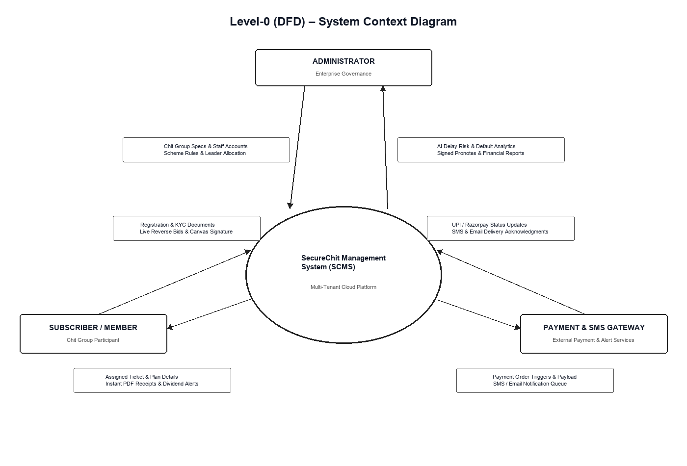

Level-1 (DFD) – Administrator & Organization Governance Module
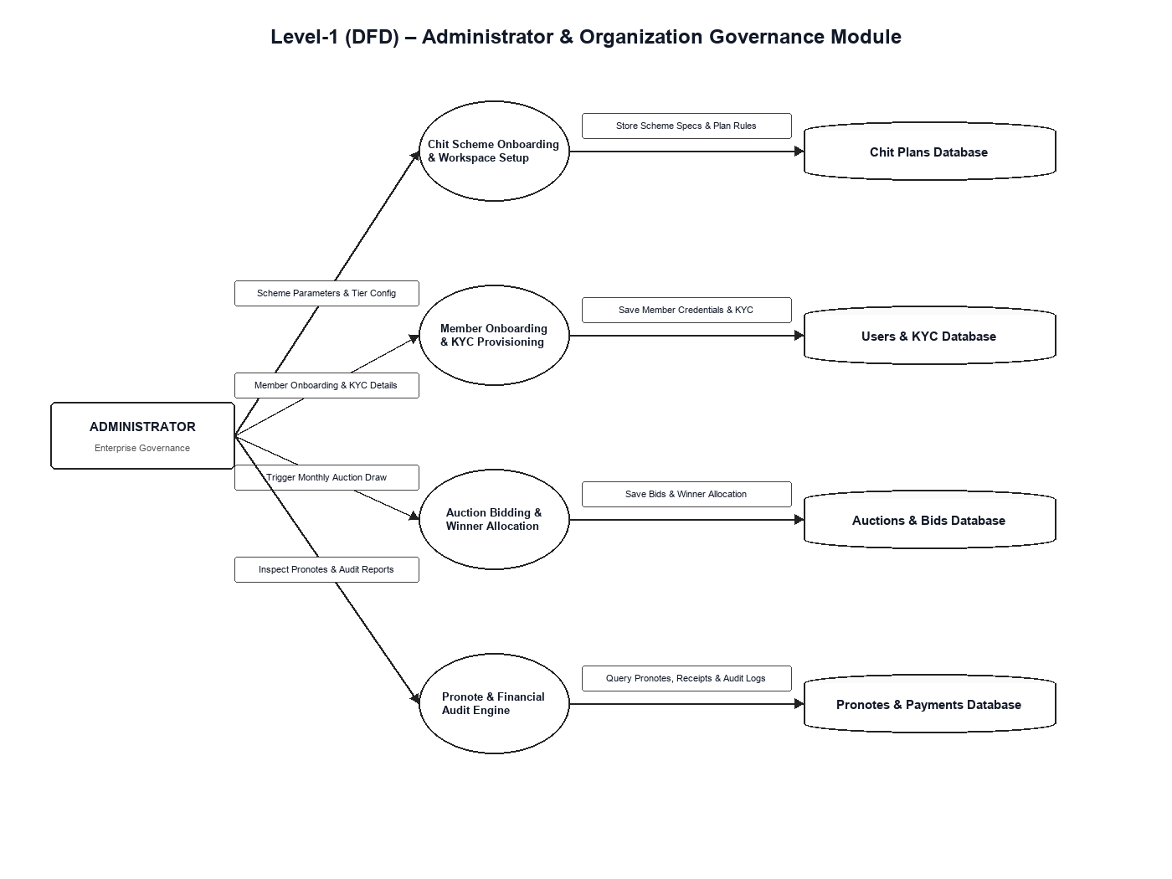

Level-2 (DFD) – Auction Bidding & Pronote Execution Module
