SECURE CHIT:DIGITAL CHIT FUND
MANAGEMENT SYSTEM

Submitted in partial fulfillment of the requirements for
the award of the degree of

Bachelor of Science in Computer Science

By

R.NARESHKUMAR (24UCS08)
APR.JEGATHEESH VARSHAN(24UCS08)

Under the Guidance of

Mrs. SM. VALLI B.E., M.C.A., M.Phil



Department of Computer Science
Thiagarajar College (Autonomous)
(Affiliated to Madurai Kamaraj University)
Re-accredicted with ‘A++’ Grade by NAAC
Ranked 20th in NIRF2025
Madurai – 625009

October - 2026.

Thiagarajar College (Autonomous)
(Affiliated to Madurai Kamaraj University)
Re-Accredited with ‘A++’ Grade by NAAC
Ranked 20th in NIRF

Department of Computer Science

This is to certify that “SECURE CHIT:DIGITAL CHIT FUND MANAGEMENT SYSTEM” is a bonafide project work done by R.NARESHKUMAR(24UCS08) and APR.JEGATHEESH VARSHAN(24UCS06) of B.Sc Computer Science during the sixth semester. Submitted for the final viva voce held on
________________.

Project Guide  (SM. VALLI) | Head of the Department  (SM. VALLI)

External Examiner

APR.JEGATHEESH VARSHAN(24UCS06)
B.Sc Computer Science
Department of Computer Science
Thiagarajar College (Autonomous)
Madurai – 625009.

Declaration

Hereby I declare that this software product “SECURE CHIT:DIGITAL CHIT FUND MANAGEMENT SYSTEM” has been done thoroughly at the outset of my knowledge and has not been drafted out to any other modes of information. This software has been purely developed by me.

Place : Signature
Date:

APR.Jegatheesh varshan (24UCS06)

R.NARESHKUMAR (24UCS08)
B.Sc Computer Science
Department of Computer Science
Thiagarajar College (Autonomous)
Madurai – 625009.

Declaration

Hereby I declare that this software product “SECURE CHIT:DIGITAL CHIT FUND MANAGEMENT SYSTEM” has been done thoroughly at the outset of my knowledge and has not been drafted out to any other modes of information. This software has been purely developed by me.

Place : Signature
Date:

R.Nareshkumar
(24UCS08)

ACKNOWLEDGEMENT
We extend our sincere thanks to the Almighty for blessing us with the physical strength, mental ability, and determination that enabled us to complete this project effectively.
We are grateful to our respected Principal, Dr. D. PANDIARAJA, M.Sc., M.Phil., P.G.D.C.A., B.Ed., Ph.D., Thiagarajar College, Madurai, for granting us the opportunity to carry out this project work under the esteemed guidance of our department.
We wish to express our profound gratitude to the Head of the Department of Computer Science, Mrs. SM. VALLI, B.E., M.C.A., M.Phil. We sincerely thank her for her valuable guidance, constant encouragement, and support throughout the progress of this work.
We are especially indebted to our Project Guide Mrs. SM. VALLI, B.E., M.C.A., M.Phil., for her patient guidance, constructive suggestions, and for having faith in our ability. Her keen interest and valuable feedback at every stage greatly contributed to the successful completion of this project.
We also extend our heartfelt thanks to all the faculty members of the Department of Computer Science for their constant support, academic guidance, and encouragement during the course of our project.
Finally, we express our deep sense of gratitude to our family members and friends for their unwavering encouragement, moral support, and understanding, which have been a pillar of strength throughout our work.

SI.NO | TITLE | PAGENO
1 | INTRODUCTION  - Abstract  - Project Description | 3  4
2 | SYSTEM ANALYSIS  - Existing System  - Proposed System | 6  6
3 | SYSTEM CONFIGURATION  - Hardware Specification  - Software Specification | 8  8
4 | SYSTEM DESIGN  - Data Flow Diagram  - Module Design  - Module Description | 15  17  18
5 | SYSTEM IMPLEMENTATION  - Sample Coding | 21
6 | SYSTEM TESTING  - System Testing  - Types of Testing | 55  55
7 | INPUT OUTPUT SCREEN | 57
8 | CONCLUSION | 68
9 | FUTURE ENHANCEMENT | 70
10 | BIBLIOGRAPHY | 72

INTRODUCTION

1. INTRODUCTION

1.1 ABSTRACT:

In tier-2 cities such as Madurai, the domestic service sector remains unorganized and is largely driven by informal word-of-mouth references. Households searching for an electrician, plumber, or carpenter have no reliable way to verify a technician’s identity, skills, or pricing. SkillServe is a localized, on-demand home services marketplace that connects urban customers with verified skilled professionals across Madurai through one transparent digital platform.

The system has three role-based modules: Customer, Professional / Worker, and Administrator. Customers register using email OTP verification, search for workers by trade, locality, and rating, and book appointments. Workers undergo an administrator-supervised KYC approval process using documents such as Aadhaar or PAN before their profiles become publicly visible. After the work is completed, the worker raises an itemized digital bill covering the visiting charge, labour, and spare parts.

A key feature of SkillServe is its two-step payment settlement. Customers can pay through a Razorpay test gateway or via UPI / QR using a 12-digit UTR reference, and the worker must verify the payment receipt before the booking is completed. If the payment is not received, the booking remains open, allowing the customer to use the Pay Again option. The platform is built using React 19 and Vite for the frontend, Java 17 and Spring Boot 3.5.16 for the backend, and MySQL 8.0 for the database.1.2

PROJECT DESCRIPTION
The project aims to implement SecureChit, a trusted enterprise digital chit fund management platform that replaces traditional paper ledgers, manual cash collection, and physical auction halls with a verified, transparent, and legally accountable digital process. The system focuses on member identity verification (KYC), automated chit group lifecycles, real-time reverse auction bidding, instant dividend distribution, legally binding digital Promissory Note execution, and secure installment settlement with administrator verification.
The main objectives of the project are given below:
- Role-based Interface: A responsive web interface tailored for Chit Members (Subscribers) and Administrators (Foreman).
- Verified Onboarding & KYC: Administrator review and verification of government identity proofs (Aadhaar / PAN) before chit group enrollment.
- Chit Group Management: Automated group lifecycle tracking, member slot allocation, monthly installment scheduling, and scheme rule enforcement.
- Real-time Reverse Auction: Live bidding engine with reverse auction price drops, emergency rank prioritization, and transparent winner selection.
- Automated Dividend Engine: Instant computation of foreman commission (capped at 5%) and uniform distribution of auction discounts as member dividends to reduce subsequent monthly dues.
- Digital Promissory Note (Pronote): Automated legal Promissory Note generation (PRN-2026-XXXX) with HTML5 canvas touch/mouse digital signatures and PDF rendering upon winning an auction.
- Dual-channel Payments & Verification: Instant installment settlement via direct UPI / QR code payment, transaction ID tracking, admin verification, and safe retry handling for pending payments.
- Security and Integrity: BCrypt password hashing, JWT bearer token authentication, role-based access control (RBAC), and relational database audit logging.
Scope: The project covers the complete rotating savings and credit association (ROSCA) lifecycle—from member onboarding, KYC verification, and group enrollment to monthly reverse bidding, digital promissory note signing, installment payment submission, admin verification, and final chit settlement. The platform complies with standard chit fund regulations by enforcing a 5% foreman commission cap and 95% prize pool distribution, generating tamper-proof digital receipts in the format REC-2026-XXXX and legal promissory notes in the format PRN-2026-XXXX.

SYSTEM ANALYSIS

2. SYSTEM ANALYSIS

2.1 EXISTING SYSTEM:
At present, traditional chit fund operations and rotating savings associations (ROSCAs) in local communities rely heavily on manual registers, physical branch visits, cash collections, and informal verbal agreements. The conventional process has several critical vulnerabilities and operational bottlenecks:
- Manual Book-Keeping:
  - Paper Ledgers & Registers: All transactions, contributions, and balance sheets are maintained manually in physical logbooks.
  - Prone to Record Tampering: Physical registers can be easily altered, forged, or manipulated without authorization.
  - High Risk of Data Loss: Physical ledgers are vulnerable to environmental damage (fire, water), misplacement, or physical decay.
  - No Real-Time Tracking for Members: Subscribers have no immediate visibility into their accumulated savings, upcoming dues, or group status without personally contacting the foreman.
- Lack of Transparency:
  - Hidden Company Commissions: Foremen often deduct arbitrary administrative charges exceeding statutory limits.
  - Unclear Dividend Calculations: Manual distribution calculations obscure the exact auction discount and net dividend due to each member.
  - Manual Auction Bidding Disputes: Physical bidding hall sessions and paper-slip token draws lead to accusations of favoritism, proxy bidding, or collusion.
  - No Verifiable Audit Logs: The absence of timestamped operational histories makes dispute resolution nearly impossible.
- Payment & Security Risks:
  - Physical Cash Handling Risks: Cash collection agents face theft, loss, and accounting discrepancies during transit.
  - Delayed Manual Verifications: Cash and cheque clearances take days to reconcile, delaying prize money disbursement.
  - Unverified Member Identities: Lack of formal KYC verification allows unvetted or high-risk participants into the chit group.
  - No Digital Payment Proof: Members are often given loose paper slips or no receipts at all, leaving them without legal proof of payment.
- Physical Promissory Note (Pronote) Burden:
  - Borrowers must physically sign stamped paper promissory notes, causing logistical delays and risks of lost legal instruments during defaults.

2.2 PROPOSED SYSTEM:
PROPOSED SYSTEM
The proposed SecureChit platform is an enterprise-grade digital chit fund management system designed to eliminate manual vulnerabilities, ensure strict statutory compliance, and bring absolute transparency to rotating savings and credit associations. It automates the entire chit lifecycle—from Aadhaar/PAN-based KYC onboarding, automated scheme creation, and real-time reverse auction bidding to emergency prioritization, HTML5 canvas digital Promissory Note execution, and QR/UPI payment settlements.
The platform streamlines operations through a secure web architecture, providing separate role-based dashboards for Members and Administrators (Foreman), ensuring that every financial transaction and auction event is verifiable, tamper-proof, and accountable.
Key Capabilities & Architecture:
- Automated Chit Scheme Engine: Configures and manages tiered chit plans (Bronze, Silver, Gold) with automated tracking of total chit value, installment schedules, duration, and maximum subscriber slots.
- Transparent Month-by-Month Auction & Dividend Schedule: Real-time reverse auction bidding engine that records live bids, automatically identifies winning discount values, and computes net dividend distributions instantly.
- 5% Foreman Commission Auto-Calculation: Strictly enforces the statutory 5% foreman commission ceiling while distributing 95% of the auction discount equally among all active subscribers to reduce their monthly installment dues.
- AI Emergency Prioritization Engine: An algorithmic bidding and priority assignment system that evaluates and ranks members based on critical financial necessity:
  - Rank 1: Hospital / Medical Emergency
  - Rank 2: Higher Education / School Fees
  - Rank 3: Marriage / Family Function
  - Rank 4: Business Capital / Expansion
  - Rank 5: Personal Savings / Investment
- Digital Promissory Note (Pronote) Module: Automatically generates legally structured promissory notes in the format PRN-2026-XXXX upon auction completion. Winning members execute their agreement using an HTML5 touch/mouse canvas signature before loan disbursal.
- Instant UPI / QR Code Payment Integration: Members settle dues instantly by scanning dynamic GPay / PhonePe UPI QR codes with transaction UTR verification.
- Safe Payment Settlement & Verification: Pending or unverified transactions do not lock the member's account; payments follow a safe two-step verification workflow (pending $→$admin verified $→$success) with retry capabilities.
- Verified Digital Receipts: Automatically generates tamper-proof, downloadable PDF receipts in the format REC-2026-XXXX with full audit details.

COMPARISON OF EXISTING AND PROPOSED SYSTEM:
Dimension | Existing Informal Mechanism | SkillServe Solution
Record Keeping | Paper ledgers, physical registers; high risk of tampering, decay, or loss. | Centralized PostgreSQL database with automated backups and real-time ledger tracking.
Member Verification | Informal referrals; no background or identity checks. | Mandatory Aadhaar and PAN KYC upload with administrator verification.
Chit Schemes | Fixed, rigid informal chit circles with manual member coordination. | Automated Chit Scheme Engine with tiered plans (Bronze, Silver, Gold).
Auction & Bidding | Physical hall meetings; prone to disputes, proxy bidding | Real-time digital reverse auction engine with transparent live bid track
Emergency Priority | Informal favoritism or arbitrary decisions by the foreman. | 5-Tier AI Emergency Prioritization
Security & Auditing | No access control or audit trails; zero operational accountability. | Verified 1-to-5-star ratings BCrypt password hashing, JWT authentication, RBAC, and immutable audit logs.

SYSTEM CONFIGURATION

3. SYSTEM CONFIGURATION

3.1 HARDWARE SPECIFICATIONS

- Processor : Intel Core i5
- Installed RAM : 8.00 GB DDR4 (minimum: 4.00 GB)
- Hard Disk : 256 GB SSD (minimum: 20 GB free disk space)
- Network : Wi-Fi 802.11ac / Gigabit Ethernet, minimum 10 Mbps broadband internet connection
- Display : 1920 × 1080 Full HD (minimum: 1024 × 768)
- Client Device : Desktop PC, Laptop, Android / iOS Smartphone or Tablet with a modern web browser (Google Chrome, Microsoft Edge, Mozilla Firefox, Safari)

3.2 SOFTWARE SPECIFICATIONS

- Operating System : Windows 10 / Windows 11 (64-bit) / Linux (Ubuntu 22.04 LTS)
- Front-end Technology : React 18.2.0, Vite 5.0.0, HTML5 (Canvas API), Tailwind CSS 3.3.5, JavaScript (ES6+), Axios 1.18.1
- Back-end Technology : Python 3.11+, FastAPI 0.138.1, Uvicorn 0.29.0 ASGI Server (SQLAlchemy 2.0.51, Pydantic v2, Passlib 1.7.4, Python-Jose 3.5.0)
- Database : PostgreSQL 16 (database: Secure / securechit_db, driver: psycopg2-binary 2.9.12)
- Document & PDF Engine : ReportLab 5.0.0, Pillow 12.2.0 (for automated PDF receipts and promissory notes)
- QR & Payment Engine : Python qrcode 8.2 (dynamic UPI QR code generation for GPay / PhonePe)
- Notification Relay : Python smtplib via TLS (Google SMTP relay on port 587)
- Build Tools & Runtime : Node.js 20.x LTS, Python Virtual Environment (venv), npm 10.x
- Development Tools : Visual Studio Code, pgAdmin 4 / DBeaver, Postman 11
- Ports : React Frontend 5173 / 5174, FastAPI Backend 8000, PostgreSQL Database 5433 (or 5432)

3.3 ABOUT THE LANGUAGE

FRONT-END TECHNOLOGY

The front end of SecureChit is engineered as a high-performance Single-Page Application (SPA). HTML5 establishes semantic markup across modules and provides the HTML5 <canvas> API, enabling subscribers to draw and submit digital signatures for legal Promissory Notes using a touchscreen, mouse, or stylus. Tailwind CSS delivers a modern, utility-first responsive layout with custom breakpoints for mobile (480 px), tablet (768 px), and desktop (1200 px+) screens. JavaScript (ES6+) manages asynchronous HTTP communication with the backend via Axios and async/await syntax.
React 18 powers the component hierarchy, using hooks such as useState (managing live bidding inputs, modal visibility, and payment forms), useEffect (handling data polling, auction status synchronization, and notification fetches), and useNavigate for secure role-based routing. Vite 5 provides ultra-fast Hot Module Replacement (HMR) and optimized production bundles. Specialized UI libraries, including lucide-react for financial iconography, react-custom-roulette for interactive auction draws, and canvas-confetti for auction-win and payment success animations, deliver a responsive and engaging user experience.

BACK-END TECHNOLOGY

Python 3.11+ provides clean syntax, rapid execution, and native asynchronous programming capabilities via asyncio. FastAPI 0.138.1 serves the RESTful API endpoints running on top of the high-speed Uvicorn ASGI server, integrating the following core modules:
- FastAPI APIRouter: Implements modular, role-delimited REST controllers for authentication, member onboarding, chit plan administration, reverse-auction bidding, digital promissory note management, and installment payments.
- Pydantic v2: Enforces strict runtime data validation, automatic serialization, request payload filtering, and automatic OpenAPI (Swagger UI) documentation generation.
- SQLAlchemy 2.0 ORM & Alembic: Maps Python model classes to PostgreSQL relational tables, enforces foreign key constraints across members and payments, and manages safe database schema migrations.
- Passlib & Python-Jose: Implements BCrypt password hashing with cryptographic salt generation and JWT (JSON Web Token) bearer authorization for secure, stateless session handling.
- ReportLab & QRCode: Programmatically compiles legal Promissory Note agreements (PRN-2026-XXXX) and official transaction receipts (REC-2026-XXXX) into downloadable PDF documents alongside real-time dynamic UPI payment QR codes.
PostgreSQL 16, utilizing the relational MVCC engine, guarantees strict ACID compliance, ensuring tamper-proof ledger entries, accurate auction records, and relational integrity across chit fund schemes.

SYSTEM DESIGN

4.1.DATA FLOW DIAGRAM
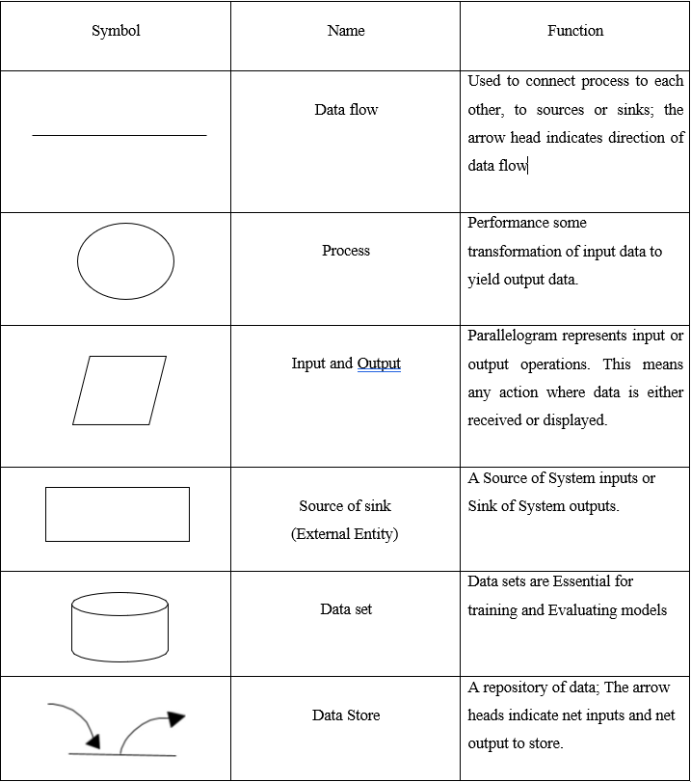

Context Level Diagram (Level 0 DFD)
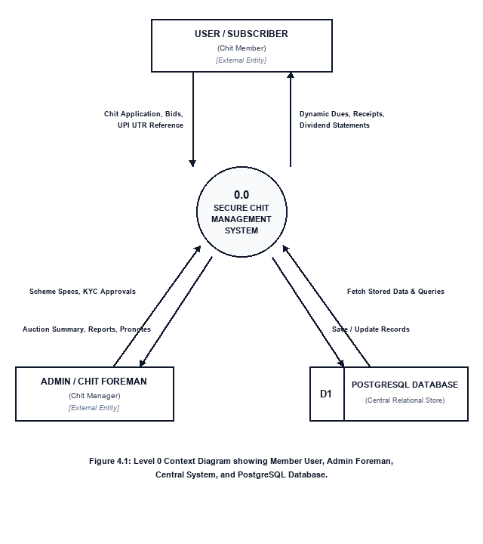
Figure 4.1: Level 0 Context Diagram showing Member User, Admin Foreman, Central System, and PostgreSQL Database.

System Overview & Subsystem Decomposition (Level 1 DFD)
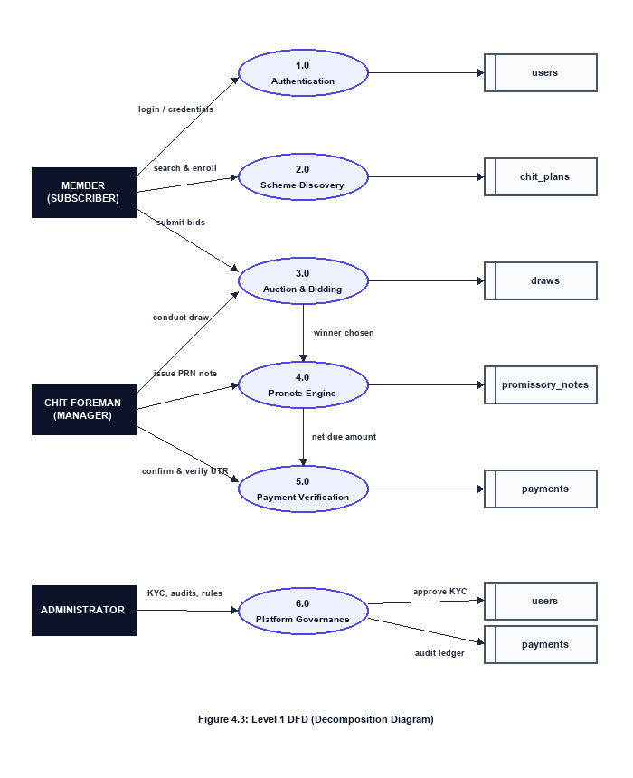
Figure 4.3: Level 1 DFD (Decomposition Diagram)

Auction Bidding & Pronote Workflow (Level 2 DFD)

4.2 MODULE DESIGN
Four-Tier Architecture:
SecureChit follows a four-tier, decoupled client–server architecture: the React presentation layer, the FastAPI API gateway and security layer, the Python business logic and computation engine layer, and the PostgreSQL data persistence layer.
The platform is structured across four clearly separated tiers, each handling a distinct responsibility — from user interface rendering, API routing and authentication, core business computation, to persistent relational data storage.

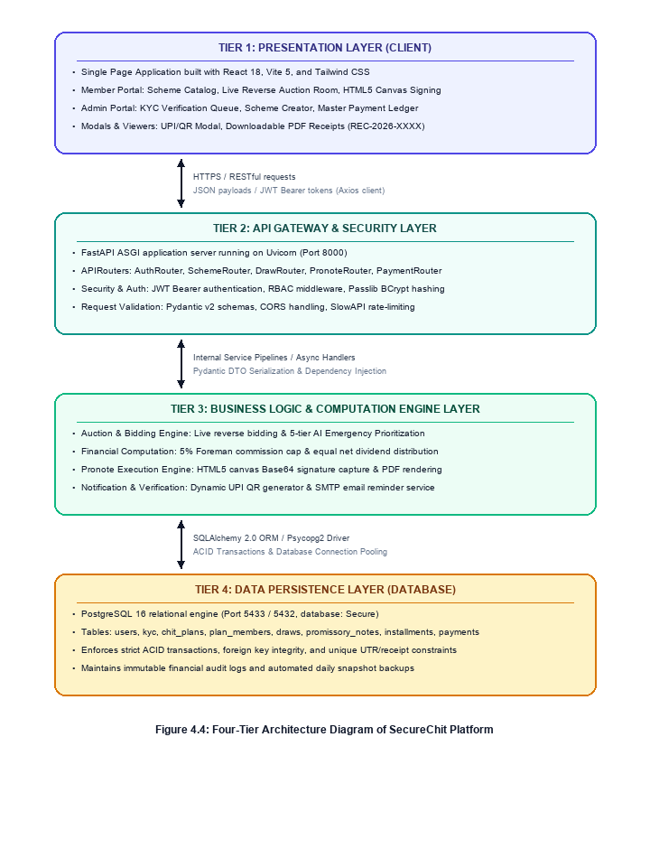
Figure 4.4: Four-Tier Architecture Diagram of SecureChit Platform

