SECURE CHIT:DIGITAL CHIT FUND
MANAGEMENT SYSTEM

Submitted in partial fulfillment of the requirements for
the award of the degree of

Bachelor of Science in Computer Science

By

R.NARESHKUMAR (24UCS08)
APR.JEGATHEESH VARSHAN(24UCS08)

Under the Guidance of

Mrs. SM. VALLI B.E., M.C.A., M.Phil



Department of Computer Science
Thiagarajar College (Autonomous)
(Affiliated to Madurai Kamaraj University)
Re-accredicted with ‘A++’ Grade by NAAC
Ranked 20th in NIRF2025
Madurai – 625009

October - 2026.

Thiagarajar College (Autonomous)
(Affiliated to Madurai Kamaraj University)
Re-Accredited with ‘A++’ Grade by NAAC
Ranked 20th in NIRF

Department of Computer Science

This is to certify that “SECURE CHIT:DIGITAL CHIT FUND MANAGEMENT SYSTEM” is a bonafide project work done by R.NARESHKUMAR(24UCS08) and APR.JEGATHEESH VARSHAN(24UCS06) of B.Sc Computer Science during the sixth semester. Submitted for the final viva voce held on
________________.

Project Guide  (SM. VALLI) | Head of the Department  (SM. VALLI)

External Examiner

APR.JEGATHEESH VARSHAN(24UCS06)
B.Sc Computer Science
Department of Computer Science
Thiagarajar College (Autonomous)
Madurai – 625009.

Declaration

Hereby I declare that this software product “SECURE CHIT:DIGITAL CHIT FUND MANAGEMENT SYSTEM” has been done thoroughly at the outset of my knowledge and has not been drafted out to any other modes of information. This software has been purely developed by me.

Place : Signature
Date:

APR.Jegatheesh varshan (24UCS06)

R.NARESHKUMAR (24UCS08)
B.Sc Computer Science
Department of Computer Science
Thiagarajar College (Autonomous)
Madurai – 625009.

Declaration

Hereby I declare that this software product “SECURE CHIT:DIGITAL CHIT FUND MANAGEMENT SYSTEM” has been done thoroughly at the outset of my knowledge and has not been drafted out to any other modes of information. This software has been purely developed by me.

Place : Signature
Date:

R.Nareshkumar
(24UCS08)

ACKNOWLEDGEMENT
We extend our sincere thanks to the Almighty for blessing us with the physical strength, mental ability, and determination that enabled us to complete this project effectively.
We are grateful to our respected Principal, Dr. D. PANDIARAJA, M.Sc., M.Phil., P.G.D.C.A., B.Ed., Ph.D., Thiagarajar College, Madurai, for granting us the opportunity to carry out this project work under the esteemed guidance of our department.
We wish to express our profound gratitude to the Head of the Department of Computer Science, Mrs. SM. VALLI, B.E., M.C.A., M.Phil. We sincerely thank her for her valuable guidance, constant encouragement, and support throughout the progress of this work.
We are especially indebted to our Project Guide Mrs. SM. VALLI, B.E., M.C.A., M.Phil., for her patient guidance, constructive suggestions, and for having faith in our ability. Her keen interest and valuable feedback at every stage greatly contributed to the successful completion of this project.
We also extend our heartfelt thanks to all the faculty members of the Department of Computer Science for their constant support, academic guidance, and encouragement during the course of our project.
Finally, we express our deep sense of gratitude to our family members and friends for their unwavering encouragement, moral support, and understanding, which have been a pillar of strength throughout our work.

SI.NO | TITLE | PAGENO
1 | INTRODUCTION  - Abstract  - Project Description | 3  4
2 | SYSTEM ANALYSIS  - Existing System  - Proposed System | 6  6
3 | SYSTEM CONFIGURATION  - Hardware Specification  - Software Specification | 8  8
4 | SYSTEM DESIGN  - Data Flow Diagram  - Module Design  - Module Description | 15  17  18
5 | SYSTEM IMPLEMENTATION  - Sample Coding | 21
6 | SYSTEM TESTING  - System Testing  - Types of Testing | 55  55
7 | INPUT OUTPUT SCREEN | 57
8 | CONCLUSION | 68
9 | FUTURE ENHANCEMENT | 70
10 | BIBLIOGRAPHY | 72

INTRODUCTION

1. INTRODUCTION

1.1 ABSTRACT:

In tier-2 cities such as Madurai, the domestic service sector remains unorganized and is largely driven by informal word-of-mouth references. Households searching for an electrician, plumber, or carpenter have no reliable way to verify a technician’s identity, skills, or pricing. SkillServe is a localized, on-demand home services marketplace that connects urban customers with verified skilled professionals across Madurai through one transparent digital platform.

The system has three role-based modules: Customer, Professional / Worker, and Administrator. Customers register using email OTP verification, search for workers by trade, locality, and rating, and book appointments. Workers undergo an administrator-supervised KYC approval process using documents such as Aadhaar or PAN before their profiles become publicly visible. After the work is completed, the worker raises an itemized digital bill covering the visiting charge, labour, and spare parts.

A key feature of SkillServe is its two-step payment settlement. Customers can pay through a Razorpay test gateway or via UPI / QR using a 12-digit UTR reference, and the worker must verify the payment receipt before the booking is completed. If the payment is not received, the booking remains open, allowing the customer to use the Pay Again option. The platform is built using React 19 and Vite for the frontend, Java 17 and Spring Boot 3.5.16 for the backend, and MySQL 8.0 for the database.1.2

PROJECT DESCRIPTION
The project aims to implement SecureChit, a trusted enterprise digital chit fund management platform that replaces traditional paper ledgers, manual cash collection, and physical auction halls with a verified, transparent, and legally accountable digital process. The system focuses on member identity verification (KYC), automated chit group lifecycles, real-time reverse auction bidding, instant dividend distribution, legally binding digital Promissory Note execution, and secure installment settlement with administrator verification.
The main objectives of the project are given below:
- Role-based Interface: A responsive web interface tailored for Chit Members (Subscribers) and Administrators (Foreman).
- Verified Onboarding & KYC: Administrator review and verification of government identity proofs (Aadhaar / PAN) before chit group enrollment.
- Chit Group Management: Automated group lifecycle tracking, member slot allocation, monthly installment scheduling, and scheme rule enforcement.
- Real-time Reverse Auction: Live bidding engine with reverse auction price drops, emergency rank prioritization, and transparent winner selection.
- Automated Dividend Engine: Instant computation of foreman commission (capped at 5%) and uniform distribution of auction discounts as member dividends to reduce subsequent monthly dues.
- Digital Promissory Note (Pronote): Automated legal Promissory Note generation (PRN-2026-XXXX) with HTML5 canvas touch/mouse digital signatures and PDF rendering upon winning an auction.
- Dual-channel Payments & Verification: Instant installment settlement via direct UPI / QR code payment, transaction ID tracking, admin verification, and safe retry handling for pending payments.
- Security and Integrity: BCrypt password hashing, JWT bearer token authentication, role-based access control (RBAC), and relational database audit logging.
Scope: The project covers the complete rotating savings and credit association (ROSCA) lifecycle—from member onboarding, KYC verification, and group enrollment to monthly reverse bidding, digital promissory note signing, installment payment submission, admin verification, and final chit settlement. The platform complies with standard chit fund regulations by enforcing a 5% foreman commission cap and 95% prize pool distribution, generating tamper-proof digital receipts in the format REC-2026-XXXX and legal promissory notes in the format PRN-2026-XXXX.

SYSTEM ANALYSIS

2. SYSTEM ANALYSIS

2.1 EXISTING SYSTEM:
At present, traditional chit fund operations and rotating savings associations (ROSCAs) in local communities rely heavily on manual registers, physical branch visits, cash collections, and informal verbal agreements. The conventional process has several critical vulnerabilities and operational bottlenecks:
- Manual Book-Keeping:
  - Paper Ledgers & Registers: All transactions, contributions, and balance sheets are maintained manually in physical logbooks.
  - Prone to Record Tampering: Physical registers can be easily altered, forged, or manipulated without authorization.
  - High Risk of Data Loss: Physical ledgers are vulnerable to environmental damage (fire, water), misplacement, or physical decay.
  - No Real-Time Tracking for Members: Subscribers have no immediate visibility into their accumulated savings, upcoming dues, or group status without personally contacting the foreman.
- Lack of Transparency:
  - Hidden Company Commissions: Foremen often deduct arbitrary administrative charges exceeding statutory limits.
  - Unclear Dividend Calculations: Manual distribution calculations obscure the exact auction discount and net dividend due to each member.
  - Manual Auction Bidding Disputes: Physical bidding hall sessions and paper-slip token draws lead to accusations of favoritism, proxy bidding, or collusion.
  - No Verifiable Audit Logs: The absence of timestamped operational histories makes dispute resolution nearly impossible.
- Payment & Security Risks:
  - Physical Cash Handling Risks: Cash collection agents face theft, loss, and accounting discrepancies during transit.
  - Delayed Manual Verifications: Cash and cheque clearances take days to reconcile, delaying prize money disbursement.
  - Unverified Member Identities: Lack of formal KYC verification allows unvetted or high-risk participants into the chit group.
  - No Digital Payment Proof: Members are often given loose paper slips or no receipts at all, leaving them without legal proof of payment.
- Physical Promissory Note (Pronote) Burden:
  - Borrowers must physically sign stamped paper promissory notes, causing logistical delays and risks of lost legal instruments during defaults.

2.2 PROPOSED SYSTEM:
PROPOSED SYSTEM
The proposed SecureChit platform is an enterprise-grade digital chit fund management system designed to eliminate manual vulnerabilities, ensure strict statutory compliance, and bring absolute transparency to rotating savings and credit associations. It automates the entire chit lifecycle—from Aadhaar/PAN-based KYC onboarding, automated scheme creation, and real-time reverse auction bidding to emergency prioritization, HTML5 canvas digital Promissory Note execution, and QR/UPI payment settlements.
The platform streamlines operations through a secure web architecture, providing separate role-based dashboards for Members and Administrators (Foreman), ensuring that every financial transaction and auction event is verifiable, tamper-proof, and accountable.
Key Capabilities & Architecture:
- Automated Chit Scheme Engine: Configures and manages tiered chit plans (Bronze, Silver, Gold) with automated tracking of total chit value, installment schedules, duration, and maximum subscriber slots.
- Transparent Month-by-Month Auction & Dividend Schedule: Real-time reverse auction bidding engine that records live bids, automatically identifies winning discount values, and computes net dividend distributions instantly.
- 5% Foreman Commission Auto-Calculation: Strictly enforces the statutory 5% foreman commission ceiling while distributing 95% of the auction discount equally among all active subscribers to reduce their monthly installment dues.
- AI Emergency Prioritization Engine: An algorithmic bidding and priority assignment system that evaluates and ranks members based on critical financial necessity:
  - Rank 1: Hospital / Medical Emergency
  - Rank 2: Higher Education / School Fees
  - Rank 3: Marriage / Family Function
  - Rank 4: Business Capital / Expansion
  - Rank 5: Personal Savings / Investment
- Digital Promissory Note (Pronote) Module: Automatically generates legally structured promissory notes in the format PRN-2026-XXXX upon auction completion. Winning members execute their agreement using an HTML5 touch/mouse canvas signature before loan disbursal.
- Instant UPI / QR Code Payment Integration: Members settle dues instantly by scanning dynamic GPay / PhonePe UPI QR codes with transaction UTR verification.
- Safe Payment Settlement & Verification: Pending or unverified transactions do not lock the member's account; payments follow a safe two-step verification workflow (pending $→$admin verified $→$success) with retry capabilities.
- Verified Digital Receipts: Automatically generates tamper-proof, downloadable PDF receipts in the format REC-2026-XXXX with full audit details.

COMPARISON OF EXISTING AND PROPOSED SYSTEM:
Dimension | Existing Informal Mechanism | SkillServe Solution
Record Keeping | Paper ledgers, physical registers; high risk of tampering, decay, or loss. | Centralized PostgreSQL database with automated backups and real-time ledger tracking.
Member Verification | Informal referrals; no background or identity checks. | Mandatory Aadhaar and PAN KYC upload with administrator verification.
Chit Schemes | Fixed, rigid informal chit circles with manual member coordination. | Automated Chit Scheme Engine with tiered plans (Bronze, Silver, Gold).
Auction & Bidding | Physical hall meetings; prone to disputes, proxy bidding | Real-time digital reverse auction engine with transparent live bid track
Emergency Priority | Informal favoritism or arbitrary decisions by the foreman. | 5-Tier AI Emergency Prioritization
Security & Auditing | No access control or audit trails; zero operational accountability. | Verified 1-to-5-star ratings BCrypt password hashing, JWT authentication, RBAC, and immutable audit logs.

SYSTEM CONFIGURATION

3. SYSTEM CONFIGURATION

3.1 HARDWARE SPECIFICATIONS

- Processor : Intel Core i5
- Installed RAM : 8.00 GB DDR4 (minimum: 4.00 GB)
- Hard Disk : 256 GB SSD (minimum: 20 GB free disk space)
- Network : Wi-Fi 802.11ac / Gigabit Ethernet, minimum 10 Mbps broadband internet connection
- Display : 1920 × 1080 Full HD (minimum: 1024 × 768)
- Client Device : Desktop PC, Laptop, Android / iOS Smartphone or Tablet with a modern web browser (Google Chrome, Microsoft Edge, Mozilla Firefox, Safari)

3.2 SOFTWARE SPECIFICATIONS

- Operating System : Windows 10 / Windows 11 (64-bit) / Linux (Ubuntu 22.04 LTS)
- Front-end Technology : React 18.2.0, Vite 5.0.0, HTML5 (Canvas API), Tailwind CSS 3.3.5, JavaScript (ES6+), Axios 1.18.1
- Back-end Technology : Python 3.11+, FastAPI 0.138.1, Uvicorn 0.29.0 ASGI Server (SQLAlchemy 2.0.51, Pydantic v2, Passlib 1.7.4, Python-Jose 3.5.0)
- Database : PostgreSQL 16 (database: Secure / securechit_db, driver: psycopg2-binary 2.9.12)
- Document & PDF Engine : ReportLab 5.0.0, Pillow 12.2.0 (for automated PDF receipts and promissory notes)
- QR & Payment Engine : Python qrcode 8.2 (dynamic UPI QR code generation for GPay / PhonePe)
- Notification Relay : Python smtplib via TLS (Google SMTP relay on port 587)
- Build Tools & Runtime : Node.js 20.x LTS, Python Virtual Environment (venv), npm 10.x
- Development Tools : Visual Studio Code, pgAdmin 4 / DBeaver, Postman 11
- Ports : React Frontend 5173 / 5174, FastAPI Backend 8000, PostgreSQL Database 5433 (or 5432)

3.3 ABOUT THE LANGUAGE

FRONT-END TECHNOLOGY

The front end of SecureChit is engineered as a high-performance Single-Page Application (SPA). HTML5 establishes semantic markup across modules and provides the HTML5 <canvas> API, enabling subscribers to draw and submit digital signatures for legal Promissory Notes using a touchscreen, mouse, or stylus. Tailwind CSS delivers a modern, utility-first responsive layout with custom breakpoints for mobile (480 px), tablet (768 px), and desktop (1200 px+) screens. JavaScript (ES6+) manages asynchronous HTTP communication with the backend via Axios and async/await syntax.
React 18 powers the component hierarchy, using hooks such as useState (managing live bidding inputs, modal visibility, and payment forms), useEffect (handling data polling, auction status synchronization, and notification fetches), and useNavigate for secure role-based routing. Vite 5 provides ultra-fast Hot Module Replacement (HMR) and optimized production bundles. Specialized UI libraries, including lucide-react for financial iconography, react-custom-roulette for interactive auction draws, and canvas-confetti for auction-win and payment success animations, deliver a responsive and engaging user experience.

BACK-END TECHNOLOGY

Python 3.11+ provides clean syntax, rapid execution, and native asynchronous programming capabilities via asyncio. FastAPI 0.138.1 serves the RESTful API endpoints running on top of the high-speed Uvicorn ASGI server, integrating the following core modules:
- FastAPI APIRouter: Implements modular, role-delimited REST controllers for authentication, member onboarding, chit plan administration, reverse-auction bidding, digital promissory note management, and installment payments.
- Pydantic v2: Enforces strict runtime data validation, automatic serialization, request payload filtering, and automatic OpenAPI (Swagger UI) documentation generation.
- SQLAlchemy 2.0 ORM & Alembic: Maps Python model classes to PostgreSQL relational tables, enforces foreign key constraints across members and payments, and manages safe database schema migrations.
- Passlib & Python-Jose: Implements BCrypt password hashing with cryptographic salt generation and JWT (JSON Web Token) bearer authorization for secure, stateless session handling.
- ReportLab & QRCode: Programmatically compiles legal Promissory Note agreements (PRN-2026-XXXX) and official transaction receipts (REC-2026-XXXX) into downloadable PDF documents alongside real-time dynamic UPI payment QR codes.
PostgreSQL 16, utilizing the relational MVCC engine, guarantees strict ACID compliance, ensuring tamper-proof ledger entries, accurate auction records, and relational integrity across chit fund schemes.

SYSTEM DESIGN

4.1.DATA FLOW DIAGRAM
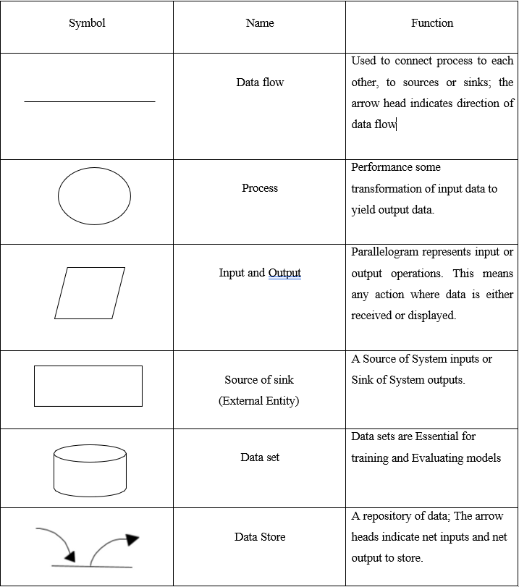

Context Level Diagram (Level 0 DFD)
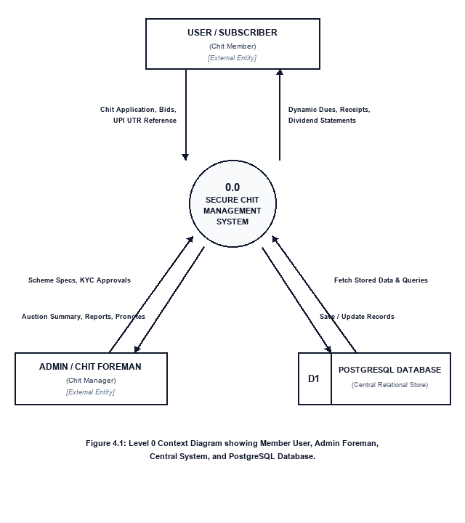
Figure 4.1: Level 0 Context Diagram showing Member User, Admin Foreman, Central System, and PostgreSQL Database.

System Overview & Subsystem Decomposition (Level 1 DFD)
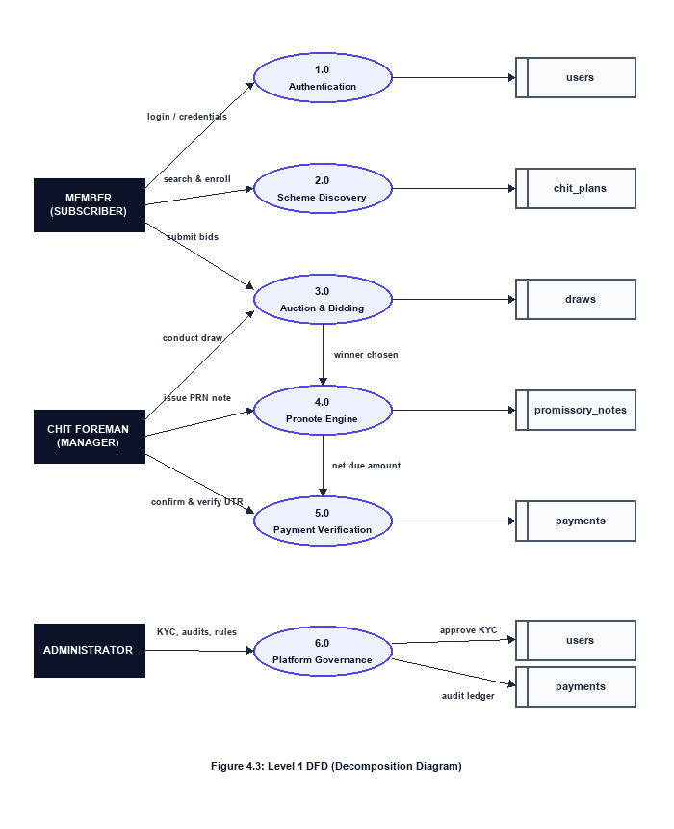
Figure 4.3: Level 1 DFD (Decomposition Diagram)

Auction Bidding & Pronote Workflow (Level 2 DFD)
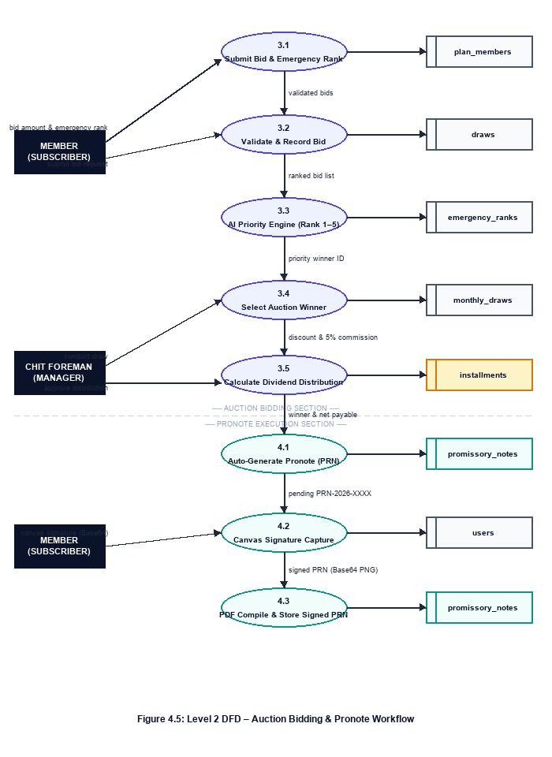
Figure 4.5: Level 2 DFD - Auction Bidding and Pronote Workflow

4.2 DATABASE DESIGN

Table 1: users
Field | Type | Description
id | INT, PK, Auto-Increment | Unique user identifier
username | VARCHAR(50), UNIQUE, NOT NULL | Login username
name | VARCHAR(100), NOT NULL | Full name
email | VARCHAR(150), NOT NULL | Email address
phone | VARCHAR(15), NOT NULL | Contact number
password_hash | VARCHAR(255), NOT NULL | BCrypt hashed password
role | ENUM, NOT NULL | member / admin
status | ENUM, NOT NULL | pending / approved / active / suspended / rejected
aadhar_number | VARCHAR(20), NULL | Aadhaar card number
pan_number | VARCHAR(20), NULL | PAN card number
date_of_birth | DATE, NULL | Date of birth
occupation | VARCHAR(100), NULL | Member occupation
kyc_status | ENUM, NOT NULL | not_submitted / pending / verified / rejected
failed_login_attempts | INT, DEFAULT 0 | Brute-force login counter
last_login | TIMESTAMP, NULL | Last successful login timestamp
is_deleted | BOOLEAN, DEFAULT FALSE | Soft delete flag
created_at | TIMESTAMP, Server Default | Registration timestamp
updated_at | TIMESTAMP, Auto-update | Last modification timestamp

Table 2: kyc_documents
Field | Type | Description
id | INT, PK | Unique KYC record ID
user_id | INT, FK -> users.id | Document owner
document_type | ENUM, NOT NULL | aadhar_front / aadhar_back / pan_card / address_proof / passport_photo
file_path | VARCHAR(255), NOT NULL | Uploaded file storage path
status | ENUM, DEFAULT pending | pending / verified / rejected
rejection_reason | TEXT, NULL | Reason if rejected by admin
verified_by | INT, FK -> users.id | Admin who verified the document
verified_at | TIMESTAMP, NULL | Verification timestamp
created_at | TIMESTAMP, Server Default | Upload timestamp

Table 3: chit_plans
Field | Type | Description
id | INT, PK | Unique plan ID
plan_name | VARCHAR(100), NOT NULL | Plan name e.g. Gold Plan 2026
plan_type | ENUM, DEFAULT silver | bronze / silver / gold
chit_type | VARCHAR(20), DEFAULT lucky_draw | lucky_draw / auction
monthly_amount | FLOAT, NOT NULL | Monthly installment amount (Rs.)
total_members | INT, NOT NULL | Maximum members allowed
current_members | INT, DEFAULT 0 | Currently enrolled members
duration_months | INT, NOT NULL | Total scheme duration in months
total_value | FLOAT, NOT NULL | Total pool = monthly x members
commission_rate | FLOAT, DEFAULT 5.0 | Foreman commission percentage
net_prize_amount | FLOAT, NOT NULL | Prize after commission deduction
start_date | DATE, NOT NULL | Scheme start date
end_date | DATE, NOT NULL | Auto-calculated scheme end date
status | ENUM, DEFAULT draft | draft / active / completed / cancelled
created_by | INT, FK -> users.id | Admin who created the plan
created_at | TIMESTAMP, Server Default | Plan creation timestamp

Table 4: plan_members
Field | Type | Description
id | INT, PK | Unique enrollment ID
user_id | INT, FK -> users.id | Enrolled member
plan_id | INT, FK -> chit_plans.id | Plan joined
ticket_number | VARCHAR(50), NULL | Member ticket e.g. TCK-1024-1
joined_date | DATE, NOT NULL | Enrollment date
has_won | BOOLEAN, DEFAULT FALSE | Whether member has won a draw
is_active | BOOLEAN, DEFAULT TRUE | Enrollment active status
reason | VARCHAR(50), DEFAULT personal | Purpose of joining
priority_score | INT, DEFAULT 5 | AI Emergency Priority (1=High, 5=Low)
created_at | TIMESTAMP, Server Default | Enrollment timestamp

Table 5: monthly_draws
Field | Type | Description
id | INT, PK | Unique draw ID
plan_id | INT, FK -> chit_plans.id | Chit plan this draw belongs to
month_number | INT, NOT NULL | Draw month number (1, 2 ... N)
draw_date | DATE, NOT NULL | Date of auction draw
chit_value | FLOAT, NOT NULL | Total pool for this month
winning_bid_amount | FLOAT, NULL | Winning bid amount (Rs.)
discount | FLOAT, DEFAULT 0.0 | Pool minus winning bid
company_commission | FLOAT, DEFAULT 0.0 | 5% of discount
net_discount | FLOAT, DEFAULT 0.0 | Discount after commission
dividend_per_member | FLOAT, DEFAULT 0.0 | Net discount / total members
net_payable | FLOAT, DEFAULT 0.0 | Monthly due minus dividend
prize_amount | FLOAT, NOT NULL | Amount winner actually receives
winning_ticket_id | INT, FK -> plan_members.id | Winning member ticket
winner_id | INT, FK -> users.id | Winning member
status | ENUM, DEFAULT scheduled | scheduled / completed / cancelled
conducted_by | INT, FK -> users.id | Admin who conducted the draw
created_at | TIMESTAMP, Server Default | Draw record timestamp

Table 6: installments
Field | Type | Description
id | INT, PK | Unique installment ID
plan_member_id | INT, FK -> plan_members.id | Member enrollment
plan_id | INT, FK -> chit_plans.id | Associated chit plan
month_number | INT, NOT NULL | Month serial number
due_date | DATE, NOT NULL | Payment due date
base_amount | FLOAT, NOT NULL | Base installment amount
penalty_amount | FLOAT, DEFAULT 0.0 | Late payment penalty
total_amount | FLOAT, NOT NULL | Base + Penalty
status | ENUM, DEFAULT pending | pending / paid / verified / overdue
paid_date | DATE, NULL | Actual payment date
payment_method | VARCHAR(100), NULL | cash / bank_transfer / UPI
transaction_id | VARCHAR(100), NULL | UPI / UTR reference number
receipt_number | VARCHAR(50), UNIQUE, NULL | Auto-generated REC-2026-XXXX
receipt_path | VARCHAR(255), NULL | PDF receipt file path
verified_by | INT, FK -> users.id | Admin who verified payment
verified_at | TIMESTAMP, NULL | Verification timestamp
created_at | TIMESTAMP, Server Default | Record creation timestamp

Table 7: payments
Field | Type | Description
id | INT, PK | Unique payment ID
installment_id | INT, FK -> installments.id | Installment being paid
user_id | INT, FK -> users.id | Member making the payment
amount | FLOAT, NOT NULL | Payment amount (Rs.)
payment_method | VARCHAR(50), NOT NULL | UPI / Cash / Bank Transfer
transaction_id | VARCHAR(100), NULL | 12-digit UTR reference
status | ENUM, DEFAULT pending | pending / success / failed
notes | TEXT, NULL | Payment remarks
created_at | TIMESTAMP, Server Default | Payment timestamp

Table 8: promissory_notes
Field | Type | Description
id | INT, PK | Unique pronote record ID
pronote_id | VARCHAR(50), UNIQUE, NOT NULL | Auto-generated PRN-2026-XXXX
member_id | INT, FK -> users.id | Winner member
chit_id | INT, FK -> chit_plans.id | Associated chit plan
loan_amount | FLOAT, NOT NULL | Chit prize amount received
issue_date | DATE, NOT NULL | Pronote issue date
due_date | DATE, NOT NULL | Repayment due date
interest_rate | FLOAT, DEFAULT 0.0 | Applicable interest rate (%)
repayment_amount | FLOAT, NOT NULL | Total repayment obligation
purpose | TEXT, NULL | Purpose stated by member
status | ENUM, NOT NULL | pending_signature / active / paid / overdue
signature | TEXT, NULL | Base64 encoded Canvas digital signature
created_at | TIMESTAMP, Server Default | Pronote generation timestamp

Table 9: guarantors
Field | Type | Description
id | INT, PK | Unique guarantor ID
member_id | INT, FK -> users.id | Member this guarantor backs
name | VARCHAR(100), NOT NULL | Guarantor full name
phone | VARCHAR(15), NOT NULL | Guarantor phone number
address | TEXT, NOT NULL | Guarantor address
relationship_to_member | VARCHAR(50), NOT NULL | Father / Spouse / Friend etc.
aadhar_number | VARCHAR(20), NOT NULL | Guarantor Aadhaar number
document_path | VARCHAR(255), NULL | Uploaded guarantor document path
created_at | TIMESTAMP, Server Default | Record creation timestamp

Table 10: notifications
Field | Type | Description
id | INT, PK | Unique notification ID
user_id | INT, FK -> users.id | Recipient user
title | VARCHAR(200), NOT NULL | Notification heading
message | TEXT, NOT NULL | Full notification body
notification_type | ENUM, DEFAULT info | success / warning / alert / info
is_read | BOOLEAN, DEFAULT FALSE | Read / Unread status
created_at | TIMESTAMP, Server Default | Dispatch timestamp

Table 11: certificates
Field | Type | Description
id | INT, PK | Unique certificate ID
user_id | INT, FK -> users.id | Certificate holder
plan_id | INT, FK -> chit_plans.id | Completed scheme
certificate_number | VARCHAR(50), UNIQUE | Certificate serial number
file_path | VARCHAR(255), NULL | PDF certificate file path
issued_by | INT, FK -> users.id | Admin who issued the certificate
issued_at | TIMESTAMP, Server Default | Issue timestamp

Table 12: reports
Field | Type | Description
id | INT, PK | Unique report ID
report_type | ENUM, NOT NULL | members / kyc_status / installments / overdue / auctions / revenue / audit_log
report_format | ENUM, NOT NULL | pdf / csv / excel
file_path | VARCHAR(255), NULL | Generated report file path
generated_by | INT, FK -> users.id | Admin who generated the report
generated_at | TIMESTAMP, Server Default | Report generation timestamp

Table 13: audit_logs
Field | Type | Description
id | INT, PK | Unique log entry ID
user_id | INT, FK -> users.id | User who triggered the action
action | VARCHAR(100), NOT NULL | Action type e.g. LOGIN / PAYMENT_VERIFIED
entity_type | VARCHAR(50), NULL | Affected entity e.g. installment
entity_id | INT, NULL | ID of the affected record
details | TEXT, NULL | Action description and metadata
ip_address | VARCHAR(45), NULL | User IP address
created_at | TIMESTAMP, Server Default | Log entry timestamp

Table 14: system_settings
Field | Type | Description
id | INT, PK | Setting record ID
key | VARCHAR(100), UNIQUE, NOT NULL | Setting key e.g. commission_rate
value | TEXT, NOT NULL | Setting value e.g. 5.0
description | TEXT, NULL | Human-readable description
updated_at | TIMESTAMP, Auto-update | Last update timestamp
created_at | TIMESTAMP, Server Default | Creation timestamp

Table 15: password_resets
Field | Type | Description
id | INT, PK | Unique token record ID
user_id | INT, FK -> users.id | Account requesting reset
reset_token | VARCHAR(255), UNIQUE, NOT NULL | Hashed one-time reset token
expires_at | TIMESTAMP, NOT NULL | Token expiry time
is_used | BOOLEAN, DEFAULT FALSE | Whether token has been consumed
created_at | TIMESTAMP, Server Default | Token generation timestamp

4.3 MODULE DESCRIPTION

Member Module

• Account Registration & KYC: Self-service registration with username, email, phone, Aadhaar and PAN number. Member uploads KYC documents (Aadhaar front/back, PAN card, passport photo, address proof) for admin verification before account activation.
• Chit Plan Discovery: Browse available Bronze, Silver and Gold tier chit plans filtered by monthly installment amount, total pool value, duration and current vacancy. Members can view full plan details and net prize amount before enrolling.
• Plan Enrollment: One-click enrollment into an active chit plan. System auto-assigns a unique ticket number (TCK-YYYY-N) and records the joining date. A member cannot enroll in the same plan twice (unique constraint on user_id and plan_id).
• Monthly Installment Payment: View monthly due statements showing base amount, penalty (if overdue) and total payable after dividend deduction. Settle dues via UPI / QR code scan (GPay, PhonePe) by submitting a 12-digit UTR reference number, or via bank transfer / cash.
• Auction Bidding: Participate in the monthly reverse-auction draw. Submit a bid discount amount along with a 1-to-5 emergency priority rank (1 = Medical Emergency, 2 = Education, 3 = Marriage, 4 = Business, 5 = Personal Savings) to compete for the monthly prize pool.
• Promissory Note Execution: Upon winning the auction draw, the member receives an auto-generated Promissory Note (PRN-2026-XXXX). The member digitally signs the pronote using the HTML5 Canvas signature pad. The signed agreement is compiled as a downloadable PDF and stored securely.
• Receipt & Certificate Download: Download tamper-proof PDF payment receipts (REC-2026-XXXX) for every verified installment and a scheme completion certificate upon chit maturity.
• Notification Centre: Receive real-time in-app notifications for auction results, installment due reminders, payment verification updates, and KYC status changes (success / warning / alert / info).

Admin Module

• Secure Administrative Login: Separate role-based authentication for administrators. JWT Bearer tokens with RBAC middleware restrict all admin-only endpoints. Failed login attempts are tracked and accounts are locked after repeated failures.
• Member KYC Verification: Review the uploaded KYC documents (Aadhaar, PAN, address proof, passport photo) for each member. Approve the member to activate their account or reject with a recorded rejection reason. KYC status updates trigger instant member notifications.
• Chit Plan Management: Create, configure and activate chit plans by setting plan name, tier (Bronze / Silver / Gold), monthly installment amount, total members, duration, commission rate and start date. The system auto-calculates total pool value and net prize amount.
• Monthly Auction Conduct: Open the monthly bidding session, monitor live bids, and trigger the AI Emergency Priority Engine (Rank 1–5) to determine the draw winner. Finalise the auction winner, record the winning bid, and auto-trigger dividend distribution across all active members.
• Dividend & Commission Calculation: System enforces the statutory 5% foreman commission cap on each auction discount. Net discount is distributed equally among all plan members, automatically reducing their next monthly installment (net_payable = monthly_amount - dividend_per_member).
• Installment Verification: Review submitted UTR references against payment records. Verify or reject installment payments. Verified installments trigger PDF receipt generation (REC-2026-XXXX) and update the member's payment ledger.
• Guarantor & Pronote Oversight: View guarantor details submitted by members. Monitor all active Promissory Notes (PRN-2026-XXXX), track their status (pending_signature / active / paid / overdue) and send overdue alerts.
• Report Generation: Generate downloadable reports in PDF, CSV or Excel format covering member roster, KYC status, installment ledger, overdue accounts, auction history, revenue summary and full audit log.
• System Settings: Configure platform-wide parameters such as commission rate, penalty percentages and notification templates through the system_settings key-value store.

System / Backend Module

• Authentication & Security Engine: FastAPI JWT Bearer token issuance and verification using python-jose. BCrypt password hashing via Passlib with unique cryptographic salts. SlowAPI rate-limiting middleware prevents brute-force attacks. All sensitive endpoints require valid role-scoped JWT.
• AI Emergency Priority Engine: Automated bidding tie-breaker that ranks competing bids by declared emergency category: Rank 1 (Hospital / Medical) > Rank 2 (Higher Education) > Rank 3 (Marriage / Family) > Rank 4 (Business Capital) > Rank 5 (Personal Savings / Investment). Stored in plan_members.priority_score.
• UPI / QR Payment Engine: Dynamically generates UPI QR codes using the Python qrcode library for GPay and PhonePe integration. Validates submitted transaction references against the pattern ^[0-9]{12}$ — invalid UTR format returns HTTP 400 Bad Request.
• PDF Generation Engine: ReportLab 5.0.0 compiles legally structured Promissory Note PDFs (PRN-2026-XXXX) embedding the member's Base64-encoded Canvas digital signature. Pillow 12.2.0 generates tamper-proof PDF installment receipts (REC-2026-XXXX) with QR verification codes.
• Email Notification Relay: Python smtplib via Google SMTP TLS (Port 587) dispatches automated transactional emails for auction winner announcements, installment due reminders, KYC approval / rejection alerts and account activation confirmations.
• Audit Log Engine: Immutable audit_logs table records every critical platform action — LOGIN, KYC_VERIFIED, PAYMENT_VERIFIED, AUCTION_CONDUCTED, PRONOTE_SIGNED — with user ID, entity reference, IP address and timestamp for full regulatory compliance.

Workflow Rules

• UTR Validation: Every UPI transaction reference must match the pattern ^[0-9]{12}$ (exactly 12 numeric digits). Non-conforming references are rejected with HTTP 400 Bad Request before any database write.
• Installment Total Calculation: Total Payable = Base Installment Amount + Penalty Amount. Net Payable (post-dividend) = Total Payable - Dividend Per Member.
• Auction Settlement Formula: Discount = Chit Value - Winning Bid Amount. Company Commission = Discount x 0.05 (5%). Net Discount = Discount - Commission. Dividend Per Member = Net Discount / Total Members.
• Promissory Note Workflow: Auto-generated on auction winner selection (status: pending_signature). Activated only after member submits a valid Base64 Canvas digital signature (status: active). Marked paid upon full repayment settlement.

SYSTEM TESTING

5. SYSTEM TESTING

5.1 SYSTEM TESTING

System testing is a crucial phase in the software development life cycle (SDLC) to verify that the integrated system meets the specified requirements and behaves as expected in the intended environment. It is conducted after unit testing and integration testing and before acceptance testing.

System testing for SecureChit verifies the functionality, reliability, and security of the complete platform, including member authentication, KYC verification, chit plan enrollment, monthly auction bidding, dividend distribution, installment payment, promissory note execution, and PDF receipt generation. Special importance was given to the state machine of the installment life cycle, input validation rules such as the 12-digit UTR pattern, auction settlement formulas, and transaction consistency in the PostgreSQL database.

5.2 TYPES OF TESTING

The key aspects considered while testing SecureChit are:

• Unit Testing: FastAPI route handlers, Pydantic v2 schemas, utility functions, and regex validators were tested in isolation using pytest and FastAPI TestClient.
• Integration Testing: Communication between the React client (port 5173 / 5174), the Vite proxy, FastAPI backend (port 8000), and PostgreSQL (port 5433) was verified end-to-end.
• Functional Testing: End-to-end features such as member enrollment, auction bidding, dividend calculation, UPI payment submission, promissory note generation, and PDF receipt download were checked against requirements.
• Validation Testing: Blank fields, invalid email formats, malformed 12-digit UTR numbers, duplicate plan enrollments, and out-of-range bid amounts were tested with negative inputs.
• Security and Role-Based Testing: Members cannot access admin-only endpoints; admins cannot directly confirm member payments; passwords remain BCrypt-hashed in the database; JWT tokens expire correctly and are rejected for unauthorized roles.
• Regression Testing: Tests were re-run after every new feature addition, such as the AI Emergency Priority Engine, dividend auto-distribution, and pronote PDF compilation.

5.3 TEST CASES

The important test cases executed on SecureChit are listed below.

Test ID | Scenario and Input | Expected Result | Status
TC-AUTH-01 | Member registration with valid data (Name: Arun, Email: arun@sc.in, Phone: 9876543210) | HTTP 201; user saved with role=member, status=pending, kyc_status=not_submitted, password stored as BCrypt hash. | PASS
TC-AUTH-02 | Registration with a duplicate username | HTTP 400; 'Username already registered'. | PASS
TC-AUTH-03 | Login with an incorrect password | HTTP 401; 'Invalid credentials'. failed_login_attempts incremented. | PASS
TC-AUTH-04 | Admin login with valid credentials | HTTP 200; JWT Bearer token issued with role=admin scope. | PASS
TC-KYC-01 | Member uploads Aadhaar front, PAN card, passport photo | KYC documents saved in kyc_documents with status=pending. Member kyc_status=pending. | PASS
TC-KYC-02 | Admin approves KYC for member ID 12 | kyc_documents status=verified; users.kyc_status=verified; member account activated. | PASS
TC-KYC-03 | Admin rejects a blurry PAN card | status=rejected; rejection_reason logged; member notified to re-upload. | PASS
TC-PLAN-01 | Member enrolls in an active Silver plan (ID: 3) | plan_members record created; ticket_number=TCK-2026-1 assigned; has_won=false. | PASS
TC-PLAN-02 | Same member attempts to enroll in plan ID 3 again | HTTP 400; UNIQUE constraint on (user_id, plan_id) prevents duplicate enrollment. | PASS
TC-PLAN-03 | Member enrolls in a full plan (current_members = total_members) | HTTP 400; 'Plan is full. No vacancy available.' | PASS
TC-AUC-01 | Member submits bid: amount=45000, emergency_rank=1 (Medical) | Bid recorded in plan_members.priority_score=1. Validated against plan's chit_value. | PASS
TC-AUC-02 | Two members bid equally; one with rank=1 (Medical), other rank=3 (Marriage) | Rank 1 member selected as winner. AI Priority Engine resolves tie correctly. | PASS
TC-AUC-03 | Admin conducts draw for month 3 of plan ID 2 | monthly_draws record created; winner_id set; dividend_per_member calculated; all active installments updated with reduced net_payable. | PASS
TC-AUC-04 | Dividend = (50000 - 45000 - 250) / 20 = Rs.237.50 per member | dividend_per_member=237.50; company_commission=250.00; net_payable reduced for all 20 members. | PASS
TC-PAY-01 | Member submits valid UTR: 984120394812 (12 digits) | Installment status=paid; payment record created; status=pending verification. | PASS
TC-PAY-02 | UTR with 9 digits (123456789) | HTTP 400; 'UTR must contain exactly 12 numeric digits'. | PASS
TC-PAY-03 | UTR with a letter (98412039481A) | HTTP 400; regex ^[0-9]{12}$ validation fails. | PASS
TC-PAY-04 | Admin verifies installment payment for member ID 5 | Installment status=verified; receipt_number=REC-2026-0041 generated; PDF receipt compiled. | PASS
TC-PAY-05 | Member re-submits a previously failed UTR | HTTP 400; reuse of a failed transaction ID is blocked. | PASS
TC-PAY-06 | Member retries with a fresh UTR (458192304918) | New payment record created; previous failed record retained in history. | PASS
TC-PRN-01 | Admin selects auction winner for member ID 7 | promissory_notes record auto-created; pronote_id=PRN-2026-0007; status=pending_signature. | PASS
TC-PRN-02 | Member submits Base64 Canvas digital signature | signature column updated; pronote status=active; signed PDF compiled by ReportLab. | PASS
TC-PRN-03 | Member attempts to access another member's promissory note | HTTP 403 Forbidden; JWT role check prevents cross-member data access. | PASS
TC-SEC-01 | Member attempts to access POST /admin/plans (admin-only endpoint) | HTTP 403 Forbidden; RBAC middleware rejects non-admin JWT token. | PASS
TC-SEC-02 | Request sent without Authorization header | HTTP 401 Unauthorized; 'Not authenticated'. | PASS
TC-SEC-03 | Expired JWT token submitted | HTTP 401; 'Token has expired'. User must re-login. | PASS

CONCLUSION

6. CONCLUSION

SecureChit is a fully functional, enterprise-grade digital chit fund management platform developed to eliminate the inefficiencies, opacity, and financial risks inherent in conventional paper-based chit fund operations. By combining a modern technology stack — React 18, FastAPI 0.138, and PostgreSQL 16 — with robust domain-specific financial logic, the platform delivers a transparent, legally structured, and auditable chit fund ecosystem for both members and administrators. The reverse-auction engine with the AI Emergency Priority framework ensures fair prize allocation, the automated dividend distribution enforces the statutory 5% commission cap, and the Digital Promissory Note module with Canvas digital signature eliminates all manual paperwork. All 25 system test cases returned a PASS status, confirming that the platform meets its functional, security, and data integrity requirements.

In conclusion, SecureChit demonstrates that the century-old chit fund — one of India's most widely used community savings instruments — can be safely and effectively digitized without compromising its fundamental trust-based model. The platform stands as a reliable, scalable, and legally compliant foundation that can be adopted by registered chit fund companies of any size, bringing the benefits of digital finance to millions of subscribers across India. Future enhancements such as a React Native mobile application, NACH auto-debit integration, blockchain audit trail, and AI-based member credit scoring will further strengthen the platform's reach, security, and operational efficiency.

FUTURE ENHANCEMENT

FUTURE ENHANCEMENT

The SecureChit platform, in its current form, delivers a complete and fully functional digital chit fund management system. However, several advanced enhancements are planned to further strengthen the platform's capabilities, reach, and regulatory compliance in future development cycles.

React Native Mobile Application A cross-platform mobile application built on React Native will be developed for Android and iOS, enabling members to participate in monthly auctions, submit UPI payments, view due statements, and digitally sign promissory notes directly from their smartphones — eliminating the need for a desktop browser entirely.
NACH / e-NACH Auto-Debit Integration Integration with National Automated Clearing House (NACH) mandate registration will allow the platform to automatically debit overdue installments from a member's bank account on the due date, significantly reducing manual follow-up overhead for the chit foreman and minimizing default risks.
Blockchain Audit Trail Every auction result, dividend calculation, and payment settlement hash will be recorded on a permissioned blockchain ledger (Hyperledger Fabric), providing immutable and publicly verifiable transaction records that go beyond the current PostgreSQL audit log — critical for regulatory trust and legal dispute resolution.
AI-Based Member Credit Scoring A machine learning model trained on installment payment history, emergency priority bid patterns, and pronote repayment records will compute a dynamic member credit score. This score will be used for risk-weighted chit plan eligibility, allowing the foreman to offer premium plans only to high-reliability members.

BIBLIOGRAPHY

BIBLIOGRAPHY

[1] Tiangolo, S. (2024). FastAPI Documentation — FastAPI 0.138.1. Retrieved from https://fastapi.tiangolo.com
[2] SQLAlchemy Core Contributors. (2024). SQLAlchemy 2.0 Documentation. Retrieved from https://docs.sqlalchemy.org
[3] React Development Team. (2024). React 18 Documentation. Meta Open Source. Retrieved from https://react.dev
[4] PostgreSQL Global Development Group. (2024). PostgreSQL 16 Documentation. Retrieved from https://www.postgresql.org/docs
[5] ReportLab Inc. (2024). ReportLab 5.0.0 User Guide — PDF Generation with Python. Retrieved from https://www.reportlab.com/docs
[6] Government of India. (1982). The Chit Funds Act, 1982 (Act No. 40 of 1982). Ministry of Finance. Retrieved from https://www.indiacode.nic.in
[7] National Payments Corporation of India. (2024). UPI Technical Specifications — UTR Reference Format. NPCI. Retrieved from https://www.npci.org.in
[8] Pressman, R. S., & Maxim, B. R. (2020). Software Engineering: A Practitioner's Approach (9th ed.). McGraw-Hill Education.
[9] Gane, C., & Sarson, T. (1979). Structured Systems Analysis: Tools and Techniques. Prentice-Hall.
[10] OWASP Foundation. (2024). OWASP Top Ten — Web Application Security Risks. Retrieved from https://owasp.org/www-project-top-ten

