**TERRAFORM:**

1.

What is Terraform, and why is it used in the context of infrastructure automation?

Hide Answer

Terraform is an open-source [infrastructure as code](https://www.turing.com/blog/infrastructure-as-code-iac-guide/) (IaC) tool developed by HashiCorp. It allows you to define and manage your infrastructure declaratively using a simple and human-readable configuration language.

Terraform is used for infrastructure automation to provision and manage resources across various cloud providers and on-premises environments in a consistent and reproducible manner.

2.

Explain the difference between declarative and imperative approaches in infrastructure provisioning.

Hide Answer

In declarative provisioning, you define the desired end state of your infrastructure without specifying the exact steps to reach that state. Terraform follows a declarative approach, where you describe the desired infrastructure configuration, and it automatically determines the necessary actions to create or modify resources.

In contrast, the imperative approach involves specifying explicit instructions or commands to perform each step of infrastructure provisioning. Examples of imperative tools include shell scripts or configuration management tools like Ansible or Chef.

3.

How does Terraform ensure the idempotency of resource provisioning?

Hide Answer

Terraform ensures idempotency by maintaining a state file that keeps track of the resources it manages. When you run Terraform apply, Terraform compares the desired state described in the configuration with the current state recorded in the state file.

It then determines the necessary actions to reach the desired state and applies only the required changes to achieve that state. This approach allows Terraform to converge the infrastructure to the desired state regardless of the number of times you run Terraform.

4.

What are the main advantages of using Terraform over traditional infrastructure provisioning methods?

Hide Answer

Some advantages of using Terraform over traditional methods are:

Infrastructure as code: Terraform allows you to define your infrastructure in code, enabling version control, collaboration, and repeatability.

Automation and reproducibility: Terraform automates the provisioning process, making it repeatable and consistent across environments.

Cloud-agnostic: Terraform supports multiple cloud providers, allowing you to manage infrastructure using a single tool regardless of the underlying cloud technology.

State management: Terraform tracks the state of managed resources, enabling it to make precise changes and perform updates intelligently.

Scalability: Terraform can manage large and complex infrastructures, handle dependencies, and orchestrate resource provisioning efficiently.

5.

What is the Terraform state file, and why is it important?

Hide Answer

The Terraform state file is a JSON or binary file that stores the current state of the managed infrastructure. It records resource metadata, dependencies, and other relevant information. The state file is critical for Terraform's operation as it allows the tool to understand the existing infrastructure and track changes over time.

It helps Terraform determine the delta between the desired state and the actual state during subsequent runs, enabling it to apply the necessary updates accurately.

6.

Describe the lifecycle of a Terraform resource.

Hide Answer

The lifecycle of a Terraform resource consists of four stages:

Creation: When you define a resource in the Terraform configuration and run Terraform apply, Terraform creates the resource by making API calls to the provider.

Update: If you modify the resource configuration, Terraform detects the changes during the next Terraform application. It determines the necessary updates and applies them to the existing resource, ensuring it matches the desired state.

Read: During the Terraform plan or Terraform apply commands, Terraform reads the current state from the state file and the provider to understand the existing infrastructure and compare it with the desired state.

Deletion: If you remove a resource from the Terraform configuration and run Terraform apply, Terraform identifies the resource as no longer desired and proceeds to delete it from the infrastructure by making API calls to the provider.

7.

How can you specify dependencies between resources in Terraform?

Hide Answer

In Terraform, you can specify dependencies between resources using the depends_on attribute within resource blocks. By including this attribute, you define an explicit ordering of resource creation and ensure that one resource is created before another. This helps manage dependencies when one resource relies on the existence or configuration of another resource.

8.

What is the purpose of the Terraform plan command?

Hide Answer

The Terraform plan command is used to create an execution plan that shows the changes Terraform will apply to the infrastructure. It compares the desired state defined in the configuration with the current state recorded in the state file.

The plan command provides a summary of the actions Terraform will take, such as creating, modifying, or deleting resources. It allows you to review and verify the changes before applying them to the infrastructure.

9.

What are Terraform variables, and how can you use them in your infrastructure code?

Hide Answer

Terraform variables allow you to parameterize your infrastructure code and make it more reusable and configurable. Variables can be defined in Terraform configuration files or separate variable files. You can use variables to customize resource configurations, such as specifying the number of instances or setting environment-specific values.

By leveraging variables, you can avoid hardcoding values and easily reuse and share your infrastructure code across different environments.

10.

How does Terraform handle secrets and sensitive data?

Hide Answer

Terraform provides mechanisms to handle secrets and sensitive data securely. One approach is to use environment variables or input variables to pass sensitive values at runtime, ensuring they are not stored in plain text in the configuration files or state.

Another option is to use external secret management systems, such as HashiCorp Vault, to retrieve sensitive data during the Terraform execution. These practices help keep secrets separate from the infrastructure code and enhance security.

11.

What are Terraform backends, and how do they help in state management?

Hide Answer

Terraform backends are components responsible for storing and retrieving the Terraform state. They provide a persistent and centralized storage location for the state file, enabling collaboration and state sharing among team members.

Backends can store the state remotely, allowing concurrent access and locking to prevent conflicts. By using backends, you can avoid local state file storage and ensure the consistency and durability of the Terraform state.

12.

Explain the difference between Terraform's local and remote backends.

Hide Answer

Terraform's local backend is the default backend and stores the state file on the local disk. It is suitable for solo development or situations where remote collaboration is not required. The local backend does not support state locking, making it prone to conflicts in team environments.

On the other hand, Terraform's remote backends store the state file remotely, enabling collaboration and concurrent access. Remote backends offer features like state locking, versioning, and additional security controls.

Examples of remote backends include Amazon S3, Azure Blob Storage, or HashiCorp Terraform Cloud. Using remote backends is recommended for team-based workflows to ensure consistency and avoid conflicts when multiple team members work on the same infrastructure.

13.

How does Terraform handle dependencies between modules?

Hide Answer

Terraform handles dependencies between modules through the use of input and output variables. Modules can define input variables that represent dependencies required from the calling module. The calling module provides these values as arguments when calling the module.

Additionally, modules can define output variables to expose specific values to the calling module. This mechanism allows Terraform to establish a clear relationship and pass data between modules, enabling them to work together while maintaining modularity.

14.

What is the purpose of the "Terraform init" command?

Hide Answer

The "Terraform init" command initializes a Terraform working directory. It downloads and installs the necessary provider plugins, sets up the backend configuration, and prepares the directory for Terraform operations.

15.

How can you import existing infrastructure into Terraform?

Hide Answer

Infrastructure can be imported into Terraform by using the import command. This command associates an existing resource to a defined resource in Terraform configuration. This can help in managing resources that were not initially created with Terraform, or in adopting Terraform for pre-existing infrastructure.

Here is an example of its syntax:

terraform import [options] ADDR ID

* ADDR is the address of the Terraform resource to associate with the existing resource.
* ID is a resource-specific identifier to select the exact resource to import.

16.

Explain the concept of Terraform workspaces and when to use them.

Hide Answer

Terraform workspaces provide a way to manage multiple instances of a Terraform configuration. Workspaces allow you to have separate sets of resources for different environments, such as development, staging, and production. They help in maintaining isolated environments and managing the state of each workspace.

17.

How does Terraform handle variable interpolation in strings?

Hide Answer

Terraform allows variable interpolation in strings using the "${var.NAME}" syntax. When the configuration is processed, Terraform replaces the variable references with their corresponding values.

18.

What are provider plugins in Terraform, and how do they work?

Hide Answer

Provider plugins in Terraform are responsible for managing the resources of a specific cloud or infrastructure platform. They translate Terraform configurations into API calls to create, update, and delete resources.

Provider plugins are distributed separately and are automatically installed and managed by Terraform when initializing a configuration.

19.

Describe how you can use Terraform to provision resources in different cloud providers simultaneously.

Hide Answer

To provision resources in different cloud providers simultaneously, you can define multiple provider blocks in your Terraform configuration. Each provider block specifies the provider plugin and its configuration specific to the cloud provider being used. Terraform will manage resources across all defined providers during the execution.

20.

How can you leverage Terraform's "count" and "for_each" features for resource iteration?

Hide Answer

You can use the "count" and "for_each" features in resource blocks to iterate and create multiple instances of a resource. "count" allows you to create a fixed number of resource instances, while "for_each" allows you to create instances based on a map or set of values

21.

What is Terraform's "force-unlock" command used for?

Hide Answer

Terraform's force-unlock command is commonly used in situations where the automatic locking mechanism fails to unlock due to system crashes or unexpected termination of Terraform commands. It manually unlocks the state for a particular workspace.

When you run commands such as terraform apply or terraform plan, Terraform locks your state files to prevent conflicts and inconsistency caused by concurrent writes. These locks help protect your infrastructure by preventing simultaneous modifications.

However, in some cases, you may need to manually unlock the state file using the force-unlock command. This situation could arise if a Terraform command is prematurely terminated and does not have the chance to unlock the state file.

The syntax for the command is:

terraform force-unlock LOCK_ID [DIR]

* LOCK_ID is the lock ID (a unique identifier), which Terraform gives you when the locking operation goes wrong.
* DIR sets the path to your Terraform directory. If you don't set this, the command defaults to the current directory.

22.

Explain how to use the Terraform "output" block for exporting resource information.

Hide Answer

The output block in Terraform is used to define values that will be highlighted to the user upon terraform apply, or can be easily queried by the terraform output command. This can be really useful for exporting key resource information, such as IP addresses, hostnames, and other attributes for the resources created by a Terraform configuration.

Here's an example of how to declare an output block:

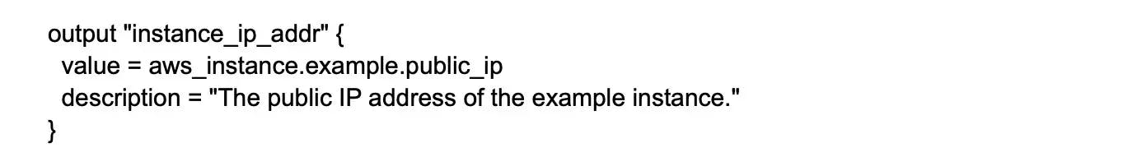

In this example, instance_ip_addr is the name of the output, while the value attribute corresponds to the public IP address of the resource named example of type aws_instance. The description attribute is optional and provides information about the output.

After applying your configuration with terraform apply, Terraform will display this output:

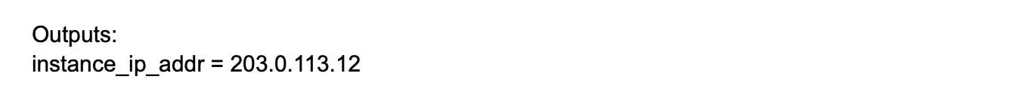

23.

How can you handle resource dependencies between multiple Terraform configurations?

Hide Answer

To handle resource dependencies between multiple Terraform configurations, you can use Terraform's "data" block to reference resources from other configurations. By using the "data" block, you can import values or information from other configurations and use them in your current configuration to establish dependencies.

24.

Describe the purpose of Terraform's "version" constraints in module declarations.

Hide Answer

The "version" constraints in module declarations specify the acceptable versions of a module to be used. They help ensure that the configuration is compatible with a specific version of the module and prevent unexpected changes or incompatibilities when updating the module.

25.

What is the difference between Terraform's "destroy" and "refresh" commands?

Hide Answer

Terraform's destroy and refresh commands are part of its suite of commands, but they serve vastly different purposes related to the lifecycle management of resources.

The destroy command is used to destroy or delete the Terraform-managed infrastructure. It is the opposite of terraform apply. Where the apply command creates or modifies infrastructure to match your configuration, destroy de-provisions all resources that the current Terraform configuration is managing.

On the other hand, the refresh command is used to reconcile the state Terraform has recorded with the real-world infrastructure. It does this by querying the provider to get the current status of resources.

26.

How can you define multiple providers for different regions within the same configuration file?

Hide Answer

To define multiple providers for different regions within the same configuration file, you can use provider aliases. Provider aliases allow you to access different providers based on their configurations, such as specifying different regions or authentication details. These aliases can then be referenced in resource blocks to associate them with the desired provider.

27.

Explain the benefits of using the Terraform "plan" command for infrastructure changes.

Hide Answer

The "Terraform plan" command provides a preview of the changes that will be applied to the infrastructure. It shows the actions Terraform will take, such as creating, modifying, or deleting resources, based on the current state and the proposed changes.

This helps in understanding the impact of changes before actually applying them, enabling better review and validation of the planned modifications.

28.

Describe the process of using Terraform's "remote state data" feature for cross-configuration communication.

Hide Answer

Terraform's "remote state data" feature allows you to retrieve information from another Terraform configuration's state file. By referencing the remote state, you can access and use values from other configurations, facilitating communication and coordination between different Terraform-managed resources.

29.

How can you use the "depends_on" attribute in Terraform resource blocks?

Hide Answer

The "depends_on" attribute in Terraform resource blocks defines an explicit dependency between resources. It ensures that the resource with the "depends_on" attribute is created or modified before the dependent resources, regardless of any implicit ordering. This attribute is useful when there are dependencies that Terraform cannot automatically detect.

30.

What is the purpose of the Terraform "import" command?

Hide Answer

The "Terraform import" command is used to import existing resources into the Terraform state. It allows Terraform to manage and track existing resources that were not initially created using Terraform, enabling their inclusion in the Terraform configuration and state management.

31.

How can you use Terraform to manage infrastructure across multiple cloud providers simultaneously?

Hide Answer

Terraform supports managing infrastructure across multiple cloud providers by utilizing provider plugins specific to each provider. By defining provider blocks and their configurations for each cloud provider, Terraform can orchestrate the provisioning and management of resources across multiple providers in a single configuration.

32.

What is the purpose of the "Terraform refresh" command, and when would you use it?

Hide Answer

The "Terraform refresh" command retrieves the current state of the infrastructure resources and updates the Terraform state file to match the real-world resources. It is useful when changes have been made outside of Terraform's control and the state file needs to be updated to accurately reflect the actual state of the infrastructure.

33.

Describe how you can use the "Terraform state" command to manage Terraform state files.

Hide Answer

The "Terraform state" command provides various subcommands to manage Terraform state files. It allows you to inspect, modify, and perform operations on the Terraform state. Common subcommands include "list" to list resources in the state, "mv" to move resources between states, and "rm" to remove resources from the state.

34.

Explain the concept of remote state locking in Terraform and its importance in team collaboration.

Hide Answer

Remote state locking in Terraform prevents concurrent modifications to the same state file by multiple users. When a user runs a Terraform command that modifies the state, the lock is acquired to prevent conflicts.

This ensures consistency and prevents data corruption in team-based workflows, where multiple users might be working on the same infrastructure.

35.

How can you manage infrastructure secrets securely in Terraform, such as API keys or passwords?

Hide Answer

To manage infrastructure secrets securely in Terraform, you can use environment variables or external systems like HashiCorp Vault. Storing sensitive data directly in Terraform configuration files is discouraged. Instead, you can define variables for secret values and populate them from external sources at runtime, ensuring confidentiality and separation of secrets from the configuration.

Looking for remote developer job at US companies?

Work at Fortune 500 companies and fast-scaling startups from the comfort of your home

[Apply Now](https://developers.turing.com/?referrer=https://www.bing.com/)

Intermediate Terraform Interview Questions and Answers

1.

Explain the concept of Terraform providers and their role in resource provisioning.

Hide Answer

Terraform providers are plugins that enable Terraform to interact with specific infrastructure platforms, such as AWS, Azure, or GCP. They provide a way for Terraform to manage and provision resources on these platforms. Each provider implements resource types and APIs to create, update, and delete resources.

By configuring a provider in Terraform, you can leverage its resource types to define infrastructure as code and manage the lifecycle of resources on the target platform.

2.

What is the purpose of Terraform modules, and how do they promote reusability?

Hide Answer

Terraform modules are self-contained packages of Terraform configurations that encapsulate a specific set of resources and their associated dependencies. Modules promote reusability by allowing you to define and share infrastructure components across projects and teams.

With modules, you can abstract complex configurations into reusable building blocks, reducing duplication, and improving maintainability. Modules can be published and consumed internally or through public module registries, enabling code sharing and collaboration.

3.

How does Terraform handle remote state management?

Hide Answer

Terraform uses remote state management to store and share the state file, which contains the current state of the infrastructure. Remote state management involves storing the state file in a remote backend, such as AWS S3, Azure Blob Storage, or HashiCorp Terraform Cloud.

Storing the state remotely allows for collaboration, locking, and centralized management. By using a remote state, multiple users or teams can work on the same infrastructure and maintain a consistent and up-to-date view of the infrastructure state.

4.

Describe how you can use Terraform workspaces to manage multiple environments.

Hide Answer

Terraform workspaces provide a way to manage multiple environments within a single Terraform configuration. Each workspace represents a distinct state and set of variables. By creating separate workspaces for different environments (e.g., development, staging, production), you can maintain environment-specific configurations without duplicating the entire codebase.

Workspaces allow you to switch between environments easily, ensuring isolation and maintaining separate states and variable values for each environment.

5.

How can you handle resource failures and retries in Terraform?

Hide Answer

Terraform provides built-in mechanisms to handle resource failures and retries. When a resource creation or update fails, Terraform detects the failure and automatically rolls back changes for that resource. It can then retry the operation based on the specified retry settings.

Terraform also supports various error-handling techniques, such as using count and conditional expressions to conditionally create or destroy resources based on the success or failure of other resources. These features help ensure the reliability and resilience of infrastructure deployments.

6.

Explain the concept of Terraform backends and the available options.

Hide Answer

Terraform backends define where Terraform stores the state file and how it interacts with it. Backends can be local or remote. Local backends store the state file on the local disk, which is suitable for individual use or small teams. Remote backends store the state file remotely, allowing for collaboration, locking, and centralized management.

Terraform provides several remote backend options, including AWS S3, Azure Blob Storage, and HashiCorp Terraform Cloud. Each backend option has its configuration settings and benefits, enabling flexibility and scalability in state management.

7.

How can you organize your Terraform codebase for better maintainability?

Hide Answer

To organize a Terraform codebase for better maintainability, you can adopt various practices:

Modularization: Break down the codebase into reusable modules, encapsulating related resources and configurations.

Folder Structure: Organize files into logical folders based on resource types, environments, or modules.

Naming Conventions: Use consistent and descriptive naming conventions for resources, variables, and modules.

Documentation: Include comments, README files, or documentation to provide guidance and context for the codebase.

Version Control: Utilize a version control system like Git to track changes, collaborate, and roll back if needed.

By following these practices, you can enhance code readability, reusability, and collaboration, making the codebase easier to maintain and evolve.

8.

What is the Terraform interpolation syntax, and how can you use it?

Hide Answer

Terraform interpolation syntax allows you to reference and combine values within Terraform configurations. It uses the ${} syntax to interpolate variables, attribute references, or functions. Interpolation enables dynamic configuration generation and composition.

You can use interpolation to reference variables, access resource attributes, concatenate strings, perform arithmetic operations, and more. It provides flexibility and programmability to define configurations that adapt to changing requirements or conditions.

9.

How does Terraform handle drift detection and reconciliation?

Hide Answer

Terraform handles drift detection by comparing the state stored in the state file with the current state of the infrastructure. During a Terraform application, it detects any differences between the two states and identifies resources that have drifted.

To reconcile the drift, Terraform determines the necessary actions (create, update, or delete) to bring the infrastructure back to the desired state defined in the configuration. By applying the changes, Terraform ensures that the infrastructure aligns with the intended configuration and resolves any discrepancies.

10.

Describe how Terraform applies changes to your infrastructure and what happens during a Terraform application.

Hide Answer

During a Terraform application, Terraform examines the configuration and state to determine the changes needed to reach the desired state. It creates an execution plan that outlines the actions required for resource creation, modification, or deletion. After confirming the execution plan, Terraform applies the changes by invoking the respective provider APIs.

It provisions or updates resources according to the plan and updates the state file with the new infrastructure state. Terraform captures the output values of the resources, which can be used for further configuration or reference in subsequent Terraform runs.

11.

Explain the difference between Terraform's "apply" and "refresh" commands.

Hide Answer

The "apply" command in Terraform is used to create or update the infrastructure based on the current configuration. It compares the configuration with the current state, determines the necessary changes, and applies them to the infrastructure.

On the other hand, the "refresh" command is used to reconcile the state with the actual resources in the infrastructure. It updates the state file by querying the infrastructure provider APIs and refreshing the resource information in the state. The "refresh" command does not make any changes to the infrastructure; it only updates the state file to reflect the current state accurately.

12.

What are Terraform provisioners, and how can you use them?

Hide Answer

Terraform provisioners are used to execute scripts or commands on a remote resource during the provisioning process. They are typically used to perform configuration tasks, such as software installations, package updates, or service configurations.

Terraform provides several types of provisioners, including "local-exec," "remote-exec," and "file." By configuring provisioners within resource blocks, you can define the necessary actions to be executed on the provisioned resources, ensuring they are properly configured after creation or update.

13.

Describe how to use Terraform with infrastructure-as-a-service (IaaS) providers.

Hide Answer

Terraform integrates seamlessly with various IaaS providers, such as AWS, Azure, and Google Cloud Platform. To use Terraform with an IaaS provider, you need to configure the provider credentials and connection settings in the Terraform configuration.

Once configured, you can define resource blocks using the provider-specific resource types and configure them according to the desired infrastructure specifications. When running Terraform commands, such as "init," "plan," and "apply," Terraform communicates with the IaaS provider APIs to provision, update, or delete the specified resources.

14.

What is the purpose of Terraform's "null_resource," and when would you use it?

Hide Answer

The "null_resource" in Terraform represents a resource that doesn't directly correspond to a physical or virtual infrastructure object. It is a placeholder resource that can be used to execute provisioners or perform actions that are not tied to a specific resource type.

The "null_resource" can be helpful when you need to perform tasks like running local-exec provisioners, calling external scripts, or executing commands that are not related to a particular resource. It provides flexibility and allows for custom actions within the Terraform workflow.

15.

How can you manage secrets and sensitive data in Terraform?

Hide Answer

Managing secrets and sensitive data in Terraform require careful consideration to ensure security. Best practices include:

* Storing secrets outside of version-controlled files, using tools like HashiCorp Vault or cloud-specific secret management services.
* Utilizing Terraform input variables or environment variables to pass sensitive values securely during runtime.
* Encrypting sensitive data using tools like Terraform Vault provider or native encryption mechanisms provided by the infrastructure platform.
* Avoid writing secrets in plain text within Terraform configurations or logs.

By following these practices, you can protect sensitive information and minimize the risk of exposing secrets unintentionally.

16.

Explain how to use Terraform workspaces for environment-specific variable values.

Hide Answer

Terraform workspaces allow you to define environment-specific variable values by associating different values with each workspace. You can create separate variable files for each workspace or use conditional expressions within the variable definitions to set environment-specific values.

When switching between workspaces, Terraform loads the corresponding variable values, ensuring that each environment uses the appropriate configuration settings. This flexibility enables you to manage variables and configurations specific to different environments, facilitating efficient infrastructure deployment across multiple stages.

17.

Describe how to use Terraform's "locals" block for creating reusable expressions.

Hide Answer

The "locals" block in Terraform allows you to define reusable expressions within the configuration. By defining variables or expressions within the "locals" block, you can assign them values based on other variables, attribute references, or calculations.

These local values can be used within the configuration to simplify and centralize complex expressions, avoiding duplication. The "locals" block promotes code reuse, improves readability, and provides a way to encapsulate logic or calculations that are used across multiple resource definitions.

18.

What is the difference between Terraform modules and remote modules?

Hide Answer

Terraform modules are self-contained packages of Terraform configurations that encapsulate a specific set of resources and their associated dependencies. They promote code reusability and modularity by allowing you to define and share infrastructure components across projects and teams.

Remote modules, on the other hand, refer to modules hosted remotely, typically in a version control repository or a module registry. Remote modules provide a way to retrieve and use pre-configured modules directly from a remote source. They enable code sharing, versioning, and collaboration by allowing users to consume modules without manually copying or managing the module code locally.

In summary, modules are the concept of reusable infrastructure configurations, while remote modules are a way to access and consume those reusable configurations from remote sources.

19.

How can you perform targeted resource deployment in Terraform?

Hide Answer

Targeted resource deployment in Terraform can be achieved by using the "-target" flag with the "apply" or "plan" command. By specifying the target resource's address or name, Terraform focuses only on that particular resource and its dependencies during the deployment or planning process.

Targeted deployment is useful while isolating changes to specific resources without affecting the rest of the infrastructure.

20.

Explain the concept of Terraform's "data" blocks and their use cases.

Hide Answer

Terraform's "data" blocks allow the retrieval and use of data from remote systems or APIs during the Terraform execution. Data blocks can fetch information such as AWS AMI IDs, VPC details, or external configuration settings. They enable Terraform to incorporate external data into the configuration, making it dynamic and adaptable to the current state of the infrastructure or external services.

21.

Explain the process of using Terraform's "remote-exec" provisioner with Windows instances.

Hide Answer

Using the "remote-exec" provisioner with Windows instances involves configuring the provisioner block in Terraform to execute commands or scripts on the remote Windows machine.

The provisioner typically requires authentication details, such as SSH or WinRM credentials, to establish a remote connection. Once connected, the provisioner can run PowerShell commands or scripts to perform desired configurations on the Windows instance.

22.

Describe how to use Terraform's "count.index" and "count.indexes" for resource customization.

Hide Answer

Terraform's "count.index" and "count.indexes" allow for resource customization based on the count of a resource. The "count.index" variable represents the current index of a resource within a count block.

It can be used to generate unique resource names or perform conditional logic based on the index. The "count.indexes" variable provides a list of all indices within a counted block, allowing for more advanced resource customization based on multiple indices.

23.

What are Terraform workspaces, and how do they differ from Terraform environments?

Hide Answer

Terraform workspaces are used to manage multiple instances of the same infrastructure within a single Terraform configuration. Each workspace represents a distinct state and set of variables. Workspaces provide a convenient way to deploy and manage different environments, such as development, staging, and production, without the need for separate configurations or projects.

In contrast, Terraform environments refer to separate copies of the entire Terraform codebase with their isolated state and resources.

24.

Explain how to use the Terraform "sensitive" argument to hide sensitive output values.

Hide Answer

The "sensitive" argument in Terraform is used to hide sensitive output values when displaying the Terraform plan or applying the output. By marking an output variable as sensitive, its value will be masked in the output, preventing accidental exposure of sensitive information. This is useful when dealing with outputs that contain passwords, private keys, or other confidential data that should not be visible to everyone.

25.

How can you define dynamic block attributes using Terraform's "dynamic" blocks?

Hide Answer

Terraform's "dynamic" blocks allow for the dynamic creation of repeated nested blocks within resource configurations. They provide a flexible way to define variable-length blocks, where the number of blocks depends on the values of other variables or data sources.

Dynamic block attributes can be generated based on lists, maps, or other complex data structures, enabling dynamic resource creation and configuration.

26.

Describe how to use the Terraform "locals" block for conditional expressions.

Hide Answer

The "locals" block in Terraform can be used to define conditional expressions by leveraging Terraform's built-in functions and conditionals. By combining conditional logic with locals, you can create reusable expressions that adapt to different scenarios or conditions.

This helps simplify complex expressions, make [code more readable](https://www.turing.com/kb/start-reading-code-the-right-way), and improve maintainability.

27.

What is the purpose of Terraform's "lifecycle" block and when would you use it?

Hide Answer

Terraform's "lifecycle" block allows the specification of lifecycle-specific configuration for resources. It provides control over resource behavior during creation, update, and deletion. The lifecycle block supports configuration options like resource creation and update timeouts, prevent destruction, ignore changes, and more.

It is useful when you need fine-grained control over resource management and want to define specific behavior for certain resources.

28.

How can you use Terraform to manage non-cloud infrastructure resources?

Hide Answer

Terraform can manage non-cloud infrastructure resources by utilizing various provisioners and external tools. Provisioners like "local-exec" or "remote-exec" can execute scripts or commands on local or remote instances, enabling the configuration of non-cloud resources.

Additionally, Terraform can be integrated with infrastructure deployment tools like Ansible or Chef to handle the provisioning and configuration of non-cloud resources, leveraging their respective capabilities.

29.

Explain how Terraform handles drift detection and resource reconciliation.

Hide Answer

Terraform handles drift detection and resource reconciliation by comparing the current state stored in the state file with the desired state defined in the configuration. During a Terraform application, it detects any differences between the two states and determines the necessary actions to converge the infrastructure to the desired state.

Terraform can create, update, or delete resources as needed to reconcile the differences and bring the infrastructure into the desired state.

30.

Describe the process of using the Terraform "plan-out" flag for plan output preservation.

Hide Answer

The "plan-out" flag in Terraform is used to preserve the planned output to a file for later use. By specifying the "-out" flag followed by a filename, Terraform saves the execution plan to that file. The preserved plan file can be used to apply the exact planned changes at a later time, ensuring consistency between the planned and applied changes.

31.

Explain the process of using Terraform workspaces to handle environment-specific configurations.

Hide Answer

Terraform workspaces are used to handle environment-specific configurations by creating separate workspaces for each environment (e.g., development, staging, production). Each workspace can have its own set of variables, allowing for environment-specific configuration values.

By switching between workspaces, you can target and manage different environments without modifying the underlying configuration files, simplifying environment-specific deployments.

32.

How can you implement conditional resource creation based on variables in Terraform?

Hide Answer

Conditional resource creation based on variables in Terraform can be achieved using the "count" parameter or the "for_each" argument. By defining a conditional expression with these constructs, you can control whether a resource is created or not based on the value of a variable or condition. This allows for dynamic resource creation, enabling the infrastructure to adapt based on the provided input.

33.

Describe how you can use Terraform with infrastructure deployment tools like Ansible or Chef.

Hide Answer

Terraform can be used in conjunction with infrastructure deployment tools like Ansible or Chef to manage infrastructure provisioning and configuration. Ansible or Chef can handle tasks such as installing software, configuring servers, and managing services, while Terraform focuses on infrastructure provisioning and orchestration.

By combining Terraform with these tools, you can achieve a comprehensive infrastructure automation solution.

34.

How can you use Terraform with infrastructure orchestration tools like Kubernetes or Docker Swarm?

Hide Answer

Terraform can be used with infrastructure orchestration tools like Kubernetes or Docker Swarm to manage the deployment and configuration of containerized applications. Terraform can provision the underlying infrastructure resources (e.g., virtual machines, networking), while Kubernetes or Docker Swarm can handle the container orchestration and application deployment. Together, they provide a powerful solution for managing container-based workloads at scale.

1.

Explain the role of Terraform data sources and how you can use them.

Hide Answer

Terraform data sources allow you to fetch and reference information from external systems or existing resources. They provide a way to query and import data into your Terraform configurations.

You can use data sources to retrieve attributes or metadata from various sources such as cloud providers, databases, or APIs. This data can then be used to make decisions, configure resources, or establish dependencies within your infrastructure.

2.

How can you perform blue-green deployments using Terraform?

Hide Answer

Blue-green deployments involve creating two identical environments (blue and green) and switching traffic from one to the other. In Terraform, you can achieve this by creating two sets of infrastructure resources with slight differences, such as different AWS Auto Scaling Groups or Azure Virtual Machine Scale Sets.

Once the new environment (green) is provisioned and tested, you can update the load balancer or DNS records to direct traffic to the green environment. Terraform enables you to manage the infrastructure changes required for blue-green deployments in a declarative and automated manner.

3.

Describe the process of using Terraform with an immutable infrastructure.

Hide Answer

Immutable infrastructure refers to the practice of creating and deploying infrastructure components as immutable artifacts. With Terraform, you can achieve an immutable infrastructure by treating infrastructure as code and rebuilding the entire infrastructure stack whenever changes are required.

The process involves defining all resources and configurations in Terraform code, executing Terraform application to create a new set of infrastructure, and replacing the existing infrastructure with the new one. This approach promotes reliability, consistency, and easier rollbacks since the infrastructure is never modified in place.

4.

How can you integrate Terraform with CI/CD pipelines?

Hide Answer

Terraform can be integrated with [CI/CD pipelines](https://www.turing.com/kb/ci-cd-pipeline) to automate the deployment and management of infrastructure. Here's the typical process:

* Commit the Terraform configurations to a version control system (e.g., Git).
* Set up a CI/CD pipeline that monitors changes to the Terraform code repository.
* In the pipeline, execute Terraform commands such as init, validate, and plan to ensure the configurations are valid and generate an execution plan.
* Use Terraform's apply command to create or modify infrastructure based on the approved changes.
* Optionally, leverage infrastructure testing and verification tools to validate the deployed infrastructure.
* Finally, trigger additional pipeline stages for application deployment, testing, and release.

5.

Explain the concept of remote execution in Terraform and its benefits.

Hide Answer

Remote execution in Terraform involves running the Terraform commands remotely on a dedicated infrastructure or service. This approach offers several benefits, including:

Isolation: The remote execution environment is separate from the local development environment, minimizing the impact of local issues on Terraform operations.

Consistency: By executing Terraform commands in a controlled environment, you ensure consistent tooling versions, dependencies, and configurations across the team.

Collaboration: Multiple team members can access and execute Terraform operations in a shared environment, facilitating collaboration and knowledge sharing.

Scalability: Remote execution can leverage infrastructure resources optimized for large-scale Terraform operations, such as executing plans or applying changes in parallel.

6.

How can you manage Terraform state locking for team collaboration?

Hide Answer

Terraform state locking is crucial for preventing concurrent modifications to the same infrastructure. To manage state locking for team collaboration, you can use a remote backend with built-in state locking support.

Terraform supports various remote backends like Amazon S3, Azure Storage, or HashiCorp Consul. By configuring a remote backend, Terraform automatically handles the state locking, ensuring that only one user or process can modify the state at a time.

This prevents conflicts and data corruption when multiple team members are working on the same infrastructure concurrently.

7.

Describe how you can implement conditional resource creation in Terraform.

Hide Answer

Terraform allows conditional resource creation through the use of the count meta-argument. By specifying a condition within the count block of a resource, you can control whether the resource should be created or not based on the evaluation of the condition.

For example, you can use count with an input variable to conditionally create resources based on user input or other dynamic factors. Terraform evaluates the condition during the planning phase and creates the resource instances accordingly.

This feature enables you to dynamically control the creation of resources based on various conditions.

8.

Explain the concept of dynamic nested blocks in Terraform.

Hide Answer

Dynamic nested blocks in Terraform allow you to generate complex nested configurations based on input data or dynamic conditions. By using dynamic blocks, you can create repeated blocks of configurations without hardcoding them.

For example, you can dynamically generate multiple AWS security group rules based on an input variable containing a list of rules. Dynamic blocks provide flexibility and reduce repetition in your Terraform code, making it easier to manage and scale configurations that require dynamic or variable-sized nested blocks.

9.

How can you perform rolling updates or zero-downtime deployments with Terraform?

Hide Answer

Rolling updates or zero-downtime deployments involve updating infrastructure components without causing service disruptions. With Terraform, you can achieve this by utilizing features such as rolling deployment strategies and lifecycle hooks.

For example, you can define an AWS Auto Scaling Group with a rolling update policy to gradually replace instances while ensuring the overall availability of the application. Terraform allows you to specify update policies, health checks, and other parameters to control the pace and behavior of updates, minimizing downtime and ensuring smooth transitions.

10.

Describe the process of using Terraform workspaces in a team environment.

Hide Answer

Terraform workspaces provide a way to manage multiple distinct sets of infrastructure configurations within a single root module. In a team environment, each team member can create their workspace, allowing them to work independently without interfering with each other's state files. The process involves:

* Creating a workspace using the Terraform workspace new command.
* Switching to the desired workspace using Terraform workspace select.
* Applying changes to the selected workspace with Terraform apply.
* Each workspace maintains its state file, isolating the infrastructure for each team member or environment.

11.

How can you manage multiple environments with separate Terraform state files?

Hide Answer

To manage multiple environments with separate Terraform state files, you can leverage Terraform workspaces or separate directories for each environment.

Each environment's infrastructure can be defined in its own set of Terraform configurations. By using workspaces, you can keep the infrastructure definitions within the same root module but maintain separate state files for each environment.

Alternatively, you can use separate directories for each environment and maintain separate state files manually. Managing separate state files ensures the isolation and independent management of each environment's infrastructure.

12.

Describe the process of creating custom Terraform providers.

Hide Answer

Creating custom Terraform providers involves implementing a provider plugin that conforms to the Terraform Provider Protocol. The process generally includes the following steps:

* Set up a development environment with the appropriate tooling, including the Terraform SDK and language-specific dependencies.
* Implement the necessary CRUD (Create, Read, Update, Delete) operations for managing resources within the target system or API.
* Define the provider's schema to map Terraform resource types to their corresponding API endpoints or actions.
* Compile and package the provider into a plugin binary compatible with Terraform.
* Install the custom provider plugin in the Terraform environment where it will be used.
* Use the provider's resources and data sources in Terraform configurations to manage resources within the target system.

13.

What are the benefits of using Terraform's "remote-exec" provisioner?

Hide Answer

The "remote-exec" provisioner in Terraform allows executing commands on remote resources after they have been created or updated. Some benefits of using this provisioner include:

Configuration management: The provisioner enables running scripts or commands to configure newly provisioned resources with custom settings or dependencies.

Bootstrapping: You can automate the initial setup and configuration of resources, making them ready for use as soon as they are provisioned.

Flexibility: The provisioner supports running arbitrary commands, making it versatile for various use cases.

Integration: By combining the "remote-exec" provisioner with other Terraform resources, you can create powerful and automated configuration management workflows.

14.

How can you leverage the Terraform Graph command for visualizing resource dependencies?

Hide Answer

The Terraform Graph command generates a visual representation of resource dependencies within a Terraform configuration. By running Terraform graphs, you can obtain a graph in the DOT format. This graph can be converted to various visual formats, such as PNG or SVG, using graph visualization tools.

Leveraging the Terraform Graph command helps you understand the relationships and dependencies between resources, identify potential issues, and gain insights into the overall structure of your infrastructure.

15.

Explain the purpose of the Terraform "taint" and "untaint" commands.

Hide Answer

The Terraform "taint" command is used to mark a resource as tainted, which indicates that it needs to be recreated on the next Terraform run. Tainting a resource effectively forces Terraform to destroy and recreate it, even if no changes are detected. This can be useful when troubleshooting or when a resource becomes corrupted and needs to be recreated.

The "untaint" command, on the other hand, removes the tainted state from a resource. It allows you to revert the taint status of a resource so that subsequent Terraform runs will only recreate it if there are actual changes detected.

16.

Describe the process of using the Terraform "for" expression for dynamic resource creation.

Hide Answer

The Terraform "for" expression allows dynamic resource creation based on a list or map variable. The process involves:

* Defining a list or map variable that contains the necessary input values for resource creation.
* Using the "for" expression within a resource block to iterate over the variable and generate multiple instances of the resource.
* Within the "for" expression, define the resource attributes or arguments that vary based on the iteration.
* Terraform will create the specified number of resource instances based on the length of the variable, with each instance having the desired attributes or arguments as defined within the "for" expression.

17.

What are Sentinel policies, and how do they enhance Terraform's security?

Hide Answer

Sentinel is a policy-as-code framework integrated with Terraform to enforce compliance and security requirements. Sentinel policies are rules defined in a high-level language that govern the behavior of Terraform configurations and actions.

These policies enable you to enforce access controls, security practices, naming conventions, and other governance rules. By integrating Sentinel policies, you can ensure that infrastructure changes conform to organizational policies and prevent the deployment of non-compliant or insecure configurations.

18.

Explain using the "Terraform.tfvars" file for variable assignment.

Hide Answer

The "Terraform.tfvars" file is used to assign values to variables declared within Terraform configurations. Instead of defining variables directly within the configuration files, you can store them in the "Terraform.tfvars" file, which Terraform automatically loads.

This approach simplifies the management of variable values, especially when working with sensitive or environment-specific information. By separating variable assignments from the configuration files, you can provide different "Terraform.tfvars" files for different environments or teams, allowing for more flexible and reusable configurations.

19.

How can you automate the execution of Terraform commands using scripting languages?

Hide Answer

The automation of Terraform commands can be achieved by leveraging scripting languages such as Bash, Python, or PowerShell. Scripting languages provide the ability to orchestrate and execute Terraform commands programmatically.

For example, you can write scripts that automate the execution of Terraform init, plan, and apply commands, passing in the necessary arguments and handling any required input or authentication.

These scripts can be integrated into CI/CD pipelines, scheduled jobs, or other automation frameworks to enable the continuous and automated management of infrastructure.

20.

Describe the process of using Terraform with Kubernetes and managing Kubernetes resources.

Hide Answer

When using Terraform with Kubernetes, you can manage Kubernetes resources by utilizing the Kubernetes provider. The process involves:

* Configuring the Kubernetes provider in your Terraform code, specifying the necessary connection details to the Kubernetes cluster.
* Defining Kubernetes resources such as deployments, services, or config maps using Terraform resource blocks.
* Specifying the desired state of the Kubernetes resources in Terraform configurations.
* Running Terraform apply to create or update the defined Kubernetes resources in the cluster.
* Terraform will interact with the Kubernetes API server, creating, modifying, or deleting the specified resources based on the desired state.

21.

How can you create and manage Terraform workspaces programmatically?

Hide Answer

Terraform workspaces can be created and managed programmatically using the Terraform CLI or Terraform SDK. The process involves:

* Using the Terraform CLI commands or SDK functions to create a new workspace.
* Assigning a name and any necessary variables to the workspace.
* Performing operations on the workspace, such as selecting or deleting it, using the appropriate CLI commands or SDK functions.
* You can write scripts or use [programming languages](https://www.turing.com/blog/in-demand-programming-languages-to-learn/) like Python or Go to interact with the Terraform CLI or SDK and automate workspace creation and management as per your requirements.

22.

Explain the purpose of Terraform's "tainted" attribute and how it affects resource management.

Hide Answer

The "tainted" attribute in Terraform indicates whether a resource has been manually marked as tainted or corrupted. When a resource is tainted, Terraform treats it as potentially needing replacement in the next Terraform run, regardless of whether there are any changes detected.

The "tainted" attribute is a way to manually trigger the destruction and recreation of a resource. This can be useful for troubleshooting or when you want to force the recreation of a resource to ensure its integrity.

23.

Describe the process of using Terraform's "partial configuration" for partial state import.

Hide Answer

Using Terraform's "partial configuration" for partial state import involves specifying a subset of resources in a configuration file that corresponds to the desired state to be imported. By using the -target option with the Terraform import command, you can import specific resources into Terraform's state file without importing the entire configuration.

This allows for selective management and updates of specific resources while keeping the rest of the state intact.

24.

What are Terraform "backend configurations," and how do they affect state storage?

Hide Answer

Terraform "backend configurations" define the settings for storing and retrieving the Terraform state file. They determine where the state is stored, such as a local file or a remote storage system like Amazon S3 or HashiCorp Consul. Backend configurations are specified in the Terraform configuration file using the backend block. The choice of backend affects how Terraform manages and retrieves state data, providing features like remote state locking and collaboration capabilities.

25.

How can you implement automated testing for Terraform code?

Hide Answer

Automated testing for Terraform code can be implemented using tools such as Terratest or kitchen-Terraform. These tools allow you to write test cases and execute them against your Terraform codebase.

Automated testing helps validate the correctness of infrastructure changes, detect issues early, and ensure the desired state matches the actual state. It involves creating test fixtures, defining test scenarios, executing Terraform operations, and asserting the expected outcomes.

26.

Explain the process of using Terraform with external data sources.

Hide Answer

Using Terraform with external data sources involves utilizing data sources to fetch information from external systems or APIs and use that data in your Terraform configurations. The data block is used to define data sources, which can retrieve information like AMIs, security groups, or DNS records.

Terraform queries the external system during the planning phase and uses the fetched data to make decisions about resource creation and configuration.

27.

Describe how to use Terraform's "trigger" block for resource-level event-driven actions.

Hide Answer

Terraform's "trigger" block allows you to specify event-driven actions at the resource level. It can be used to trigger custom actions when certain events occur, such as the creation or deletion of a resource.

By defining a trigger block within a resource block, you can associate the resource with an external script or command to execute. This enables you to perform additional actions or integrations based on the occurrence of specific resource events.

28.

What is Terraform's "module registry," and how can you leverage it?

Hide Answer

Terraform's "module registry" is a central repository for sharing and discovering Terraform modules. The module registry allows users to publish their modules, which are reusable and shareable components of Terraform configurations.

By leveraging the module registry, you can easily discover existing modules that address your infrastructure needs, reducing duplication of effort. You can reference modules in your Terraform code using their registry URL and version.

29.

Explain the concept of "remote state data" and how it can be used for cross-configuration communication.

Hide Answer

"Remote state data" refers to storing Terraform's state in a remote location, such as a shared storage system or a remote backend. By storing the state remotely, different configurations and teams can share and access the same state data.

This enables cross-configuration communication, where one configuration can read data from another configuration's state. It helps facilitate infrastructure dependencies, coordination, and collaboration between different Terraform projects

30.

Describe using the Terraform "destroy-timeouts" attribute for resource destruction control.

Hide Answer

The Terraform "destroy-timeouts" attribute allows you to control the destruction time limit for resources during the Terraform destroy operation. By specifying a timeout value for a resource in the configuration, you can set a maximum duration for Terraform to wait before forcefully destroying the resource if it takes longer than expected.

This attribute helps prevent resources from being stuck in the destruction process indefinitely and allows for better resource management during destruction.

31.

What are the advantages of using Terraform's "count" feature over resource duplication?

Hide Answer

Using Terraform's "count" feature provides advantages over resource duplication by allowing you to dynamically create multiple instances of a resource based on a given condition or variable. With "count," you can define a resource block with a count value that evaluates an expression, such as a variable or a conditional statement.

Terraform then creates the specified number of resource instances, reducing code duplication and enabling more efficient resource management and scalability.

Wrapping up

Remember that knowing Terraform's essential principles, such as state management, resource provisioning, and infrastructure maintenance, is critical to acing your interview. Additionally, keep up to speed on the latest Terraform features and practices to demonstrate your commitment to ongoing learning and growth.

If you're searching for a high-paying remote software development job, Turing is the place to be. You can get matched to Silicon Valley jobs from the comfort of your own home with Turing, so if you believe you have what it takes to join the top development teams, sign up now.

If you are a hiring manager seeking top [Terraform developers](https://www.turing.com/hire/terraform-developers) from across the world, Turing can help you find them in a matter of seconds. Our powerful AI-powered vetting platform objectively evaluates developers' hard and soft skills which boosts the strength of your business.

#### 1.

What is Jenkins? Why is Jenkins widely used?

Hide Answer

It is an open-source automation tool that automates software development parts in relation to building, testing, deploying, and facilitating CI/CD. Also, it keeps track of the version control system. Further, it is a server-based system that runs on servlet containers.

* Jenkins is a popular automation tool that is widely used in software development for several reasons.
* To automate the testing of builds.
* To detect errors in software development.
* For real-time monitoring of code and integrating changes into the build.
* Jenkins is very suitable for building [CI/CD pipeline](https://www.turing.com/kb/ci-cd-pipeline).

#### 2.

List some features of Jenkins.

Hide Answer

Some of the valiant features of Jenkins are:

* Free and open source
* A good collection of plugins
* Pipeline support
* Easy to set-up
* Easy upgrades

#### 3.

List some features of Groovy in Jenkins.

Hide Answer

* Dynamic [object oriented programming language](https://www.turing.com/kb/object-oriented-programming-help-the-developers-to-code-better) that serves as a scripting language for Java platforms.
* Orchestrate Jenkins pipeline.
* Enables different teams to provide support for work in varied languages
* Syntax similar to Java makes it seamless with the Java interface
* Provides features such as Java compatibility and development support.

#### 4.

Mention the steps required to install Jenkins.

Hide Answer

Step 1: Install Java  
Step 2: Install the Apache Tomcat server  
Step 3: Download the war file in Jenkins  
Step 4: Deploy this file

#### 5.

What commands can start Jenkins?

Hide Answer

* To start Jenkins,
* Firstly, open the command prompt
* Secondly, navigate to the directory to locate Jenkins war
* Lastly, run the following command:  
  D:>java -jar Jenkins.war

#### 6.

Explain "Continuous Integration" w.r.t to Jenkins.

Hide Answer

Continuous Integration (CI) is a software development practice that involves automatically building, integrating, and testing code as it is introduced and committed to a code repository. With respect to Jenkins, an open-source automation tool, here's how it works:

To implement Continuous Integration with Jenkins, follow these steps:

**Installation and setup**: Install Jenkins on your server or local machine and configure it according to your project needs.

**Creating a Jenkins job**: Create a new Jenkins job to build and test your software project. You can define triggers based on different events such as code commits or scheduled intervals. Configure the job to fetch the source code from a version control system like Git, Mercurial, or SVN.

**Build process**: Configure the build process in Jenkins, including specifying build tools like Maven or Gradle for Java projects, or any relevant build system for your project`s language. Jenkins will perform actions like code compilation and packaging of the software.

**Automated testing**: Configure Jenkins to execute automated tests, such as unit tests, integration tests, or even end-to-end tests. Jenkins will report the test results, making it easy to identify any issues in the code.

**Notification system**: Set up notification mechanisms to inform the development team of successful or failed builds and test results. Jenkins can send notifications via email, Slack, or other messaging platforms.

**Continuous Deployment (optional)**: If you want to practice Continuous Deployment, configure the Jenkins job to automatically deploy the software to a staging or production environment upon a successful build.

Through these steps, Jenkins streamlines the process of Continuous Integration, ensuring that code is consistently merged, tested, and checked for quality as it is developed.

#### 7.

How do you set up a Jenkin job?

Hide Answer

* You can easily set up a new built job in Jenkins by following the below steps -
* Log on to your Jenkins dashboard
* Click on "New Items" which is displayed at the top left corner of your dashboard
* Enter the relevant details (Enter an item name, select "Freestyle project", and press "OK")
* Enter project details
* Enter repository URL
* After providing the details, tweak the settings under the "build" section as required
* Click "Apply" and "Save" the project
* Build source code by clicking "Build Now"
* Check the status under "Build History"
* Click on "Build Number" and then "Console Output" to see the status

#### 8.

Differentiate between Continuous Integration, Continuous Delivery, and Continuous Deployment?

Hide Answer

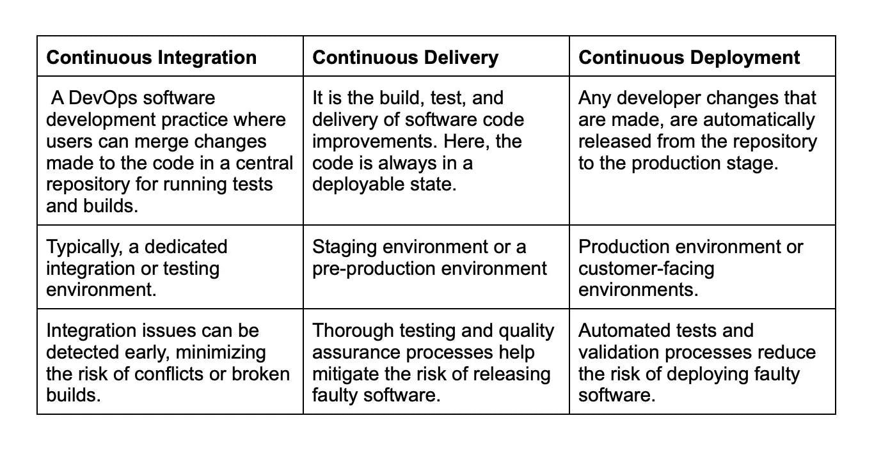

#### 9.

Explain CI/CD pipeline?

Hide Answer

A CI/CD pipeline in Jenkins automates the process of building, testing, and deploying software changes. It does so by connecting to the code repository and keeping a check for any new changes. When any change is detected Jenkins triggers the pipeline. It transits through stages like building, testing, and deploying. Jenkins compiles the code, runs tests, and deploys the application to the desired environment. Also, the pipeline ensures that the code changes meet the quality standards for fast and reliable software updates.

#### 10.

Explain Jenkins pipeline.

Hide Answer

A Jenkins pipeline is an automation technique that enables developers to define an end-to-end process for building, testing, and delivering software by orchestrating various stages of the software development life cycle. Jenkins pipelines help improve the efficiency and consistency of software delivery, ensuring faster development cycles and better code quality.

#### 11.

List the names of 3 pipelines in Jenkins.

Hide Answer

In Jenkins, the term "pipelines" generally refers to two major pipeline types: Scripted and Declarative pipelines, which are used to automate the software development process. However, there is also the Freestyle project, which, although not officially a pipeline, achieves similar objectives in a simpler way.

**Scripted Pipeline**: The Scripted pipeline is a more powerful way to configure Jenkins jobs, using a Groovy-based Domain Specific Language (DSL). The Scripted pipeline code is written as a script, allowing developers to define the entire build process, test execution, and post-build actions. Scripted pipelines are represented by a Jenkinsfile stored in the project's source code repository, ensuring version control and a single source of truth for the pipeline configuration.

**Declarative Pipeline**: The Declarative pipeline is an evolution of the Scripted pipeline, also using a Groovy-based DSL, but with an easier-to-read and maintain syntax. This pipeline type has a structured syntax, making it well-suited for more complex automation tasks. Declarative pipelines are represented by a Jenkinsfile within the source code repository, providing version control and easy access for pipeline updates.

**Freestyle Project**: The Freestyle project is an easy-to-configure Jenkins job that uses a graphical user interface to define the build process, tests, and post-build actions. Although not as flexible as the Scripted and Declarative pipelines, Freestyle projects are suitable for relatively simple build processes.

#### 12.

Before you use Jenkins, what are the necessary requirements?

Hide Answer

Before using Jenkins, which is a popular open-source automation server oftentimes used for Continuous Integration/Continuous Deployment (CI/CD) processes, you need:

**A source code repository**: A source code repository, such as Git, SVN, or Mercurial, acts as a central hub where the project's source code is stored and managed. This allows for effective team collaboration, strong version control, and enables Jenkins to fetch the latest code for building and deploying tasks.

**A build script**: This is a set of instructions or procedures that define how to compile, test, and package your application. Build scripts, often crafted using tools like Maven, Gradle, or Ant, specify the software's dependencies, the required build tools, and any custom commands necessary for the build process.

Remember, Jenkins can work with many different languages and tools, so having your environment correctly set up to work with your chosen language and toolchain is also key.

Also, you'd need to have a proper understanding of how to configure Jenkins as per your project needs, as Jenkins server requires proper setup to function optimally. This may include setting up different jobs, chains of jobs, nodes, and installing necessary plugins.

#### 13.

List some useful Jenkins plugins.

Hide Answer

**Git Plugin**: Enables Jenkins to fetch code from Git repositories and integrate with popular Git-based platforms such as GitHub, GitLab, and BitBucket.

**Pipeline Plugin**: Facilitates the creation of scripted and declarative pipelines, allowing users to automate their CI/CD workflows and integrate multiple build steps.

**Maven Integration Plugin**: Provides build triggers and enhanced support for building Maven-based projects.

**Blue Ocean Plugin**: Offers a modern, visually appealing interface with improved user experience for Jenkins Pipeline and other plugin-related views.

**Role-based Authorization Strategy**: Implements a role-based access control strategy that manages the permissions of users and groups.

**Performance Plugi**n: Analyzes and visualizes the performances of different tests, like JMeter and JUnit, to identify trends and potential issues.

#### 14.

What can you do for creating a backup and copying of files in Jenkins?

Hide Answer

Creating backups and copying files in Jenkins are essential tasks to ensure the security of your configurations, job data, and system settings. Here's how you can perform these tasks in Jenkins:

**Backup**:  
To create a backup of your Jenkins settings and data, you can use the "ThinBackup" plugin or manually back up essential files and folders.

ThinBackup Plugin: This plugin automates the backup process. After installing it, you can configure backup settings, such as location, backup intervals, and the retention policy for old backups.

Manual Backup: To manually back up your Jenkins data, you should archive the following directories and files:

* $JENKINS_HOME directory, which contains job configurations, build artifacts, and system settings.
* plugins directory, which contains all installed plugin files and their configurations.
* secrets directory, which holds encrypted secrets like API tokens and credentials.
* config.xml, jenkins.model.JenkinsLocationConfiguration.xml and hudson.tasks.Mailer.xml which store Jenkins system settings.

**Copying Files**:

To copy files within Jenkins jobs or across different jobs, you can use the "Copy Artifact" plugin or leverage build steps in the Jenkins Pipeline.

Copy Artifact Plugin: Install the Copy Artifact plugin to copy artifacts from other jobs or between different build stages. Configure the settings (source job, artifacts to copy, and target directory) within the Post-build Actions or Build Wrappers of your Jenkins job.

Jenkins Pipeline Steps: In the Jenkins script of your pipeline, you can use various steps to copy files. Here are some examples:

* stash and unstash steps to store and retrieve files across different stages in a pipeline.
* archiveArtifacts step to store build artifacts and make them accessible from the Jenkins UI.
* Use shell or batch scripts (via sh step on Linux/macOS or bat step on Windows) to copy files to different directories or across jobs. You can leverage commands like cp (for Unix-based systems) or copy (for Windows) in the script.

Regularly backing up your Jenkins configuration and using efficient file copying mechanisms ensures that you can quickly recover and restore your Jenkins setup in case of any issues or errors.

#### 15.

For a core plugin, how can you deploy a custom build?

Hide Answer

You can deploy a custom build as follows:

* First stop Jenkins
* Then you will need to copy the custom HPI to $Jenkins_Home/plugins
* Next, delete the earlier expanded plugin directory
* Then create an empty file called PLUGIN_NAME.hpi.pinned
* Finally, again start Jenkins.

#### 16.

Explain to me the process for moving or copying Jenkins from one server to another?

Hide Answer

To move or copy Jenkins from one server to another, you can follow these general steps:

**Backup Jenkins Home Directory**: The home directory contains all the necessary configurations, plugins, and job configurations. It is important to back up this directory before proceeding. you can locate the Jenkins home directory on the source server.

**Install Jenkins on the Target Server**: Install Jenkins on the new server using the same version as the source server. You can refer to the official Jenkins installation instructions depending on your operating system.

**Transfer the backed-up Jenkiuns home directory**: while doing this process ensure that file permissions and ownership are preserved during the transfer.

**Start Jenkisn on new server**: For this you can use appropriate commands for your operating system like sudo service Jenkins start (Linux) or starting the Jenkins service from the Services panel (Windows).

**Verify configurations and functionality through the web interface**: To ensure that everything is working as expected you can run sample buikds and tests.

**Update DNS and URLs if needed**: Update DNS records or any references to the old server's IP address or URLs in your system,

**Monitor and troubleshoot:** You can refer to Jenkins logs and documentation for troubleshooting guidance.

#### 17.

Can you list some continuous integration tools except Jenkins?

Hide Answer

In addition to Jenkins, there are several other Continuous Integration (CI) tools available to help automate the software development process. Some popular CI tools include:

**Travis CI**: A cloud-based CI service, integrated with GitHub and offering support for multiple programming languages. Travis CI is widely used in open-source projects and has a simple configuration with YAML-based settings.

**CircleCI**: A cloud-based CI/CD platform that supports modern development practices like containerization and microservices. CircleCI integrates with popular version control systems (like GitHub and BitBucket) and offers a YAML-based configuration to define workflows.

**GitLab CI/CD**: GitLab comes with a built-in CI/CD tool, allowing you to maintain your code repository and CI/CD pipelines in a single platform. GitLab CI/CD supports Docker containers and runners, making it easy to set up and run builds in parallel.

**TeamCity**: A CI server created by JetBrains, TeamCity offers a rich interface and supports a wide array of plugins and build tools. It enables easy setup of build pipelines and displays real-time build results in a comprehensive dashboard.

Also read - [Top CI/CD tools to increase productivity](https://www.turing.com/kb/top-cicd-tools-you-should-learn-in-2022)

#### 18.

If in a pipeline, one job works well, but the other fails, what would be your next step?

View Answer

You can simply restart the pipeline from the point it failed by using “restart from stage”.

#### 19.

Tell me how Jenkins works.

Hide Answer

The following steps define the working of Jenkins

* Jenkins checks for changes in the repository regularly.
* With changes defined, Jenkins develops a new build.
* Next Jenkins moves stage after stage in its usual pipeline.
* If any stage fails, the Jenkins build stops. The software then informs the respective team about it.
* However, if the stage completes properly, the code implements itself in the server to begin the testing.
* After the testing phase, Jenkins shares the result with the team.

#### 20.

How are Maven, Ant, and Jenkins different?

Hide Answer

Maven, Ant, and Jenkins are all key tools in the software build and continuous integration process but they serve distinct roles:

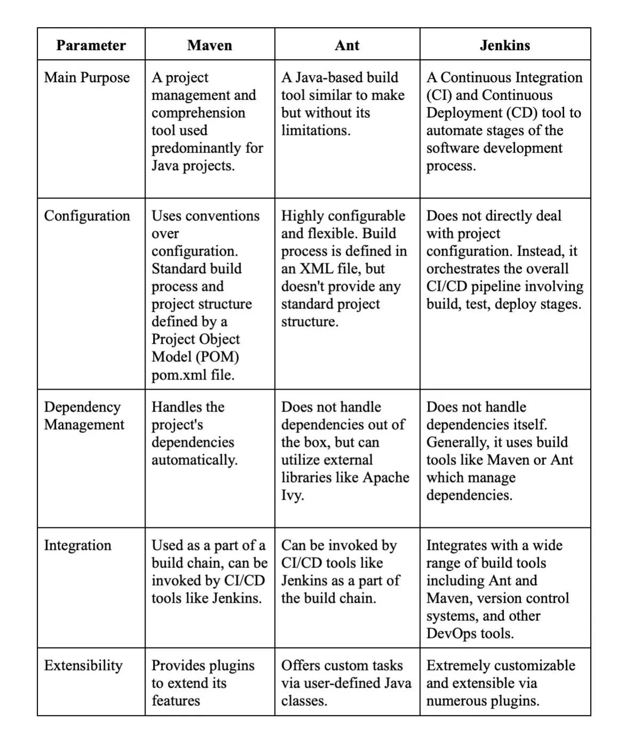

#### 21.

How are Bamboo and Jenkins different ?

Hide Answer

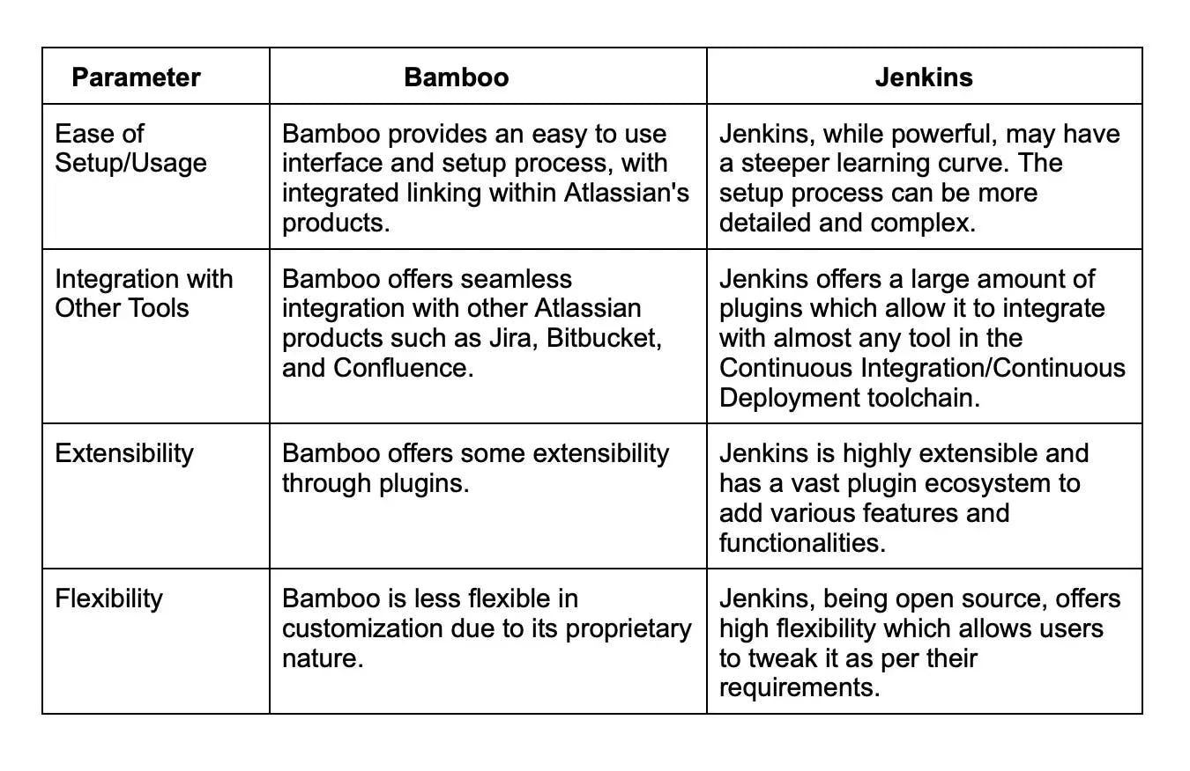

#### 22.

What is an Agent Directive in Jenkins?

Hide Answer

The Agent directive in Jenkins indicates where and when to execute the Pipeline or a specific stage in the Pipeline. The agent section specifies where all the stages of the Pipeline should be executed. By 'where', we are referring to the environment which could be any machine that Jenkins can access, such as a different server or a cloud-based environment.

It can be declared at the top level inside the pipeline block, or within a stage directive for executing specific stages on different agents. This directive helps in segregating the tasks across different agents, boosting performance, and it allows parallel execution.

For instance, different agent directives help Jenkins execute build, test, and deploy stages on different environments or machines. This allocation helps in improved pipeline execution as stages that do not depend on each other can be executed concurrently on different agents.

Also, each agent directive creates a separate workspace, ensuring isolation of environments, and this workspace contains all the necessary files for executing a given stage in the pipeline.

#### 23.

What is the use of Jenkins with Selenium?

Hide Answer

Jenkins is a widely used Continuous Integration tool that allows for frequent code changes to be built, tested, and deployed. Selenium, on the other hand, is a popular framework for automated testing of web applications.

Using Jenkins with Selenium has numerous advantages:

**Automated Testing**: By integrating Selenium with Jenkins, you can automate your testing process. When a new change is committed to the version control system, Jenkins can automatically trigger Selenium to execute test cases on your web application. This helps in providing quick feedback on the functionality of the application.

**Scheduled Testing**: Jenkins allows you to schedule Selenium test cases to run at specified times. This ensures regular checks on the functionality of your application and helps to spot issues early.

**Parallel Test Execution**: Jenkins with Selenium Grid can run tests in parallel on different machines, thereby, reducing the testing time for large projects.

**Reporting**: Jenkins can gather and visualize test results data over time, and the pipeline or project status, which helps in monitoring the trends and improving testing strategies.

#### 24.

How to configure Third-party tools in Jenkins?

Hide Answer

Configuring third-party tools in Jenkins generally involves a few common steps. Here is a more specific approach:

**Install the Third-Party Software**: On your Jenkins server or agent, install the specific third-party software tool that you would like to use in your Jenkins workflow.

**Install the Relevant Jenkins Plugin**: In many cases, for Jenkins to interact with third-party software, a specific Jenkins plugin may be required. You can search for and install these from the Jenkins UI by visiting the "Plugin Manager" under "Manage Jenkins". These plugins typically allow Jenkins to understand how to interact with each specific tool.

**Configure the Third-Party Tool in Jenkins**:

* Navigate to "Manage Jenkins" from the Jenkins dashboard.
* Choose “Global Tool Configuration”. Here, you will find options to configure many different tools. These options exist due to the plugins installed in step 2.
* Under the appropriate section, add a new tool. Here, you will typically provide the name of the installation, and might also specify the path to where the tool is installed on the Jenkins server or agent.

**Use the Third-Party Tool:** Once the tool is correctly installed and configured, you can now use it within your Jenkins pipeline or job configurations. Check the plugin documentation for exact usage instructions, as it will vary from tool to tool.

#### 25.

How can you integrate Git with Jenkins?

Hide Answer

To integrate Git with Jenkins, you first need to make sure the necessary Git plugin is installed. Jenkins offers a Git plugin that allows you to use Git as your Source Code Management (SCM) tool, which is crucial for building projects.

Here's a step-by-step process:

**Check if Git Plugin is Installed**: Jenkins comes with some plugins out of the box, but Git is not one of them. So it's best to check and install if necessary. Go to the Jenkins dashboard, click on "Manage Jenkins > Manage Plugins > Installed Tab". Look for 'Git Plugin'. If it's not there, switch to the "Available" tab, search for it and install it.

**Create a New Jenkins Job**: On your Jenkins dashboard, click on "New Item". Enter your project name and select the appropriate job type (e.g., 'Freestyle project'). Click on "OK" to create the job.

**Configure Source Code Management**: On the job configuration page, navigate to the "Source Code Management" section. Select "Git" and input your repository URL in the "Repository URL" field.

**Specify Branches to Build**: In the "Branches to build" section, specify the branch that you want Jenkins to build. By default, it's set to "*/master", meaning it will build the master branch.

**Save Configuration**: After providing all the necessary info, click on "Save" to save the configuration.

#### 26.

Explain how to integrate Kubernetes with Jenkins.

Hide Answer

Jenkins can be integrated with Kubernetes, an open-source system for automating deployment, scaling, and management of containerized applications. A Kubernetes cluster can handle the runtime environments of CI/CD workflows.

The integration of Jenkins with Kubernetes has several advantages:

**Dynamic scalability**: Kubernetes can spin up Jenkins agents dynamically based on demand. This is efficient and cost-effective, as resources are only used when needed.

**Isolation of environments**: Each Jenkins job can run in a separate Kubernetes Pod. This prevents job interference, maintains environment consistency, and improves security.

So, how do you integrate Jenkins with Kubernetes? At a high level, here are the steps:

**Install Jenkins on a Kubernetes cluster**: This can be done using a Helm chart, a preconfigured package of Kubernetes resources.

**Configure Kubernetes plugin in Jenkins**: Install the Kubernetes plugin using the Jenkins plugin manager. You can configure it by going to 'Manage Jenkins' > 'Configure System' > 'Cloud' > 'Kubernetes' and entering your Kubernetes' API server URL and credentials, among other details.

**Specify Kubernetes Pod template**: The Pod template defines the containers and volumes for the Jenkins agents. You can specify the Docker image, command to run, and the workspace volume, among other options.

**Use Kubernetes agents in a Pipeline**: Finally, in your Jenkins Pipeline script, you can specify the agent as Kubernetes and use the defined Pod template.

#### 27.

List some default environmental variables in Jenkins.

Hide Answer

Jenkins provides a set of default environment variables that you can use within your Jenkins jobs:

**JOB_NAME**: This variable holds the name of the job that is currently executing. This would be the name you gave the job when you first set it up.

**NODE_NAME**: This variable holds the name of the node where the build is currently running. For instance, it could be 'master' for the main Jenkins server or the name of an agent node if you're using distributed builds.

**WORKSPACE**: This variable points to the workspace directory where Jenkins runs the build. This is the directory containing the checked-out source code, and it's where any build steps are run by default.

**BUILD_URL**: This variable contains the URL of the build results. If you navigate to this URL, you can see the details and status of the current build.

**JENKINS_URL**: This variable provides the base URL of the Jenkins master server. If Jenkins is running on port 8080 of localhost, for instance, this value would be as follows:



#### 28.

What can you do for the broken build in the Jenkins project?

Hide Answer

A broken build occurs when your project fails to compile or test failures occur in your Jenkins project. Here are the general steps you can follow to fix it:

**Investigate the Build Failure**: Anytime a Jenkins build fails, the first step should be to examine the Console Output of the failed build. This contains the log of the execution of the entire build including what steps were run, in what order, and the output or error messages from those steps.

**Identify the Error**: Within the console's output, search for error logs or failure messages that indicate what caused the broken build. This could be anything, ranging from compiling error, failing tests, issues with fetching from the repository, or problem with the build environment setup.

**Check Recent Changes**: Next, inspect any recent changes that may have led to the build break. It could be changes to the code, build script, or Jenkins configuration. Jenkins maintains an SCM ChangeLog that lists recent changes related to your source code.

**Update Your Local Workspace**: Once you identify the possible root cause, try to replicate the error in your local workspace. If the error can be reproduced, it's time to fix it.

**Apply the Fix**: Make the necessary changes to the code, configurations, or build scripts based on your findings. It could require fixing the code, adding missing dependencies, adjusting build script, or tweaking the Jenkins job configuration.

**Test**: Test the changes thoroughly in your local environment before committing and pushing them to the repository.

**Rebuild**: After your changes have been pushed, trigger a build in Jenkins manually, or let it happen automatically if you've configured Jenkins for it.

#### 29.

Differentiate between Jenkins and Hudson.

Hide Answer

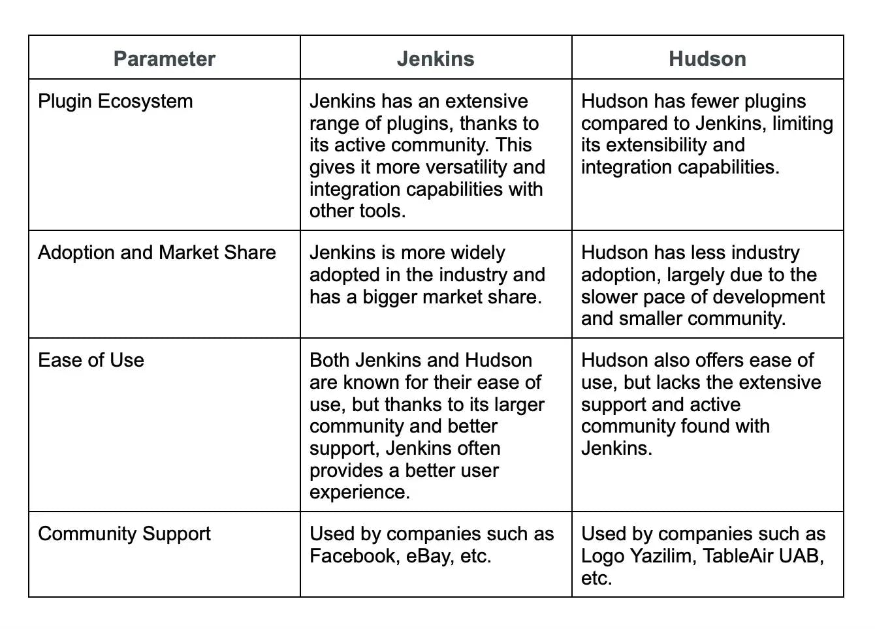

#### 30.

What is the concept of Jenkinsfile?

Hide Answer

A Jenkinsfile is a text file that contains the definition of a Jenkins Pipeline and is checked into source control. Written in Groovy DSL, it's essentially the "blueprint" for your Jenkins Pipeline, specifying what stages should execute and what actions should happen at each stage.

#### 31.

Explain a plugin in Jenkins and its importance?

Hide Answer

A plugin in Jenkins is essentially a software module that adds specific features and capabilities to the system. It's a way to extend Jenkins's default functionality by installing additional tools directly from the Jenkins Plugin Manager.

With over 1500 publicly available plugins, Jenkins provides a highly versatile platform suitable for meeting a wide range of CI/CD requirements. This diverse catalog of plugins is one of the main reasons Jenkins has gained immense popularity.

The importance of plugins in Jenkins lies in their capabilities to:

**Project Customization**: Plugins allow you to customize your CI/CD pipeline to cater to specific project needs, be it the type of project, the tools used in the project, or the processes adhered to by the team.

**Integration**: Plugins allow Jenkins to integrate with a multitude of development, testing, and deployment technologies, as well as communication tools. Examples include Git, Docker, Kubernetes, Azure, AWS, Slack, and more.

**Added Functionality**: Plugins can provide additional build steps, post-build actions, UI improvements, reporting capabilities, and more.

**Ease of Installation and Management**: Plugins are easy to install, update, and manage from the Jenkins UI. A feature of Jenkins allows checking the compatibility of plugins with the current Jenkins version, thereby ensuring smooth operation.

#### 32.

How can you install and configure a Slack notification plugin?

Hide Answer

* On the Jenkins dashboard click on "Manage Jenkins".
* Now click on "Manage Plugins" and select the "Available" tab.
* Now find "Slack Notification". Install it.
* Next go to the job configuration page and add a "Post-build Action" to "Send build notifications to Slack".
* Enter the Slack credentials and select the channel to send notifications to.

#### 33.

Explain the build in Jenkins.

Hide Answer

In Jenkins, a "build" refers to a single run of a project. This generally involves many stages: checking out code from a version control system, compiling the code, running unit tests or static code analysis, packaging the compiled code into deployable artifacts and, in some cases, deploying the application.

Each time Jenkins runs a build of a project, it will have a unique build number, and it will maintain a history of execution status, console output, and any artifacts saved or test results reported. It helps in identifying when and where a problem occurred and fixing it more effectively.

Here's an example of a build trigger using the Jenkins REST API



#### 34.

Tell me about a job in Jenkins, and how can you create one.

Hide Answer

A Job in Jenkins is a user-defined term for a set of operations that Jenkins needs to perform, often referred to as a project. It can range from building software, running tests, deploying code, running scripts, or a combination of such tasks. Each job, when configured and run, results in a 'build', representing an execution of the job.

Steps to follow to create a job in Jenkins

* Visit the Jenkins dashboard and find "New Item".
* Type the name of the job and select the job type.
* Now configure the job by adding build steps, triggers, and post-build actions.
* Save this configuration.

#### .

What is the difference between a container and a virtual machine?

Hide Answer

A container is an isolated and lightweight runtime environment that shares the host system's OS kernel, libraries, and resources. It provides process-level isolation and allows applications to run consistently across different environments.

On the other hand, a virtual machine is a complete and independent OS installation running on virtualized hardware, providing full isolation and running multiple instances of OS and applications.

#### 2.

What is Docker Engine?

Hide Answer

Docker Engine is a client-server application that provides the core functionality for building, running, and managing Docker containers. It consists of a Docker daemon (server) and a Docker CLI (client) that communicate with each other. The Docker Engine manages the container lifecycle, networking, storage, and other essential aspects of the Docker platform.

#### 3.

What is a Docker image?

Hide Answer

A Docker image is a lightweight, standalone, and executable software package that includes everything needed to run a piece of software including the code, runtime, libraries, dependencies, and system tools. It is created from a set of instructions defined in a Dockerfile and can be used to create Docker containers.

#### 4.

What is Docker Hub?

Hide Answer

Docker Hub is a cloud-based registry provided by Docker that allows developers to store, share, and distribute Docker images. It provides a central repository of public and private Docker images. This makes it easy to discover and access pre-built images created by the Docker community and other organizations.

#### 5.

How do you create a Docker container from an image?

Hide Answer

To create a Docker container from an image, you use the **docker run** command followed by the image name. For example, **docker run myimage:tag** will create and start a new container based on the specified image. Additional options can be provided to configure container settings such as networking, volume mounts, environment variables, and more.

#### 6.

What is a Dockerfile?

Hide Answer

A Dockerfile is a text file that contains a set of instructions for building a Docker image. It provides a declarative and reproducible way to define the software stack, dependencies, and configuration needed for an application. Dockerfiles include commands to copy files, install packages, set environment variables, and execute other actions required to create a Docker image.

#### 7.

Talk about hypervisors and their functions.

Hide Answer

A hypervisor, also known as the Virtual Machine Monitor, is a piece of software that allows virtualization to take place. This splits the host system's resources and distributes them to each deployed guest environment.

This implies that on a single host system, different operating systems may be installed. There are two types of hypervisors:

* **Native Hypervisor**: Also known as a Bare-metal Hypervisor, this form of hypervisor operates directly on the underlying host system, allowing direct access to the host hardware and eliminating the need for a base OS.
* **Hosted Hypervisor:** This form uses the underlying host operating system, which already has an operating system installed.

#### 8.

How do you build a Docker image using a Dockerfile?

Hide Answer

To build a Docker image using a Dockerfile, you use the **docker build** command followed by the path to the directory containing the Dockerfile. For example, **docker build -t myimage:tag** . will build an image named **myimage** with the specified tag using the Dockerfile in the current directory. The Docker daemon reads the instructions from the Dockerfile and builds the image layer by layer.

#### 9.

How do you start and stop a Docker container?

Hide Answer

To start a Docker container, you use the **docker start** command followed by the container ID or name. For example, **docker start mycontainer** will start a container named **mycontainer**. To stop a running container, you use the docker stop command followed by the container ID or name. For example, **docker stop mycontainer** will stop the container.

#### 10.

List down the components of Docker.

Hide Answer

The following are the three primary Docker components:

* **Docker Client**: Performs To communicate with the Docker Host, use the Docker build and run procedures. The Docker command then uses the Docker API to conduct any queries that need to be run.
* **Docker Host**: It is a service that allows you to host Docker containers. The Docker daemon, containers, and accompanying images are all included in this package. A connection is established between the Docker daemon and the Registry. The type of metadata related to containerized apps is saved pictures.
* **Registry**: Docker images are kept in this folder. A public register and a private registry are also available. Docker Hub and Docker Cloud are two open registries that anybody can utilize.

#### 11.

How do you remove a Docker container?

Hide Answer

To remove a Docker container, you use the **docker rm** command followed by the container ID or name. For example, **docker rm mycontainer** will remove a container named **mycontainer**. If the container is currently running, you need to stop it first using the **docker stop** command.

#### 12.

How can you remove all stopped containers and unused networks in Docker?

Hide Answer

Prune is a command that gets rid of all of your stopped containers, unused networks, caches, and hanging images. Prune is one of Docker's most helpful commands. The syntax is, prune docker system $.

#### 13.

When a container exists, is it possible for you to lose data?

Hide Answer

No, it is impossible to lose any data as long as a container exists. Until the said container is deleted by you, you will not lose any data stored in that container.

#### 14.

What is Docker Compose?

Hide Answer

Docker Compose is an essential tool in the Docker ecosystem that facilitates the management of multi-container applications. It is a command-line tool that allows developers to define and run multi-container Docker applications using a simple YAML file called a "docker-compose.yml."

With Docker Compose, developers can define the services, networks, and volumes required for their application stack, streamlining the process of deploying and orchestrating interconnected containers.

#### 15.

Is there a limit on how many containers you can run in Docker?

Hide Answer

The amount of containers that may be run under Docker has no explicitly specified limit. But it all relies on the constraints, particularly the hardware constraints. The size of the program and the number of CPU resources available are two major determinants of this restriction. If your program isn't too large and you have plenty of CPU resources, we can run a lot of containers.

#### 16.

Differentiate between Container Logging and Daemon Logging.

View Answer

Logging is supported at two levels in Docker: at the Daemon level and the Container level.

* Daemon Logging

Debug, Info, Error, and Fatal are the four levels of logging used by daemons.  
Debug keeps track of everything that happened throughout the daemon's operation.  
During the execution of the daemon process, info carries all of the information as well as error information.  
Errors refer to errors that happened during the daemon process' execution.  
Fatal refers to execution faults that resulted in death.

* Container Level Logging

You can perform container level logging by executing this command: sudo docker run

–it <container_name> /bin/bash

To check for container-level logs,

enter: sudo docker logs <container_id>.

#### 17.

How will you use Docker for multiple application environments?

Hide Answer

Docker's compose capability will come in handy here. You should describe various services, networks, and containers, as well as volume mapping, in a tidy manner in the docker-compose file, and then just run the command "docker-compose up."  
You need to describe the requirements and processes which are server-specific to execute the application, especially when there are so many environments involved. It may be dev, staging, uat, or production servers. For example, you should create environment-specific docker-compose files with the name "docker-compose.environment.yml" and then based on the environment, set it up and execute the application.

#### 18.

Does Docker provide support for IPV6?

Hide Answer

Docker does, in fact, support IPv6. Only Docker daemons running on Linux servers support IPv6 networking. However, if you want the Docker daemon to support IPv6, you must edit /etc/docker/daemon.json and change the ipv6 key to true.

#### 19.

How do you scale Docker containers horizontally?

Hide Answer

To scale Docker containers horizontally, you can use Docker Swarm or a container orchestration tool like Kubernetes. With Docker Swarm, you can create a cluster of Docker nodes and use the **docker service** command to scale the desired number of replicas for service across multiple nodes. For example, **docker service scale myservice=5** will scale the service named **myservice** to 5 replicas.

#### 20.

What is the difference between the CMD and ENTRYPOINT instructions in a Dockerfile?

Hide Answer

Here are some differences between CMD and ENTRYPOINT:

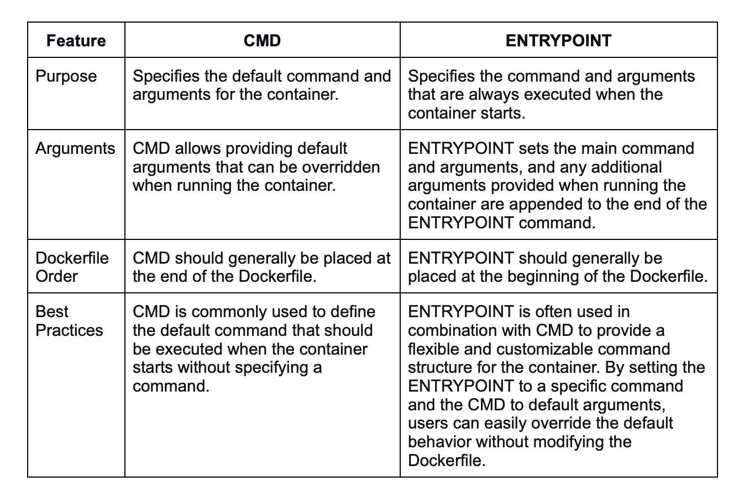

#### 21.

What is the purpose of volumes in Docker?

Hide Answer

Volumes in Docker are used to persist and share data between containers and between containers and the host system. They provide a way to store and manage data separately from the container's lifecycle, ensuring that data is preserved even if the container is stopped or removed. Volumes can be used for database files, application configurations, log files, and other types of persistent data.

#### 22.

Is it possible for a container to restart by itself?

Hide Answer

Yes, but only when specific docker-defined rules are used in conjunction with the docker run command. The policies that are accessible are as follows:

* **Off**: If the container is stopped or fails, it will not be resumed.
* **On-failure:** In this case, the container restarts itself only if it encounters failures unrelated to the user.
* **Unless-stopped**: This policy assures that a container may only resume when the user issues a command to stop it.
* **Always**: In this form of policy, regardless of failure or stoppage, the container is always resumed.

This is how you use these policies:

docker run -dit — restart [restart-policy-value] [container_name]

#### 23.

How do you expose ports in a Docker container?

Hide Answer

Ports can be exposed in a Docker container by using the -p or --publish option with the docker run command. For example, **docker run -p 8080:80 mycontainer** will expose port 80 in the container and map it to port 8080 on the host system. This allows traffic to reach the container's application through the specified host port.

#### 24.

How do you pass environment variables to a Docker container?

Hide Answer

Environment variables can be passed to a Docker container using the -e or --env option with the docker run command. For example, docker run -e MY_VAR=myvalue mycontainer will set the environment variable MY_VAR to myvalue within the container. Multiple environment variables can be passed by specifying multiple -e options or by using a .env file.

#### 25.

What is the difference between Docker restart policies "no", "on-failure", and "always"?

Hide Answer

The Docker restart policies determine the behavior of a container when it exits or when Docker restarts. The "no" restart policy means Docker will not restart the container if it exits. The "on-failure" restart policy specifies that Docker will restart the container only if it exits with a non-zero exit code. The "always" restart policy tells Docker to always restart the container regardless of its exit status.

#### 26.

What is the purpose of the Docker registry?

Hide Answer

The Docker registry is a centralized repository that stores Docker images. It serves as a distribution and collaboration platform, allowing users to publish, discover, and retrieve container images. The Docker registry can be either Docker Hub or a private registry. It provides a reliable source for sharing and deploying containerized applications.

#### 27.

What is the difference between a Docker image and a container?

Hide Answer

Here are some of the differences between a Docker image and a Docker container:

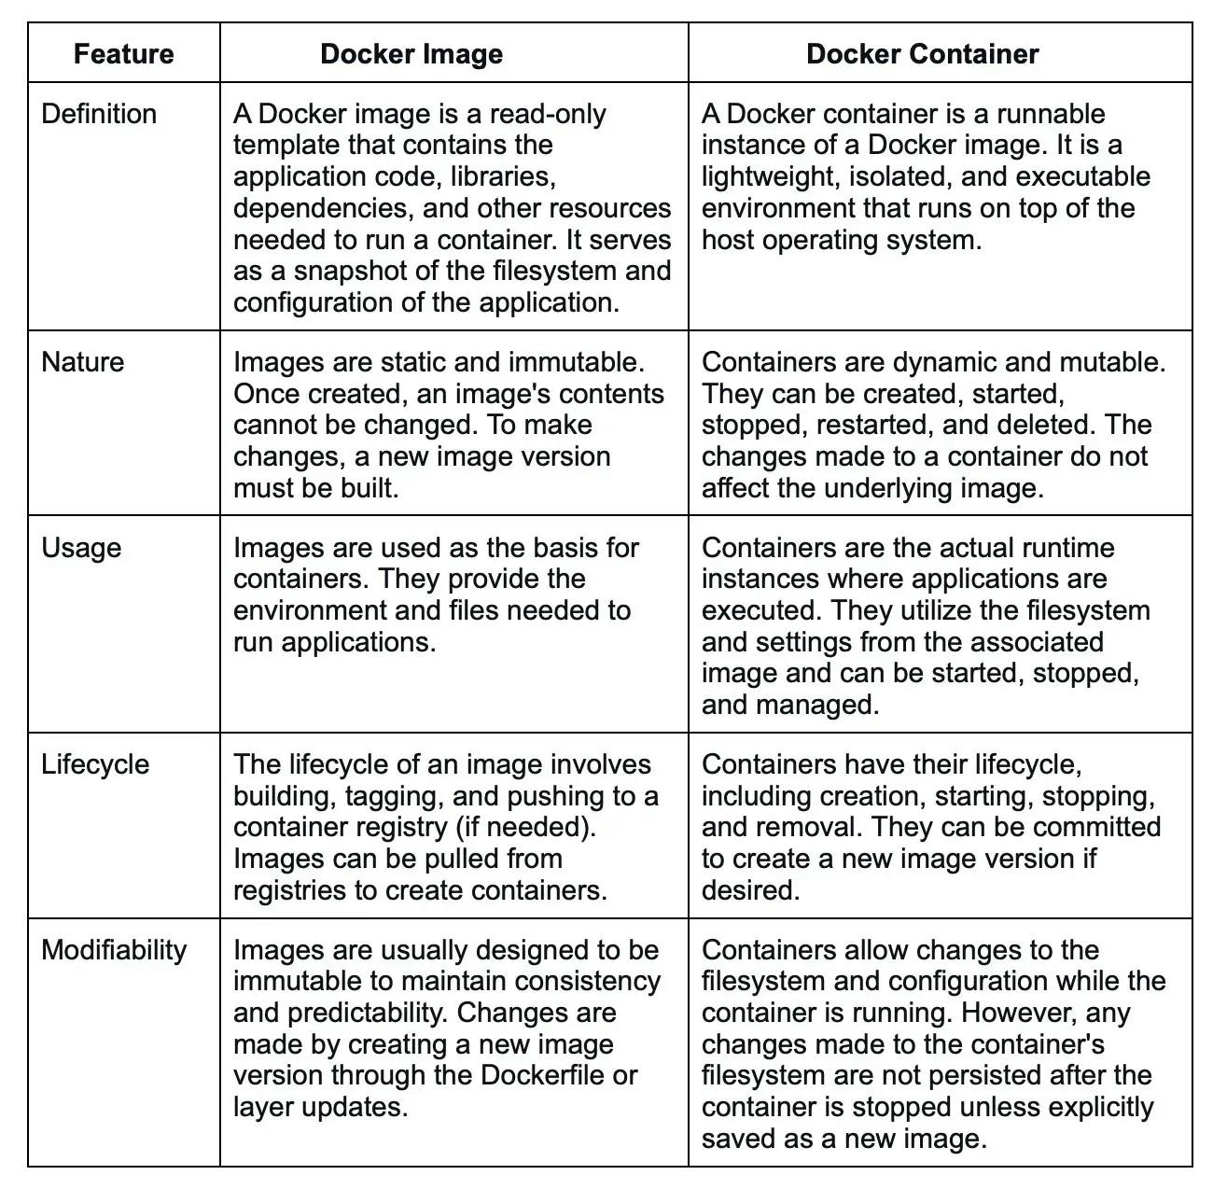

#### 28.

How do you update a Docker image?

Hide Answer

To update a Docker image, you typically rebuild it using an updated version of the source code or dependencies. This involves modifying the Dockerfile or build configuration, running the build process, and tagging the new image with an appropriate version or tag. Once the updated image is built, it can be pushed to a registry and used to create new containers or update existing ones.

#### 29.

What is the difference between a base image and a child image in Docker?

Hide Answer

A base image, also known as a parent image, is the starting point for building a Docker image. It provides the foundational software stack, OS, and runtime environment.

Meanwhile, a child image, also called a derived image, is created by extending or customizing a base image. It includes the base image's contents along with additional layers defined in the child image's Dockerfile. A child image inherits the base image's layers and can add its own modifications.

#### 30.

What is the purpose of the CMD instruction in a Dockerfile?

Hide Answer

The CMD instruction in a Dockerfile defines the default command and arguments that are executed when a container is run without specifying a command. It provides a way to set the container's main executable or script.

If the Dockerfile contains multiple CMD instructions, only the last one is used. The CMD instruction can be overridden by providing a command and arguments when running the container.

#### 31.

How do you inspect the metadata of a Docker image?

Hide Answer

You can inspect the metadata of a Docker image using the **docker image inspect** command followed by the image name or ID. For example, **docker image inspect myimage** will display detailed information about the specified image including its tags, layers, size, creation date, exposed ports, environment variables, and more. The output is in JSON format which allows you to extract specific fields programmatically.

#### 32.

What is Docker Swarm?

Hide Answer

Docker Swarm is a native clustering and orchestration solution provided by Docker for managing a cluster of Docker nodes and deploying and scaling containerized applications. It allows users to turn a group of Docker hosts into a single, virtual Docker host, making it easier to manage and scale containerized applications across multiple nodes.

Docker Swarm provides features for service discovery, load balancing, rolling updates, scaling, and fault tolerance. It simplifies the deployment and management of containerized applications across a cluster of machines.

#### 33.

What is the difference between a Docker container and a Kubernetes pod?

Hide Answer

A Docker container is a lightweight and isolated runtime environment that runs a single instance of an application. It is managed by Docker and provides process-level isolation. On the other hand, a Kubernetes pod is a higher-level abstraction that can contain one or more Docker containers (or other container runtimes). Pods provide co-located and co-managed containers, sharing networking and storage resources within a Kubernetes cluster.

Docker containers are the core units of application packaging and isolation, while Kubernetes pods are higher-level abstractions that group one or more containers together within a shared context, simplifying their management and deployment in the Kubernetes environment.

#### 34.

How does Docker handle container isolation and security?

Hide Answer

[Docker](https://www.turing.com/kb/what-is-docker-a-comprehensive-overview) provides isolation and security for containers through several mechanisms. It uses Linux kernel features like namespaces, control groups (cgroups), and seccomp profiles to create an isolated environment for each container.

Namespaces provide process-level isolation, cgroups manage resource allocation, and seccomp restricts system calls. Docker also provides security features like user namespaces, image signing, and security scanning to protect against vulnerabilities.

#### 35.

What is the purpose of a Docker volume driver?

Hide Answer

A Docker volume driver is a plugin that extends Docker's volume management capabilities. It allows you to use external storage systems or services such as Docker volumes.

Volume drivers enable features like networked storage, distributed filesystems, and integration with cloud storage providers. They provide a flexible and scalable way to handle persistent data in Docker containers across different environments and infrastructure setups.

#### 36.

How do you deploy a Docker container to a remote host?

Hide Answer

To deploy a Docker container to a remote host, you typically build a Docker image locally and push it to a registry accessible by the remote host. Then, on the remote host, you pull the image from the registry and run it using the **docker run** command.

Alternatively, you can use container orchestration tools like Docker Swarm or Kubernetes to manage and deploy containers across a cluster of remote hosts.

#### 37.

What are the benefits of using Docker in a microservices architecture?

Hide Answer

Docker offers several benefits in a [microservices architecture](https://www.turing.com/blog/microservices-best-practices/):

**Isolation**: Each microservice can run in its own container, providing process-level isolation and avoiding conflicts between dependencies.

**Scalability**: Docker containers can be easily scaled up or down to handle varying workloads, ensuring optimal resource utilization.

**Deployment flexibility**: Containers are portable and can be deployed consistently across different environments, making it easier to move or replicate microservices.

**Service composition**: Docker's container networking allows microservices to communicate with each other easily and securely.  
Rapid iteration: Docker's fast image building and deployment enable rapid iteration and continuous delivery of microservices.

**Rapid iteration**: Docker's fast image building and deployment enable rapid iteration and continuous delivery of microservices.

#### 38.

How do you debug issues in a Docker container?

Hide Answer

There are several techniques to debug issues in a Docker container:

**Logging**: Docker captures the standard output and standard error streams of containers, making it easy to inspect logs using the **docker logs** command.

**Shell access**: You can access a running container's shell using the **docker exec** command with the -it option. This allows you to investigate and troubleshoot issues interactively.

**Image inspection**: You can inspect the Docker image's contents and configuration using **docker image inspect**. This lets you check for potential misconfigurations or missing dependencies.

**Health checks**: Docker supports defining health checks for containers, allowing you to monitor the health status and automatically restart or take action based on predefined conditions.

#### 39.

What is the purpose of the "docker exec" command?

Hide Answer

The **docker exec** command is used to run a command within a running Docker container. It provides a way to execute commands inside a container's environment such as running a shell, running scripts, or interacting with running processes. For example, **docker exec -it mycontainer bash** opens a shell session within the container named **mycontainer**.

#### 40.

How do you limit the CPU and memory usage of a Docker container?

Hide Answer

Docker allows you to limit the CPU and memory usage of a container using resource constraints. You can set the CPU limit with the --cpu option and the memory limit with the --memory option when running the container using the docker run command.

For example, **docker run --cpu 2 --memory 1g mycontainer** limits the container to use a maximum of 2 CPU cores and 1GB of memory.

#### 41.

What is the significance of the "Dockerfile.lock" file?

Hide Answer

The "Dockerfile.lock" file is not a standard Docker file or artifact. It might refer to a file created by a specific build tool or framework that captures the state of the dependencies and build process at a given point in time.

It can be used to achieve deterministic builds, ensuring that the same set of dependencies and build steps are used consistently across different environments or when rebuilding the image.

#### 42.

How do you create a multi-stage build in Docker?

Hide Answer

Multi-stage builds in Docker allow you to create optimized Docker images by leveraging multiple build stages. Each stage can use a different base image and perform specific build steps. To create a multi-stage build, you define multiple **FROM** instructions in the Dockerfile, each representing a different build stage.

Intermediate build artifacts can be copied between stages using the **COPY --from** instruction. This technique helps reduce the image size by excluding build tools and dependencies from the final image.

Are you familiar with K8s?

Hide Answer

It is another name for Kubernetes, an open-source platform for managing containerized applications. Kubernetes automates the scaling, deployment, and management of containerized applications, allowing them to run consistently across different computing environments.

#### 2.

What is Kubernetes and what does it do?

Hide Answer

Kubernetes is an open-source container management tool that automates the deployment, scaling, and descaling of containers. It was developed by Google based on their experience of running containerized workloads for over 15 years. Kubernetes has become the standard tool for managing containerized applications and has a large and active community contributing to its development.

#### 3.

How are Kubernetes and Docker linked?

Hide Answer

Docker builds containers, which then communicate with each other via Kubernetes. Kubernetes supports multiple container runtimes, including Docker, CRI-O, and others. In simple terms, Kubernetes is analogous to an operating system, and Docker containers are comparable to applications installed on that operating system.

Docker is a containerization platform that allows developers to package and distribute their applications as self-contained units, known as containers. Kubernetes, on the other hand, is a container orchestration platform that automates the deployment, scaling, and management of containerized applications.

The two technologies, Kubernetes and Docker, work together to enable the deployment and management of applications in a distributed environment.

#### 4.

Can you explain what container orchestration is?

Hide Answer

Container orchestration is a process that involves managing and coordinating the deployment, scaling, and operation of multiple containers that run on a single server or across multiple servers. It automates container provisioning, networking, resource allocation, load balancing, availability, and lifecycle management tasks. Container orchestration tools, such as Kubernetes, Docker Swarm, and Apache Mesos, help ensure that containers work together seamlessly and efficiently to deliver the desired applications or services.

#### 5.

Why do we need container orchestration?

Hide Answer

Container orchestration is critical to working with containers, allowing organizations to unlock their full benefits. It can be used in any environment where you use containers.

Container orchestration is needed to manage and automate containerized applications' deployment, scaling, and management. It helps to reduce operational overhead, increase efficiency and scalability, and ensure infrastructure availability, thus helping to improve application performance.

#### 6.

List the features of Kubernetes.

Hide Answer

Some of the features of Kubernetes are:

**Automated scheduling**: Kubernetes automatically schedules containers to run on the available resources in the cluster.  
Self-healing capabilities: Kubernetes automatically replaces failed containers and reschedules them on healthy nodes in the cluster.

**Automated rollouts and rollback**: Kubernetes is responsible for automating the deployment process, enabling users to roll out new versions of their applications easily and roll them back in case of any issues.

**Horizontal scaling and load balancing**: Kubernetes automatically scales and distributes traffic across multiple instances of a containerized application.

**Configuration management**: Kubernetes enables users to define and manage the application configuration settings separately from the application code.

**Service discovery & networking**: Kubernetes provides a built-in service discovery mechanism to locate and communicate with other services in the cluster.

**Security & compliance:** Kubernetes provides several security features, including access control to ensure the security of the cluster and compliance with organizational policies.

#### 7.

How does Kubernetes help in containerized deployment?

Hide Answer

Kubernetes helps in containerized deployment by scaling, loading, balancing, and monitoring containers. You can take advantage of these features by deploying your containerized applications on a Kubernetes cluster. To do this, you create a deployment configuration that instructs Kubernetes on creating and updating instances of your application. Kubernetes manage these instances, which can automatically recover from failures and scale up or down based on demand.

#### 8.

What are clusters in Kubernetes?

Hide Answer

Clusters in Kubernetes refer to a group of interconnected physical or virtual machines called nodes that work together to efficiently and automatically run containerized applications in a distributed and fault-tolerant manner. Kubernetes clusters allow engineers to orchestrate and monitor containers across multiple physical, virtual, and cloud servers. Kubernetes clusters are designed to be highly available, resilient, and scalable. By using a cluster, engineers can take advantage of the automatic scaling and self-healing capabilities of Kubernetes for optimized application performance.

#### 9.

Explain Google Container Engine (Google Kubernetes Engine).

Hide Answer

It is a Google-managed implementation of the Kubernetes open-source management platform for clusters and Docker containers. It provides a managed environment for deploying, scaling, and managing your containerized applications using Google infrastructure. It is designed to simplify containerized applications' deployment, management, and scaling in a production environment.

#### 10.

What is Heapster?

Hide Answer

A Heapster is a cluster-wide aggregator of data that runs on each node. It is a Kubernetes project that provides a robust monitoring solution for Kubernetes clusters. Heapster is flexible and modular, making it easy to use and customize for different needs. However, Heapster has been deprecated since Kubernetes version 1.11. Its functionality has been replaced by the Kubernetes Metrics Server, which provides a more efficient and scalable way to collect and expose resource utilization data from Kubernetes nodes and pods.

#### 11.

What do you know about Minikube?

Hide Answer

Minikube is a lightweight implementation of Kubernetes, which creates a VM on your local machine. It is a tool that sets the Kubernetes environment on your laptop or PC, and it addresses a different type of use case than most other distributions, such as Rancher, EKS, and OpenShift. It creates a lightweight, self-contained environment with all the necessary components for running Kubernetes, such as the API server, etcd, and kubelet. This allows developers to experiment with Kubernetes without the need for a full-scale production environment.

#### 12.

What do you know about Kubectl?

Hide Answer

A Kubetcl is a command-line tool or platform through which you can pass commands to a cluster. Kubectl is the Kubernetes-specific command line tool that lets you communicate and control Kubernetes clusters. With Kubectl, you can deploy applications, inspect and manage cluster resources, view logs, and debug your applications running on Kubernetes. Kubectl can also be used to manage remote and cloud clusters such as GKE.

#### 13.

Can you elaborate on the above question?

Hide Answer

Kubectl allows you to deploy and manage applications on a Kubernetes cluster, inspect and debug cluster resources, and view logs and metrics, among other things.

Here's a brief overview of what Kubectl can do:

* Create, read, update, and delete Kubernetes resources (pods, services, deployments, etc.)
* Interact with the Kubernetes API server to manage cluster resources
* Monitor the status of resources and diagnose issues
* Manage Kubernetes configurations and secrets
* View logs and metrics for applications running on the cluster

#### 14.

What is a node in Kubernetes?

Hide Answer

A node is the primary worker machine in the Kubernetes cluster, also known as the minion. It may be a physical or a virtual machine depending on the cluster. It has several components, including a kubelet, container runtime, and Kubernetes components to communicate with the control plane. Nodes can run one or more containers and can be added or removed from the cluster dynamically.

#### 15.

List the main components of Kubernetes architecture.

Hide Answer

Two main components of Kubernetes architecture are the Master node and the Worker node.

**Master node**: The master node is the control plane making global decisions inside the cluster. The master node comprises the control plane components responsible for managing and coordinating the cluster. These components are the API server, scheduler, cloud controller manager, and controller manager.

**Worker node**: The worker node has four very light components, which makes sense because you want to reserve most of the space for your pods. These components are the proxy, the Kubelet, and the container runtime.

#### 16.

Can you tell me about kube-proxy?

Hide Answer

Kube-proxy can run on every node and perform TCP/UDP packet forwarding across the backend network service. Kube-proxy is an important component of Kubernetes networking that helps ensure reliable and efficient communication between pods and services within the cluster. By routing traffic to the correct destination, kube-proxy helps ensure reliable and efficient communication within the cluster.

#### 17.

What is the master node in Kubernetes?

Hide Answer

It controls and manages the worker nodes. It makes up the control plane of a cluster and is responsible for scheduling tasks and monitoring the state of the cluster. The master node has several components, such as Kube-APIServer, Kube-Controller-manager, Etcd, and Kube-Scheduler, to help manage worker nodes.

#### 18.

Tell me more about the kube-scheduler.

Hide Answer

Kube-scheduler distributes and manages the workload on the worker nodes. It uses various policies to select the most suitable node for a pod based on factors such as resource requirements, node capacity, and pod affinity/anti-affinity. The kube-scheduler component is also responsible for binding the selected node to the pod and updating the Kubernetes API server with the updated information.

#### 19.

Which node in Kubernetes keeps track of resource utilization?

Hide Answer

The node in Kubernetes that keeps track of resource utilization is the kubelet. It runs on each worker node and is responsible for managing the state of the node, including starting and stopping pods, as well as monitoring their resource usage. The Metrics Server collects the relevant resource usage stats from kubelet and generates aggregated metrics via metrics API.

#### 20.

What is Kubernetes controller manager?

Hide Answer

The Kubernetes controller manager embeds controllers and is responsible for creating a namespace. Here controllers are control loops that watch the state of your cluster, then make or request changes where needed. Every controller tries to move the current cluster state to the desired state.

#### 21.

List the different types of controllers in Kubernetes.

Hide Answer

Here are some of the types of controllers:

* Node controller
* Replication controller
* Service account and token controller
* Endpoints controller
* Namespace controller

#### 22.

What do you know about ETCD?

Hide Answer

Pronounced as "ett-see-dee," it is written in Go programming language and used to coordinate distributed work and key-value pairs. It is an open-source distributed key-value store that holds and manages the critical information distributed systems need to keep running. It is built on the Raft consensus algorithm, which ensures datastore consistency across all the nodes.

#### 23.

List the different types of services in Kubernetes.

Hide Answer

Here are some of the services in Kubernetes:

**Cluster IP**: This is the default service type in Kubernetes, and it exposes the service on a cluster-internal IP. This means that only the services inside the cluster can access it.

**Node Port**: This type of service exposes the service on a static port on each node in the cluster. This makes the service accessible from outside the cluster.

**Load balancer:** This type of service provisions an external load balancer in the cloud infrastructure and directs traffic to the Kubernetes service. This allows you to expose your service to the internet.

**External name**: This type of service maps the service to an external DNS name. This allows you to reference external services by name from within your cluster.

#### 24.

Tell me about load balancers in Kubernetes.

Hide Answer

In Kubernetes, a load balancer is a component that distributes incoming network traffic across multiple instances of an application running in a cluster. The load balancer sends connections to one server in the pool based on an algorithm to determine the next server and sends new connections to the next server, which is available. This algorithm is ideal where virtual machines incur costs, such as in hosted environments. Some of the strategies used for load balancing are Round robin, Session infinity, and IP hashing.

#### 25.

What is Ingress network?

Hide Answer

An Ingress network is a set of protocols that acts as an entry point for external traffic into the Kubernetes cluster and manages access to services within the cluster. An Ingress network is traffic whose source lies in the public internet or an external network and is sent to the destined node in the private network. It is used to manage user access for the services within the Kubernetes cluster.

#### 26.

What is the role of the Ingress network?

Hide Answer

The Ingress network manages external access to services in the cluster. Specifically, it enables the load balancing of traffic, termination of SSL/TLS, and virtual hosting for HTTP and HTTPS routes exposed from outside the cluster to services within it. The Ingress network helps streamline communication between the applications and external clients by providing a single entry point for incoming traffic.

#### 27.

Explain the cloud controller manager.

Hide Answer

The cloud controller manager lets you link the cluster to the cloud provider’s API. Cloud-controller manager allows cloud vendors to evolve independently from the core Kubernetes code by abstracting the provider-specific code. It abstracts provider-specific code and functionality, which allows cloud vendors to develop and maintain their code independently from the core Kubernetes code.

Using the CCM, cloud-specific operations such as creating and managing load balancers, block storage volumes, and cloud-specific networking resources can be performed seamlessly within a Kubernetes cluster. This allows users to take advantage of the benefits of both Kubernetes and the cloud provider while minimizing the potential for compatibility issues.

#### 28.

What are the different types of cloud controller managers?

Hide Answer

Here are some of the types of cloud controller managers:

**Node controller**: Responsible for managing the lifecycle of nodes in the cluster, such as creating, updating, and deleting nodes

**Route controller**: Manages ingress and egress traffic for services running in the Kubernetes cluster

**Volume controller**: Responsible for managing the lifecycle of volumes in the cluster, such as creating, attaching, and detaching volumes.

**Service controller**: Manages the lifecycle of Kubernetes services, such as creating, updating, and deleting services.

#### 29.

Do you know what container resource monitoring is?

Hide Answer

Container resource monitoring is the process of constantly collecting metrics. Also, it tracks the health of containerized applications to improve their health and performance and ensure they are operating smoothly. Container resource monitoring has become popular because it provides robust capabilities to track potential failures.

#### 30.

What is the init container?

Hide Answer

An init container is a type of container in Kubernetes that runs before the main application containers in a pod. The purpose of an init container is to perform initialization tasks or setup procedures that are not present in the application container images. Examples of tasks that an init container might perform include downloading configuration files, setting up a network connection, or initializing a database schema.

### Looking for remote developer job at US companies?

Work at Fortune 500 companies and fast-scaling startups from the comfort of your home

[Apply Now](https://developers.turing.com/?referrer=https://www.bing.com/)

### Intermediate Kubernetes interview questions and answers

#### 1.

List some container resource monitoring tools.

Hide Answer

Here are some of the resource monitoring tools:

* Grafana
* Kibana
* CAdvisor
* Prometheus
* SolarWinds
* ElasticSearch
* Sysdig

#### 2.

What is Grafana?

Hide Answer

Grafana is an open-source interactive data visualization platform. It was developed by Grafana Labs, which allows users to see their data via charts, graphs, and alerts for the web when connected to supported data sources. It is divided into frontend and backend, written in TypeScript and Go, respectively.

#### 3.

What is CAdvisor?

Hide Answer

CAdvisor stands for container advisor, which discovers active containers and monitors them. The tool runs as a daemon process in the background, collecting, aggregating, and processing useful DevOps information. With CAdvisor you can track historical resource usage with histograms and analyze the memory footprint of the code running on servers. It primarily helps understand resource consumption.

#### 4.

What is Prometheus?

Hide Answer

Prometheus is an open-source monitoring and alerting system of the Cloud Native Computing Foundation. It was originally developed by SoundCloud and is designed to help users monitor their systems and applications by collecting and processing real-time metrics data. Prometheus has a powerful query language and a flexible alerting system that allows users to define custom rules and receive alerts when certain conditions are met.

Additionally, Prometheus offers various options for data visualization, including built-in graph and dashboarding capabilities. Prometheus supports static and dynamic service discovery mechanisms to discover and monitor targets automatically.

#### 5.

Differentiate between a replica set and a replication controller.

Hide Answer

They are the same but differ only in using selectors to reproduce pods.The replication controller allows us to create multiple pods easily, but if a pod crashes, it ensures it is replaced with a new pod. It can scale the number of pods and update or delete multiple pods with a single command.

The replica set is the same as the replication controller except that they have more options for the selectors. They use set-based selectors to manage the pods. Here the rolling-update command won't work.

#### 6.

Which selectors does the replica set use?

Hide Answer

A replica set in Kubernetes uses label selectors to identify which pods it should manage. The selectors specify a set of key-value pairs that the replica set uses to match against the labels applied to the pods. Set-based selectors allow filtering keys according to a set of values. There are three kinds of operators: in, not in, and exists. The replica set will look for pods whose labels match the selectors.

#### 7.

Which selectors do replication controllers use?

Hide Answer

Replication controllers use label selectors to identify the set of pods that they manage. Specifically, they use equality-based selectors, which allow filtering by label key and values. These selectors look for pods with labels that match a specific key-value pair. To use an equality-based selector, you can use the "-l" or "--selector" option.

#### 8.

What do equality-based selectors do?

Hide Answer

They allow filtering by label keys and values. Thus they will only look for pods with the exact same phrase as the label. When a pod or other resource is created, it can be labeled with key-value pairs. Equality-based selectors allow you to select resources based on an exact match of those key-value pairs.

#### 9.

How do you monitor applications in Kubernetes?

Hide Answer

Application monitoring with Kubernetes is not reliant on a single monitoring provider. You can utilize resource metrics or entire metrics pipelines to collect monitoring information on new clusters.

The resource metrics pipeline only delivers a subset of metrics related to cluster components such as the Horizontal Pod Autoscaler controller and the kubectl top function. The lightweight, short-term, in-memory metrics server collects these measurements, which are then provided via the metrics.k8s.io API.

A complete metrics pipeline gives you access to more detailed metrics. Using technologies such as the Horizontal Pod Autoscaler, Kubernetes may respond to these indicators by dynamically scaling or adjusting the cluster based on its present condition.

#### 10.

What do you know about Headless service?

Hide Answer

The Headless Service creates a service grouping that does not allocate an IP address or forward traffic. So here, the spec.clusterIP is explicitly set to "None," and the spec.type is set to "ClusterIP."

This service is used for stateful apps, such as databases, where it is essential to maintain a consistent network identity for each instance. With Headless service, you don't need the proxy to reach the pods.

#### 11.

List some security measures that you can take while using Kubernetes.

Hide Answer

Here are some of the security measures we can take:

* Limit the access to ETCD
* Implement network segmentation
* Define source quota
* Provide limited access to nodes of Kubernetes

#### 12.

What do you know about federated clusters?

Hide Answer

Federated clusters help manage multiple Kubernetes clusters, which means you can manage multiple Kubernetes clusters in one place. It provides a centralized view of all the clusters, making it easier to manage and scale applications across different clusters.

Using a federated cluster, you can deploy and manage applications consistently across all your clusters, enabling better workload distribution, resource management, and redundancy.

#### 13.

Explain orchestration when it comes to software and DevOps.

Hide Answer

The automated configuration, coordination, and management of computer systems, services, and applications is called orchestration in DevOps. It leverages DevOps tools that allow for version control, rapid updates and releases, and other best practices for software engineering.

Orchestration in software involves coordinating and managing multiple computer systems, applications, and/or services, stringing together various tasks to execute a larger workflow or process. These processes can consist of numerous tasks that are automated and can involve multiple systems.

#### 14.

How do you perform maintenance on the K8 node?

Hide Answer

This is one of the most popular k8s interview questions. When security updates become available, the Kubernetes administrator must execute the maintenance work of applying the security patch to the running container to prevent it from becoming vulnerable, which is an inevitable component of the administration. To safely drain the K8s node, use the following two commands:

* kubectl cordon
* kubectl drain –ignore-daemon set

#### 15.

Tell the difference between Docker Swarm and Kubernetes.

Hide Answer

Here are some key differences between Docker Swarm and Kubernetes:

Architecture: Docker Swarm is a clustering and scheduling tool for Docker containers, while Kubernetes is a container orchestration platform that can manage containers from different container runtimes such as Docker, containerd, and CRI-O.

Installation: Docker Swarm has a simple installation process, and it is relatively easy to set up and manage a Swarm cluster. Kubernetes, on the other hand, has a more complex installation process and requires a lot of configuration and setup before the cluster is up and running.

Scalability: Docker Swarm and Kubernetes can scale horizontally by adding or removing nodes, but Kubernetes has more advanced scaling features than Swarm.

Load balancing: Kubernetes has an advanced load-balancing feature that can distribute traffic across containers based on various factors such as resource utilization, network latency, and more. Swarm, on the other hand, has a simpler load-balancing mechanism that relies on round-robin scheduling.

16.

List some features of Kubernetes.

Hide Answer

Here are some of the features of Kubernetes:

* Manages clusters at the same time
* Monitors nodes and containers
* Scales resources vertically and horizontally
* Automated deployment and rollout of containerized applications
* Self-healing capabilities to restart or replace failed containers automatically
* Load balancing and service discovery for distributing traffic across containers

17.

How can you use Kubernetes for workload distribution optimization?

Hide Answer

As Kubernetes helps efficiently optimize resources, it helps with resource distribution. The orchestration tool also ensures that specific resources are used with the application to enhance overall operational efficiency.

Load balancing: Kubernetes provides a built-in load balancer to distribute incoming network traffic to the pods running on the cluster. This helps to evenly distribute the workload across the nodes in the cluster, which can help to optimize resource utilization.

Auto scaling: Kubernetes can automatically scale the number of replicas of a pod based on the resource utilization of the existing pods. This helps to ensure that there are always enough resources available to handle the workload and can help to optimize resource utilization.

Resource management: Kubernetes allows you to specify the resource requirements and limits for each pod, which helps to ensure that the right amount of resources is allocated to each pod.

18.

How can an organization improve its technical operations and keep costs low through Kubernetes?

Hide Answer

An organization can use the DevOps framework to achieve low cost and improve technical operations. Here’s how an organization can use Kubernetes to improve technical operations and keep costs low:

Automate the deployment process: Kubernetes provides automated deployment of containerized applications, which reduces manual intervention and saves time. Organizations can use Kubernetes to automate the deployment process and improve technical operations.

Efficient resource utilization: Kubernetes can optimize the use of computing resources by allowing containers to share resources and run on the same nodes. This feature helps to reduce the cost of infrastructure by utilizing resources efficiently.

Horizontal scaling: Kubernetes allows an organization to scale its applications horizontally by adding more containers to the cluster. This feature allows organizations to handle increased traffic without over provisioning resources, which can lead to cost savings.

Monitoring and logging: Kubernetes provides monitoring and logging capabilities, which allow an organization to identify and resolve issues quickly. By using these features, organizations can improve technical operations and reduce the cost of troubleshooting.

19.

What is contained in node status?

Hide Answer

A node status contains address, condition, capacity, and info. It identifies the status of the nodes within the system.

Address: It depends on your cloud provider or bare metal configuration whether you have to use it or not.

Condition: It discusses the status or conditions of all running nodes.

Capacity: This block tells about the total resources processed by the node.

Info: It discusses general information about the node, such as the Kubernetes version, kernel version, container runtime details, and the current operating system which the node uses.

20.

Tell the process name that runs on the Kubernetes master node.

Hide Answer

The process that runs on the Kubernetes master node is the Kube-apiserver. This process is the access point for all the REST commands that control the cluster. It is the only Kubernetes control panel component with a user-accessible API and the sole master component you will interact with. It acts as a gateway to the cluster and supports life cycle orchestration.

21.

Explain the pod in Kubernetes.

Hide Answer

Pods are fundamental structures in Kubernetes that represent a single instance of a running process in a cluster. A pod encapsulates one or more containers, which share the same network namespace and can communicate with each other through the localhost interface.

Pods provide a logical unit of deployment in Kubernetes, allowing for easy scaling and management of containerized applications. They can be used to deploy stateless services and stateful applications that require shared storage or coordination between containers.

Each pod in Kubernetes has a unique IP address, which allows it to communicate with other pods and services in the cluster.

22.

What does a kube-scheduler do?

Hide Answer

Kube-scheduler allows nodes to schedule freshly created pods. It determines which nodes are accurate placements for every pod in the scheduling queue according to available resources and constraints. This scheduler selects an optimal node for each new Pod or unscheduled Pod for them to run on. But still, every container in pods has different requirements for resources and needs.

23.

What do you know about clusters of containers in Kubernetes?

Hide Answer

The clusters of containers in Kubernetes are a set of nodes. They create some routes so the containers running on the nodes can communicate. They allow containers to run across multiple machines and environments, such as physical, virtual, and cloud-based. Kubernetes clusters coordinate processes such as scheduling and scaling applications, maintaining a cluster's state, and implementing updates.

24.

Explain DaemonSets.

Hide Answer

The DaemonSets are pod sets that run on a host only one time on a host. And so, they are used attributes of host layers such as -network or network monitoring. DaemonSet enables you to run the Kubernetes pod on the cluster nodes that fulfill certain criteria or requirements. It ensures that some or all nodes run a copy of a pod. DaemonSets are used to deploy background services, run cluster storage, log collection, and deploy a node monitoring daemon on every node

25.

List some initial namespaces from which Kubernetes starts.

Hide Answer

Some initial namespaces are as follows:

Default: This namespace is included by Kubernetes so that users can start using the new cluster without needing first to create a namespace.

Kube-system: It is the namespace for objects and is created by the Kubernetes system.

Kube-public: This namespace is readable to authenticated and non-authenticated clients alike. It is reserved mainly for cluster usage.

26.

What do you know about ClusterIP?

Hide Answer

It is a default service in Kubernetes that apps inside your cluster can access. It provides a load-balanced IP address. One or more pods matching the label selector can forward traffic to the IP address.

With ClusterIP addresses, it is easier to manage and connect services in a Kubernetes cluster easier. Because each service has a unique IP address, traffic can be easily routed to the correct service without knowing the underlying pods' specific IP address.

27.

What do you know about NodePort?

Hide Answer

NodePort is a Kubernetes networking concept that allows external traffic to access a service in a cluster directly. It is done by opening a specific port on all nodes and sending traffic from this port to the service. When a service is created with a NodePort type, Kubernetes assigns a static port number to the service. The assigned port is then opened on every node in the cluster. This allows any traffic that is sent to this port on any node to be forwarded to the corresponding service.

28.

What do you know about Ingress network? And how does it work?

Hide Answer

It is an object that lets users access services from your Kubernetes, even outside the Kubernetes cluster. You can also configure the access by defining which connections reach which services.

As it is an API object, it provides some routing rules. You can easily manage user access for the services in the Kubernetes cluster through these rules. It is done through HTTPS/ HTTP. Hence users can easily set rules for traffic routing without needing load balancers.

29.

How do containers in a pod communicate?

Hide Answer

Within a pod, containers share networking space and can reach one another through localhost. This means they can communicate using standard inter-process communication mechanisms like TCP/IP or Unix domain sockets as if running on the same machine. In addition to communicating through localhost, pod containers can communicate with each other using Kubernetes services or environment variables.

30.

Differentiate between ConfigMaps and Secret?

Hide Answer

Where Secret stores critical data in an encrypted format, ConfigMaps stores the configuration of an application in a normal plain text format. However, both of them can be used as volume and be mounted on a pod through a pod definition file.

31.

Explain Kubernetes RBAC.

Hide Answer

It stands for Role-Based Access Control. It allows the management of permissions for users and groups inside a Kubernetes cluster. With RBAC, one can set access permissions and the required conditions to fulfill to gain access. Roles define a set of permissions granted to users or groups, and role bindings associate roles with specific users or groups.

Using RBAC, you can limit access to sensitive resources and ensure that only authorized users and applications can perform certain actions within the cluster. This helps to improve the security and reliability of your Kubernetes environment.

32.

How can you get a static IP for a Kubernetes load balancer?

Hide Answer

You can get a static IP for a Kubernetes load balancer by changing the DNS records. You must also check the Kubernetes version and allocate static IPs under Networking > External IP addresses. You can follow these steps for assigning a static IP:

* Reserve a static IP address from your cloud provider's pool of available IPs.
* Create a Kubernetes service of type "LoadBalancer."
* Assign the reserved static IP address to the service using the loadBalancerIP field in the service definition.
* Check that the service uses the static IP address by inspecting the service using the kubectl describe service.

33.

What tools will you use for container orchestration?

Hide Answer

Some tools we can use for container orchestration are:

Docker Swarm: It is an orchestration management tool running on Docker applications that helps in the creation and deployment of Docker nodes.

Apache Mesos: It is a cluster manager that helps in resource isolation and sharing.

Kubernetes: Kubernetes (commonly abbreviated K8s) is an open-source container orchestration system that automates software deployment, scaling, and management.

34.

Can you list some of the objects of Kubernetes?

Hide Answer

Here are some of the objects used by Kubernetes:

* Pods
* Controllers and replication set
* Cron jobs
* DaemonSets
* Distinctive identities
* Stateful sets
* Deployments

35.

Define StatefulSets.

Hide Answer

StatefulSets are a type of workload API that manage stateful applications. They can also be used to manage the scaling and deployment of pod sets. StatefulSets are often used to manage the deployment and scaling of pods that require stable network identities and persistent storage, making them well-suited for stateful workloads.

36.

Can you list some reasons why DaemonSets are used?

Hide Answer

DaemonSets are used for the following reasons:

Running system-level services: DaemonSets are often used to run system-level services that need to be deployed on every node in the cluster, such as logging agents, monitoring agents, or network services like load balancers.

Data collection: DaemonSets can collect data or metrics from each node in the cluster, such as system metrics, network traffic, or application logs.

Consistent deployment: By using DaemonSets to deploy services or applications, you can ensure that they are deployed consistently across all nodes in the cluster, which can help reduce configuration errors and ensure consistent operation.

High availability: Running services or applications as DaemonSets can provide high availability, as they can be automatically deployed on any new nodes added to the cluster and replaced if a node fails or becomes unavailable.

Resource isolation: Running services or applications as DaemonSets can provide resource isolation, as they can be deployed on specific cluster nodes with the necessary resources or configurations, such as specialized hardware or network connections.

37.

What is the purpose of Operators?

Hide Answer

In Kubernetes, managing applications isn't as simple as maintaining stateless applications where each replica reaches the required status and updates are done the same way. Because of the stateful nature of stateful applications, upgrading each replica may necessitate distinct treatment. As a result, managing stateful applications frequently necessitates using a human operator. This is where Kubernetes Operator is useful.

Kubernetes Operators are software extensions that automate the management of complex applications on Kubernetes clusters. Operators are designed to be highly customizable and adaptable to the needs of specific applications. They can perform tasks such as monitoring the health of an application, performing backups and restores, upgrading or rolling back versions, scaling resources up or down, and more.

38.

Can you tell me some Kubectl commands?

Hide Answer

Some Kubectl commands are:

* kubectl annotate
* kubectl config
* kubectl autoscale
* kubectl config current-context
* kubectl apply
* kubectl config set.
* kubectl cluster-info
* kubectl attach

39.

Why is the Kube-apiserver used?

Hide Answer

Kube-apiserver is used to configure and validate API objects. Also, it is used to enable users to interact with the Kubernetes cluster where the Kubernetes server API is used. Thus, it is the front-end part of the control plane, and it is this frontend that tests whether the incoming request is legitimate or not.

A Kube-apiserver validates and provides data for API objects and includes pods, services, and replication controllers. The API server sends command REST operations and provides the frontmost to the cluster's shared state through which all other components interact.

Syntax:

kube-apiserver [flags]