**Automated Daily Backups of Jenkins Master to Amazon S3 Bucket**

Pre-requisites:

* Amazon-Linux-Instance
* Install Jenkins
* IAM User with AdministratorAccess Policy

IAM User with AdministratorAccess Policy

Goto IAM service 🡪 Users

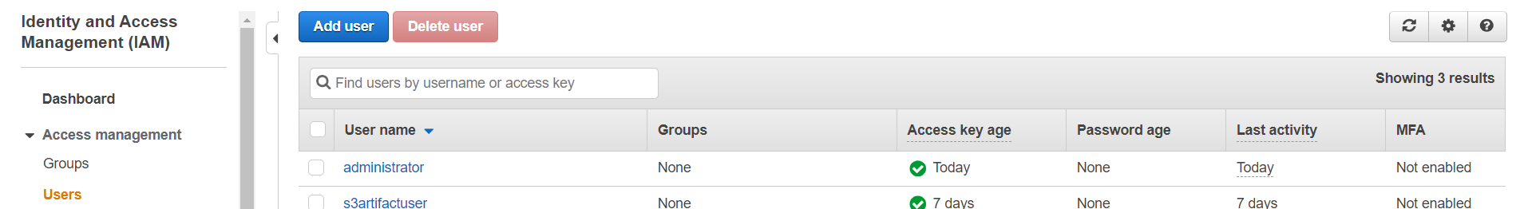

Click on Add User

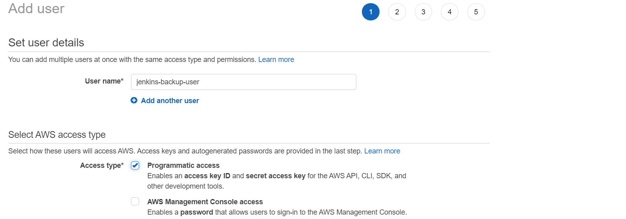

Give name for user and select programmatic access

Click on Next: Permissions

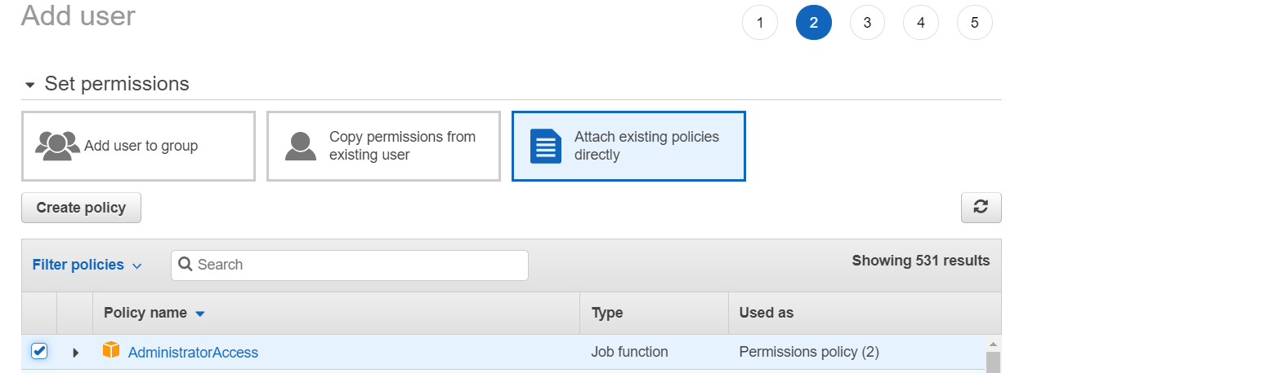

Click on Attach existing policies directly and select AdministratorAccess policy

Click on Next

Click on Create User

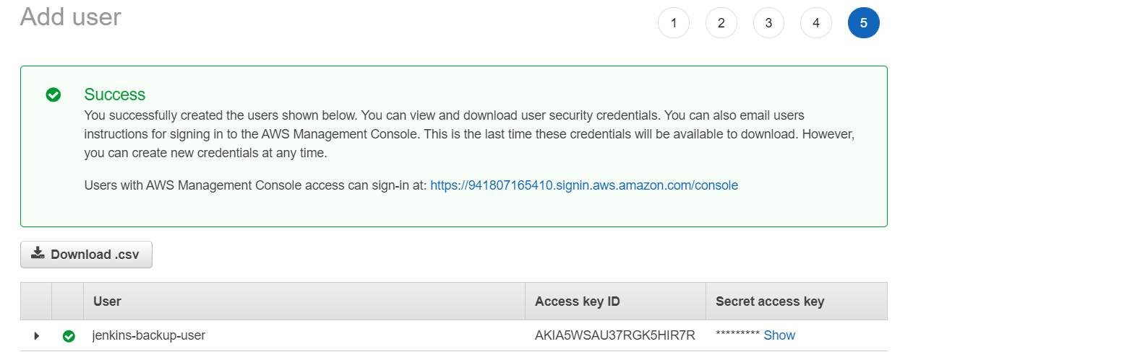

Copy Access key ID and Secret access key

Create S3 bucket to store backup data:

Goto S3 service 🡪 Create bucket

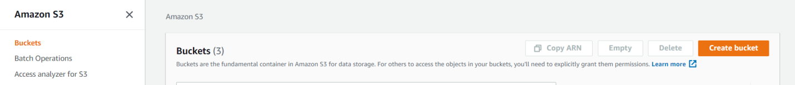

* Click on Create bucket

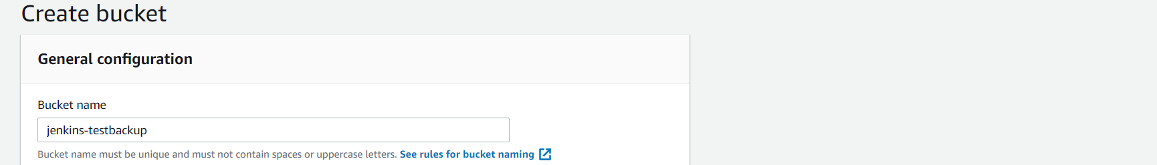

Keep Name for the bucket and Click on create bucket

Configure Access key and Secret access key as environment variables with Jenkins:

Goto Jenkins dashboard 🡪 Configure system

With in the Global properties keep Environment variables as shown below

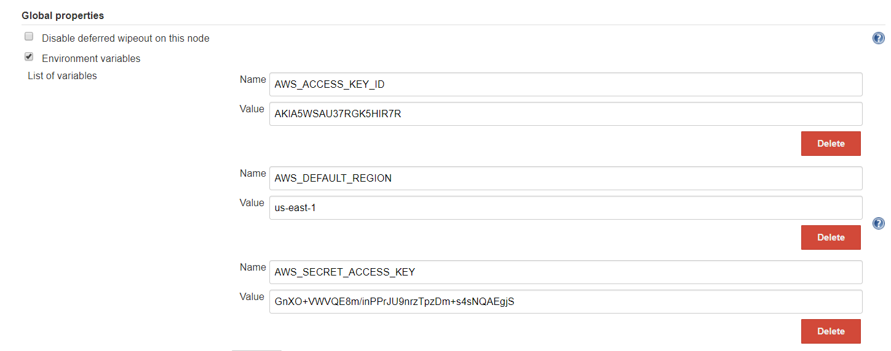

Click on Save

Create a free style job to backup Jenkins into S3 bucket:

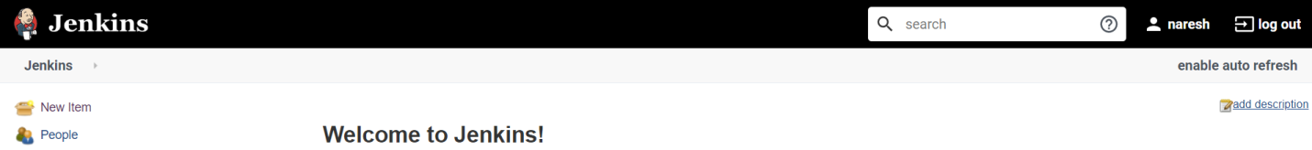

Click on New item

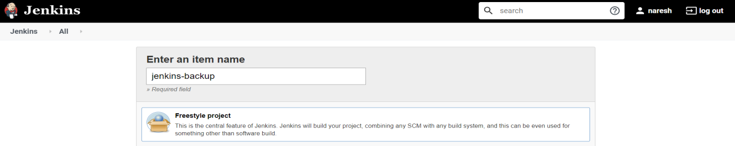

Give a name for Jenkins job and select Freestyle project

Click on OK

Goto Build Section

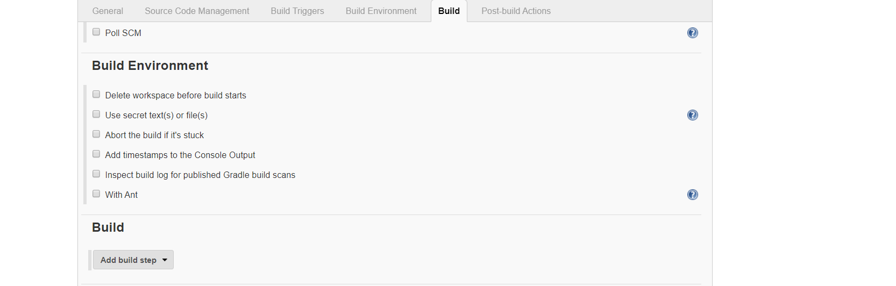

Click on Add build step

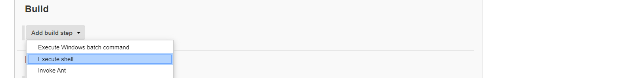

Select Execute shell

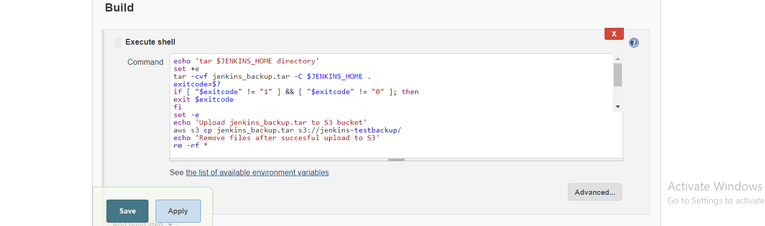

Keep data as shown in above figure

Click on save

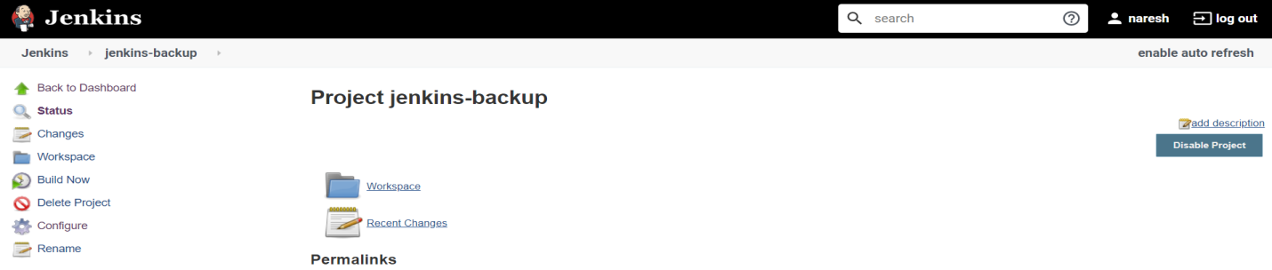

Click on Build

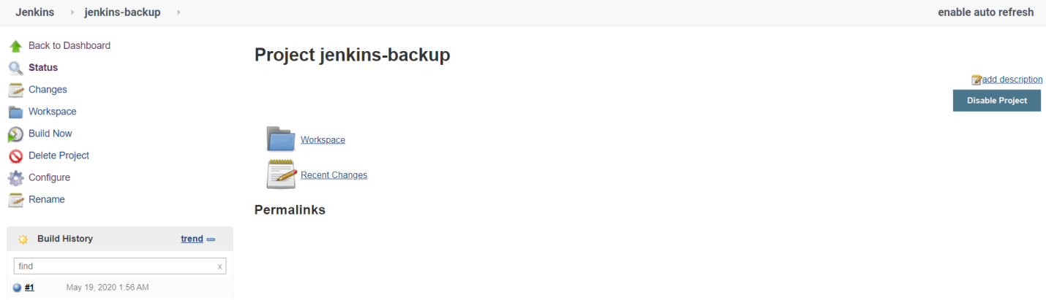

Here we can see build History shown as success

Now check S3 bucket whether the Jenkins backup file saved within our bucket on not

Goto Amazon S3 🡪 Jenkins-testbackup

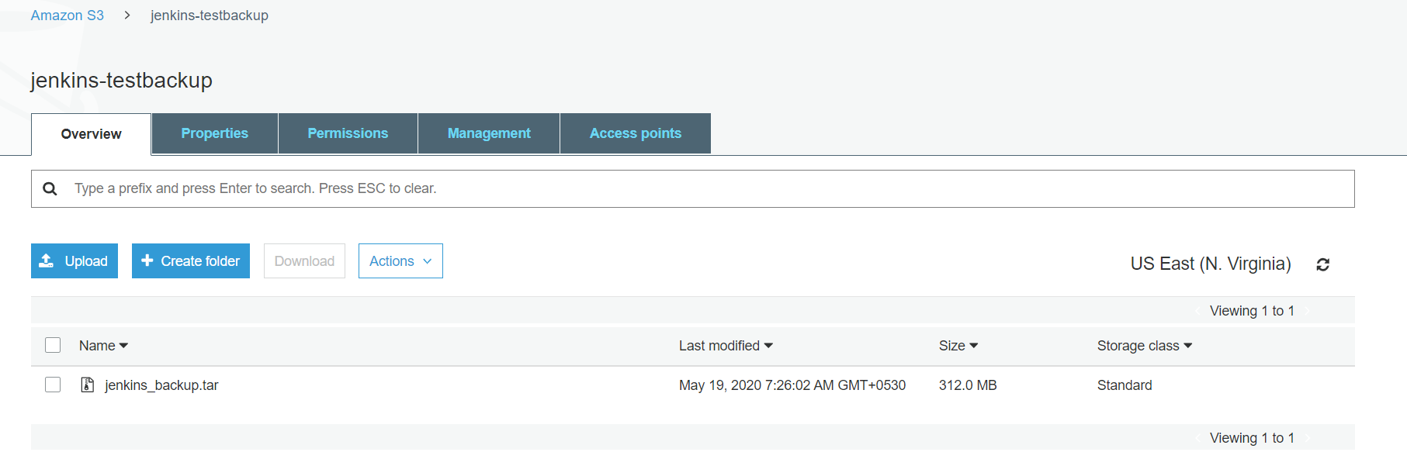

Data within the Execute shell:

echo 'tar $JENKINS_HOME directory'

set +e

tar -cvf jenkins_backup.tar -C $JENKINS_HOME .

exitcode=$?

if [ "$exitcode" != "1" ] && [ "$exitcode" != "0" ]; then

exit $exitcode

fi

set -e

echo 'Upload jenkins_backup.tar to S3 bucket'

aws s3 cp jenkins_backup.tar s3://jenkins-testbackup/

echo 'Remove files after succesful upload to S3'

rm -rf *