**Converting CSV files to Parquet files using Glue**

**Pre-requisites:**

* IAM Role
* S3 Buckets
* Glue Crawler
* Glue ETL Job

**Step:1 🡪 Creating IAM Role:**

Here we need to create Role for Glue to access Data from S3 Bucket

Goto AWS IAM Service and Click on Role



Click on **Create role**

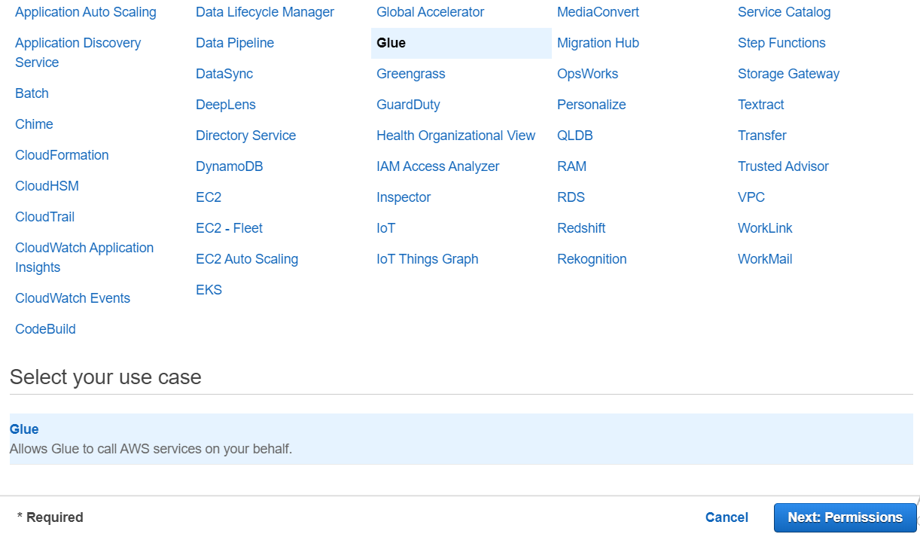

* Select **Glue** and Click on **Next**

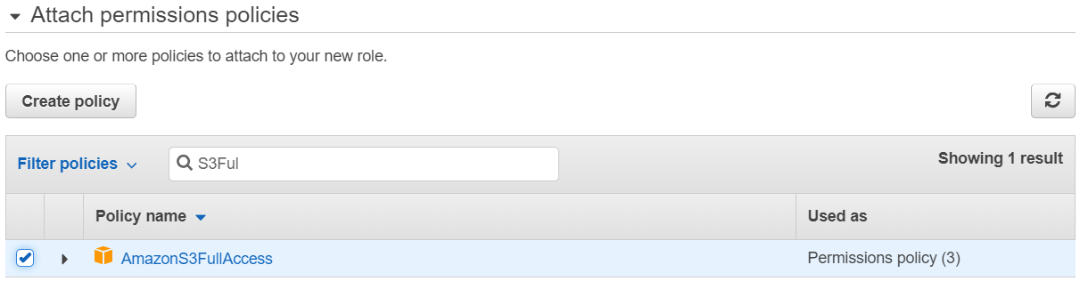

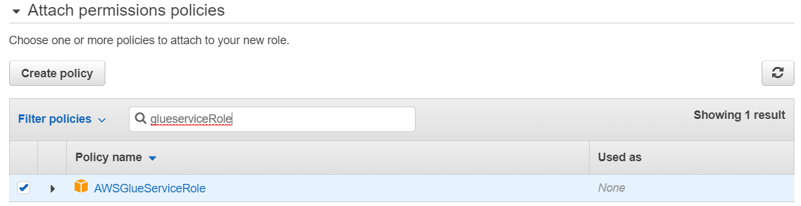

* Select **AmazonS3FullAccess** and **AWSGlueServiceRole** and Click on **Next**

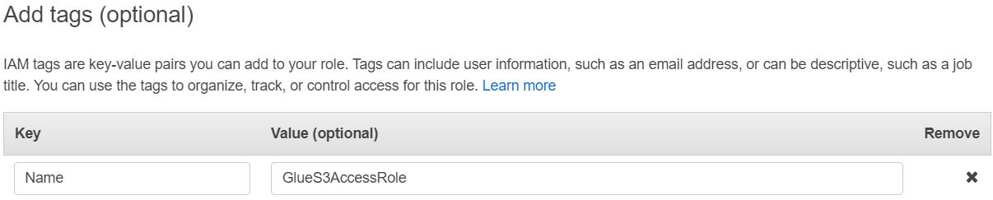

* Click on **Next**

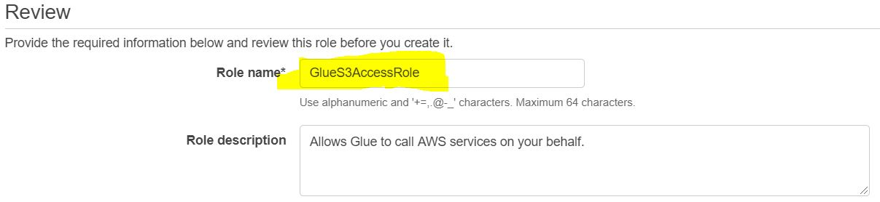

* Give a Name for Role and click on **Create Role**

**Step:2 🡪 Create S3 Buckets for storing CSV files and Storing Parquet files**

Goto AWS S3 Service:

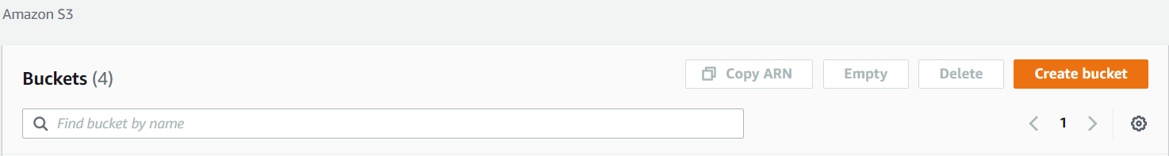

* Click on **Create bucket**

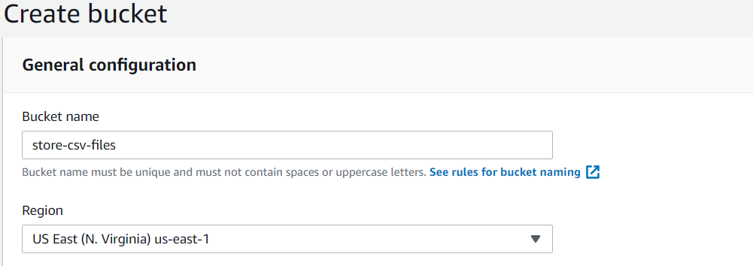

Give a name for S3 Bucket and Click on **Create bucket**

Create Another Bucket to store parquet files

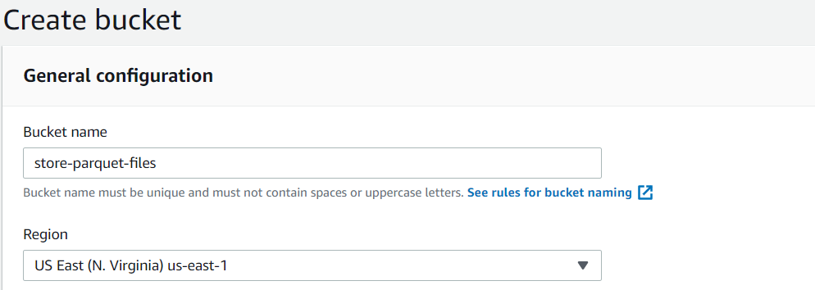

* Upload CSV file
* Click on store-csv-files bucket

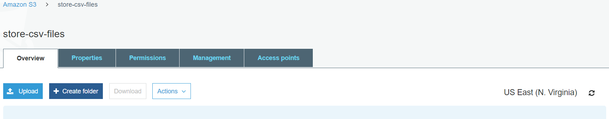

* Click on **Upload**

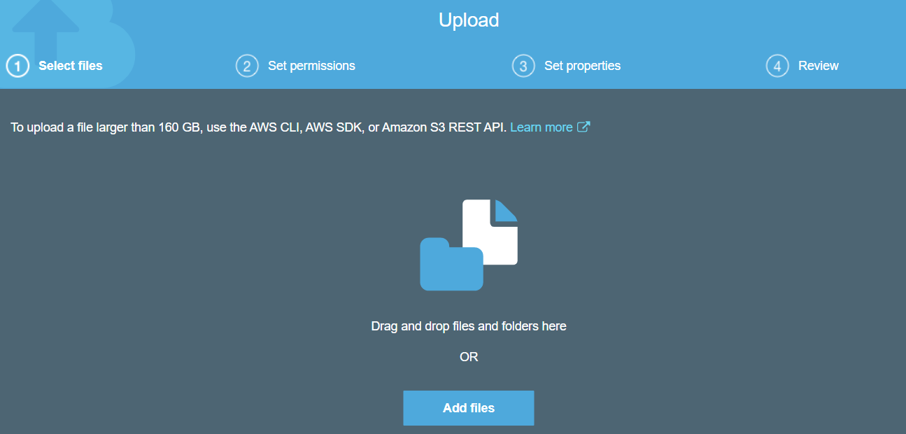

* Click on **Add files**

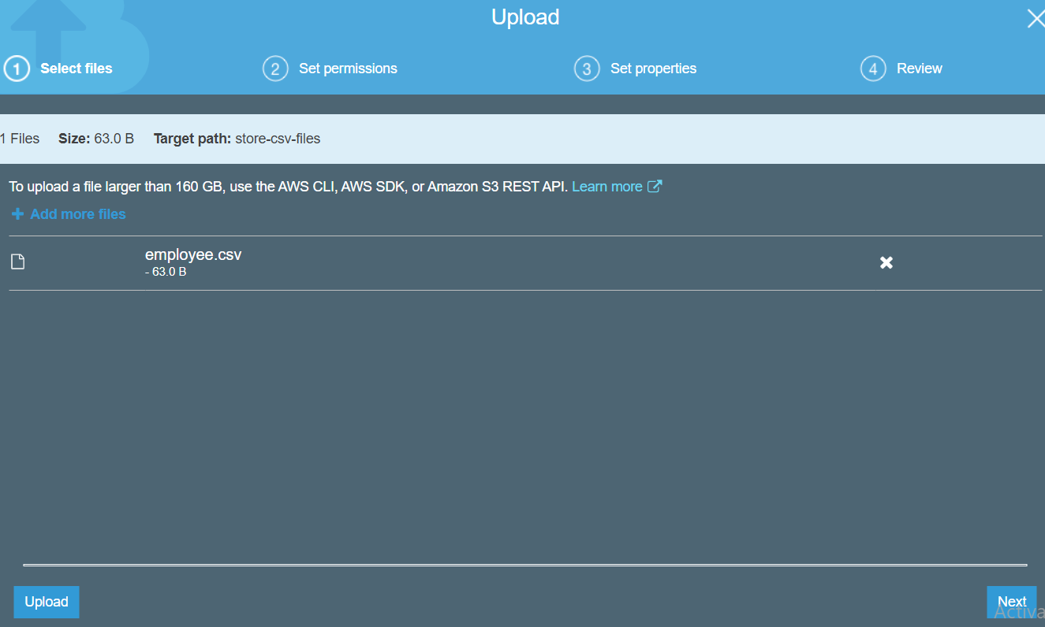

Select file and click on **Upload**

* Click on **Create bucket**

**Step:3 🡪 Create Glue Crawler**

AWS Glue Service:

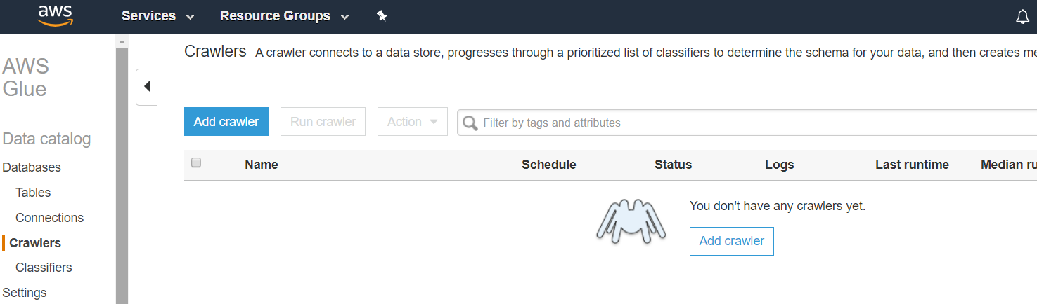

* Click on **Add crawler**

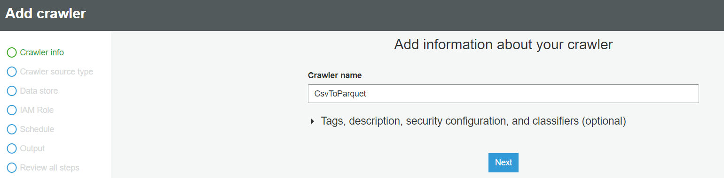

* Click on **Next**

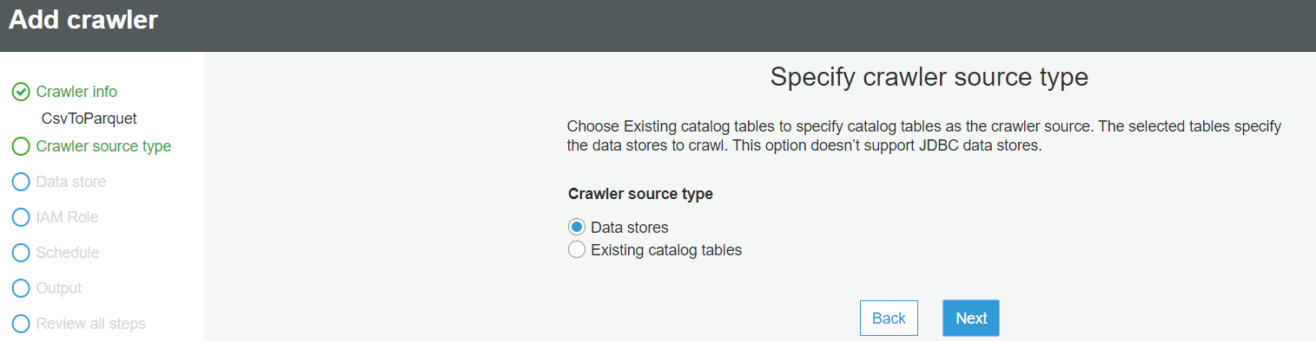

* Click on **Next**

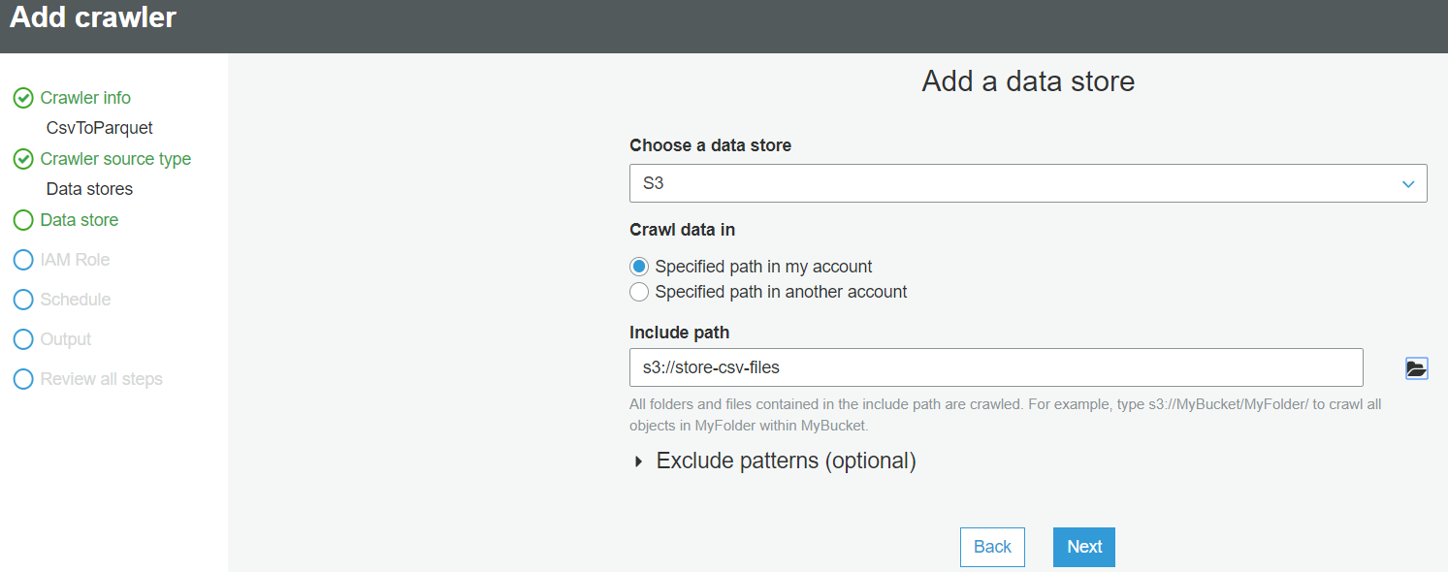

Select S3 bucket where we stored CSV files

* Click on **Next**

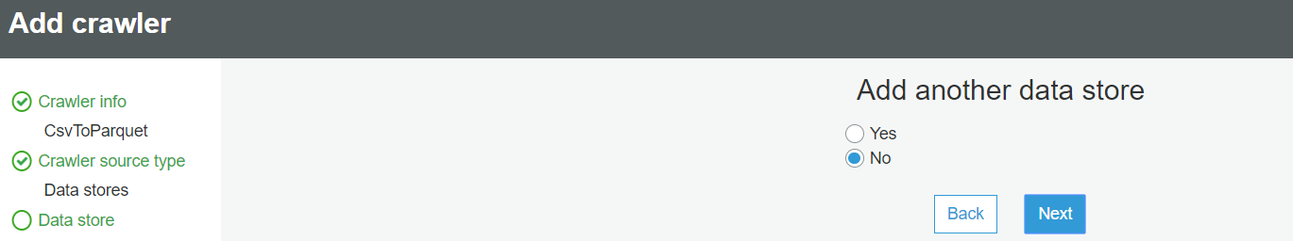

* Click on **Next**

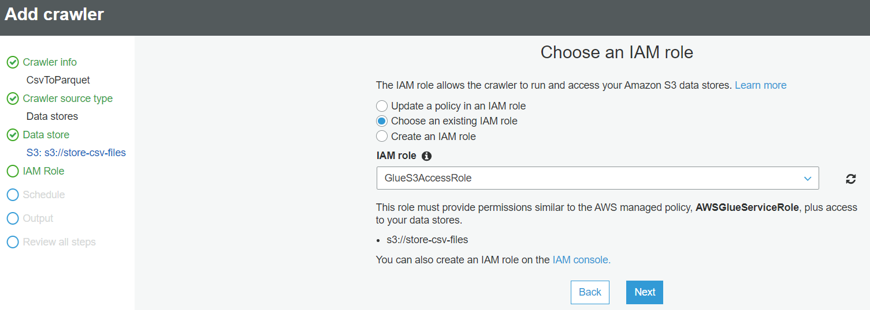

* Choose existing role which we create
* Click on **Next**

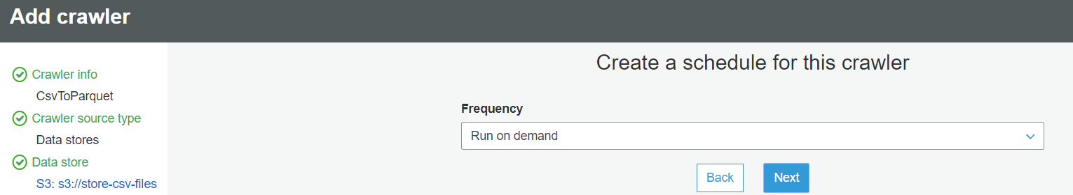

* Click on **Next**

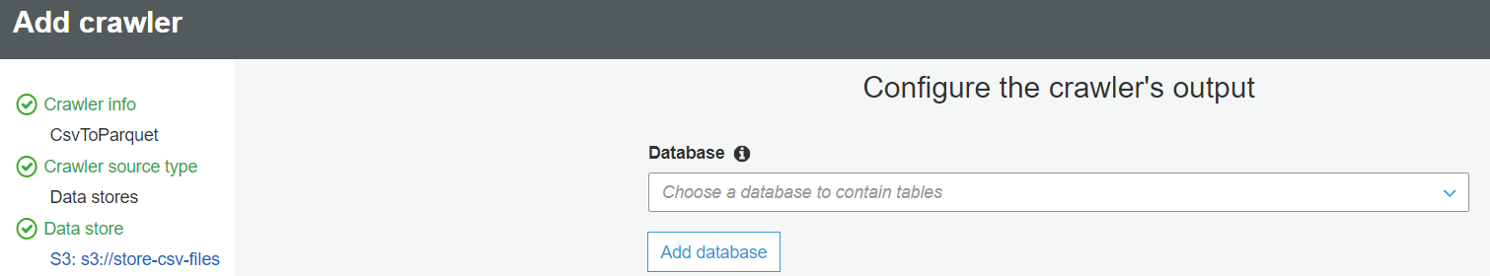

* Click on **Add database**(If not exit)

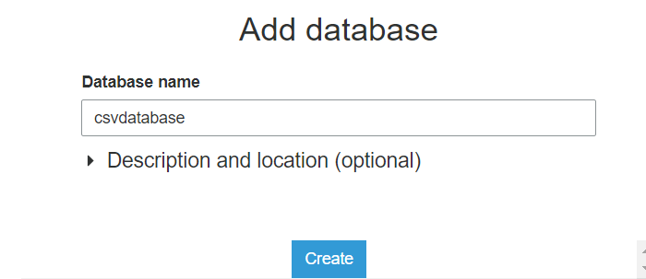

* Give some name and Click on **Create**
* Click on **Next**

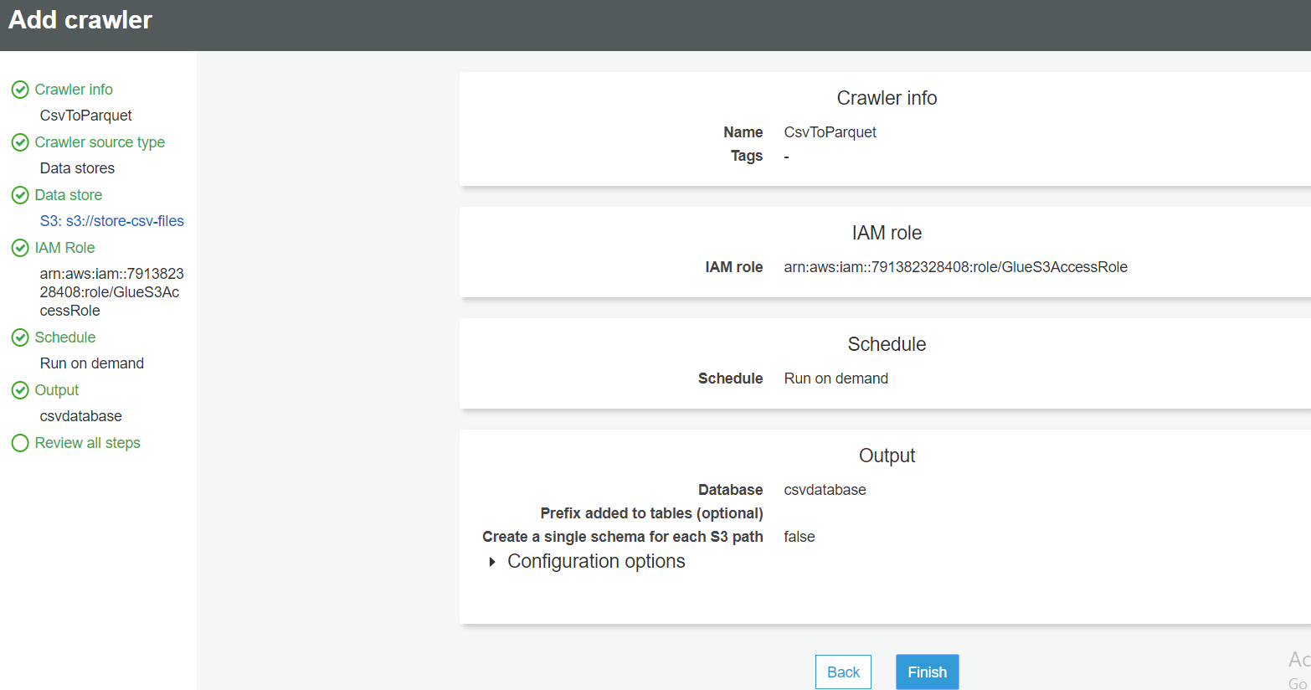

* Click on **Finish**

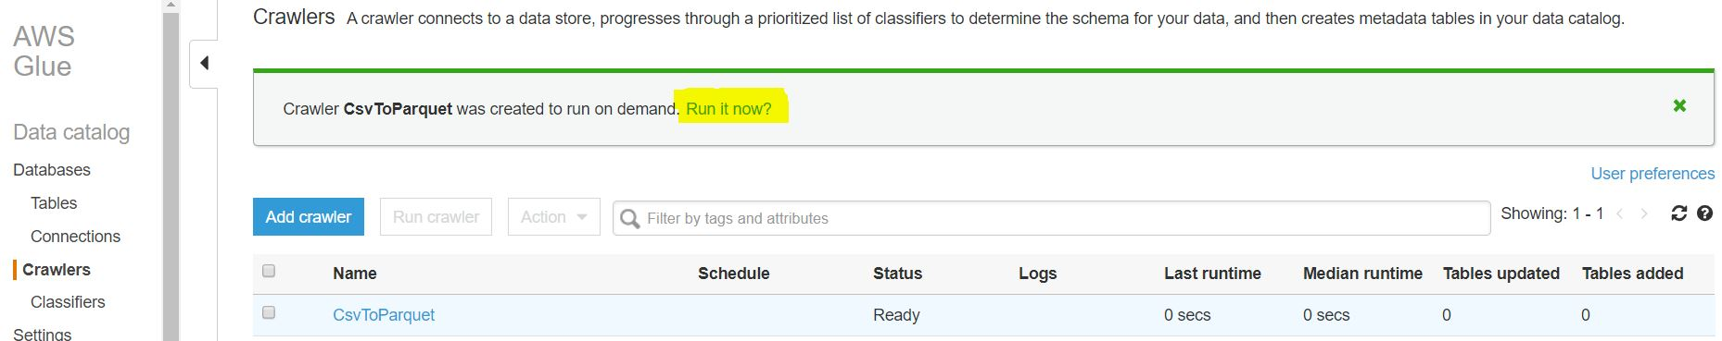

* Click on **Run it now**

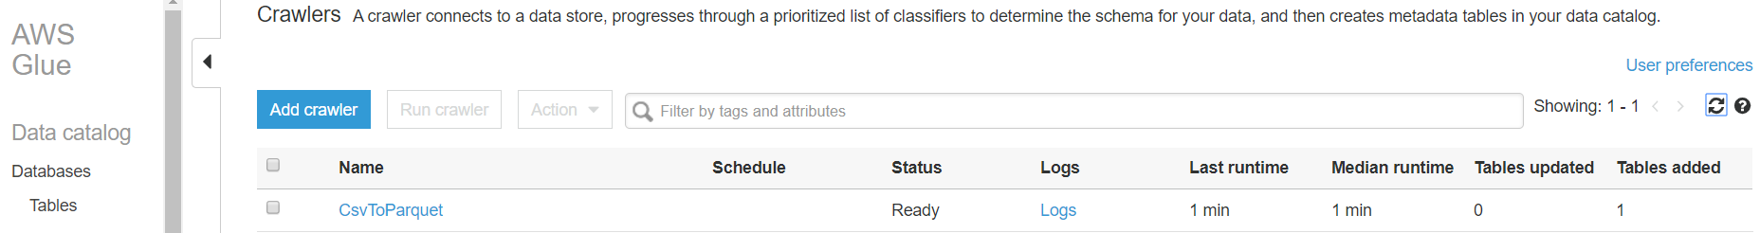

**Step:4 🡪 Create Glue ETL Job**

Goto AWS Glue Services

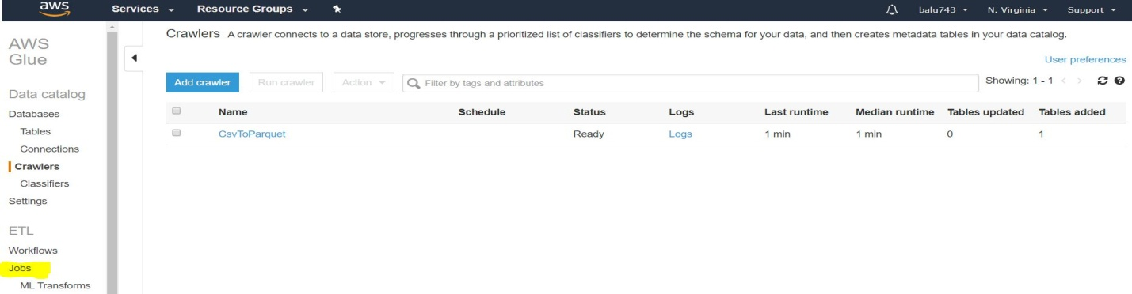

* Click on **Jobs**



* Click on **Add job**

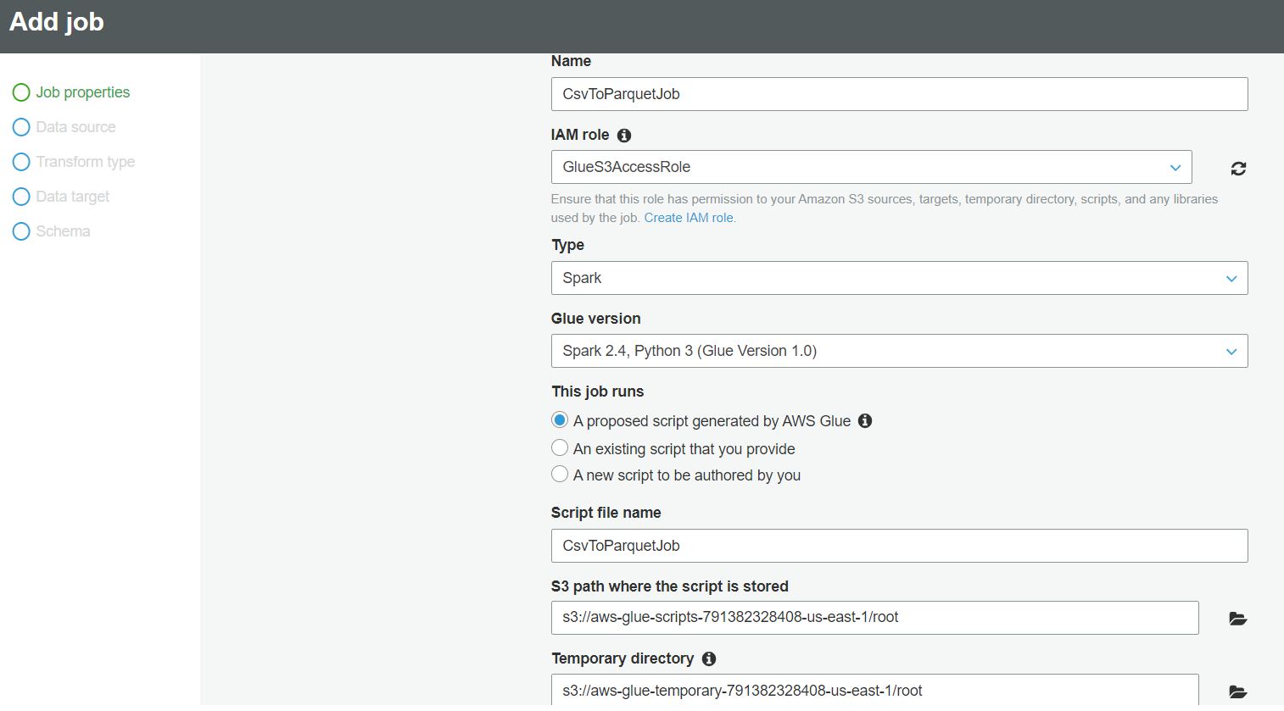

* Click on **Next**

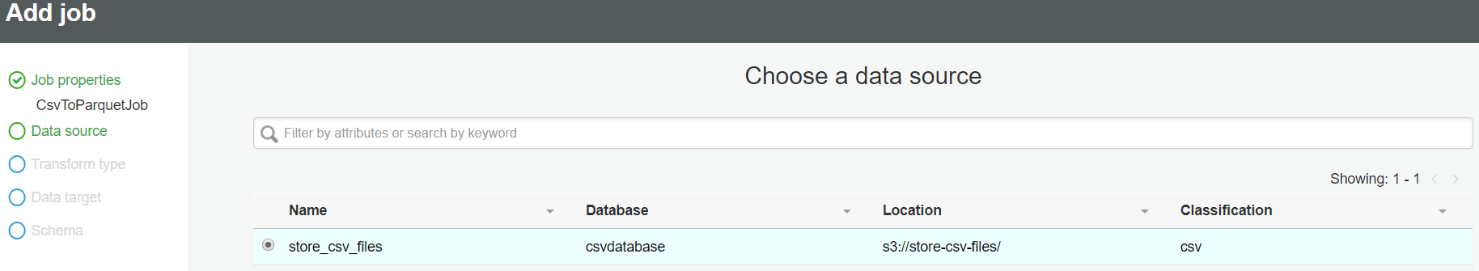

Select data source which we created database in crawlers

* Click on **Next**

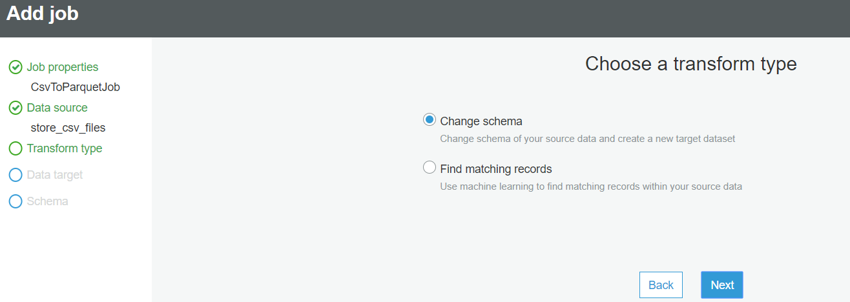

* Click on **Next**

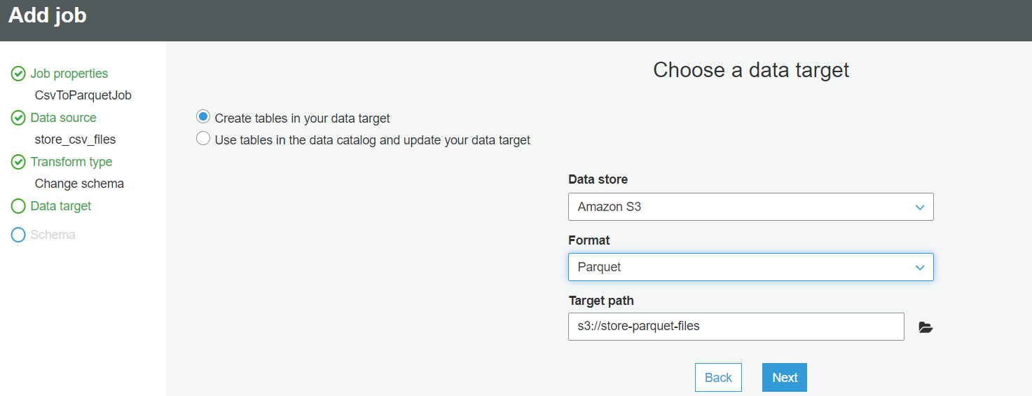

* Choose a data target as above
* Click on **Next**

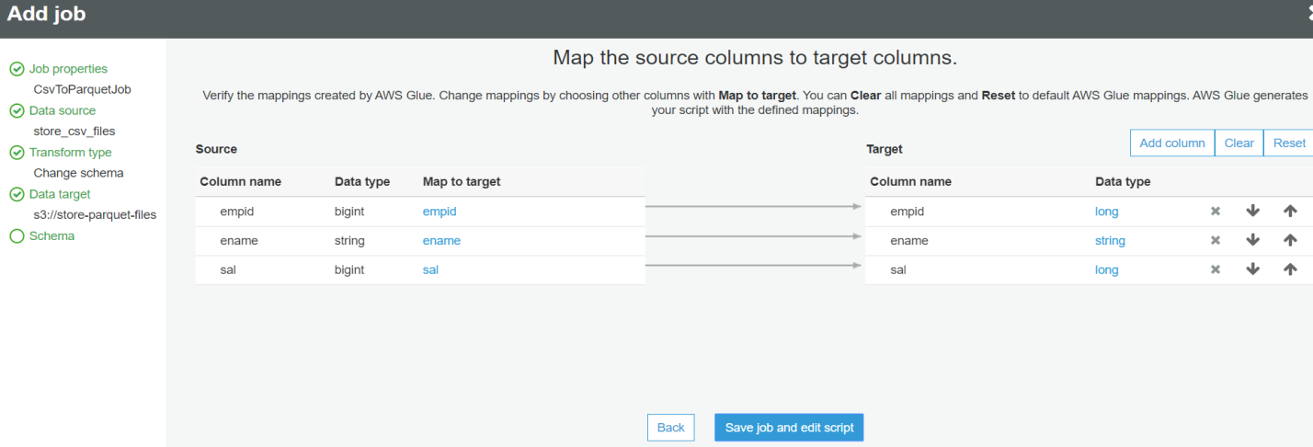

* Click on **Save job and edit script**

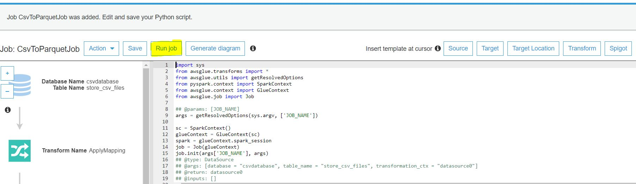

* Click on **Run Job**

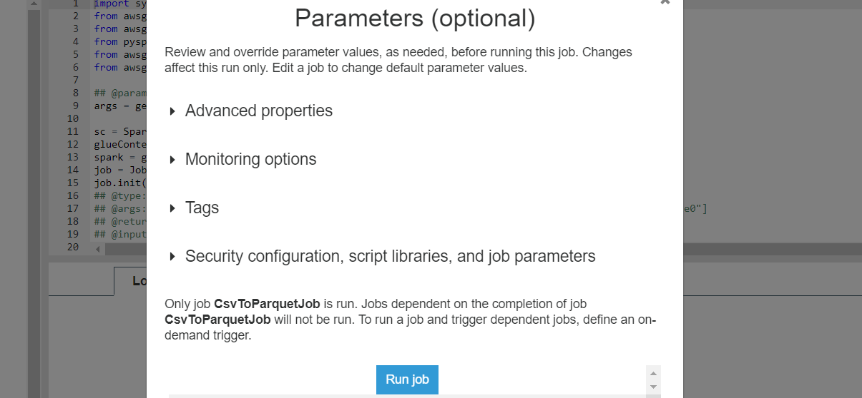

* Click on **Run job**
* Wait until we get logs

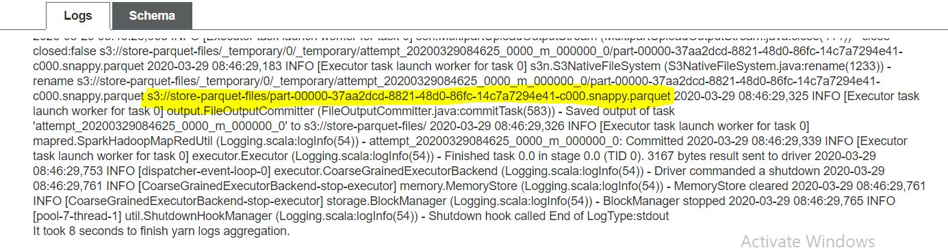

* We get logs like as above
* Goto S3 bucket and check whether parquet file saved in target folder or not

