Test Driven Development is a software development approach
where you write tests before writing the actual code.
The cycles usually follow
Red → Green → Refactor:
- Red: Write a failing test for a new functionality.
- Green: Write the minimal code to make the test pass.
- Refactor: Clean up the code while keeping the tests passing.

Benefits of TDD
- Improved Code Quality: By writing tests first, developers clarify requirements and build code that satisfies specific conditions.
- Reduced Bugs: Catch errors early in the development cycle through rigorous testing.
- Refactor with Confidence: Automated tests act as a safety net, allowing for code improvements without breaking existing functionality.
- Better Documentation: Tests serve as a form of documentation, demonstrating how the code should behave.

xUnit Example:
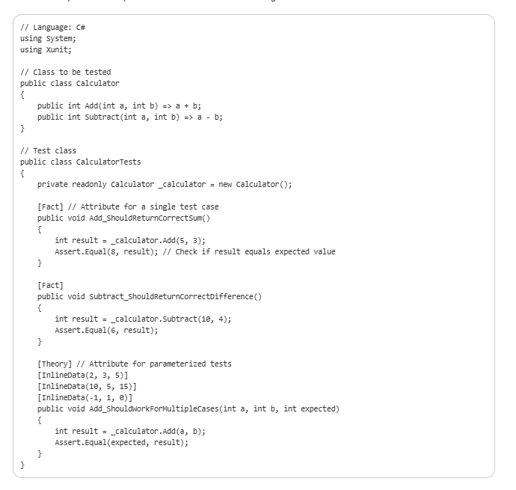

Key Points:
- [Fact]: Marks a simple, single test method.
- [Theory] and [InlineData]: Allow parameterized tests with multiple inputs.
- Assert.Equal(expected, actual): Common assertion to verify the values.
- You can also use other assertion methods like Assert.True, Assert.False, Assert.Throws, etc., for more complex logic.

NUnit Framework:

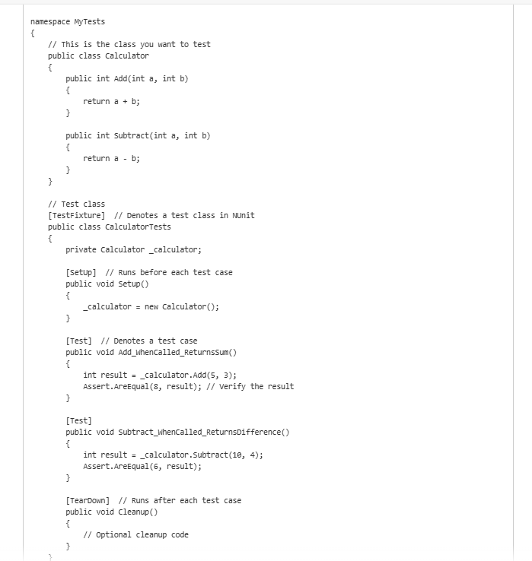

Key NUnit Features
- Attributes: TestFixture, Test, SetUp, TearDown, TestCase, Ignore, etc., allow structured testing.
- Assertions: Assert.AreEqual, Assert.IsTrue, Assert.Throws, etc., help verify expected results.
- Parameterized Tests: You can use [TestCase] for running the same test with multiple sets of data.
- Integration with CI/CD: NUnit tests can easily be run in automation pipelines using tools like Azure DevOps, Jenkins, or GitHub Actions.

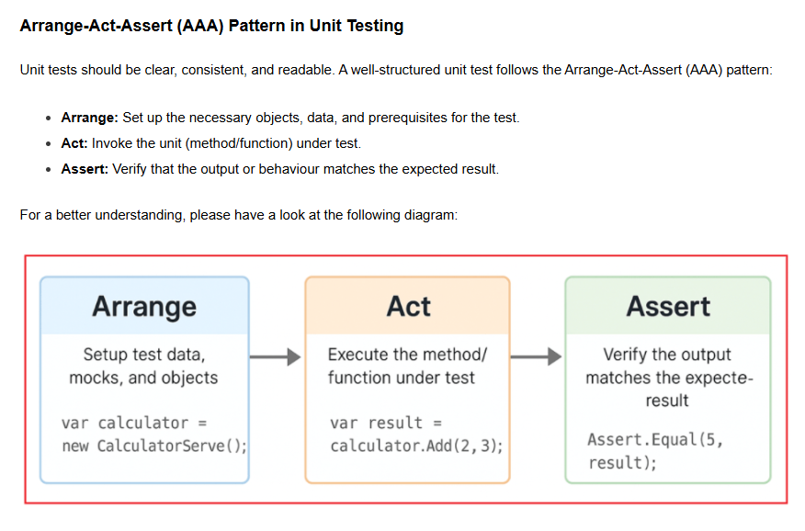

Xunit with Moq

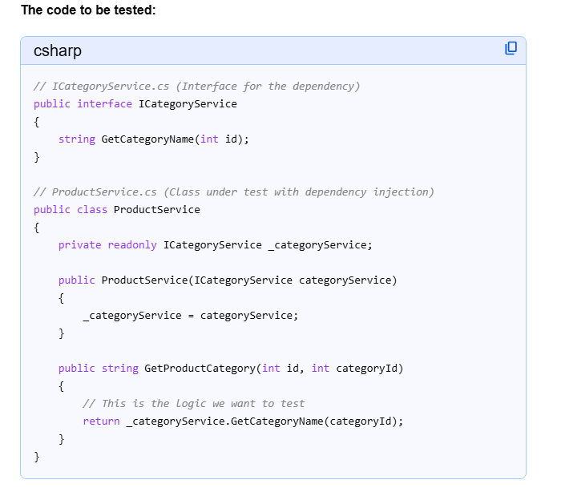

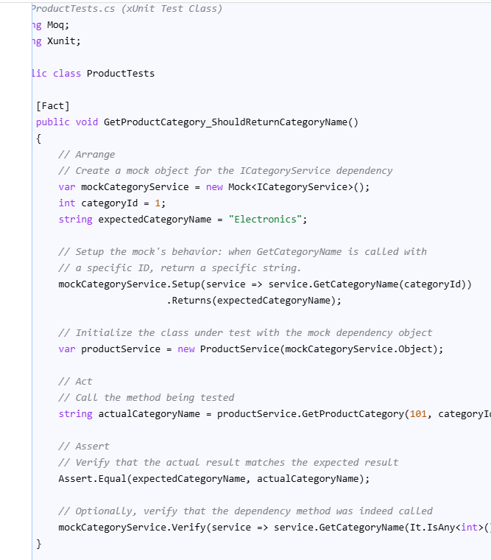

// ProductTests.cs (xUnit Test Class)
using Moq;
using Xunit;
public class ProductTests
{
[Fact]
public void GetProductCategory_ShouldReturnCategoryName()
{
// Arrange
// Create a mock object for the ICategoryService dependency
var mockCategoryService = new Mock<ICategoryService>();
int categoryId = 1;
string expectedCategoryName = "Electronics";
// Setup the mock's behavior: when GetCategoryName is called with
// a specific ID, return a specific string.
mockCategoryService.Setup(service => service.GetCategoryName(categoryId))
.Returns(expectedCategoryName);
// Initialize the class under test with the mock dependency object
var productService = new ProductService(mockCategoryService.Object);
// Act
// Call the method being tested
string actualCategoryName = productService.GetProductCategory(101, categoryId);
// Assert
// Verify that the actual result matches the expected result
Assert.Equal(expectedCategoryName, actualCategoryName);

mockCategoryService.Verify(service => service.GetCategoryName(It.IsAny<int>()), Times.Once());
}
}

