Microservices:
Monolithic architecture, where all the functionalities are targeted to build into a single project/application.
Microservices helps to separate functionalities to develop in a more modular way, and all modules work together to accomplish the specific targeted tasks.
Link:
https://dotnettutorials.net/lesson/microservices-using-asp-net-core/

Microservice Vs. Monolith Architecture
Monolithic | Microservices
Dependent & compounded project development of User Interface, Business Functional Components, and Database Logic. | Multiple Services are developed with a single  purpose each.
Single Database due to complex coupled development | Dedicated Database for each microservice  due to modularity.
Single programming Language dependency for the Backend (Business logic) | Ability to choose multiple  technologies/languages for each microservice.
The solution has to be deployed into a single Server. Physical Separation of deployment and maintenance is complex. | Each of the Microservices can be deployed  anywhere on the web with ease.
Different business functionalities, technically called modules or components, will be tightly coupled to the application itself. | Loosely Coupled Architecture because  of the modular approach.

Components of microservice architecture:
A microservices architecture typically includes several components:
- API Gateway: Serves as the single-entry point for client requests, directing them to the appropriate microservices and potentially handling tasks like authentication and logging. Ocelot is an example used in .NET Core.
- Service Registry and Discovery: Essential for dynamic communication, allowing services to find each other. A Service Registry tracks active services, and Service Discovery enables services to locate them. Examples include Consul and Eureka.
- Load Balancer: Distributes incoming traffic across service instances for improved availability and resource use. NGINX, Azure Load Balancer, and AWS Elastic Load Balancer are examples.
- Database per Service: Each microservice manages its own database, promoting data autonomy and scalability. An example provided by C# Corner is an Order Service using SQL Server and a User Service using MongoDB.
- Message Broker (Asynchronous Communication): Facilitates communication by allowing services to exchange messages via queues. RabbitMQ, Apache Kafka, and Azure Service Bus are common examples.
- Containerization and Orchestration: Microservices are often packaged in containers using tools like Docker for consistency. Kubernetes helps manage and scale these containers.
- Logging and Monitoring: Centralized solutions like ELK Stack, Prometheus, and Grafana provide insights into system health and aid troubleshooting.

A typical microservices diagram includes the following elements:
- Clients:
These are users or external systems that send requests to the application.
- API Gateway:
A single entry point that receives client requests and routes them to the appropriate microservice, handling tasks like authentication, load balancing, and request aggregation.
- Microservices:
Independent, loosely coupled services, each responsible for a specific business function (e.g., a "User Service" or "Product Service").
- Domain Databases:
Each microservice typically has its own private database, ensuring data isolation and service independence.
- Message Bus (Optional):
A communication layer for asynchronous, event-driven interactions between microservices, enabling them to react to events or communicate without direct dependencies.
- Containerization (Optional):
Technologies like Docker and Kubernetes are often used to package and deploy microservices as lightweight, isolated containers, enhancing portability and scalability.

Benefits
- Independent Scalability: Each service can be scaled up or down based on its specific demands.
- Resilience: If one service fails, it doesn't bring down the entire application.
- Modularity: The application is broken into smaller, manageable components.
- Technology Diversity: Teams can choose the best technology for each service.
- Faster Development Cycles: Independent services enable parallel development and faster deployment.

Realtime Example:
Decomposing the E-commerce application into Microservices
Instead of a single monolithic application, we can break down the E-commerce functionality into several independent microservices:
- User Service: Manages user accounts, authentication, authorization, and customer profiles.
- Product Catalog Service: Handles product information, including details, categories, pricing, and searching.
- Shopping Cart Service: Manages adding, removing, and updating items in the user's shopping cart.
- Order Service: Processes new orders, manages order statuses, and interacts with other services (like Inventory and Payment).
- Inventory Service: Tracks product stock levels and updates availability when orders are placed.
- Payment Service: Handles payment processing, including payment gateway integrations and transaction management.
- Shipping Service: Manages shipping details, tracking, and communication with shipping carriers.

1)User--> Manages User Details
2)Product CatLog-->Handle Product Information
3)Shopping cart-->Manages add remove update items in user shopping cart
4)Order --> Process new order, manages order
5)Inventory--> Track product stocks and update availability
6)Payment-->Handle payment processing
7)shipping-->Manages shipping details

Technical and operational disadvantages
- Increased complexity:
Managing a system of many independent services is more complex than a single, monolithic application.
- Operational overhead:
There are higher costs and efforts associated with deployment, monitoring, and maintenance of multiple services.
- Data management challenges:
Maintaining data consistency and integrity across different services and databases is difficult and requires sophisticated solutions.
- Testing complexity:
Performing integration testing and end-to-end testing is more challenging due to the distributed nature of the system.
- Debugging difficulties:
Pinpointing an issue can be harder as a single request might span multiple services and their logs.
- Deployment challenges:
Coordinating deployments across multiple services can be complex and requires strong automation.
- Inter-service communication:
Communication between services over a network can introduce latency and potential points of failure.
- Higher costs:
Initial development and ongoing operational costs can be higher than with a monolith.

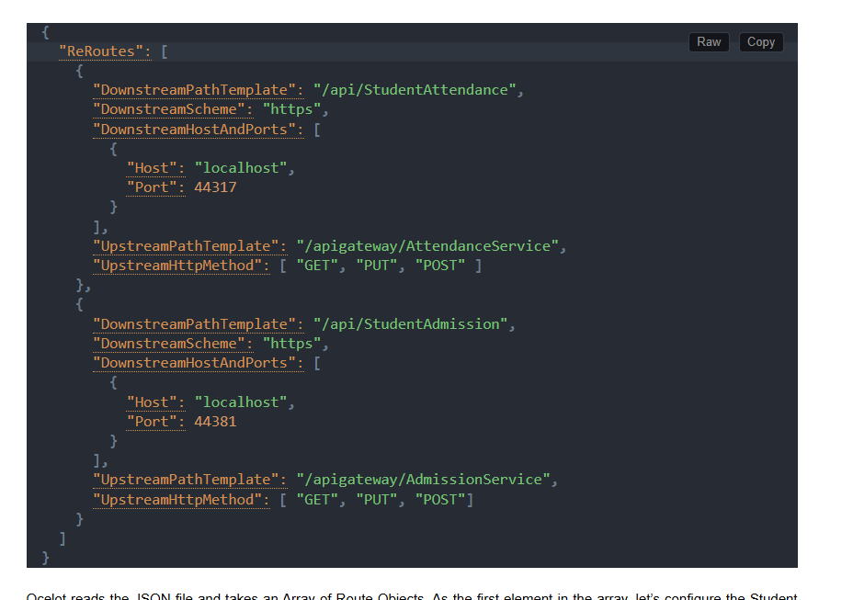

Imp Question:
How do you scale microservices independently?
Answer:
- Deploy each microservice in Docker containers.
- Use Kubernetes Horizontal Pod Autoscaler for scaling based on CPU/memory.
- Implement Health Checks in .NET Core using Microsoft.Extensions.Diagnostics.HealthChecks.
Imp Question:
You have multiple microservices (OrderService, PaymentService, InventoryService) in a .NET Core application. The OrderService needs to call PaymentService and InventoryService to complete an order. How would you implement communication between these services?
Answer:
- Use HTTP-based communication via HttpClient or gRPC for synchronous calls.
- For resilience:
  - Implement Polly for retries, circuit breakers, and fallback.
  - Use API Gateway (e.g., Ocelot) to route requests.
- For asynchronous communication:
- Use message brokers like RabbitMQ, Azure Service Bus, or Kafka.
- Implement event-driven architecture using Domain and Integration Events.

Microservice Failure solutions:
When a service fails in a microservice architecture built with .NET Core, implementing resilient strategies is key to maintaining system stability and availability [2]. Key patterns and practices include:
1. Resilience Patterns
Implementing these patterns helps prevent single service failures from causing a cascade effect across the entire system:
- Circuit Breaker: The circuit breaker pattern prevents an application from repeatedly trying to invoke a failing service [2]. When a service fails consistently, the circuit "opens," and subsequent calls fail fast without waiting for a timeout. A popular library for this in .NET is Polly, which can be integrated with HttpClientFactory [2].
- Retry and Timeout: Configure your services to automatically retry failed operations for a specific number of times or with an exponential backoff strategy [2]. Set strict timeouts for service requests to ensure that failing services do not tie up resources indefinitely.
- Bulkhead: This pattern isolates groups of calls to a backend service into their own resource pools (e.g., specific HttpClient instances or thread pools) [2]. This prevents a failure or performance issue in one service from exhausting the resources needed by others.
- Fallback: When a service call fails (perhaps the circuit breaker is open), the application can execute a fallback logic, such as returning cached data, default values, or a user-friendly error message, to provide a graceful degradation of service [2].

2. Communication and Orchestration
How services communicate plays a crucial role in failure handling:
- Asynchronous Communication: Use message queues (like RabbitMQ, Azure Service Bus, or Kafka) for communication between services whenever possible [2]. If a consumer service is down, the message remains in the queue until it can be processed, ensuring no data loss.
- API Gateways: An API Gateway (like Ocelot in .NET Core) acts as a single-entry point for clients and can implement policies such as rate limiting, authentication, and service discovery [2]. It can also use the circuit breaker pattern to prevent requests from reaching unhealthy services.
- Health Checks: Implement regular health checks (/health endpoints) for your services [2]. Tools like AspNetCore.HealthChecks can be used to monitor the status of dependencies like databases, queues, and other services.

3. Monitoring and Observability
Quickly detecting and diagnosing failures is essential:
- Centralized Logging: Use a centralized logging solution (e.g., Elasticsearch, Splunk, Application Insights) to aggregate logs from all services [2]. This helps trace requests and identify the source of errors.
- Distributed Tracing: Tools like OpenTelemetry with Jaeger or Zipkin help visualize the flow of a request across multiple services, making it easier to pinpoint which service failed and why [2].
- Alerting and Monitoring: Set up monitoring and alerting (e.g., Prometheus and Grafana) to notify development teams immediately when service health degrades or errors occur [2].

Takeaway Points:
1)Implement Circuit breaker pattern to avoid cascading failures
Using Poly.net library
2)Implement retry and timeouts operations
3)Implement Fall-back -means returning cached data or default value
4)Implement Asynchronous communication using service bus
message remains in queue until it can be processed
5)Use API Gateway can implement policies rate limiting, authentication
and uses circuit breaker pattern.
6)Implement Health Check to monitor status of database. Queues and other services

Micro front-end refers to a design pattern in software architecture where the user interface (UI) of a web application is broken down into smaller parts for more manageable parts known as micro front-ends. Each micro frontend is a self-contained module and is responsible for rendering a specific section of the overall user interface.

1)Micro Frond End is Modular architecture where frontend components are independently developed, deployed, and maintained.

2)Allows the use of different technology stacks for different frontend components.

3) Fast development cycle, team can work independently

