Introduction
Rate limiting is essential for managing traffic to your APIs, protecting against misuse, and ensuring system stability.

Overview of Rate Limiting in ASP.NET Core 8
With ASP.NET Core 8, Microsoft introduced native support for rate limiting through the Microsoft.AspNetCore.RateLimiting middleware. This middleware simplifies rate limiting by allowing you to set limits on how many requests a client can make within a given period.

Step 1: Install the Rate Limiting Package:
Make sure you have the Microsoft.AspNetCore.RateLimiting package. This is included in .NET 8 by default, so no additional installation is needed if you’re using .NET 8.

Step 2: Configure Rate Limiting in Program.cs
Now that we have our project, we’ll configure rate limiting by setting a global rate limit on incoming requests. The FixedWindowRateLimiter is a common choice for setting limits on a specific period.

- Add Rate Limiting Middleware to Program.cs:
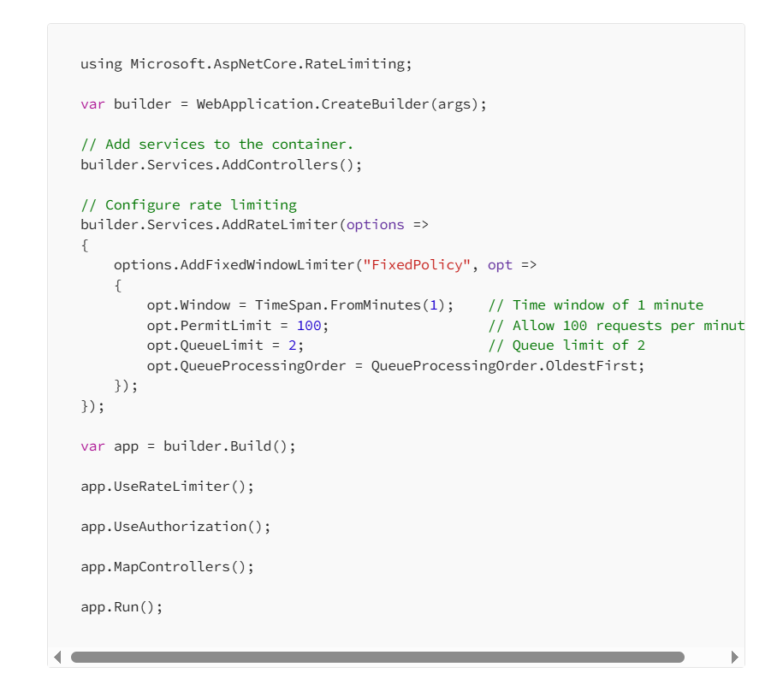

2. Explanation:
- Window: Sets the time window for rate limiting (1 minute in this example).
- PermitLimit: Allows 100 requests per minute.
- QueueLimit: Queues 2 additional requests if the limit is reached.
- QueueProcessingOrder: Processes queued requests in the order they arrived.

Step 3: Apply the Rate Limiting Policy to Specific Endpoints
You can apply this rate-limiting policy globally or to specific controllers/endpoints.



