Factory Design Pattern:
a factory is a class with a method. That method creates and returns different objects based on the received input parameter.

In the Factory Design pattern, we create an object without exposing the Object Creation and Initialization logic to the client, and the client will refer to the newly created object using a common interface.

This pattern focuses on creating a single type of object. It defines an interface or abstract class for creating an object, but allows subclasses to decide which concrete class to instantiate. The responsibility of object creation is delegated to a factory method within a class.
Abstract Factory Pattern:
This pattern provides an interface for creating families of related or dependent objects without specifying their concrete classes. It acts as a "factory of factories," where each concrete factory in the family is responsible for creating a set of related products.

Example:
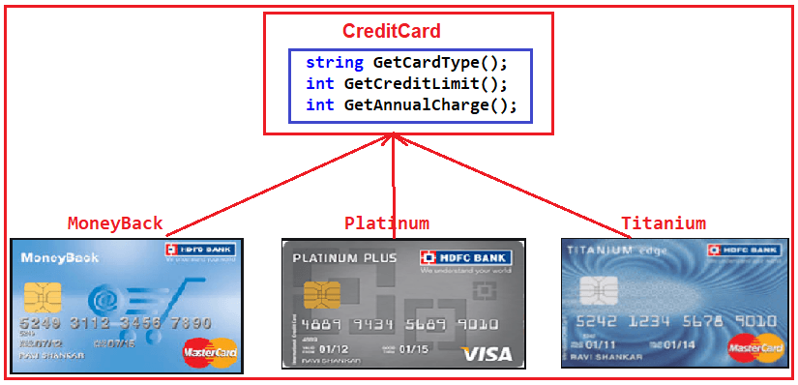

https://dotnettutorials.net/lesson/factory-design-pattern-csharp/
https://engx.space/global/en/blog/advanced-asp-net-core-interview-questions-answers
https://www.scholarhat.com/tutorial/aspnet/asp-net-core-interview-questions
https://dikmenonur.medium.com/microservice-architecture-with-corq-and-mediatr-patterns-cf9bc837becb
https://www.milanjovanovic.tech/blog/3-ways-to-create-middleware-in-asp-net-core

Advantages:
- Simplifies Object Creation: Centralizes the creation logic.
- Promotes Loose Coupling: The client code depends on abstractions, not concrete implementations.
- Scalability: Adding new types of objects is easier without modifying existing code.

Disadvantages:
- Complexity: Adds an extra layer of abstraction.
- Overhead: May not be necessary for simple applications.
Factory Pattern vs Abstract Factory Pattern:
1. Intent
Factory Pattern: Creates a single type of object.
Abstract Factory Pattern: Creates families of related or dependent objects.
2. Complexity
Factory Pattern: Simpler, deals with the creation of one type of object.
Abstract Factory Pattern: More complex, deals with multiple related objects.
3. Number of Classes
Factory Pattern: Involves fewer classes.
Abstract Factory Pattern: Involves more classes, especially when dealing with families of objects.
4. Real-World Analogy
Factory Pattern: A bakery producing different types of cakes.
Abstract Factory Pattern: A bakery producing cakes, cookies, and pastries – a family of related bakery products.
Singleton Design Pattern:
The purpose of the singleton design pattern is to ensure that a class only has one instance and provide a global point of access to it throughout the life of an application. Access of one instance is preferred to avoid unexpected results.
A class should have the following structure for singleton pattern:
- Class should be sealed.
- Should have a private or protected constructor. No public and parameterized constructors.
- Should have a static property (with a private backing field) to return an instance of a class. A static method can also be used to return an instance.
- At least have one non-static public method for a singleton operation.
- Configuration Management: A single instance to manage configuration settings across an application.
- Logging: A single logging instance to log messages from different parts of an application.
- Caching: A single cache instance to store and retrieve data efficiently.
- Database Connections: A single instance to manage database connections.

Advantage:
- Reduced memory usage
- Improve Performance
- Simplified Access and Control
Disadvantage:
1)Tight Coupling
2)Testing Challenges
3)Violation SRP and reduced Flexibility and scalability
Link: Singleton Pattern in C# with Example - Dot Net Tutorials
https://www.youtube.com/watch?v=s6cfVpbJkOA

CQRS (Command Query Responsibility Segregation) design pattern:
The CQRS (Command Query Responsibility Segregation) design pattern separates the read and write operations of a data store into two distinct models: commands for write operations (creating, updating, deleting data) and queries for read operations (retrieving data).
Using a Mediator Pattern:
Libraries like MediatR are commonly used to facilitate the dispatching of commands and queries to their respective handlers, decoupling the sender from the receiver.

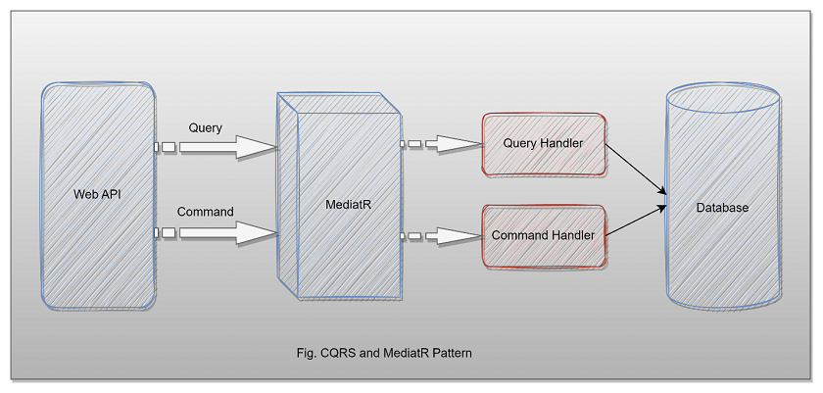

The main advantages of doing this include:
- Separate teams can work on these operations
- Each can be made to scale according to their own needs. Write operations are mostly used much less than read operations
- Each can have their own security as per requirements
- Read operations can have a different architecture to support caching, conversions to data transformation objects as required by clients
- Write operations can include data validation. lookups etc.

CQRS Pattern:
The Command and Query Responsibility Segregation (CQRS) pattern states that we must separate the operations for reading the data from the operations for writing or updating the data. This means that functions for reading and writing data are not kept in the same interface or class. The main advantages of doing this include:
Key Benefits
- Independent Scaling: Read and write workloads often have different usage patterns (e.g., an application might be read-heavy). CQRS allows the read and write models (and their associated data stores) to be scaled independently based on their specific demands, which is not possible in traditional CRUD architectures.
- Performance Optimization: Each side can be optimized for its specific function. The query side can use a denormalized schema or specialized databases (like NoSQL or an in-memory cache) to serve queries efficiently without complex joins. The command side can be optimized for transactional integrity and complex business logic.
- Flexibility and Maintainability: The clear separation of concerns makes the codebase more organized and easier to understand. Changes or new features can be introduced to one model without significantly impacting the other, improving developer productivity and allowing systems to evolve more easily.
- Specialized Data Storage: CQRS allows the use of different database technologies for the read and write models (e.g., a relational database for the write model and a document database for the read model), choosing the best tool for each specific task.
- Improved Security: By separating the models, stricter security controls and validation logic can be applied to the command side, ensuring that only authorized entities can make changes to the system's state.
- Integration with Event Sourcing: CQRS pairs well with the Event Sourcing pattern, which stores all state changes as a sequence of events. This provides a reliable audit trail, facilitates the reconstruction of the system's state at any point in time, and enables robust event-driven architectures.
- Parallel Development: In larger teams, developers can work on the command (write) and query (read) sides of the system independently, using different technologies and deployment schedules, which can speed up development time

Repository Pattern:
The Repository Design Pattern is a structural pattern that mediates data access by providing an abstraction over the data layer.
It allows you to decouple the data access logic and business logic by encapsulating the data access logic in a separate repository class. This pattern provides a collection-like interface for accessing domain objects.

Benefits:
1)Decoupling: Separates the data access logic from business logic, promoting cleaner code organization and separation of concerns.
2)Testability: Makes the application easier to unit test by allowing mocking of the repository.
3)Consistency: Centralizes data access logic, ensuring consistency across different parts of the application.
4)Flexibility: Makes it easier to switch out data access technology (e.g., from Entity Framework to another ORM) without changing the business logic.

How to secure wb api:
1. Authentication and Authorization
Authentication is the process of verifying the identity of a user or system, while authorization defines what actions a user or system is allowed to perform.
    - JWT Bearer Tokens: A widely used standard for securely transmitting information between parties as a JSON object.
    - OAuth 2.0/OpenID Connect: Protocols for delegated authorization and authentication, often used with external identity providers like Azure AD or IdentityServer.
    - API Keys: Simpler for application-to-application scenarios where user identity is not required.
  - Authorization: Control access to specific resources or actions based on the authenticated user's roles or claims. Use the [Authorize] attribute on controllers or actions.

2.HTTPS Redirection:
  - Enforce the use of HTTPS to encrypt data in transit, protecting against eavesdropping and man-in-the-middle attacks. Configure HTTPS redirection in Program.cs.

3.Input Validation:
  - Validate all incoming data to prevent injection attacks (SQL injection, XSS) and ensure data conforms to expected formats and constraints. Use data annotations and custom validation logic.

4.CORS (Cross-Origin Resource Sharing) Configuration:
  - Configure CORS policies to explicitly define which origins are allowed to access your API, preventing unauthorized cross-origin requests.

5.Rate Limiting:
  - Implement rate limiting to prevent abuse and denial-of-service attacks by restricting the number of requests a client can make within a specific timeframe. Libraries like AspNetCoreRateLimit can assist.

6.Security Headers:
  - Add relevant security headers (e.g., Content Security Policy, X-Content-Type-Options) to enhance browser-side security.

