FREQUENTLY ASKED QUESTIONS-IMM

Contents
1. Summary 2
2. How to connect an OPC UA client to the Wittmann 4.0 router via IMM B8 using port 14970? 2

Summary
This document summarizes frequently asked questions regarding the connection setup, configuration, and data interface for connecting an OPC UA client to the Wittmann 4.0 router via IMM B8.

How to connect an OPC UA client to the Wittmann 4.0 router via IMM B8 using port 14970?
- Ensure that the OPC UA client is connected to the Wittmann 4.0 Router before initiating the connection to the IMM B8
- Navigate to UaExpert.
- On the main screen, click the plus button highlighted in the image below to open the Add Server window.
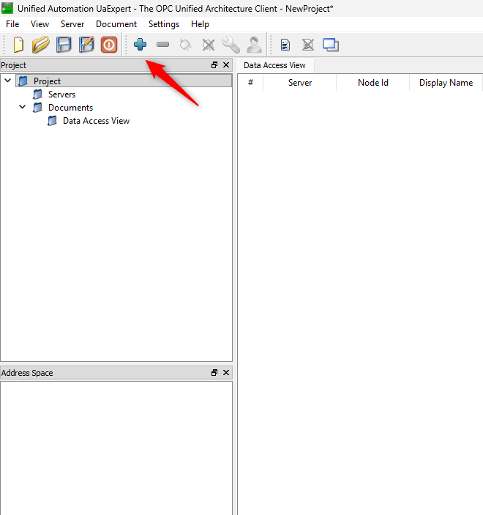
- Double-click the entry under Custom Discovery highlighted below
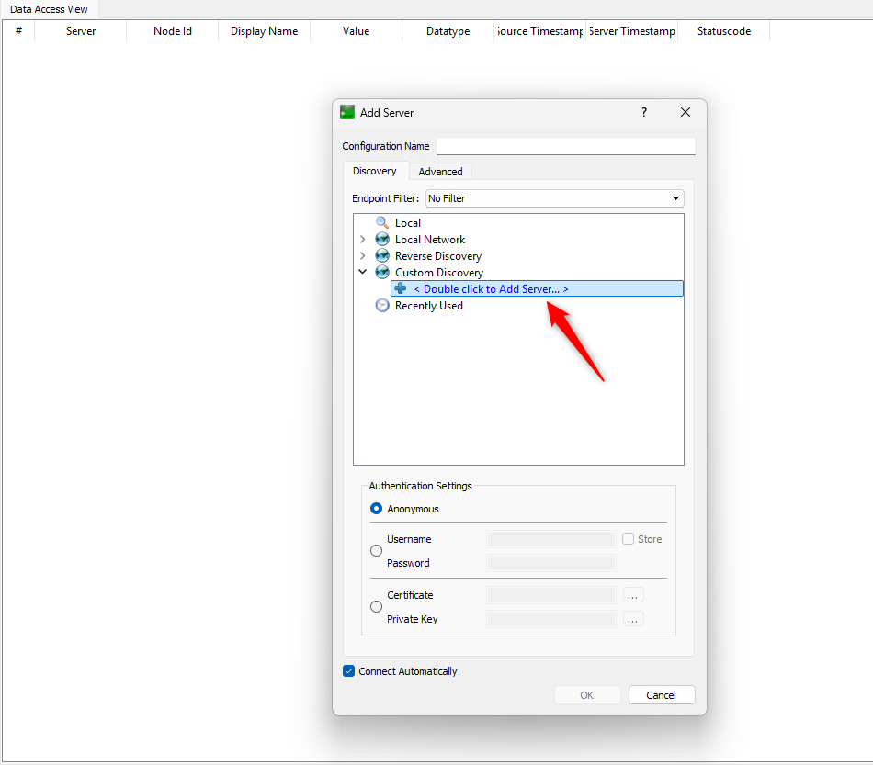

Note: Use port 14970 in Euromap 77 OPC UA to connect to the IMM.
Click OK to connect.

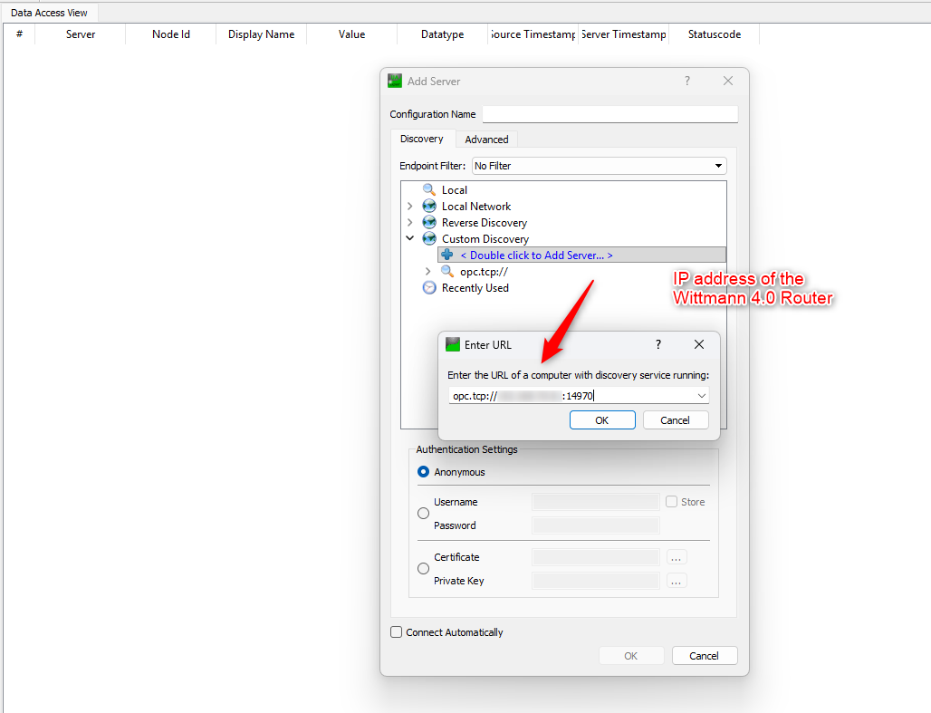

- Click Yes on the following message box

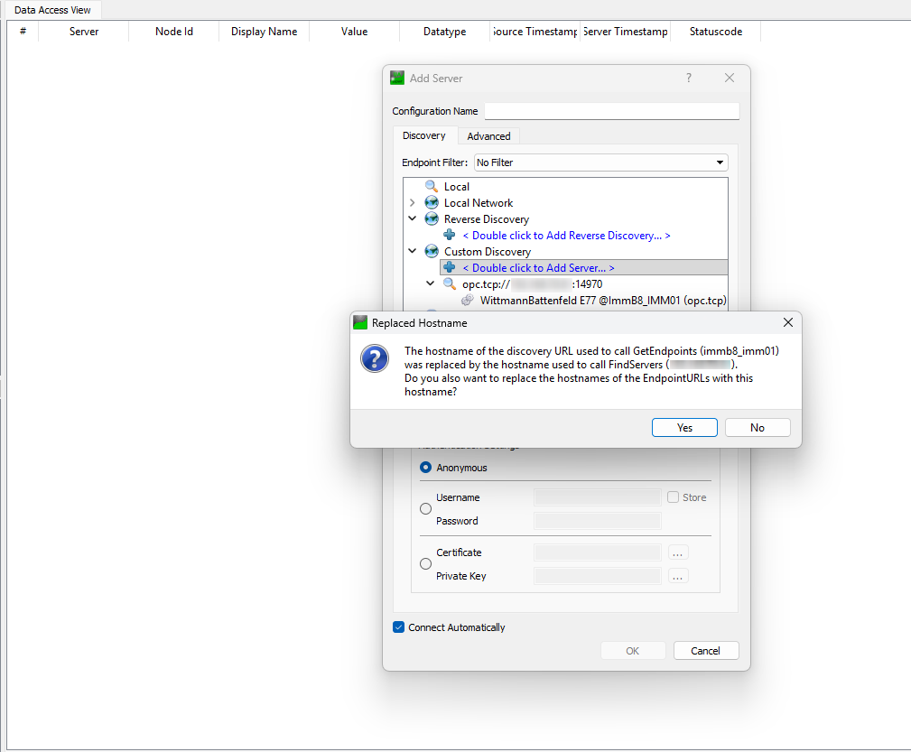

- Double-click on None - None (uatcp-uasc-uabinary), then click OK to connect.

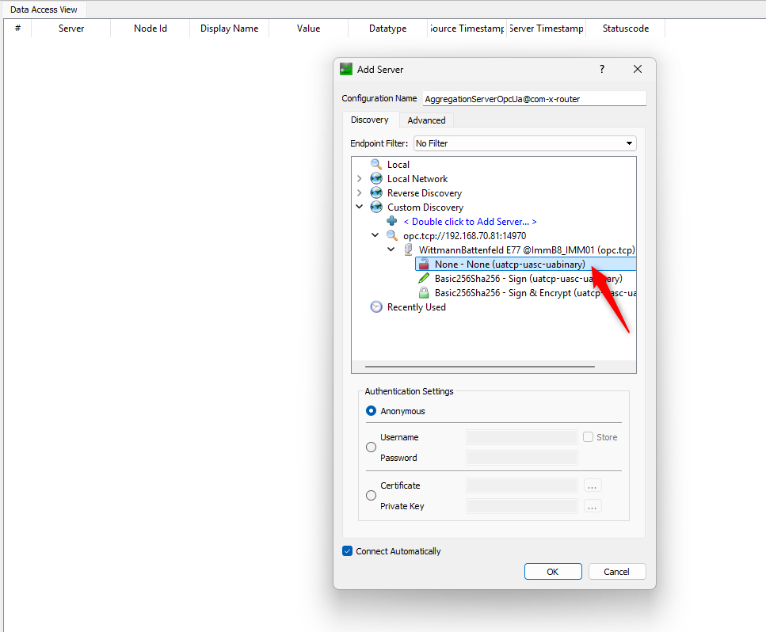

- Check the Trust Server Certificate checkbox, then click Continue.

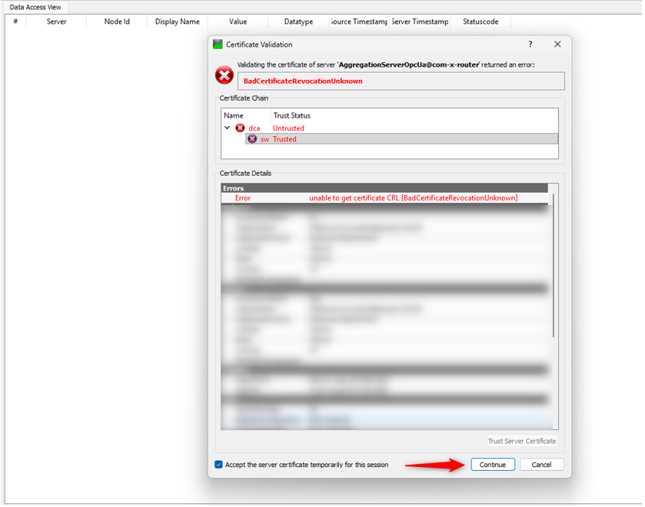

- Right-click on Aggregation ServerOpcUa@com-x-router and select Properties.
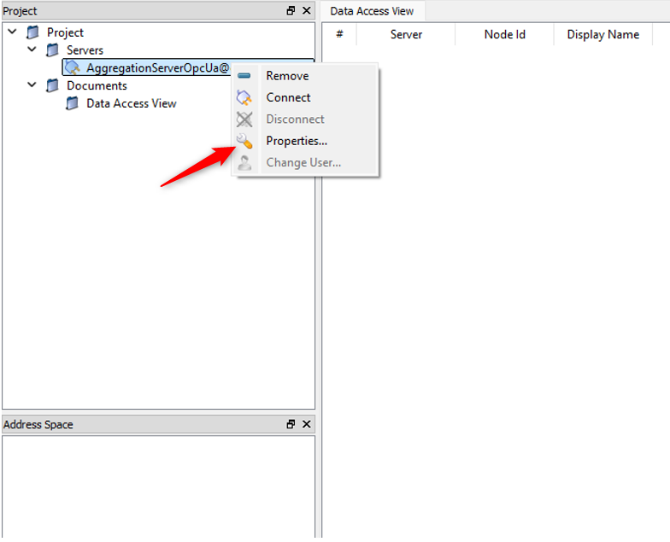

- A Server Settings pop-up will appear on the screen. Change the default port from 48020 to14970 for the Euromap 77 OPC UA connection.
- Then, click OK to continue.
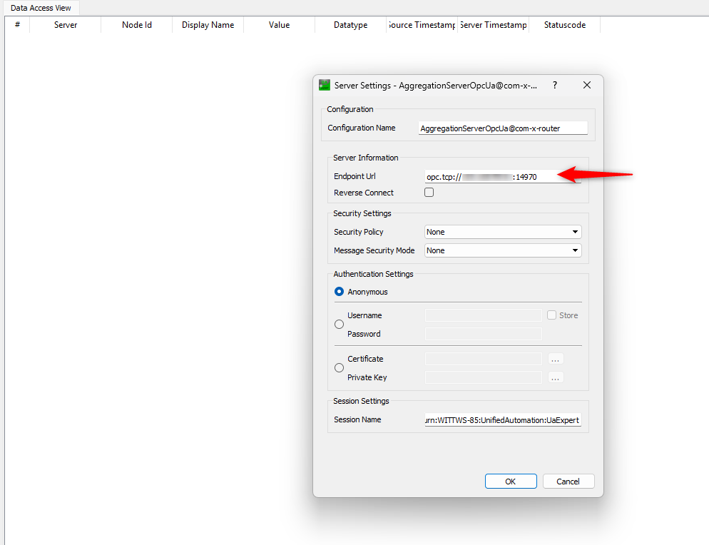

- Right-click on Aggregation ServerOpcUa@com-x-router, then click Connect.
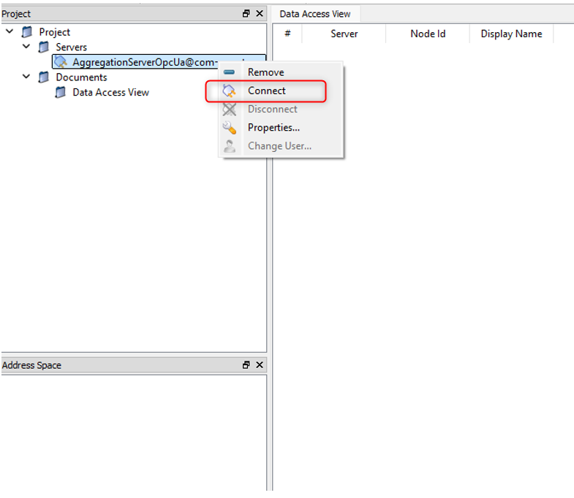

- You may receive a “URL not found” pop-up. Click OK to continue.
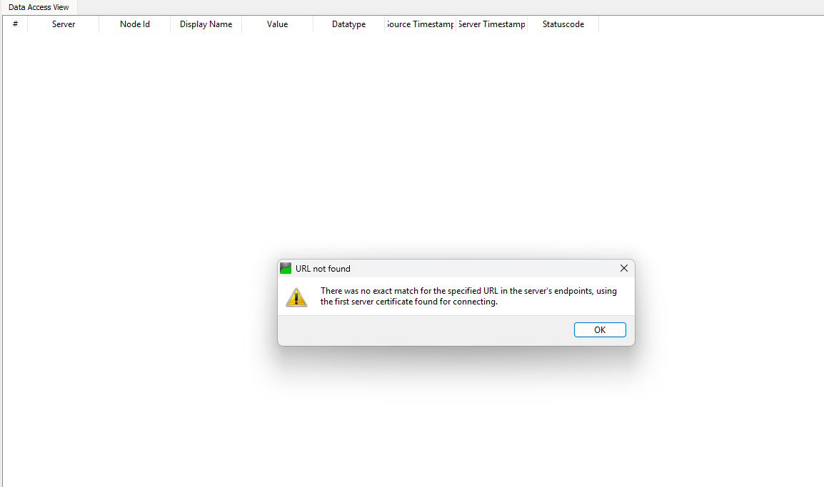

- Check the Trust Server Certificate checkbox, then click Continue.

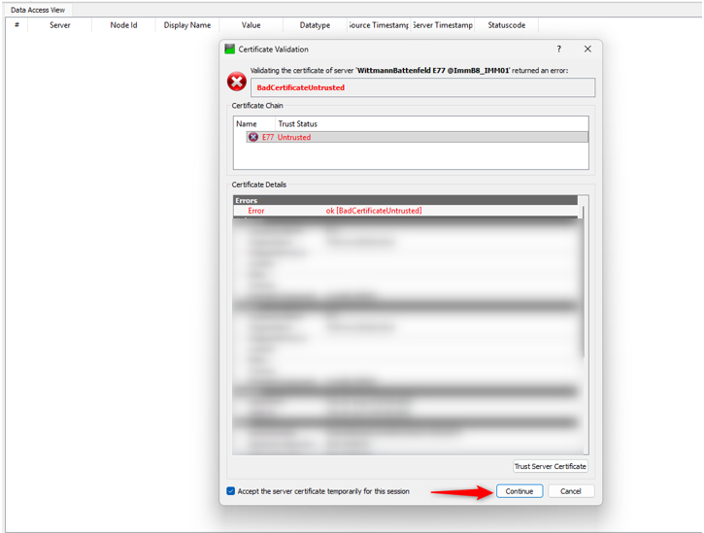

- Drag and drop the required Node Id into the Data Access View panel
Example- DeviceSet

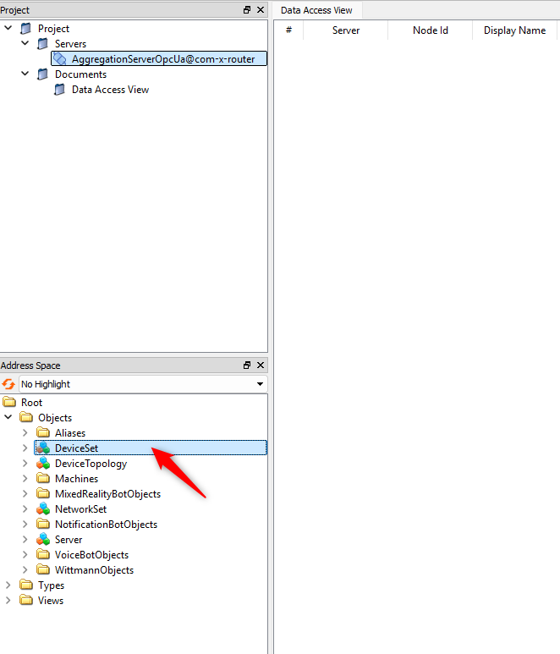

Note: If any pop-up dialog appears while dragging the Node Id to the Data Access View, click Yes.
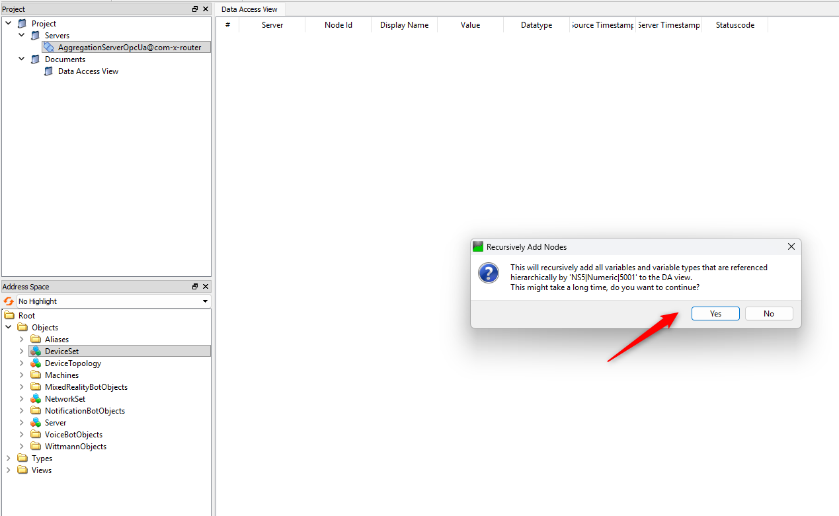

- The Nodes will be listed in the Data Access View table, completing the setup for monitoring

