How to Restart LineServers Hardware via UA Expert
- Add the Gateway Server and establish a connection.
- Navigate to cellgateway > configuration > RestartLineServerHardware
- Right click on RestartLineServerHardware and Select Call
- In the popup, choose Call without any input or output arguments

- If you encounter an error, set the username and password as given below, then repeat the above procedure
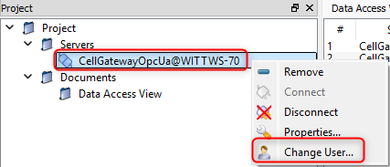
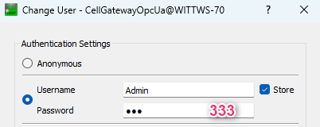

- If it succeeds, open the M8 Plus application and login using Admin credentials

