SMARTGIT-FLOW

SmartGit is a Git-based tool used to manage project files, monitor changes, and collaborate effectively with team members. It ensures that all updates are properly recorded, organized, and merged smoothly without conflicts.
It helps to:
- Track changes
- Manage branches
- Commit updates
- Merge changes

- SmartGit is a graphical tool used for Git-based version control
- It helps to manage and track changes in project files or documents
- It allows users to work with different branches (feature, bugfix, master)
- It is used to commit changes and maintain version history
- It supports merging changes from one branch to another
- It helps teams to collaborate on the same project without conflicts
- It allows users to push and pull changes between local and remote repositories

Overview of Sandbox Folder in the Repository Drive
The Sandbox folder is a local working directory on the user’s system that contains Multiple project and documents
- All document modifications are first performed in the Sandbox before being tracked in SmartGit
- It allows users to work independently without affecting the main project

Check Task in Jira
- Open your assigned task in Jira.
- Understand the requirement clearly.
Details in task:
- Document to update
- Branch name (Feature / Bugfix)

SmartGit Workflow Steps

- Open Repository in SmartGit
- Launch SmartGit.
Whenever you launch use Run as Administrator

- Branch Types

Remote Branch (origin):
- Central repository where all branches are stored
- Contains branches created from Jira (feature / bugfix)

Local Branch:
- Working branch on your system.
- You make changes here.

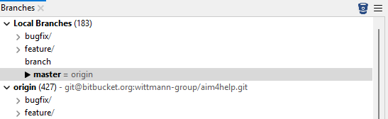

- Pull Latest Changes (Important Step)
- After creating a branch in Jira, always switch to the master branch and pull the latest changes.
- To get the latest updates from the remote repository.

- Checkout the Branch
Checkout = switching to the branch to work.
- Select the branch mentioned in Jira.
- Click Checkout to create a local branch from the origin (feature or bugfix), depending on the task, and start working on it

- Work on the Task
- Make required changes (document/updates).
- Save your work.

- Stage Changes
Staging = preparing files for commit.
- Add modified files to staging area.

- Commit Changes
- State a proper commit message.
NOTE: Always use the correct task ID you worked on. If you use a different task ID, the commit may go to another branch and cause conflicts.

- When adding a new document, include a note stating that the Document has been added.
- Commit the staged changes.

- Push Changes
Push your commits to the remote repository (origin).

- Verify in Jira
After pushing, check if your commit is linked to the Jira task.

10.Pull Request
Create a Pull Request in Jira for the task you worked on and provide a clear, heading for the pull request.

