**M LALITHA** 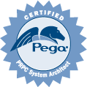

Phone: **+91-7842510029**

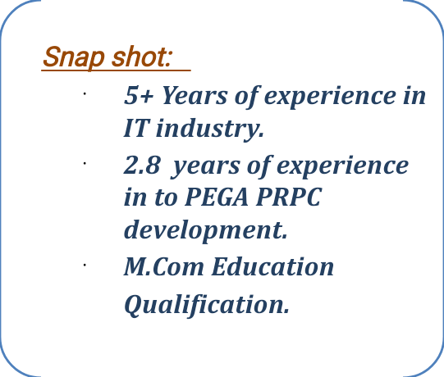e-mail: **machavarapulalitha435@gmail.com**

***Professional Overview***

* Exposure to Pega PRPC version 7.X, 8.X platform.
* Extensively worked and been a part in entire software development life cycle (SDLC) phases like Analysis, Design, Development, Unit Testing and Deployment.
* Hands on experience in Configuring Flows, Assignments, Screen Flows, Flow Actions.
* Hands on experience in designing User Interface (UI) rules such as Sections & Layouts.
* Good hands-on experience in configuring Data Transforms, Case Management.
* Involved in implementing Data pages with different sources and parametrizing Data pages.
* Hands-on experience with SLA’s, Activities, Report definitions, Navigation rule.
* Involved in handling validations.
* Hands on experience Creating properties, Decision Table and Declare Expressions.
* Good knowledge on integrations like SOAP & REST.
* Worked on Debugging and Bug fixing Activities using Clipboard, Tracer and Live-UI.
* Good exposure in requirements understanding and analyzing, tracking of defects and providing regular updates about the same.
* Excellent interpersonal, Communication, Presentation Skills and client handling ability.
* Ability to coordinate as a good team player and to work as self-motivated individual.

***Technical Preview***

**Database** : SQL server

**Reporting Tools** : JIRA

**sImplementation Tools** : PRPC(7.x, 8.x)

**Operating Systems** : Windows.

***Academic***

Masters of Commerce from ANU.

***Occupational Contour***

Working as a software Engineer in ***Mindting Software Labs PVT Ltd***, Hyderabadfrom 2017 to present.

***Certifications***

Pega PRPC Certified System Architect.

***Project Experience***

**Project 1**

**Project title : Claims System**

**Client : Genworth Financial**

**Role : Pega Developer**

**Description:**

This application enables claims processors to process the Claims from capturing FNOL details to disbursement of claim amount.

**Responsibilities:**

* Worked on Case management.
* Worked on Data Pages, Data Transforms, Flows, Flow Actions, Navigation rule, Decision Tables, Report Definitions, Activities, SLA’s.
* Design and developing User Interface using Sections, Layouts.
* Worked on Service-REST.
* Performing the unit testing after development of each user stories.
* Support QA and fixing the defects on implemented user stories.
* Worked with different tools like Tracer/Rules Inspector for troubleshooting the issues.
* Gathering the requirement from BA Team and providing estimates accordingly.
* Actively participated in daily status, backlog refinement(grooming), and functionality walkthroughs.

**Project 2**

**Project title : Policy Handling Application**

**Client : Genworth Financial**

**Role : Pega Developer**

**Description:**

This application enables the CSR to perform required operations on policies based on customer requests.

**Responsibilities:**

* Worked on Data Pages, Data Transforms, Flows, Flow Actions, Navigation rule.
* Design and developing User Interface using Sections, Layouts.
* Worked on Connect-SOAP.
* Performing the unit testing after development of each user stories.
* Support QA and fixing the defects on implemented user stories.
* Worked with different tools like Tracer/Rules Inspector for troubleshooting the issues.
* Actively participated in daily status, backlog refinement(grooming), and functionality walkthroughs.

Place:

Date:

**M Lalitha**