**RDS Instance**

1. Create a RDS instance
   1. Launch instance
   2. Standard
   3. MYSQL
   4. MYSQL 8.0
   5. Enable instance identifier name
   6. Master username and password ( Don’t lose it )
   7. DB Instance sizes
   8. Storage for the instance configuration
   9. Multi-AZ deployment
   10. Choose VPC
   11. Advance connectivity >
   12. Create a new security group ( RDS-INSTANCE-group)
   13. Database Name
   14. Backup ( Auto is necessary for read replicas)
   15. Create Database

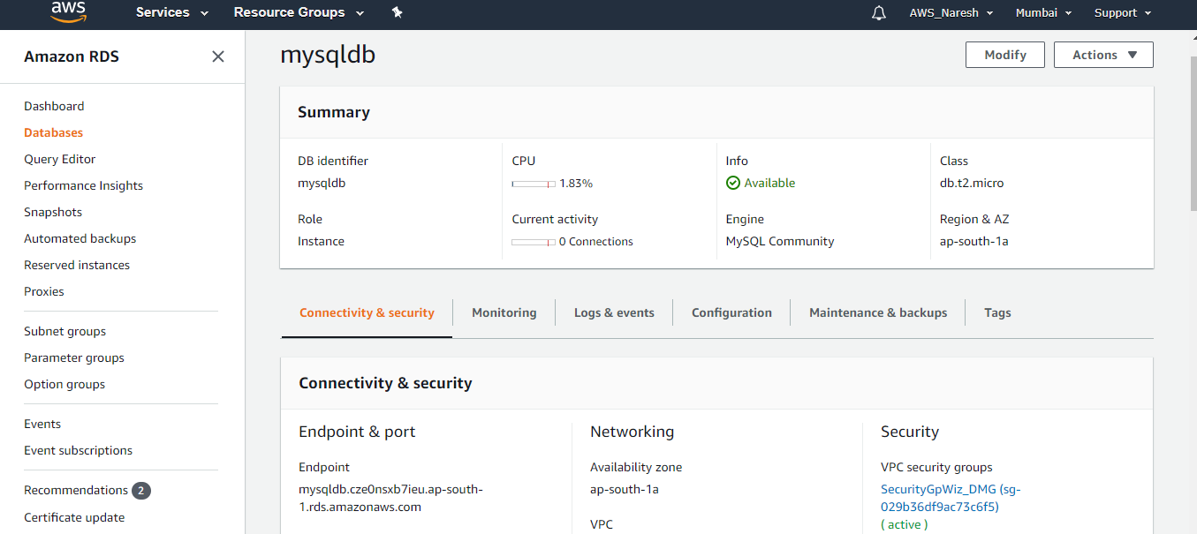

1. Launch EC2 Instance
   1. Choose Linux
   2. Free tier processor
   3. Run a boot strap script

#!/bin/bash

yum install httpd php-mysql -y

amazon-linux-extras install -y php7.3

cd /var/www/html

echo "healthy" > healthy.html

wget https://wordpress.org/latest.tar.gz

tar -xzf latest.tar.gz

cp -r wordpress/* /var/www/html/

rm -rf wordpress

rm -rf latest.tar.gz

chmod -R 755 wp-content

chown -R apache:apache wp-content

wget https://s3.amazonaws.com/bucketforwordpresslab-donotdelete/htaccess.txt

mv htaccess.txt .htaccess

service httpd start

chkconfig httpd on

* 1. Choose the WebMDz security group with port http open
  2. Choose key-pair and launch

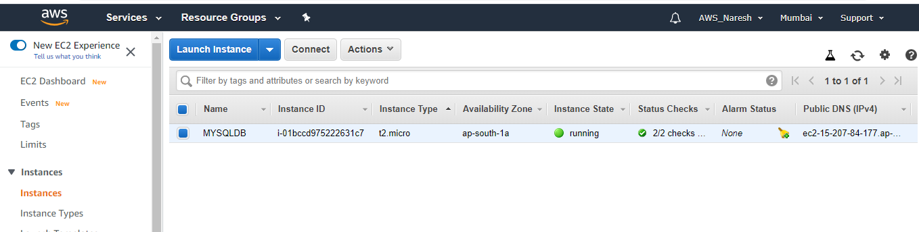

1. To make RDS to talk to ec2 security group
   1. Go to security group on left panel
   2. Choose the security group of the RDS instance
   3. Write an inbound rule to open port 3306 and choose the WEBDMZ security group as the IP
   4. Create rule and exit the screen.

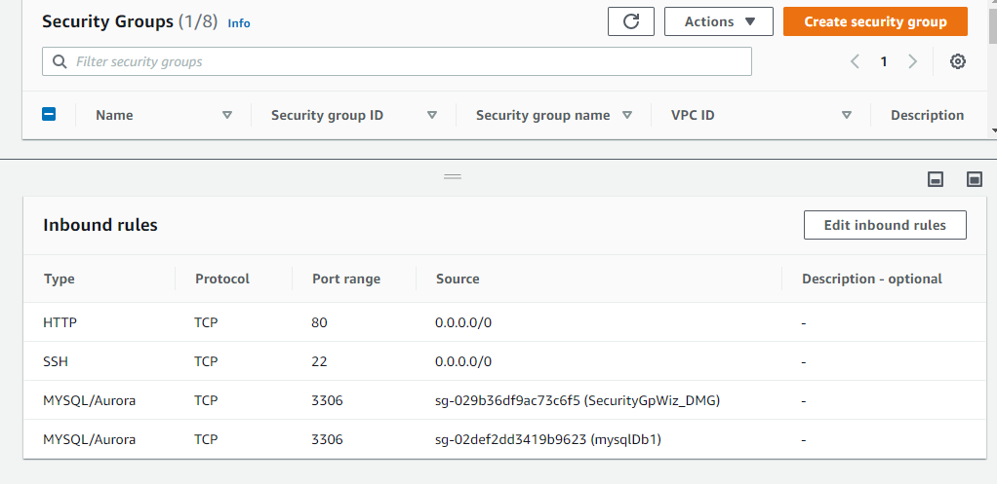

1. Install wordpress
   1. The bootstrap must have installed the word press but some configurations in order to for the WordPress to write to the database.
   2. Enter the configuration details in WordPress and login
   3. It might prompt to run a script
   4. Copy the script and ssh into your ec2 instance
   5. Navigate to cd /var/www/html/ directory
   6. Create a file ( wp-config.php)
   7. Copy paste the copied context
   8. Ctrl+x > yes > enter
   9. Go back to ec2 instance and run the installation
   10. Enter your credentials and login in to WordPress

