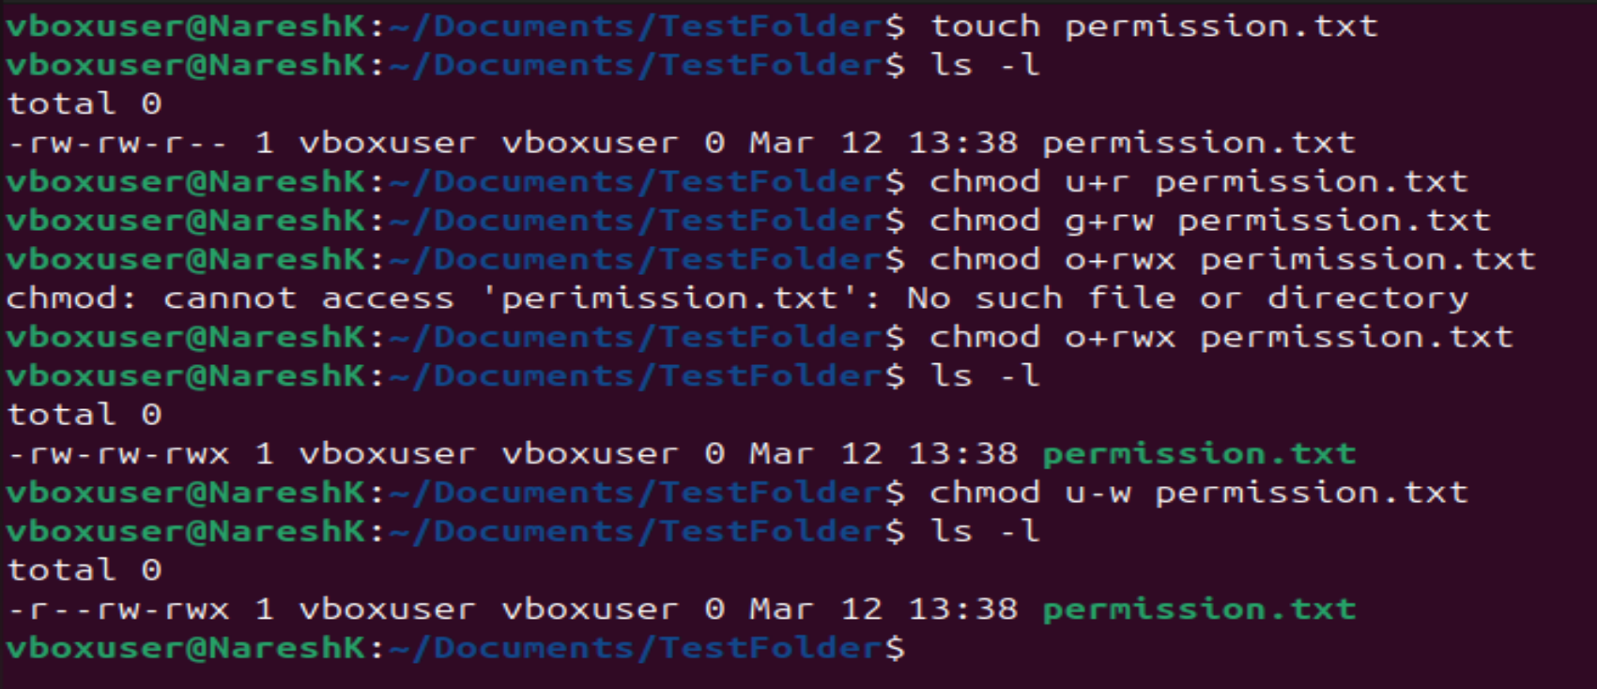

U+R -> to provide read access for only users or at user level

G+RW -> to provide read & write access for only group or at group level

O+RWX -> to provide read, write, execute access for only owner or at owner level

**Note:** u-w was used to remove write access for owner

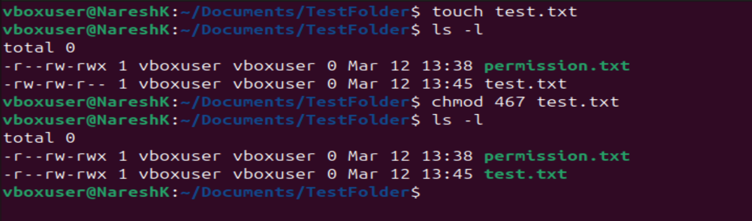

|  |  |
| --- | --- |
| **Access level** | **Octal value** |
| Read | 4 |
| Write | 2 |
| Execute | 1 |

The leftmost permission is designated for the user, who only needs read access; therefore, I use the value 4. The middle permission is for the group, which requires both read and write access, I use the value 6 (4+2). The rightmost permission is for the owner, who requires all three types of access, I use the value 7 (4+2+1).