**Step 01**: Forking the source code

**Step 02:** Dockerize the application

**Step 03**: application running on port 3000

**Step 04:** Pushing the image into Docker hub

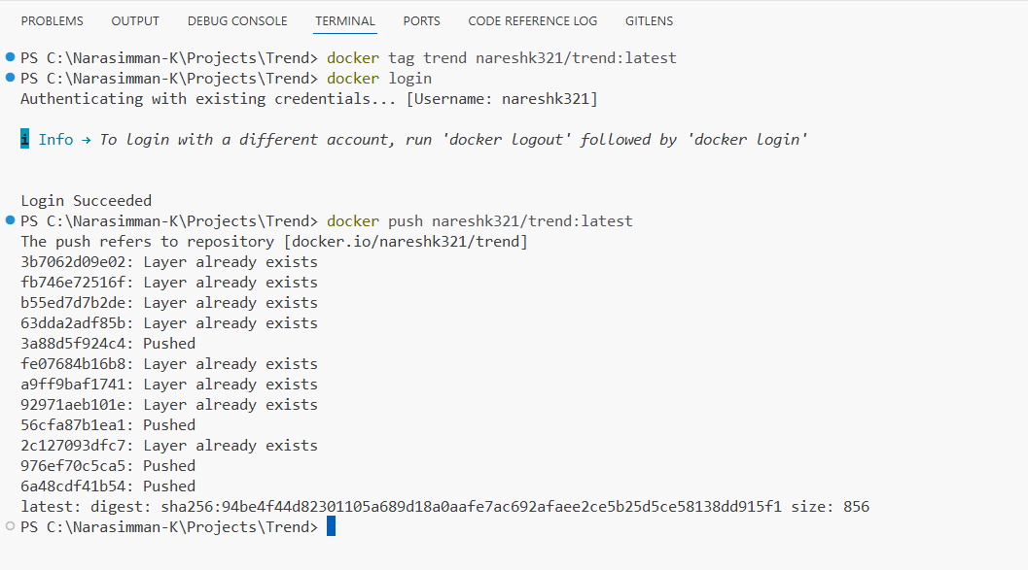

Step 05: Creating infrastructure using Terraform

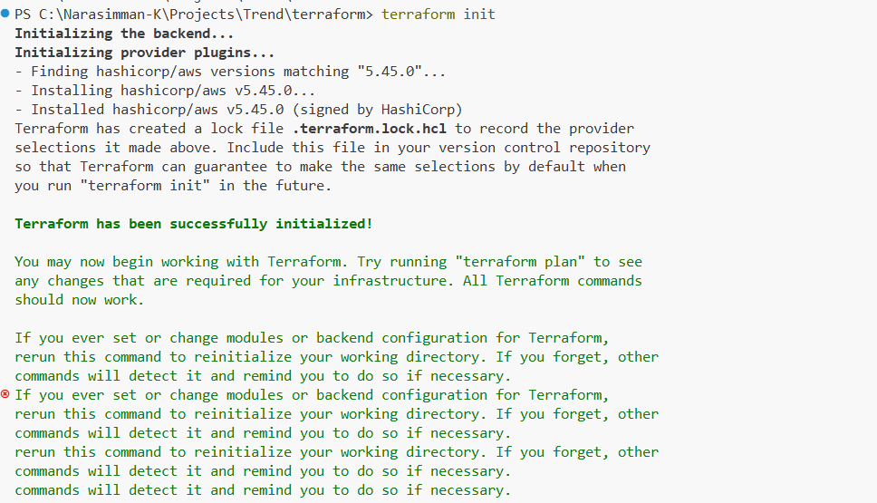

After Terraform execution, an instance has been created

Creating ekscluster.tf file

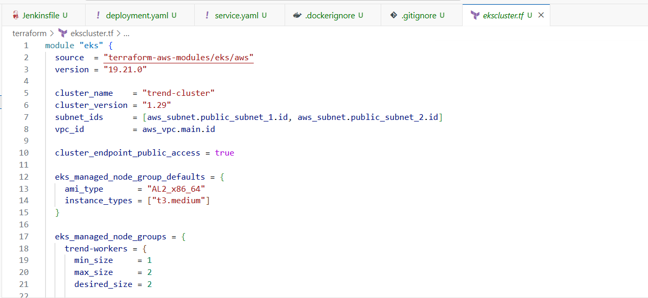

Executing Terraform with EKS

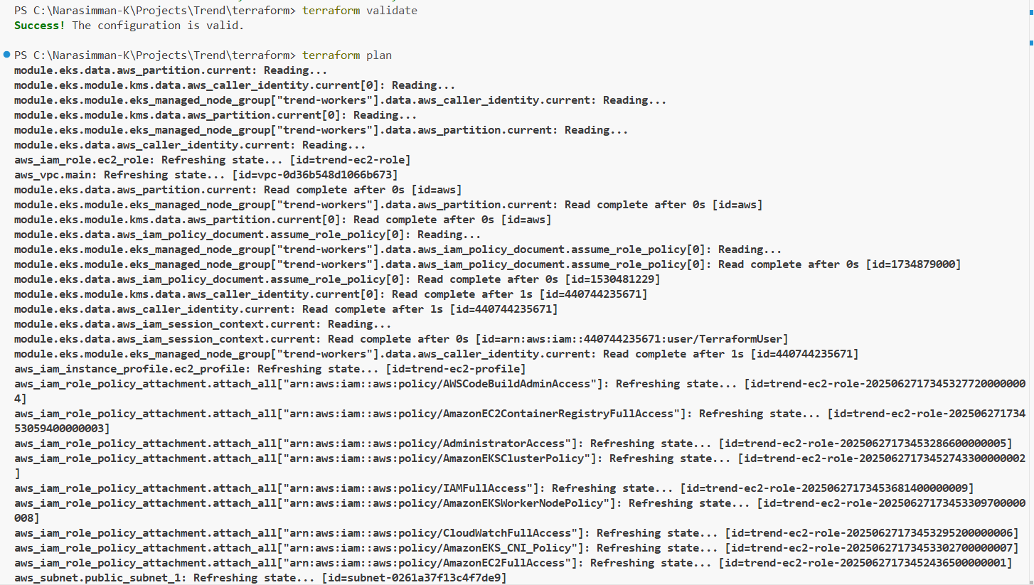

After executing Terraform for cluster creation

Worker nodes created successfully

Update kubeconfig:

Deployment.yaml

Service.yaml

Deploying the application

Load balancer

Connected to the Jenkins server:

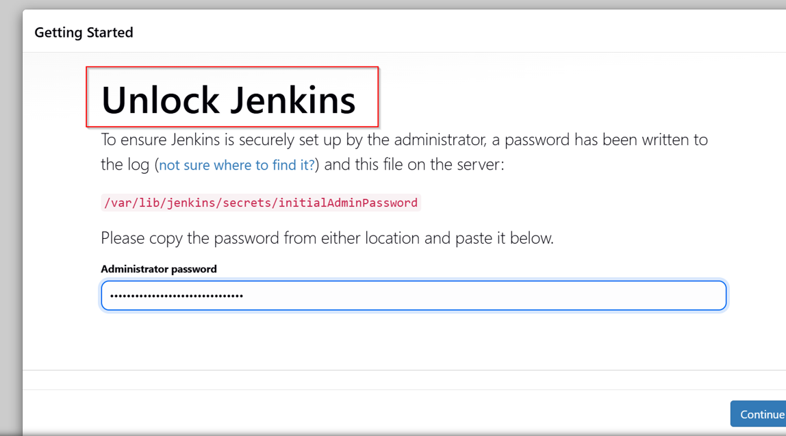

Creating Jenkinsfile:

pipeline {

agent any

environment {

DOCKER_IMAGE = "prasanth0003/react_app"

DOCKER_CREDENTIALS_ID = 'dockerhub'

}

stages {

stage('Clone Repository') {

steps {

git branch: 'main', credentialsId: 'github', url: 'https://github.com/prasanth-wizard/Trend.git'

}

}

stage('Build Docker Image') {

steps {

script {

docker.build("${DOCKER_IMAGE}")

}

}

}

stage('Login & Push to DockerHub') {

steps {

script {

docker.withRegistry('', DOCKER_CREDENTIALS_ID) {

docker.image("${DOCKER_IMAGE}").push("latest")

}

}

}

}

stage('Deploy to EKS') {

steps {

sh 'aws eks --region us-east-1 update-kubeconfig --name trend-cluster'

sh 'kubectl apply -f deployment.yaml'

sh 'kubectl apply -f service.yaml'

sh 'kubectl get svc'

}

}

}

}

Configuring the Pipeline:



