**Security Group**

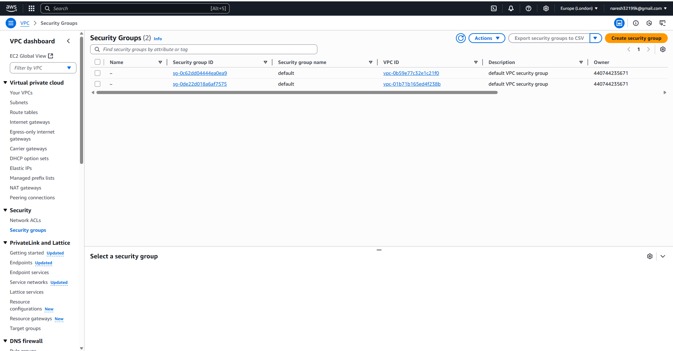

**AWS Instance Creation**

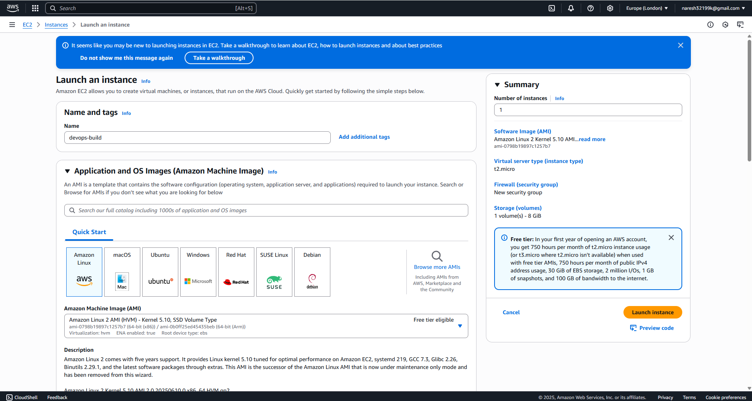

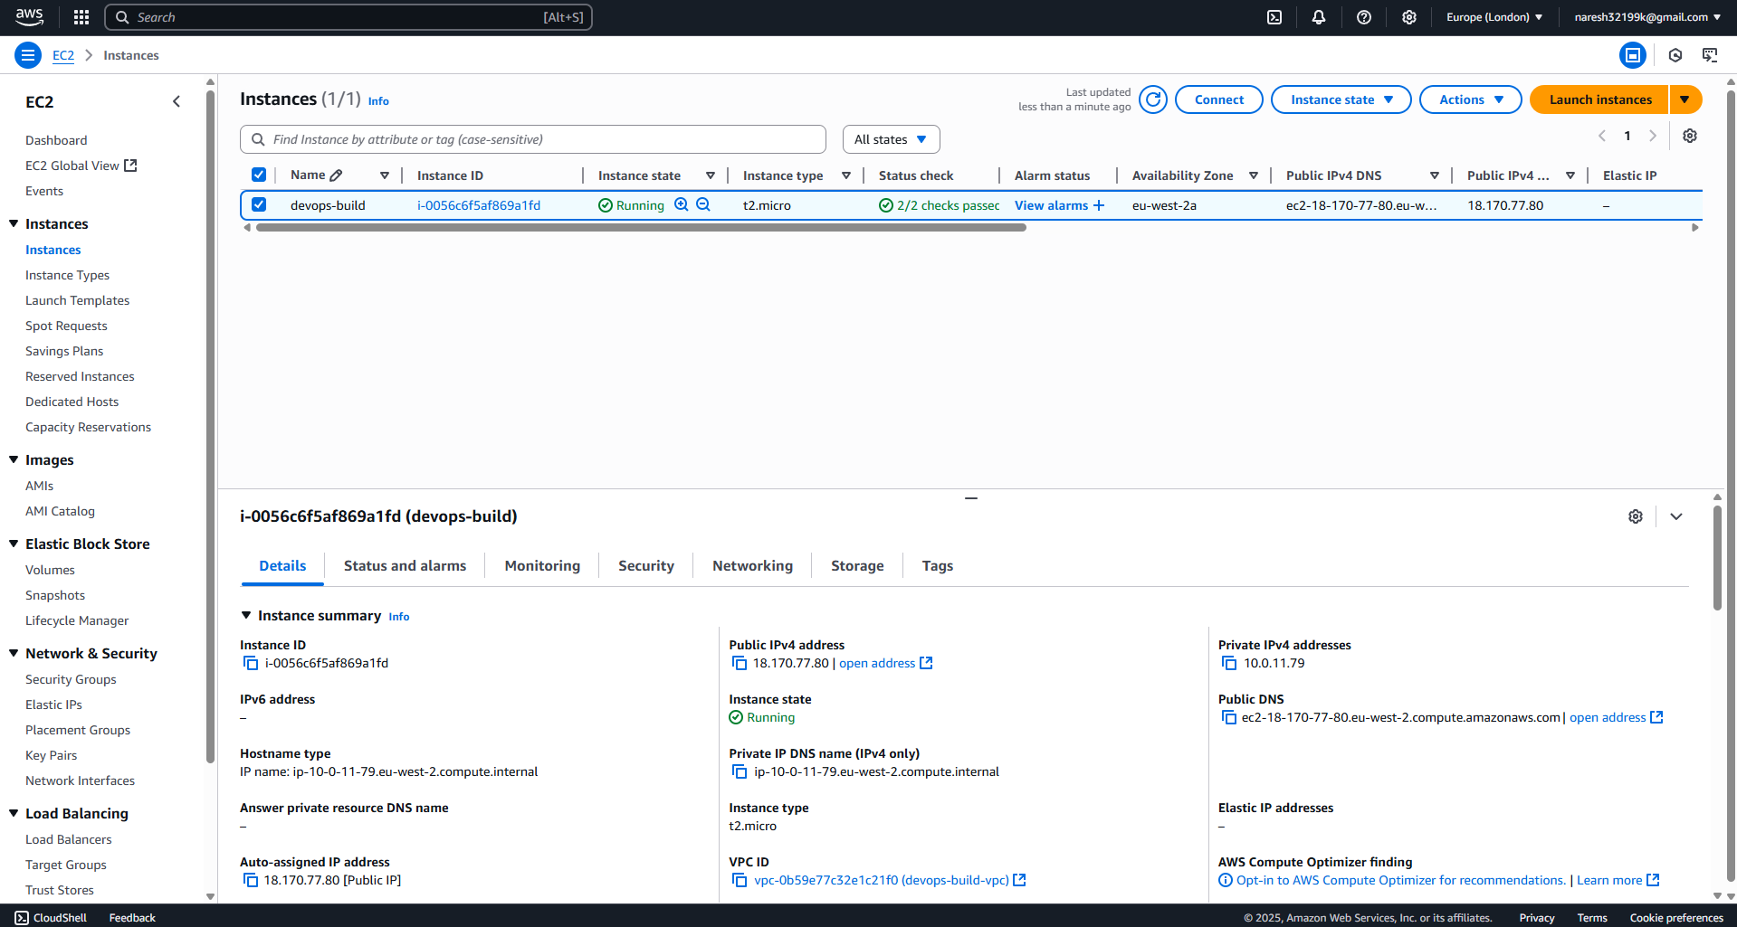

**Step 01:** Clone the Repository

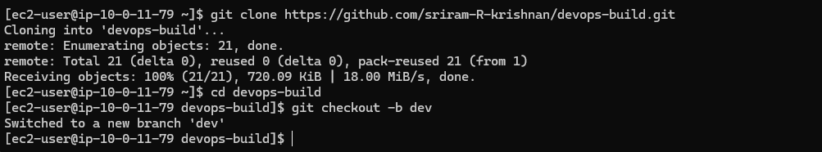

**Step 02:** Docker Configuration

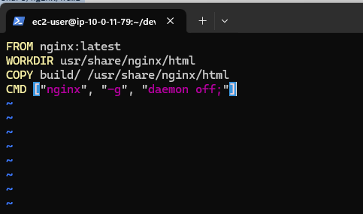

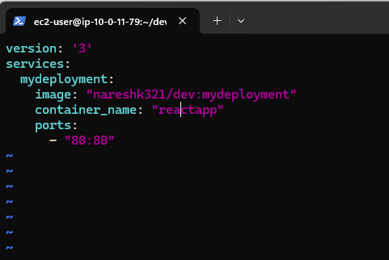

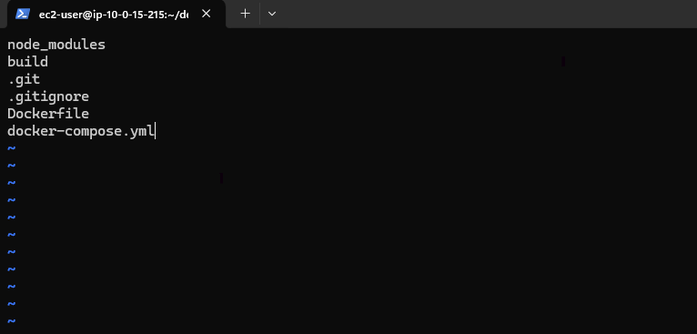

**Step 03:** Shell Scripting

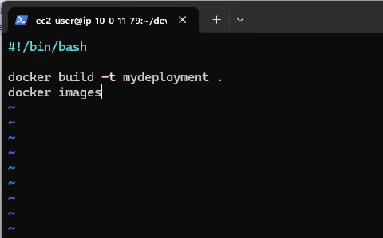

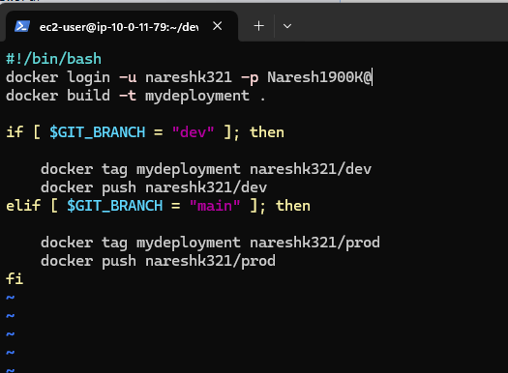

**Step 04:** GitHub Configurations

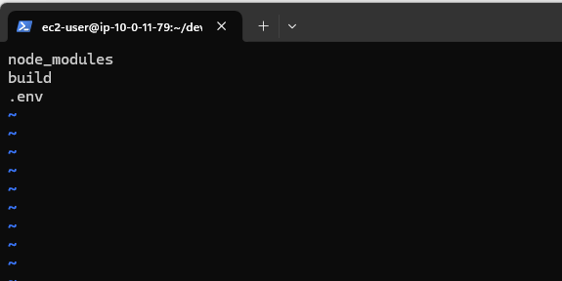

Step 05: Jenkinsfile

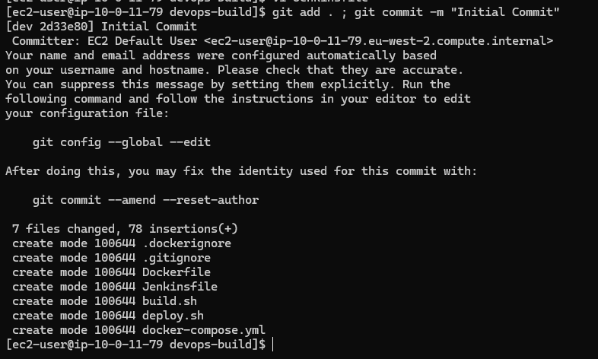

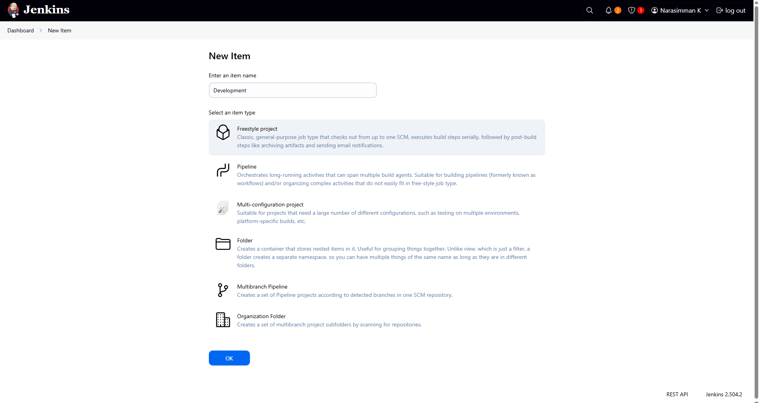

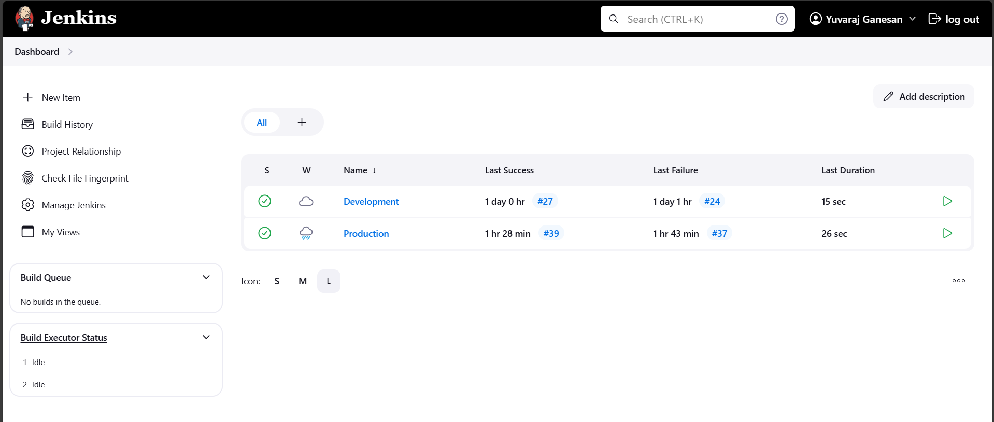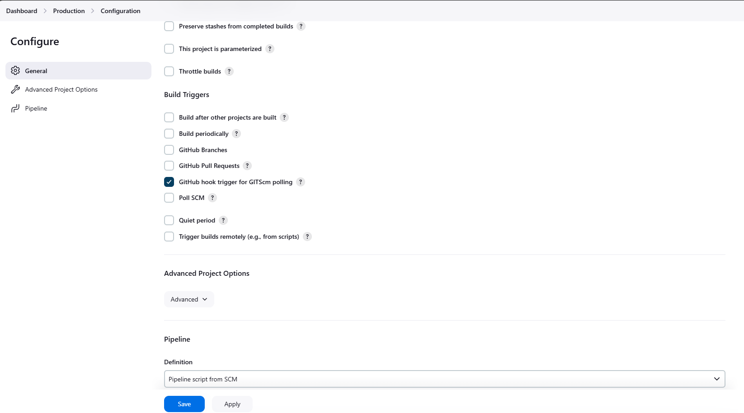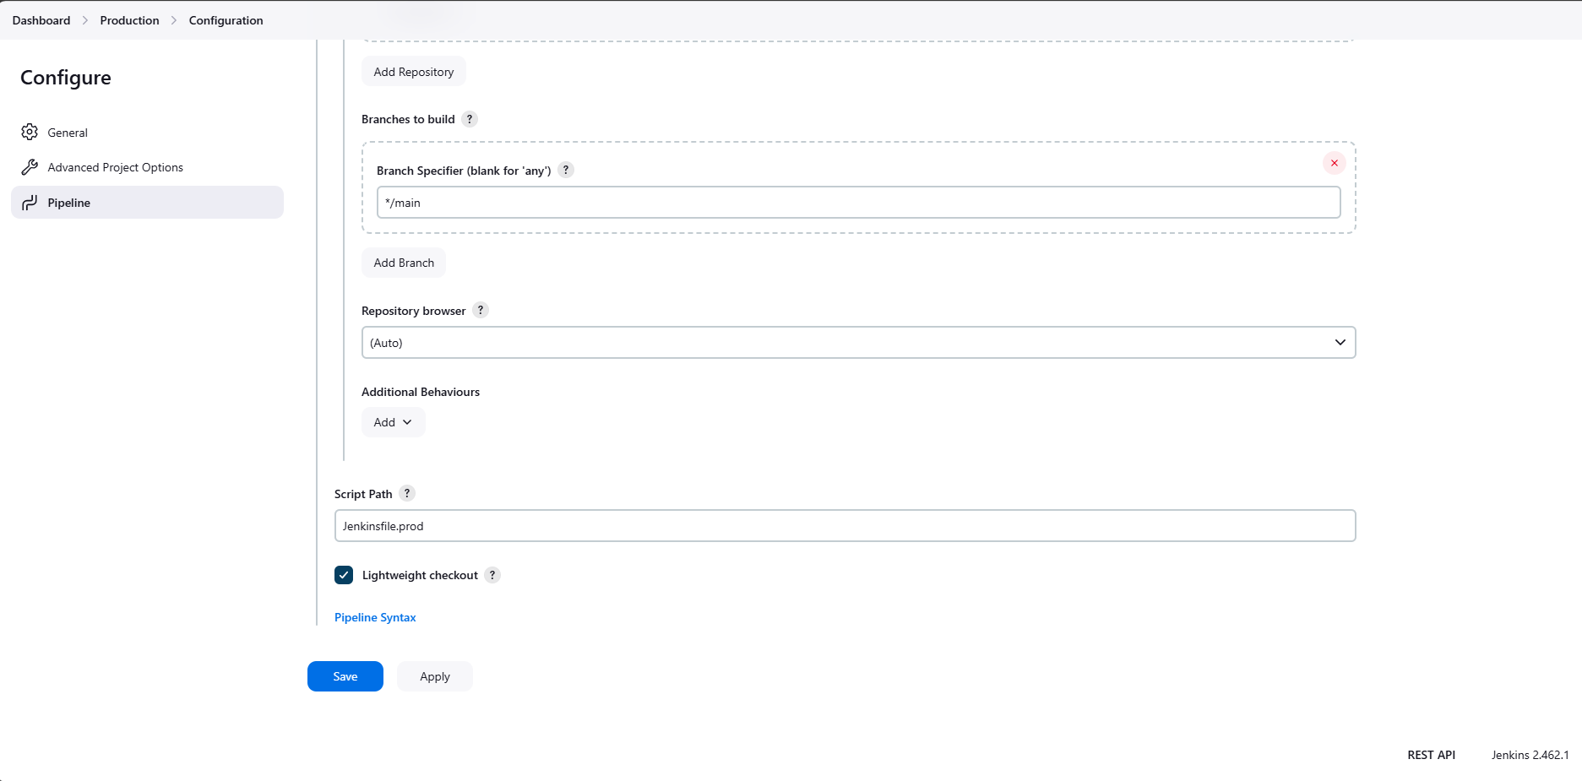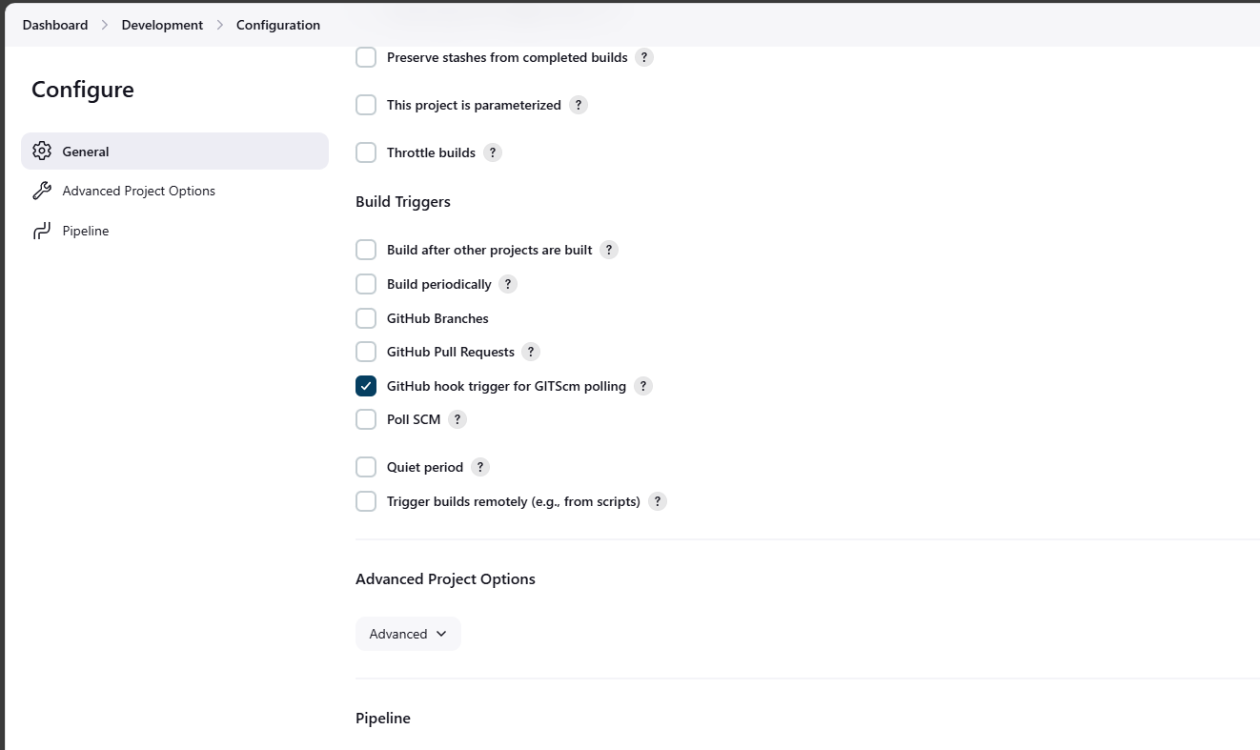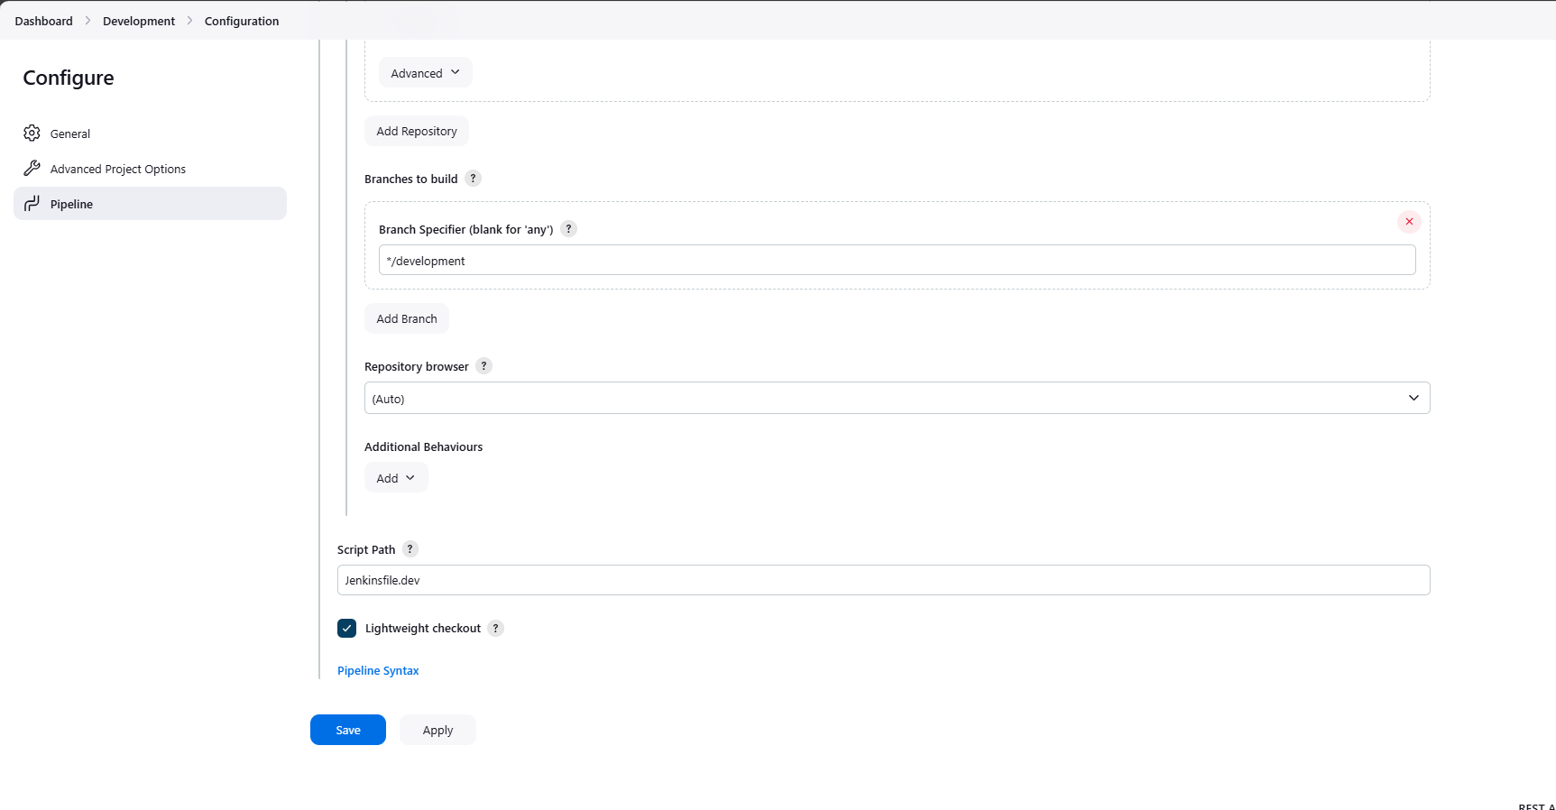

Docker Hub

Application:

Monitoring:

