1. Write a program which will find all such numbers which are divisible by 7 but are not a multiple

of 5, between 2000 and 3200 (both included). The numbers obtained should be printed in a

comma-separated sequence on a single line.

**Program :**

**#Task 1**

**#Program 1**

num_div7_mul5=[]

for x in range(2000,3201):

if ((x%7==0) and (x%5 !=0)):

num_div7_mul5.append(str(x))

print(','.join(num_div7_mul5));

**o/p:**

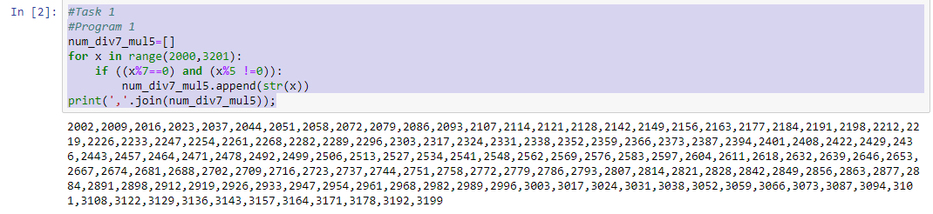

1. Write a Python program to accept the user's first and last name and then getting them printed in

the the reverse order with a space between first name and last name.

**Program:**

**#Program 2**

fname=input("Please enter first name:")

lname=input("Please enter last name:")

rev_fname=fname[::-1]

rev_lname=lname[::-1]

print(rev_fname +" "+rev_lname)

**o/p:**

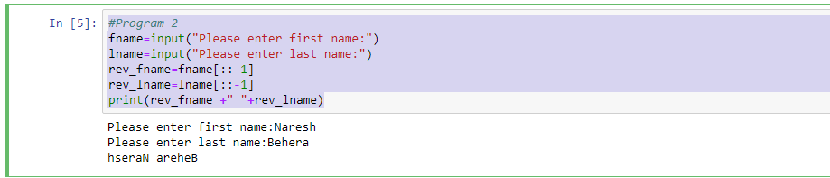

3.

Write a Python program to find the volume of a sphere with diameter 12 cm.

Formula: V=4/3 * π * r**3

**Program:**

**#Program 3**

pi=3.1415926535897931;

d=12;

r=6;

v=4/3*pi*r**3;

print("Volume of sphere with diameter 12 is : ",v);

**o/p:**

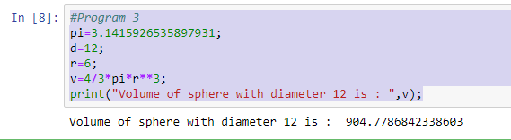

**4.**

Write a program which accepts a sequence of comma-separated numbers from console and

generate a list.

**Program:**

**#Task 2**

**#Program 4**

Num=input("Please enter sequence of comma separated numbers:")

list=Num.split(",")

print(" List :" , list);

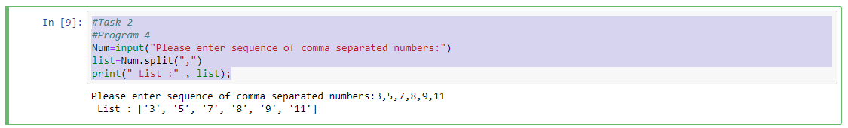

5.

Create the below pattern using nested for loop in Python.

**Program:**

**#Program 5**

n=int(input("Enter the max number of stars to be printed:"))

for i in range(n):

for j in range(i):

print("* ", end="")

print("");

for i in range(n,0,-1):

for j in range(i):

print("* ", end="")

print("")

**o/p:**

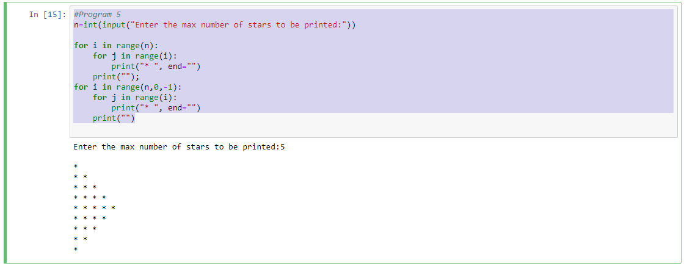

**6.**

**Write a Python program to reverse a word after accepting the input from the user.**

**#Program 6**

Str=input("Please Enter a String:")

Rev_Str=Str[::-1]

print("Reverse of String is :", Rev_Str)

o/p:

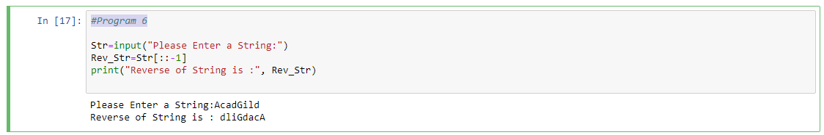

7.

Write a Python Program to print the given string in the format specified in the sample output.

WE, THE PEOPLE OF INDIA, having solemnly resolved to constitute India into a

SOVEREIGN, SOCIALIST, SECULAR, DEMOCRATIC REPUBLIC and to secure to all

its citizens

Sample Output:

WE, THE PEOPLE OF INDIA,

having solemnly resolved to constitute India into a SOVEREIGN, !

SOCIALIST, SECULAR, DEMOCRATIC REPUBLIC

and to secure to all its citizens

**Program:**

**#Program 7**

Str="WE, THE PEOPLE OF INDIA, having solemnly resolved to constitute India into a SOVEREIGN, SOCIALIST, SECULAR, DEMOCRATIC REPUBLIC and to secure to all its citizens";

print("WE, THE PEOPLE OF INDIA,\n\thaving solemnly resolved to constitute India into a SOVEREIGN, !\n\t\tSOCIALIST, SECULAR, DEMOCRATIC REPUBLIC \n\t\t and to secure to all its citizen");

