A FIELD PROJECT REPORT

on

# “TYPING SPEED TEST: A WEB-BASED APPLICATION FOR TYPING PROFICIENCY ASSESSMENT”

**Submitted**

by

231FA04165 231FA04B66

G.NARESH CH.MANASWI

231FA04C29 231FA04E98

M.VIVEK VARMA M.SAMITH REDDY

**Under the guidance of**

*Mr. Nanda Kishore*

**HOD Nominee**

*P.Kiran Kumar Raja*

*Simhadri Chinna Gopi*

Assistant Professors, Department of CSE



**DEPARTMENT OF COMPUTER SCIENCE & ENGINEERING**

**VIGNAN'S FOUNDATION FOR SCIENCE, TECHNOLOGY AND RESEARCH Deemed to be UNIVERSITY** **Vadlamudi, Guntur.**

**ANDHRA PRADESH, INDIA, PIN-522213 May-2024.**



**CERTIFICATE**

This is to certify that the Field Project entitled **“TYPING SPEED TEST: A WEB-BASED APPLICATION FOR TYPING PROFICIENCY ASSESSMENT”** that is being submitted by 231FA04165(G.Naresh),231FA04B66(Ch.Manaswi)231FA04C29(M.Vivek Varma) and 231FA0E98(M.Samith Reddy)for partial fulfilment of Field Project is a bonafide work carried out under the supervision of Mr. Nanda Kishoreand *P.Kiran Kumar Raja ,Simhadri Chinna Gopi* HoD Nominees and Assistant Professors, Department of CSE.

Mr. Nanda kishore Dr. S.V Phani Kumar

Faculty, Department of CSE  HOD, CSE



## DECLARATION

We hereby declare that the Field Project entitled **“TYPING SPEED TEST: A WEB-BASED APPLICATION FOR TYPING PROFICIENCY ASSESSMENT”** that is being submitted by

231FA04165(G.Naresh),231FA04B66(Ch.Manaswi)231FA04C29(M.Vivek Varma) and 231FA0E98(M.Samith Reddy)in partial fulfilment of Field Project course work. This is our original work, and this project has not formed the basis for the award of any degree. We have worked under the supervision Mr. Nanda Kishoreand *P.Kiran Kumar Raja , Simhadri Chinna Gopi* HoD Nominees Department of CSE.

**By**

**231FA04165(G.Naresh),**

**231FA04B66(Ch.Manaswi),**

**231FA04C29(M.Vivek Varma),**

**231FA04E98(M.Samith)**

Date:

**Contents**

|  |  |  |
| --- | --- | --- |
| **S.NO** | **Description** | **Page No.** |
| **01** | **Introduction** | **05-05** |
| **02** | **Technologies Used** | **05-05** |
| **03** | **Project Description** | **06-07** |
| **04** | **Outputs** | **08-12** |
| **05** | **Conclusion** | **12-13** |
| **06** | **Project Link** | **13-13** |
| **07** | **References** | **13-14** |

## “TYPING SPEED TEST”

**1. Introduction:**

Our aim is to construct a user friendly website named " **TYPING SPEED TEST” A WEB-BASED APPLICATION FOR TYPING PROFICIENCY ASSESSMENT** using Html ,CSS and JavaScript. This website aims to

provide an interactive platform for evaluating and improving typing skills. The web-based application allows users to take typing tests, measure their words per minute (WPM), assess accuracy, and receive feedback on their performance.

Unlike traditional typing tests, which merely display results, this application provides real-time error detection, highlights incorrect keystrokes, and suggests areas for improvement. Users can choose different difficulty levels, compete with others via leaderboards, and monitor their progress over time. Additionally, administrators can manage test content, analyze user data, and generate reports for further insights.

**2.Technologies Used**

Frontend: HTML, CSS, JavaScript

Deployment: Hosted on search engines for effective usage

**3. Project Description:**

HTML Structure:

HTML is the backbone of the project, providing the fundamental structure of the web page. It defines elements such as text input fields, buttons, and display sections where users interact with the application. The core components of the typing test, such as the text area for user input, the displayed typing passage, the start button, and result sections, are all created using HTML.

For example, an HTML <textarea> element is used to capture user input, while <p> elements display the text to be typed and show typing speed results. Buttons (<button>) allow users to start or restart the test. Additionally, HTML elements are assigned unique IDs and classes, enabling JavaScript to manipulate them dynamically during the typing test.

CSS Styling:

CSS is responsible for styling the web page, making the application visually appealing and user-friendly. It is used to design the layout, typography, colors, and interactive effects of the typing test interface. By defining styles for different elements, CSS ensures that the application maintains a consistent and professional look across different devices.

For instance, the typing input area is styled with a border, padding, and font settings to make it comfortable for users to type. The results section is formatted with larger fonts and contrasting colors to make typing speed and accuracy easily readable. Additionally, error highlighting is implemented using CSS—when a user types an incorrect character, JavaScript applies a CSS class that changes the background color of the input box to red, providing immediate visual feedback.

JavaScript Functionality:

JavaScript is the most crucial part of the project, as it adds interactivity, dynamic behavior, and real-time calculations to the typing speed test. It detects when users start typing, tracks their keystrokes, and calculates typing speed and accuracy. Unlike HTML and CSS, which are static, JavaScript enables real-time updates and user interactions.

For example, when a user starts typing, JavaScript records the start time and continuously updates the words per minute (WPM) calculation by comparing the elapsed time with the number of words typed. It also tracks errors by comparing the user’s input with the original text and dynamically updates the accuracy percentage. Additionally, JavaScript can store user progress and past scores in a database or local storage, allowing users to track their improvements over time.

**Output:**

Login page:

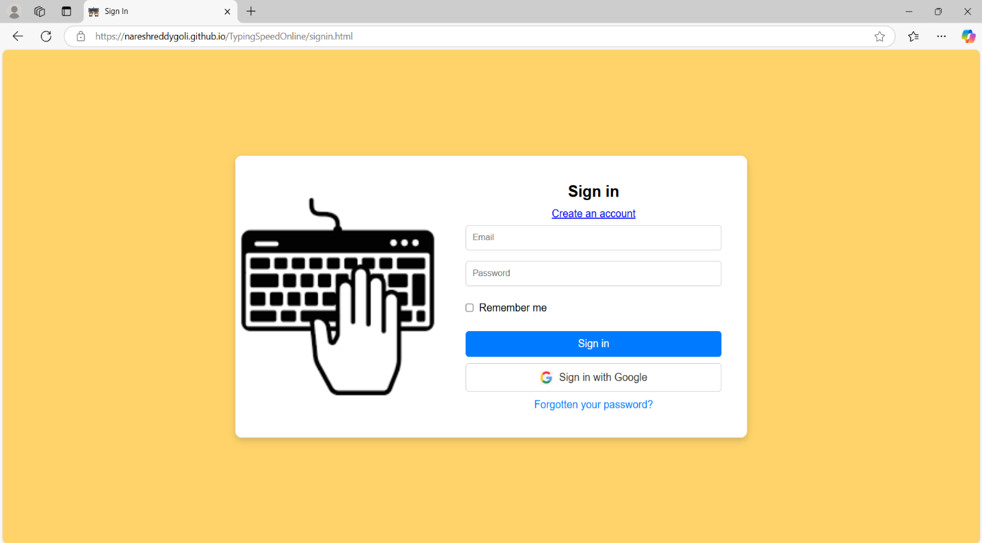

Home page:

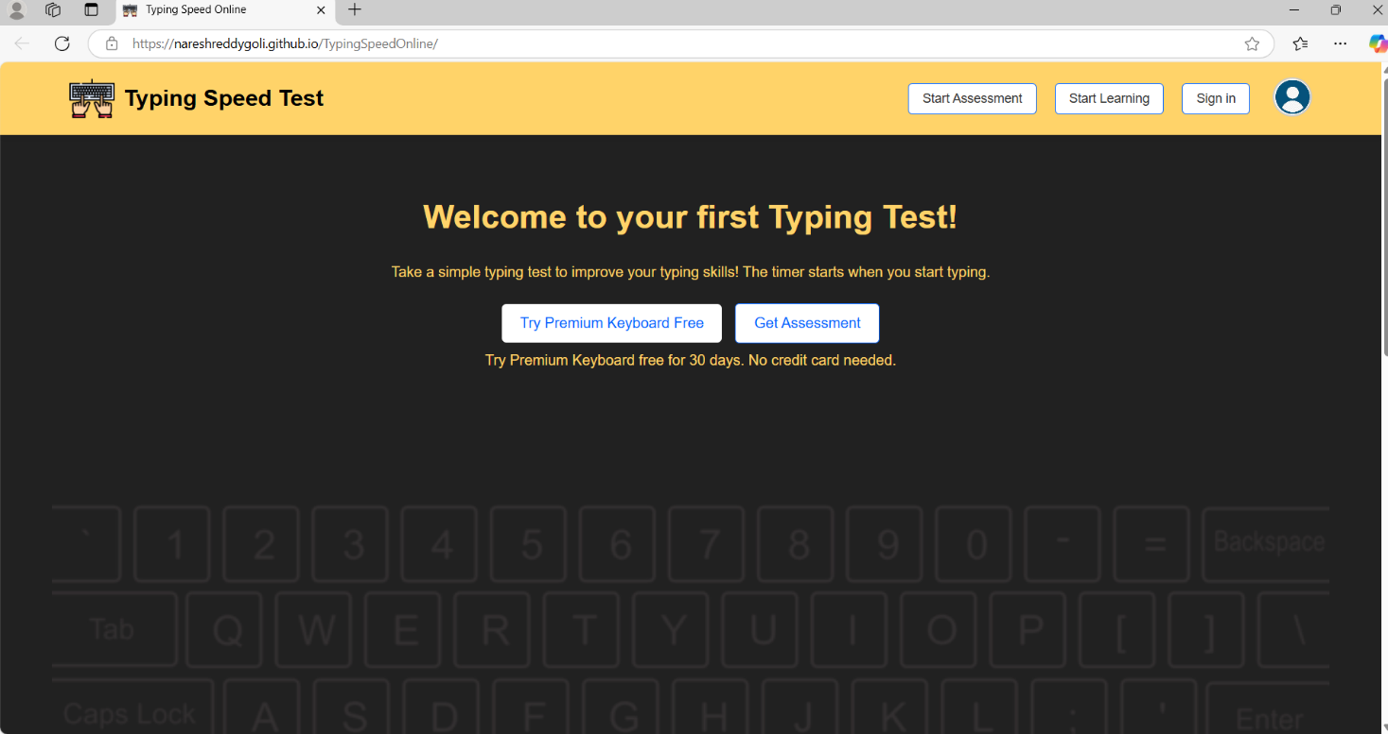

Assesment page:

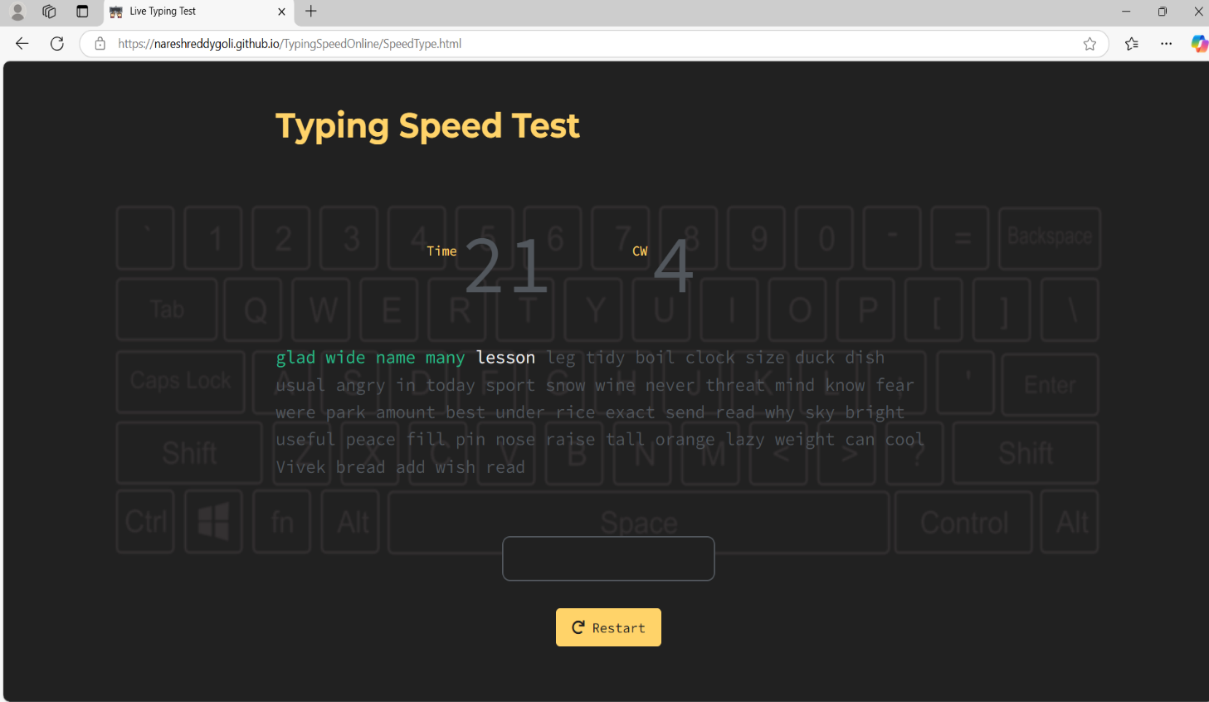

Score page:

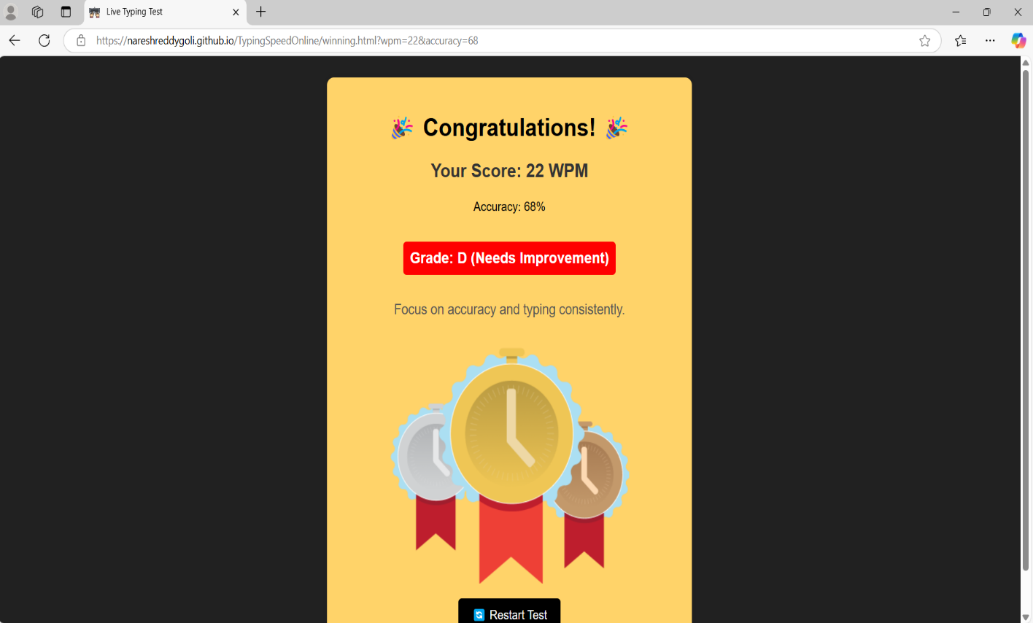

Premium Keyboard subscription page:

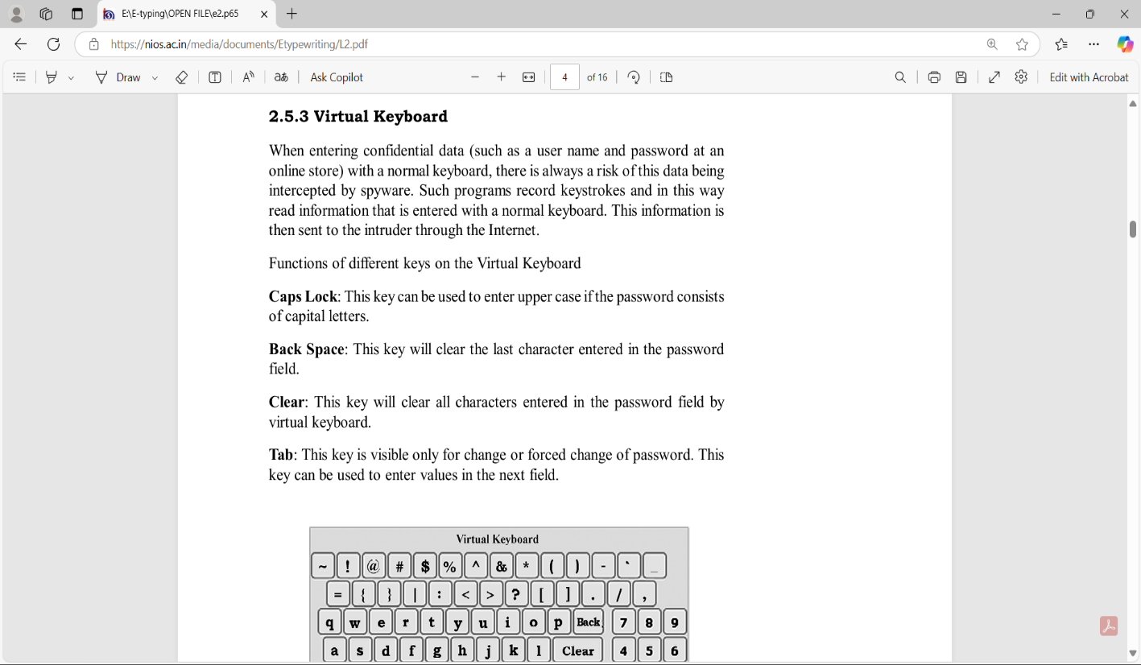

Guide lines page:

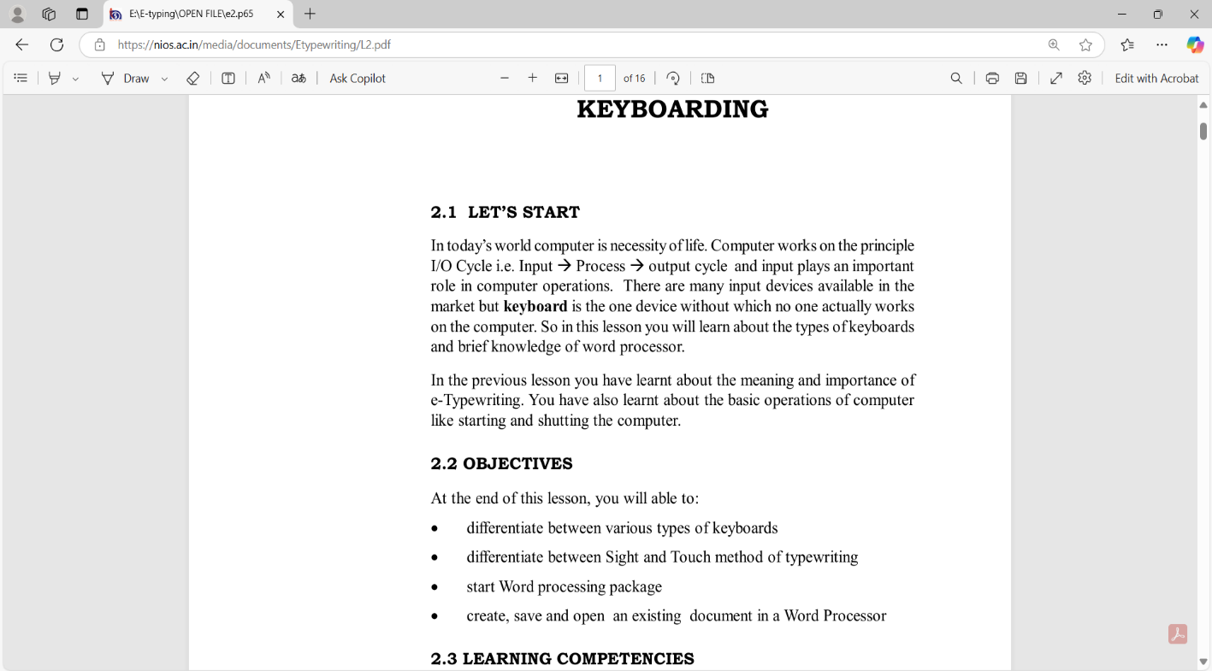

Terms and Agreement page:

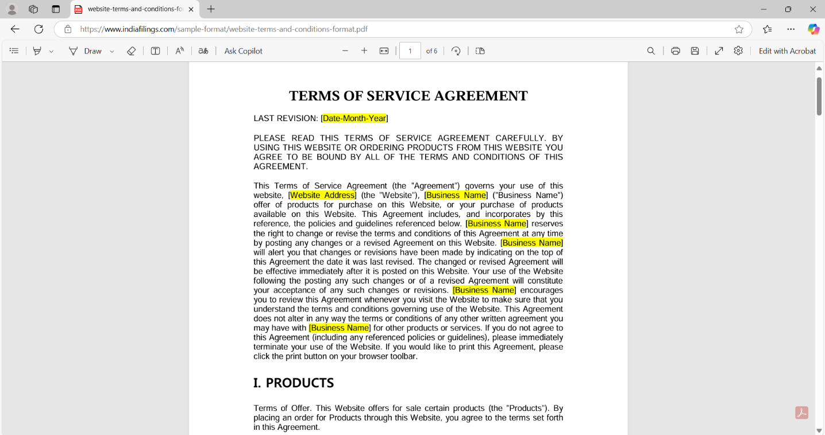

Feed Back page:

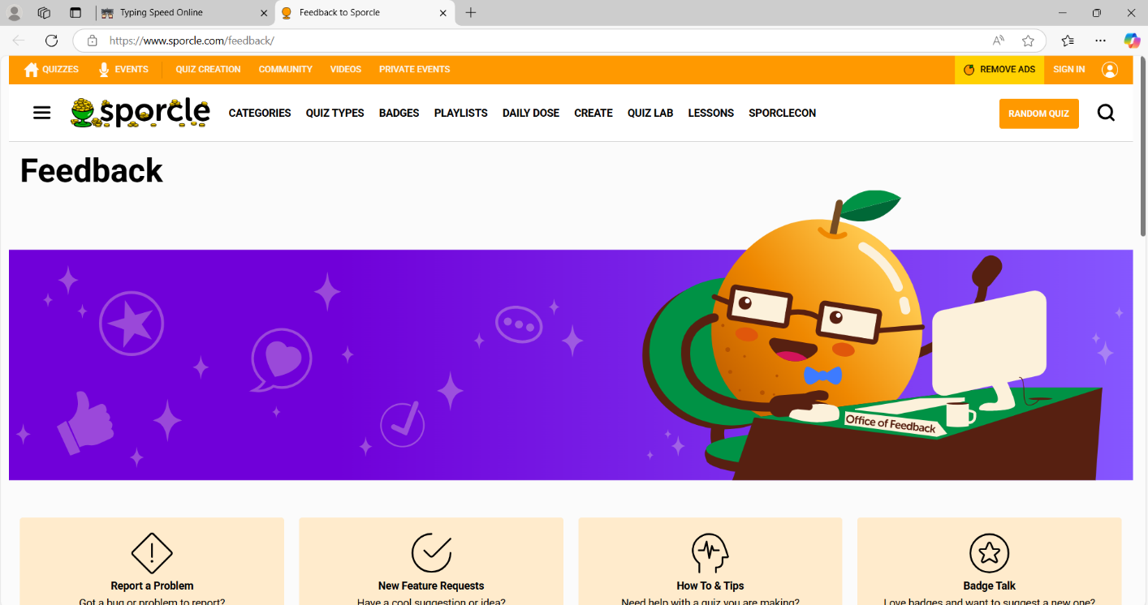

About page:

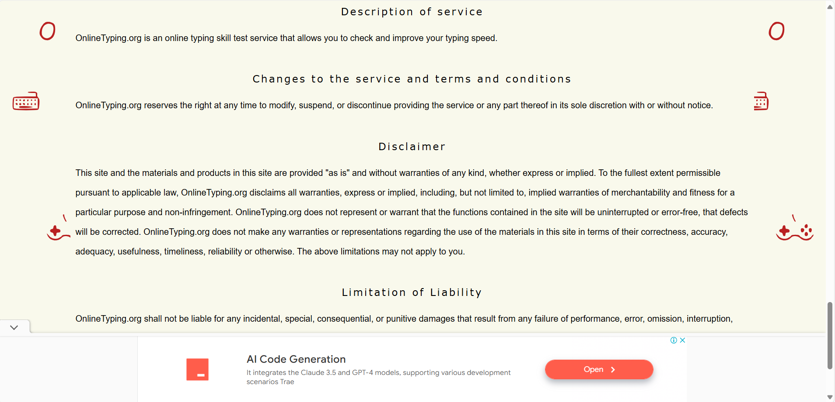

**4. Conclusion:**

This project involves the development of a web-based application designed to evaluate a user’s typing speed and accuracy. The system will measure words per minute (WPM), accuracy percentage, and error rates to provide a detailed assessment of the user’s typing proficiency. By offering real-time performance tracking, the application helps users identify their strengths and areas that need improvement. The goal is to create an engaging and interactive tool that enhances typing skills while making the learning process efficient and enjoyable.

The primary objectives of this project include developing an interactive platform where users can test and improve their typing skills while receiving real-time feedback on speed and accuracy. The system will feature various difficulty levels and test formats, including paragraphs, random words, and numbers, catering to different user needs. Additionally, user performance data will be stored and analyzed, enabling progress tracking and personalized insights to help users enhance their typing abilities over time.

Key features of the application include a simple and intuitive user interface, a typing test module with time-limited challenges, and automated WPM and accuracy calculations. The system will highlight errors, provide leaderboard rankings, and support user profiles for progress tracking. Multiple test modes with different difficulty levels will be available, along with dark mode support for enhanced usability. To further improve the user experience, the application will integrate learning modules that offer personalized suggestions to help users refine their typing skills.

**Project Link:**

<https://nareshreddygoli.github.io/TypingSpeedOnline/>

**References:**

**1. Books & Online Resources on Web Development**

Duckett, J. (2011). HTML & CSS: Design and Build Websites. John Wiley & Sons. (Great for understanding HTML and CSS basics for structuring and styling your project.)

lanagan, D. (2020). JavaScript: The Definitive Guide. O’Reilly Media. (Deep dive into JavaScript performance and optimization techniques.)

**2. Articles & Tutorials on Typing Speed Calculations**

GeeksforGeeks - How to Calculate Typing Speed in JavaScript (https://www.geeksforgeeks.org/how-to-create-a-typing-speed-test-using-javascript/)

W3Schools - JavaScript Event Listeners (https://www.w3schools.com/js/js_htmldom_eventlistener.asp) (Essential for tracking keystrokes and calculating WPM.)

These references we have used in designing, developing, and optimizing our project effectively