**Exercise 11: Implementing Dependency Injection**

**Scenario:**

You are developing a customer management application where the service class depends on a repository class. Use Dependency Injection to manage these dependencies.

**Customer.java :-**

package model;

public class Customer {

private final int id;

private final String name;

public Customer(int id, String name) {

this.id = id;

this.name = name;

}

public int getId() { return id; }

public String getName() { return name; }

@Override

public String toString() {

return "Customer [ID=" + id + ", Name=" + name + "]";

}

}

**CustomerRepository.java :-**

package repository;

import model.Customer;

public interface CustomerRepository {

Customer findCustomerById(int id);

}

**CustomerRepositoryImpl.java :-**

package repository;

import model.Customer;

public class CustomerRepositoryImpl implements CustomerRepository {

@Override

public Customer findCustomerById(int id) {

// Simulated database call

return new Customer(id, "Naresh Bairaboina");

}

}

**CustomerService.java :-**

package service;

import model.Customer;

import repository.CustomerRepository;

public class CustomerService {

    private final CustomerRepository repository;

    // ✅ Constructor-based Dependency Injection

    public CustomerService(CustomerRepository repository) {

        this.repository = repository;

    }

    public void displayCustomerById(int id) {

        Customer customer = repository.findCustomerById(id);

        System.out.println("Fetched Customer: " + customer);

    }

}

**Main.java :-**

import repository.CustomerRepository;

import repository.CustomerRepositoryImpl;

import service.CustomerService;

public class Main {

    public static void main(String[] args) {

        // Instantiate repository

        CustomerRepository repository = new CustomerRepositoryImpl();

        // Inject repository into service via constructor

        CustomerService service = new CustomerService(repository);

        // Use service to perform logic

        service.displayCustomerById(101);

    }

}

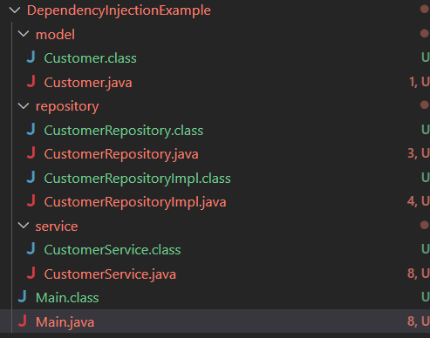

**Output :-**

