**Exercise 8: Implementing the Strategy Pattern**

**Scenario:**

You are developing a payment system where different payment methods (e.g., Credit Card, PayPal) can be selected at runtime. Use the Strategy Pattern to achieve this.

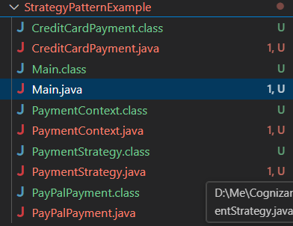

**Main.java :-**

public class Main {

    public static void main(String[] args) {

        PaymentContext context = new PaymentContext();

        // Using Credit Card Strategy

        PaymentStrategy creditCard = new CreditCardPayment("1234567890123456", "Naresh B.");

        context.setPaymentStrategy(creditCard);

        context.processPayment(4999.00);

        System.out.println("\n---------------------------\n");

        // Switching to PayPal Strategy

        PaymentStrategy paypal = new PayPalPayment("naresh@example.com");

        context.setPaymentStrategy(paypal);

        context.processPayment(2999.00);

    }

}

**CreditCardPayment.java :-**

public class CreditCardPayment implements PaymentStrategy {

    private final String cardNumber;

    private final String cardHolderName;

    public CreditCardPayment(String cardNumber, String cardHolderName) {

        this.cardNumber = cardNumber;

        this.cardHolderName = cardHolderName;

    }

    @Override

    public void pay(double amount) {

        System.out.println("Paid INR" + amount + " using Credit Card.");

        System.out.println("   Card Holder: " + cardHolderName);

        System.out.println("   Card Number: **** **** **** " + cardNumber.substring(cardNumber.length() - 4));

    }

}

**PaymentContext.java :-**

public class PaymentContext {

    private PaymentStrategy strategy;

    // Allows changing the payment method dynamically

    public void setPaymentStrategy(PaymentStrategy strategy) {

        this.strategy = strategy;

    }

    public void processPayment(double amount) {

        if (strategy == null) {

            throw new IllegalStateException("No payment strategy selected.");

        }

        strategy.pay(amount);

    }

}

**PaymentStrategy.java :-**

public interface PaymentStrategy {

    void pay(double amount);

}

**PayPalPayment.java :-**

public class PayPalPayment implements PaymentStrategy {

    private final String email;

    public PayPalPayment(String email) {

        this.email = email;

    }

    @Override

    public void pay(double amount) {

        System.out.println("Paid INR" + amount + " via PayPal.");

        System.out.println("   Account: " + email);

    }

}

**Output :-**

