San Francisco Real Estate Valuation

Naresh Kumar Mallela

University of New Haven
12/12/2025

Abstract
This report investigates the identification of undervalued residential properties in San Francisco’s post-2008 real estate market to support strategic investment decisions. Using a dataset of 1,396 property listings from February 2008 to July 2009, we applied predictive analytics to estimate fair market values and highlight investment opportunities. Multiple regression models were developed and evaluated, with Multiple Linear Regression emerging as the most accurate and generalizable approach.

Key findings reveal significant price deviations between predicted and listed values, enabling the identification of undervalued properties. Within a $7 million budget constraint, we recommend specific property combinations that maximize potential returns. This data-driven framework provides investors with a transparent, risk-aware methodology for real estate investment in volatile markets.

1. Introduction
San Francisco’s real estate market experienced dramatic fluctuations following the 2008 financial crisis, with home prices declining 20–30% by early 2009. This volatility created both uncertainty and opportunity for investors. The challenge lies in identifying properties that are fundamentally undervalued relative to their intrinsic worth, enabling strategic acquisitions during market downturns.
This project addresses the investment dilemma faced by Milton Campos, who seeks to allocate $7 million across three San Francisco properties in August 2009. Without real estate or quantitative analysis expertise, he requires a data-driven methodology to objectively assess property values and optimize his investment portfolio for medium-term profitability.

Previous research highlights the effectiveness of regression-based approaches in real estate valuation. Miller and Geltner (2005) demonstrate that hedonic pricing models, which decompose property value into constituent characteristics, provide reliable estimates in residential markets. Their work validates the use of features such as square footage, bedroom count, and location as key value determinants.
Following the 2008 crisis, studies like Shiller (2012) emphasize the importance of temporal market analysis, showing that post-crisis periods present unique buying opportunities due to emotional selling and price dislocations. Additionally, Kauffman and Lee (2015) compare multiple valuation techniques in volatile markets, finding that simpler linear models often outperform complex alternatives in generalization and interpretability.

2. Data Collection and Preparation
The analysis is based on the “San Francisco Properties” dataset (XLS924-XLS-ENG.xlsx), which includes 1,396 listings described by 12 attributes. These attributes cover numerical variables such as Price, Bedrooms, Square Feet, and Lot Size; categorical variables including Neighborhood (Low/Medium/High), Zip Code, and Loft (0/1); temporal variables such as the Listing Date; and an identifier, Property ID. Data preparation involved three major steps. First, categorical fields (Neighborhood, Zip Code, Loft) were converted to factor types to ensure correct handling during modeling.

Figure 1
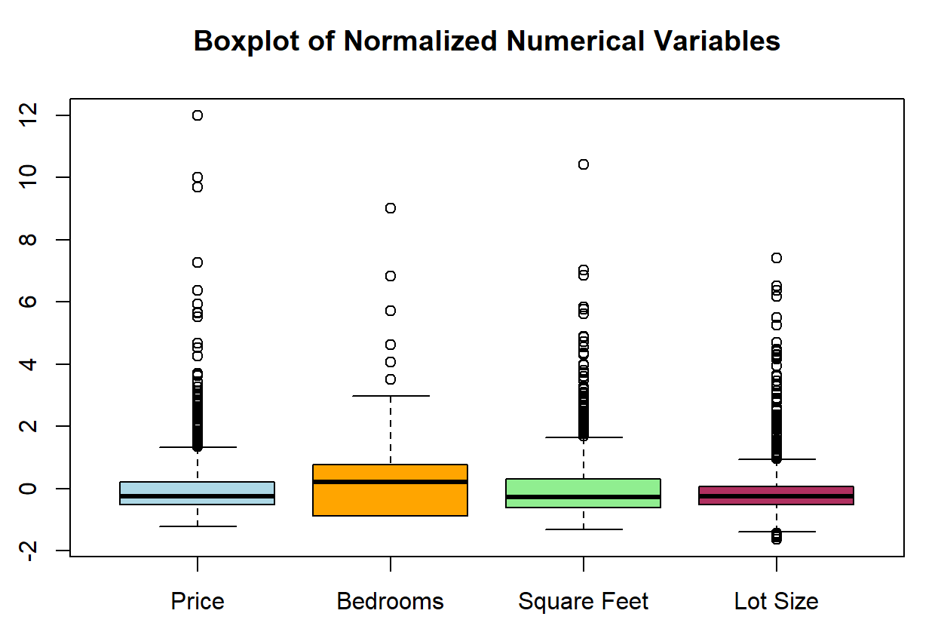
Second, outliers (figure 1) in Price, Bedrooms, Square Feet, and Lot Size were treated using IQR-based capping to reduce skewness while preserving valid observations. Third, a log transformation was applied to Price to correct right-skewness and enhance model stability. The dataset contained no missing values, confirming its completeness.

The tools used in this project include:
- R: statistical data cleaning, transformation, and model preparation.
- Power BI: Visualizing the performance of models, Housing investment suggestions
The outcome is a predictive model that estimates the value of a property given its features and location, along with insights on which variables are most influential in determining prices.

3. Methodology
This study applies predictive analytics to estimate property values using intrinsic property characteristics, with the objective of comparing model-predicted fair market values to actual listing prices in order to identify undervalued investment opportunities. Three regression algorithms were developed and evaluated: Multiple Linear Regression, which serves as the baseline model using all selected predictors; Stepwise Regression, which iteratively selects the most relevant predictors to improve model efficiency; and a Regression Tree model, which captures non-linear relationships through hierarchical data partitioning. The dataset was split into a 70/30 ratio for training and validation, and model performance was assessed using Root Mean Square Error (RMSE) across both sets to measure predictive accuracy and generalization capability.

4. Findings and Discussion
4.1 Model Performance
The following bar chart(figure 2) summarizes model performance:
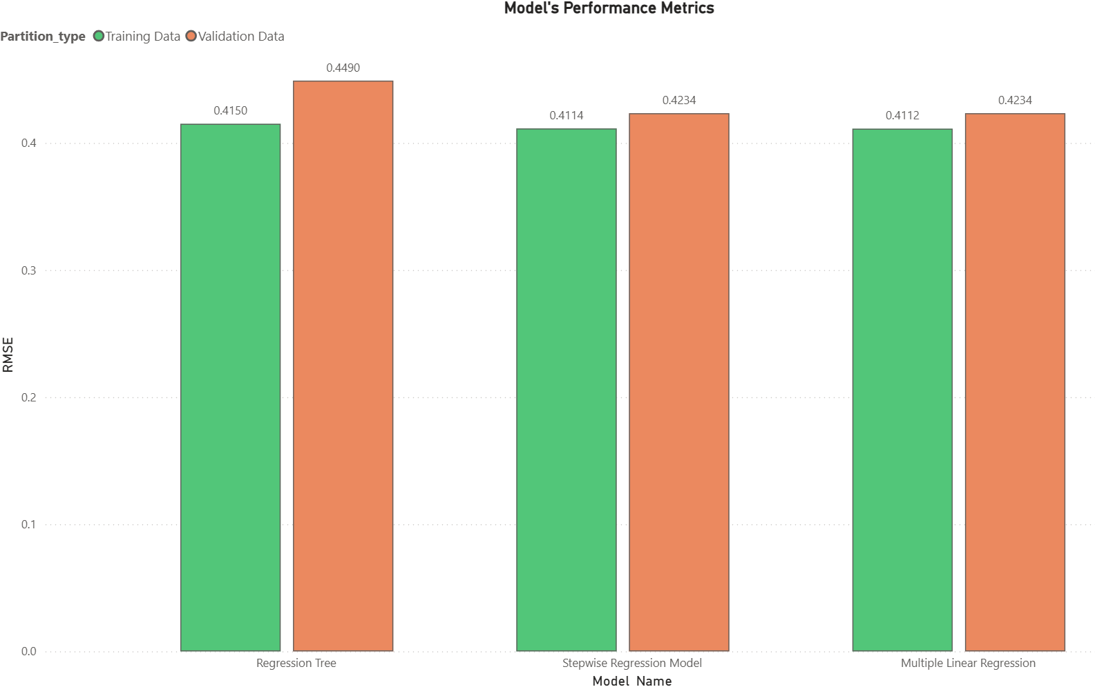
Multiple Linear Regression demonstrated the lowest and most stable RMSE across both partitions, indicating strong generalization without overfitting. Its simplicity and interpretability further support its selection as the final model.
4.2 Investment Opportunity Identification
Using the equation:
Price Deviation = Predicted Price – Actual Price
properties with positive deviations were flagged as undervalued. The top 10 three-property combinations(figure 3) within the $7 million budget were ranked by total deviation:

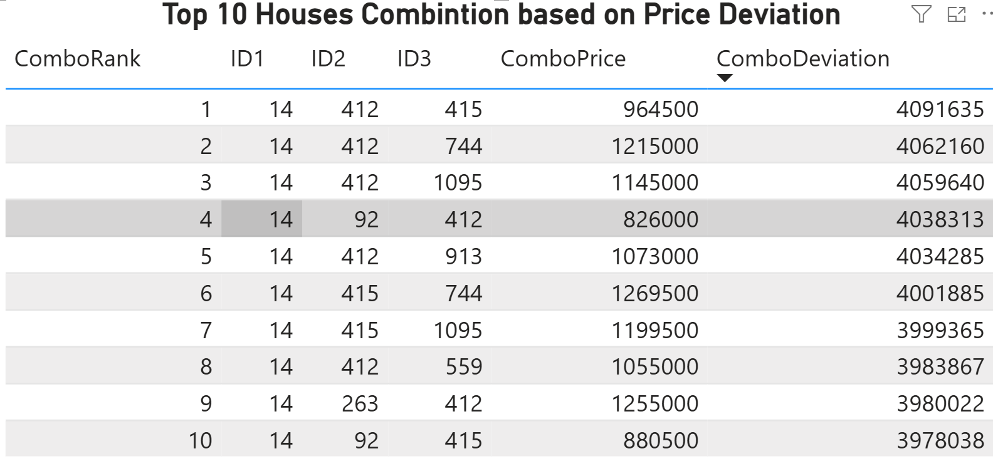

The model offers Milton Campos an objective, data-driven framework to support informed investment decisions. It helps maximize returns by identifying properties with the highest positive deviation between predicted and actual values, while also minimizing risk through statistical validation and robustness checks. Additionally, the approach ensures adherence to budget constraints by evaluating combinations of properties rather than assessing them individually. The methodology provides key strengths such as transparency, reproducibility, and strong predictive accuracy; however, it also carries limitations, including a dependence on historical data and the inability to incorporate future market shifts or qualitative attributes like property condition or curb appeal. Implementation may also present challenges, as the model requires periodic retraining with updated data and assumes stability in the underlying market relationships over time.

4. Conclusion

This project successfully developed a predictive valuation model aimed at identifying undervalued properties in post-crisis San Francisco, with Multiple Linear Regression emerging as the most effective approach. The model enabled the selection of three-property combinations that maximize investment potential while adhering to a $7 million budget. Looking forward, several opportunities exist to enhance the analysis: incorporating temporal elements to capture price trajectories over time, expanding the feature set to include macroeconomic indicators such as interest rates and employment trends, and exploring advanced modeling techniques like ensemble methods or neural networks to better account for complex non-linear relationships. Additionally, integrating geospatial data could improve valuation accuracy by capturing location-based effects. Overall, the framework developed in this study can be extended to other dynamic real estate markets, offering investors a systematic and data-driven method for identifying opportunities in uncertain economic conditions.

References

- Said, Carolyn. (2014, May 19). S.F. home prices soar to record highs. San Francisco Chronicle.
- Federal Reserve Bank of St. Louis. (n.d.). S&P/Case-Shiller CA-San Francisco Home Price Index [SFXRSA]. FRED, Federal Reserve Bank of St. Louis. Retrieved October 26, 2023, from https://fred.stlouisfed.org/series/SFXRSA.

