-- Retrieve all categories  
SELECT * FROM Category**;**

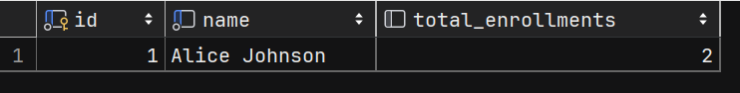

-- Retrieve a category by its ID  
SELECT * FROM Category c WHERE c.id = **1;**

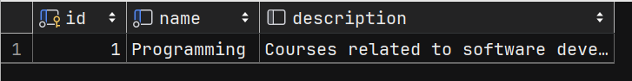

-- Retrieve a category by its name  
SELECT * FROM Category c WHERE *LOWER*(c.name) = 'data science'**;**

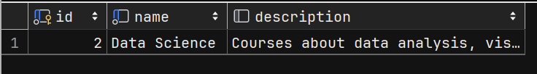

-- Finds all courses in the database  
SELECT * FROM Course c**;**

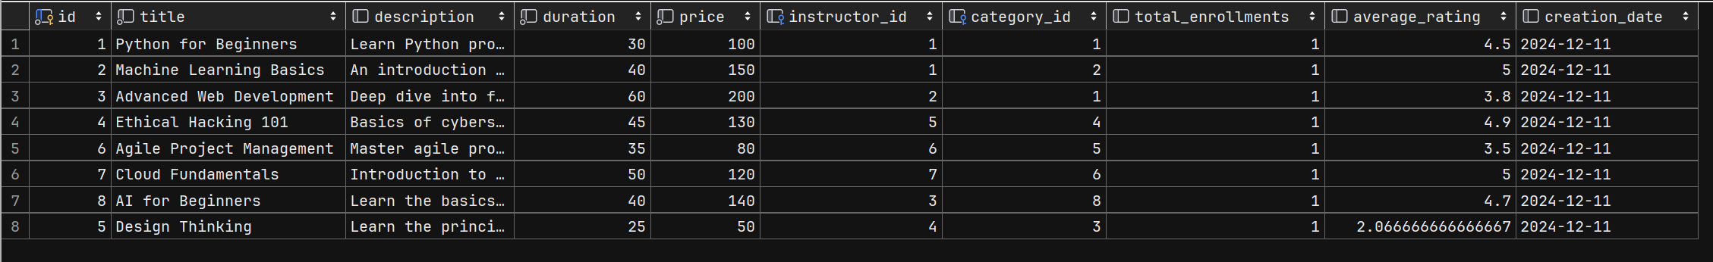

-- Retrieves the total number of courses in the database  
SELECT *COUNT*(c) FROM Course c**;**

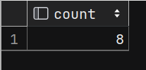

-- Finds courses sorted by title in ascending order  
SELECT * FROM Course c ORDER BY *LOWER*(c.title) ASC**;**

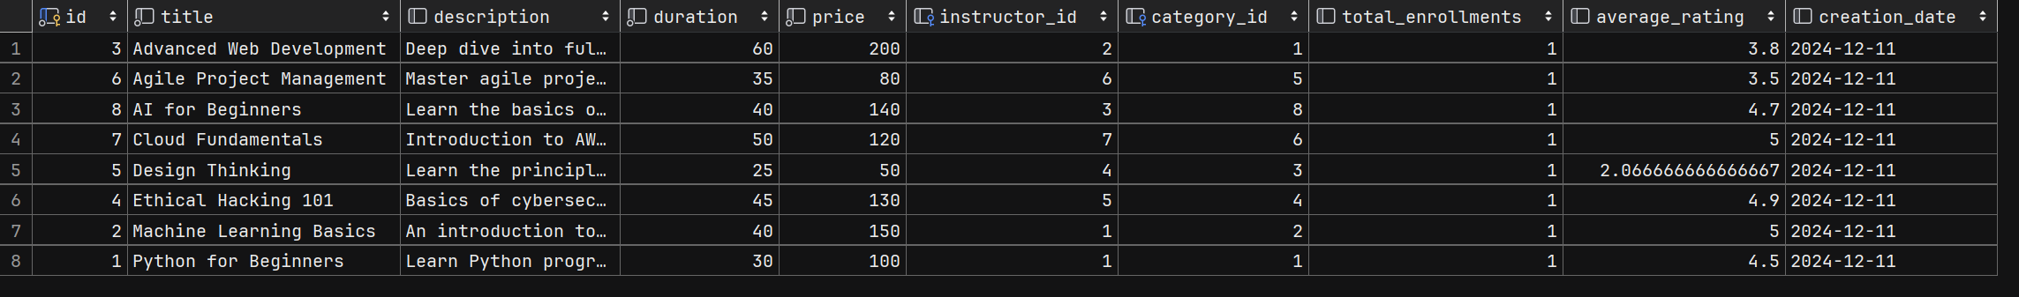

-- Finds courses with a price greater than a specific amount  
SELECT * FROM Course c WHERE c.price > **100;**

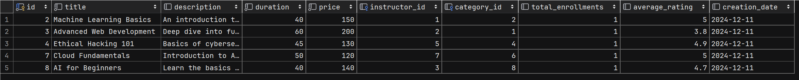

-- Finds courses with a rating greater than a specific value  
SELECT * FROM Course c WHERE c.average_rating BETWEEN **3** AND **5;**

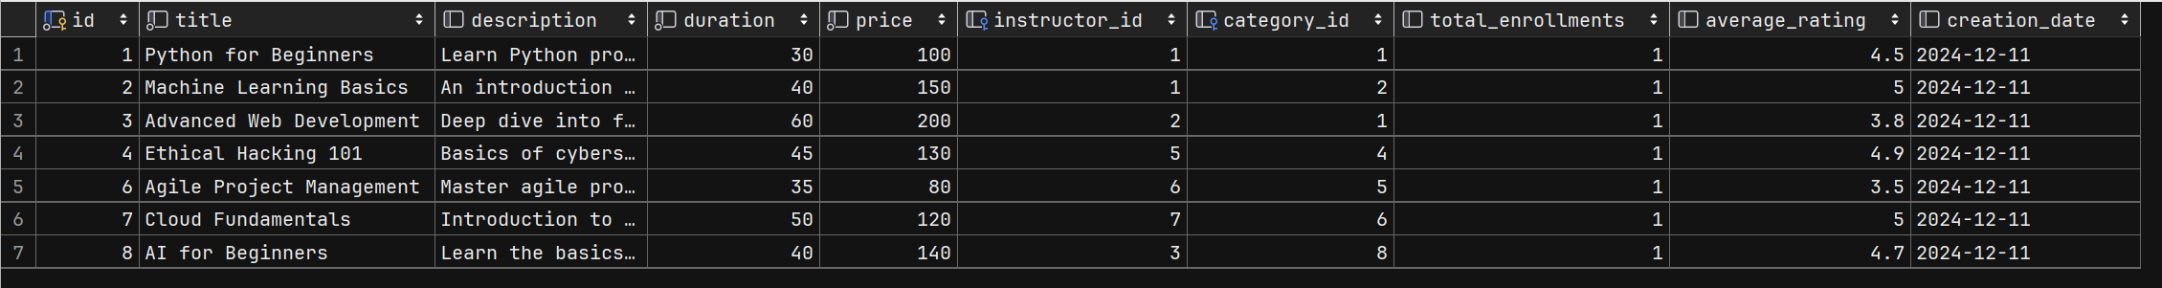

-- Finds courses by instructor ID  
SELECT * FROM Course c WHERE c.instructor_id = **1;**



-- Finds courses by student ID from the enrollment table:  
SELECT c.*  
FROM Course c  
 JOIN Enrollment e ON c.id = e.course_id  
WHERE e.student_id = **1;**



-- Finds the course with the most total enrollments  
SELECT c.id**,** c.title**,** c.total_enrollments FROM Course c  
WHERE c.total_enrollments = (  
 SELECT *MAX*(total_enrollments)  
 FROM Course  
)**;**

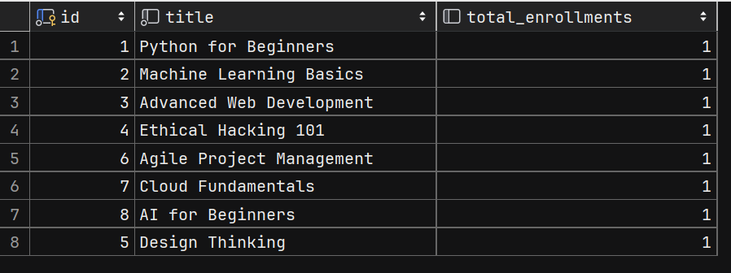

-- Retrieve feedback by student name  
SELECT f.*  
FROM Feedback f  
 JOIN Student s ON f.student_id = s.id  
 WHERE s.id = f.student_id**;**

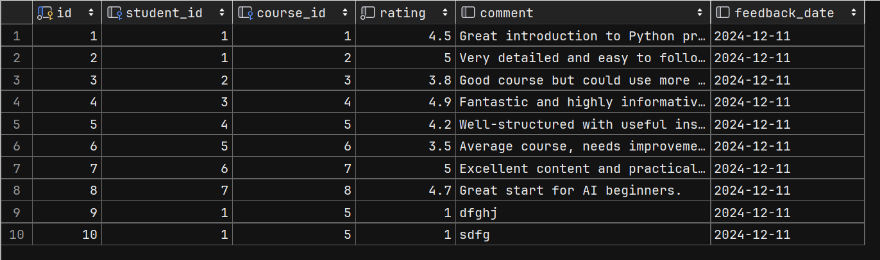

-- Retrieve feedback by course name  
SELECT f.*  
FROM Feedback f  
 JOIN Course c ON f.course_id = c.id  
WHERE *LOWER*(c.title) LIKE 'ai for beginners'**;**



-- Retrieve feedback with the highest rating  
SELECT f.*  
FROM Feedback f  
WHERE f.rating = (SELECT *MAX*(rating) FROM Feedback)**;**



-- Retrieve an instructor by its ID  
SELECT * FROM Instructor i WHERE i.id = **1;**



-- Finds instructors whose names contain the specified string  
SELECT * FROM Instructor i WHERE *LOWER*(i.name) LIKE *LOWER*(*CONCAT*('%'**,** 'john'**,** '%'))**;**

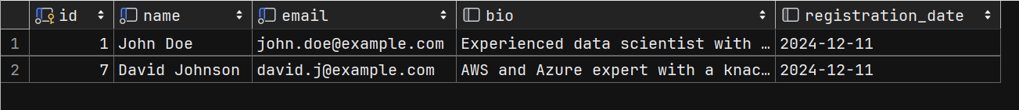

-- Finds student by name  
SELECT * FROM Student s WHERE s.name = 'Alice Johnson'**;**



-- Finds students with more enrollments  
SELECT s.id**,** s.name**,** *COUNT*(e.student_id) AS total_enrollments  
FROM Student s  
 JOIN Enrollment e ON s.id = e.student_id  
GROUP BY s.id**,** s.name  
HAVING *COUNT*(e.student_id) > **1;**

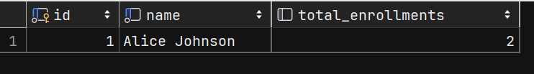

SELECT s.id**,** s.name, e.enrollment_date  
FROM Student s  
 JOIN Enrollment e ON s.id = e.student_id  
 JOIN Course c ON e.course_id = c.id  
WHERE *LOWER*(c.title) = *LOWER*('Machine Learning Basics')**;**

