重要連結:
對戰平台:140.124.184.220:8000
範例程式碼: https://github.com/t114598038/dark_chess_sample
編譯方式: gcc 程式檔名 -o 程式檔名 -lws2_32
規則限制:
- 誰先翻就什麼顏色
- 翻開才能被吃跟動
- 棋子（除炮之外）只能橫向或縱向移動一步到相鄰格
- 不能連吃
- 50步沒有吃或翻就和局(伺服器自動判定)
- 將/帥 > 士/仕 > 象/相 > 車/俥 > 馬/傌 > 砲/炮 > 卒/兵
- 同級可互吃
- 尺寸4*8
- 砲/炮：吃子時，中間必須相隔一個棋子（無論明暗），移動時不能跳躍
- 兵/卒： 兵/卒可以吃將/帥; 帥/將不能吃兵/卒
- 若傳送了不合法的指令，直接判輸
- 棋子對照表
紅方棋子 (Red)
Red_King (帥)、Red_Guard (仕)、Red_Elephant (相) 、Red_Car (俥) 、Red_Horse (傌) 、Red_Cannon (炮) 、Red_Soldier (兵)
黑方棋子 (Black)
Black_King (將) 、Black_Guard (士) 、Black_Elephant (象) 、Black_Car (車) 、Black_Horse (馬) 、Black_Cannon (砲) 、Black_Soldier (卒)
特殊狀態
Covered：尚未翻開的棋子（覆蓋狀態）。
Null：該格目前沒有棋子（空格）

測試說明:
- 創建房間:先輸入房號，之後按下建立房間
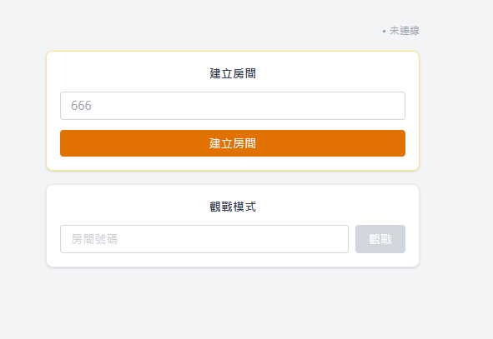
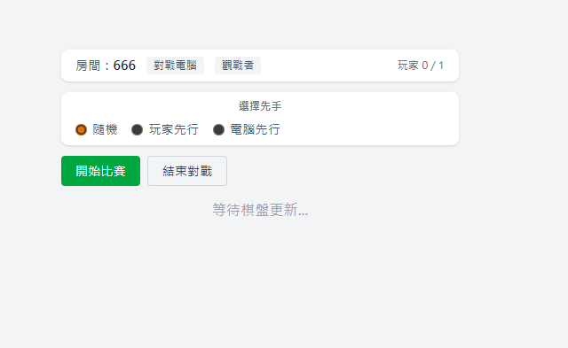
- 執行自己的C程式:
輸入: JOIN 房號來加入房間
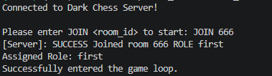
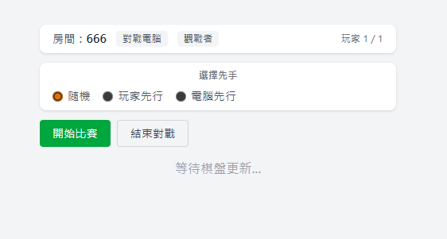
- 選擇先後手，並按下比賽開始，對戰就會開始
- 結束對戰之後按結束對戰退出房間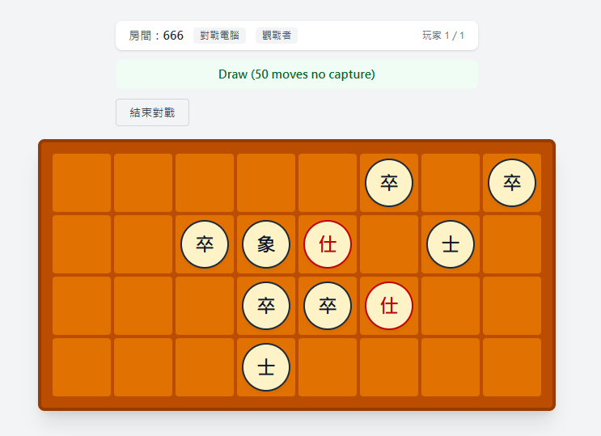
註:
- 目前房間號碼用過就不能重複用，所以會在半夜4點重啟系統
- 如果輸入違規指令將會判輸

程式說明:
需要實作make_move function:
輸入:
JOIN 比賽後會收到初始化的棋盤
UPDATE {"room_id": "666", "state": "waiting", "mode": "ai", "player_count": 1, "current_turn": null, "current_turn_role": null, "board": [], "color_table": {}, "total_moves": 0}
- room_id : 房間id
- state : 比賽狀態
- mode : 雙人或是單人對戰
- player_count : 玩家人數
- current_turn : 當前是誰的回合
- current_turn_role : 當前回合的角色是A還是B
- board : 棋盤狀態
- color_table : A、B分別是甚麼顏色
- total_moves : 總移動步數
開始比賽會收到初始化棋盤
UPDATE {"room_id": "666", "state": "playing", "mode": "ai", "player_count": 1, "current_turn": "AI_PLAYER", "current_turn_role": "B", "board": [["Covered", "Covered", "Covered", "Covered", "Covered", "Covered", "Covered", "Covered"], ["Covered", "Covered", "Covered", "Covered", "Covered", "Covered", "Covered", "Covered"], ["Covered", "Covered", "Covered", "Covered", "Covered", "Covered", "Covered", "Covered"], ["Covered", "Covered", "Covered", "Covered", "Covered", "Covered", "Covered", "Covered"]], "color_table": {}, "total_moves": 0}
第一個人翻棋會決定紅黑色
UPDATE {"room_id": "666", "state": "playing", "mode": "ai", "player_count": 1, "current_turn": "140.124.4.103:25058", "current_turn_role": "A", "board": [["Covered", "Covered", "Covered", "Covered", "Covered", "Covered", "Covered", "Covered"], ["Covered", "Covered", "Covered", "Black_Elephant", "Covered", "Covered", "Covered", "Covered"], ["Covered", "Covered", "Covered", "Covered", "Covered", "Covered", "Covered", "Covered"], ["Covered", "Covered", "Covered", "Covered", "Covered", "Covered", "Covered", "Covered"]], "color_table": {"B": "Black", "A": "Red"}, "total_moves": 1}
接下來就輪流執行旗子
輸出:
char action[32];
//走、吃或是翻旗子
sprintf(action, "%d %d %d %d\n", r, c, tr, tc); 或 sprintf(action, "%d %d\n", i / 8, i % 8);
Sleep(2000);
send_action(action); //將指令送入程式
輔助函數:
void get_piece_at(const char* json, int index, char* out_piece) {}
可以拿到棋盤上特定位置的棋子(棋子由左至右由上到下為0-31)
0~7
8~15
9~22
23~31

void get_role_color(const char* json, const char* role, char* out_color) {}
獲取指定角色 (A 或 B) 的顏色 (Red 或 Black)
註:如果回傳None代表還未開始，需先翻棋

