HABIBON, FAIZER A.
HASSAN, SHYNIEMAR A.
DE GUZMAN, FRED RITZ..
CAASI, CHRISTIAN JAY.
BSIT 3C
Activity 1 – Software Installation
Installing Jupyter Notebook
1. Go to the link provided to download the Anaconda Distribution (~500 MB Download)
https://www.anaconda.com/products/distribution



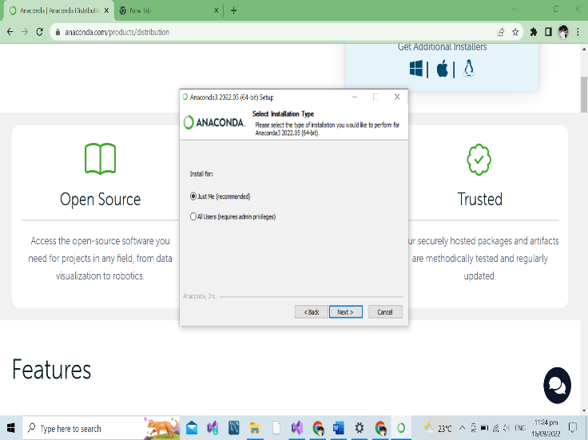
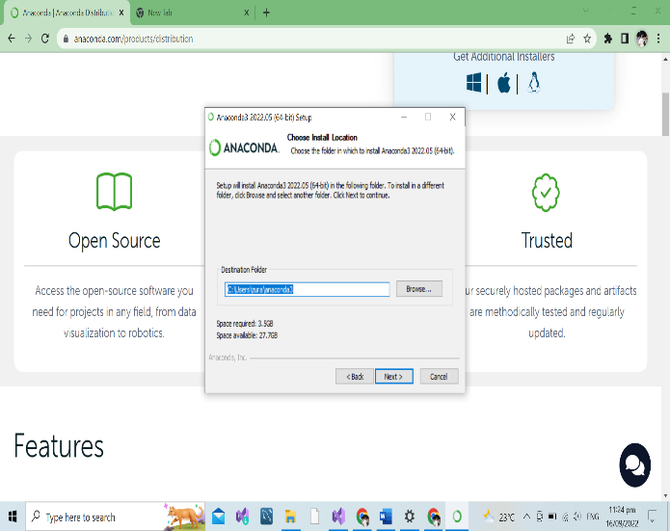
2. Run the run the setup .exe that you just downloaded. Click “Next” continuously and then click “Install” (Note: Leave both ‘Advanced Options’ unchecked).
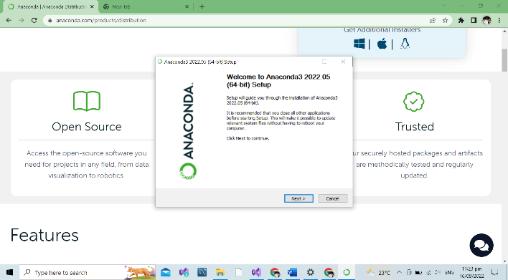
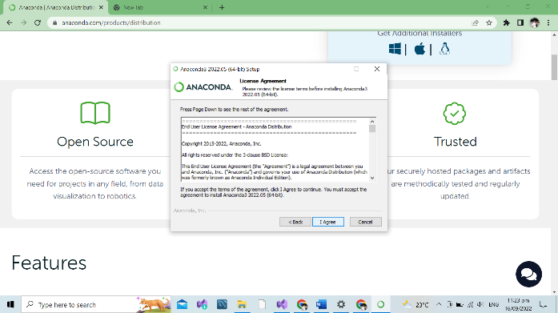
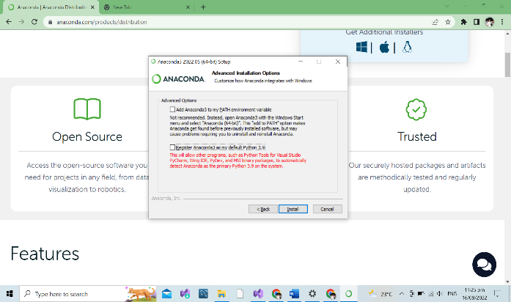
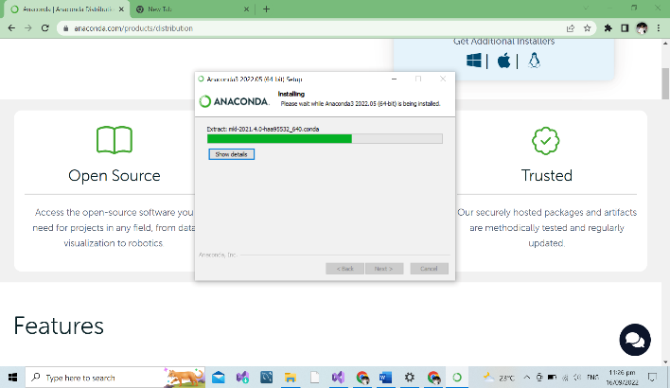

NOTE: THE INSTALL MIGHT TAKE A WHILE, PLEASE LET IT RUN WHILE IT IS INSTALLING. IT MAY LOOK AS IF THE INSTALL HAS CRASHED/STOPPED, BUT IT WILL STILL BE RUNNING.
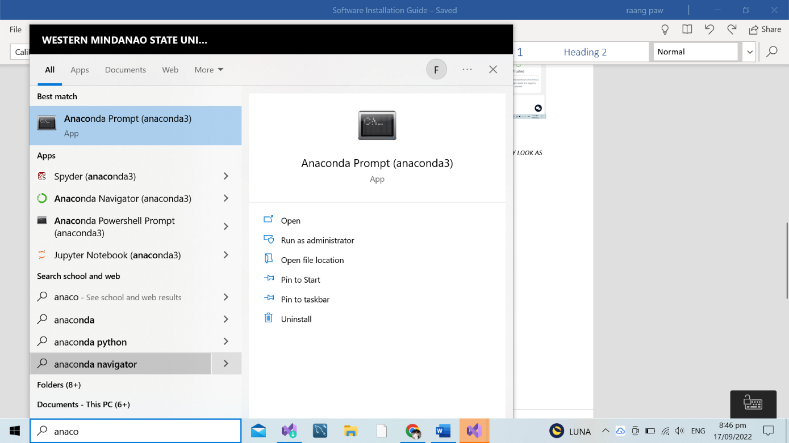
3. On the search bar of your OS, type “Anaconda Prompt” and run it.

4. On the terminal that pops up, type “jupyter notebook” without the quotation marks.
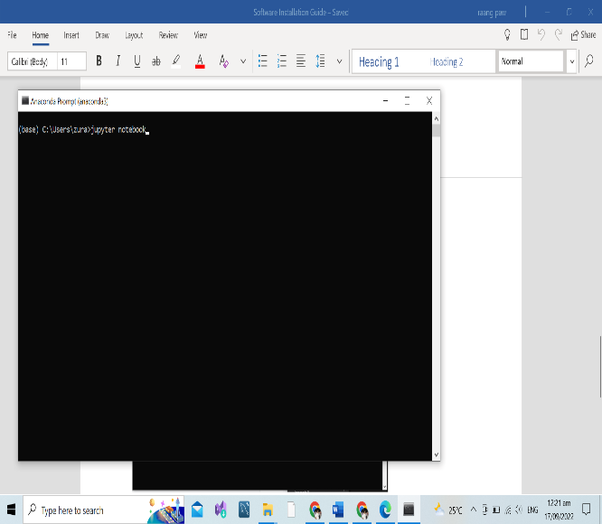
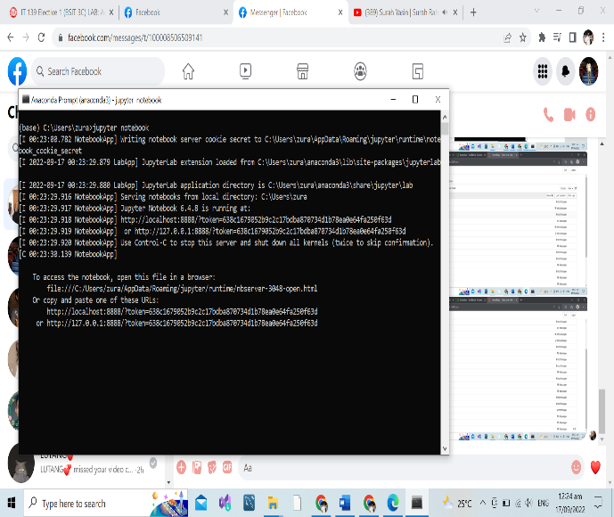

5. Take a screenshot of the page that pops up on your browser.
