Лабораторная работа №2

Самойлов Александр

Задание 1

я хочу бутерброд с сыром

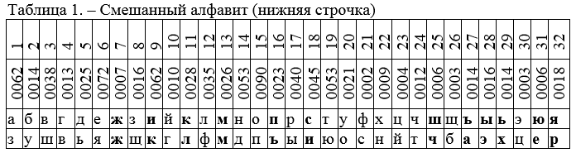

|  |  |  |  |  |  |  |  |  |  |  |  |  |  |  |  |  |  |  |  |  |  |
| --- | --- | --- | --- | --- | --- | --- | --- | --- | --- | --- | --- | --- | --- | --- | --- | --- | --- | --- | --- | --- | --- |
| ИТ | = | Я | Х | О | Ч | У | Б | У | Т | Е | Р | Б | Р | О | Д | С | С | Ы | Р | О | М |
| ШТ | = | Р | Н | П | Т | О | У | О | Ю | Я | Ы | У | Ы | П | Ь | И | И | Э | Ы | П | М |

ИТОГ РНПТОУОЮЯЫУЫПЬИИЭПМ

Задание 2

я хочу бутерброд с сыром

|  |  |  |  |  |  |  |  |  |  |  |  |  |  |  |  |  |  |  |  |  |
| --- | --- | --- | --- | --- | --- | --- | --- | --- | --- | --- | --- | --- | --- | --- | --- | --- | --- | --- | --- | --- |
| ИТ | Я | Х | О | Ч | У | Б | У | Т | Е | Р | Б | Р | О | Д | С | С | Ы | Р | О | М |
| Ключ | М | Ы | Ш | Ь | М | Ы | Ш | Ь | М | Ы | Ш | Ь | М | Ы | Ш | Ь | М | Ы | Ш | Ь |
| ШТ | М | Э | Б | Х | М | Э | Б | Х | М | Э | Б | Х | М | Э | Б | Х | М | Э | Б | Х |

ИТОГ МЭБХМЭБХМЭБХМЭБХМЭБХ

Задание 4

я хочу бутерброд с сыром

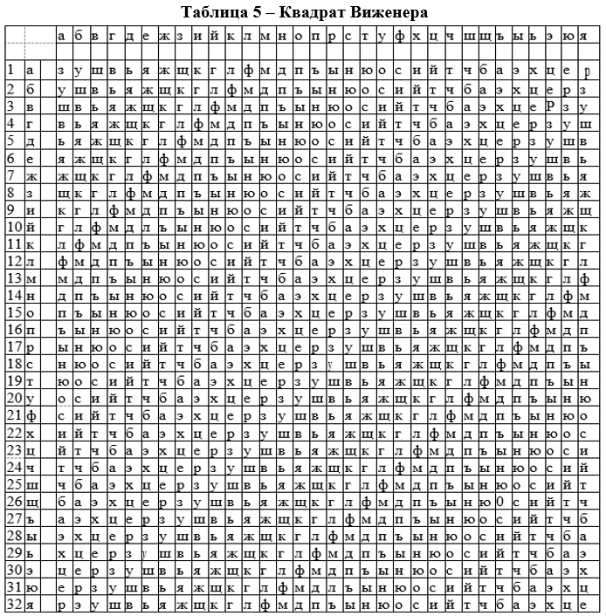

|  |  |  |  |  |  |  |  |  |  |  |  |  |  |  |  |  |  |  |  |  |
| --- | --- | --- | --- | --- | --- | --- | --- | --- | --- | --- | --- | --- | --- | --- | --- | --- | --- | --- | --- | --- |
| ИТ | Я | Х | О | Ч | У | Б | У | Т | Е | Р | Б | Р | О | Д | С | С | Ы | Р | О | М |
| Ключ | М | И | Н | С | К | М | И | Н | С | К | М | И | Н | С | К | М | И | Н | С | К |
| ШТ | ф | ц | э | к | ц | д | э | р | й | а | д | ч | э | и | э | ц | в | ц | р | й |

ИТОГ ФЦЭКЦДЭРЙАДЧЭИЭЦВЦРЦ

Задание 5

|  |  |  |  |  |  |  |  |  |  |  |  |  |  |  |  |  |  |  |  |  |
| --- | --- | --- | --- | --- | --- | --- | --- | --- | --- | --- | --- | --- | --- | --- | --- | --- | --- | --- | --- | --- |
| ИТ | Я | Х | О | Ч | У | Б | У | Т | Е | Р | Б | Р | О | Д | С | С | Ы | Р | О | М |
| Ключ | Б | О | Ч | К | А | Б | О | Ч | К | А | Б | О | Ч | К | А | Б | О | Ч | К | А |
| ШТ | э | в | я | у | о | ш | у | г | ъ | ы | ш | е | я | п | н | ю | г | щ | ч | м |
| ПЗ | 1 | 2 | 3 | 4 | 5 | 6 | 7 | 8 | 9 | 10 | 11 | 12 | 13 | 14 | 15 | 16 | 17 | 18 | 19 | 20 |

|  |  |  |  |  |  |  |  |  |  |
| --- | --- | --- | --- | --- | --- | --- | --- | --- | --- |
| L = 5 | | | | | | | | | |
| М = 1 | | М = 2 | | М = 3 | | М = 4 | | М = 5 | |
| Б | | О | | Ч | | К | | А | |
| Буква | Кол-во | Буква | Кол-во | Буква | Кол-во | Буква | Кол-во | Буква | Кол-во |
| I = 1 Э | 1 | В | 1 | Я | 1 | У | 1 | О | 1 |
| I = 2 Ш | 1 | У | 1 | Ъ | 1 | Ы | 1 | Ш | 1 |
| I = 3 Е | 1 | Я | 1 | П | 1 | Н | 1 | Ю | 1 |
| I = 4 Г | 1 | Щ | 1 | Ч | 1 | М | 1 |  |  |

|  |  |  |  |  |  |  |
| --- | --- | --- | --- | --- | --- | --- |
|  |  | 1 | 2 | 3 | 4 | 5 |
|  |  | Б | О | Ч | К | А |
| 1 | Б | 0 | -12 | -21 | -8 | 1 |
| 2 | О |  | 0 | -8 | -3 | 13 |
| 3 | Ч |  |  | 0 | 12 | 22 |
| 4 | К |  |  |  | 0 | 10 |
| 5 | А |  |  |  |  | 0 |