Character Stream class:

**1.what is character stream class?**

Character Stream Classes are used to read characters from the source and write **characters** to destination.

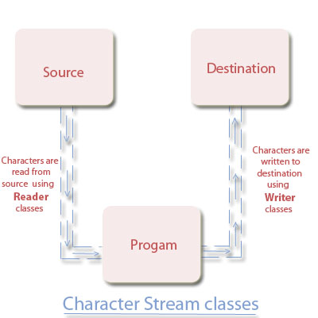

**2.types of character classes:**

**1.Reader Classes**

**2.Writer Classes**

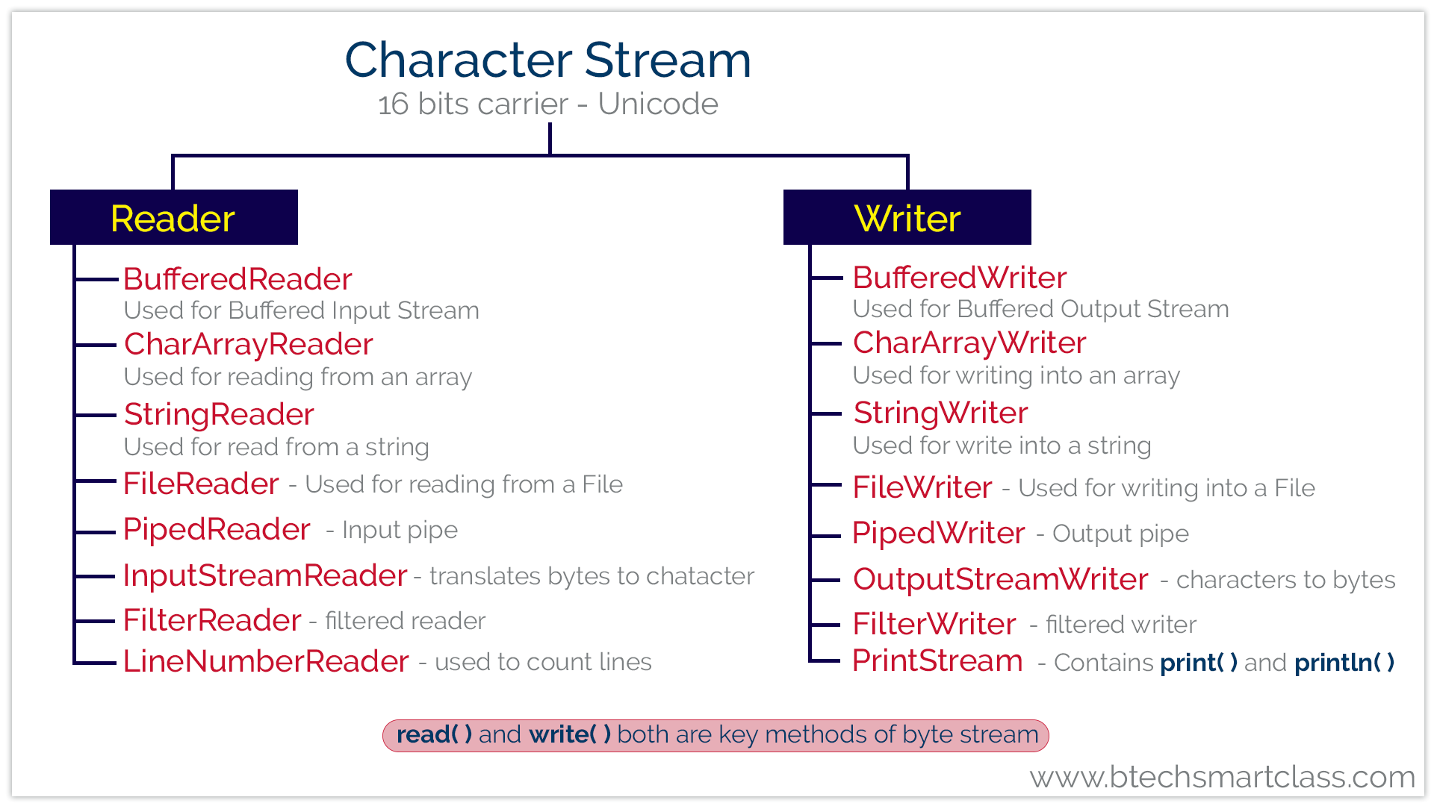

| **S.No.** | **Method with Description** |
| --- | --- |
| 1 | **int read()**  It reads the next character from the input stream. |
| 2 | **int read(char[] cbuffer)**  It reads a chunk of charaters from the input stream and store them in its byte array, cbuffer. |
| 3 | **int read(char[] cbuf, int off, int len)**  It reads charaters into a portion of an array. |
|  |  |
| 4 | **int read(CharBuffer target)**  It reads charaters into the specified character buffer. |
| 5 | **String readLine()**  It reads a line of text. A line is considered to be terminated by any oneof a line feed ('\n'), a carriage return ('\r'), or a carriage returnfollowed immediately by a linefeed. |
| 6 | **boolean ready()**  It tells whether the stream is ready to be read. |
| 7 | **void close()**  It closes the input stream and also frees any resources connected with this input stream. |

**Writer class**

The Writer class has defined as an abstract class, and it has the following methods which have implemented by its concrete classes.

| **S.No.** | **Method with Description** |
| --- | --- |
| 1 | **void flush()**  It flushes the output steam by forcing out buffered bytes to be written out. |
| 2 | **void write(char[] cbuf)**  It writes a whole array(cbuf) to the output stream. |
| 3 | **void write(char[] cbuf, int off, int len)**  It writes a portion of an array of characters. |
| 4 | **void write(int c)**  It writes single character. |
| 5 | **void write(String str)**  It writes a string. |
| 6 | **void write(String str, int off, int len)**  It writes a portion of a string. |
| 7 | **Writer append(char c)**  It appends the specified character to the writer. |
| 8 | **Writer append(CharSequence csq)**  It appends the specified character sequence to the writer |
| 9 | **Writer append(CharSequence csq, int start, int end)**  It appends a subsequence of the specified character sequence to the writer. |
| 10 | **void close()**  It closes the output stream and also frees any resources connected with this output stream. |

Enum

**1.what is an enum ?**

**2.used of an enum?**

**3.enum implantation in practically!**