Relationships

1.find all the users

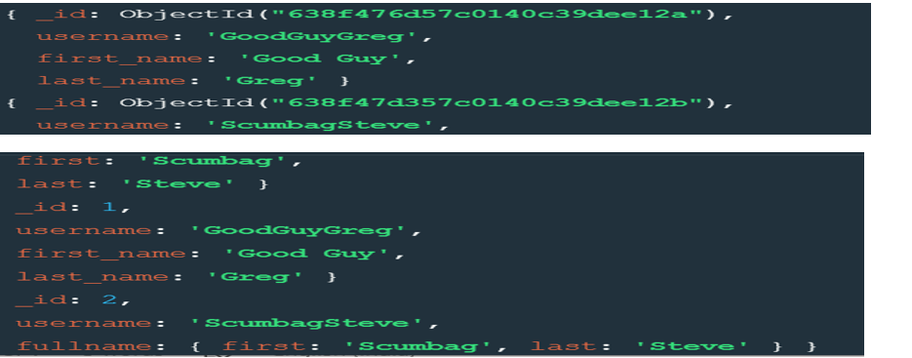

2.find all the posts

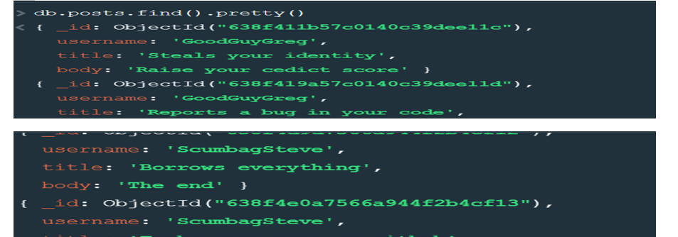

3.find all the posts that was author by “GoodGuyGreg”

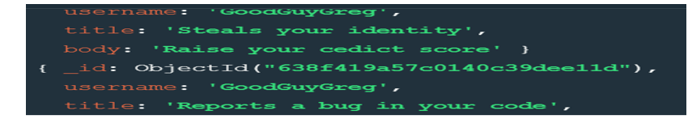

4.find all the posts that was author by “ScumbagSteve”

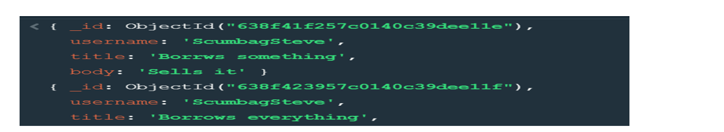

5.find all the comments

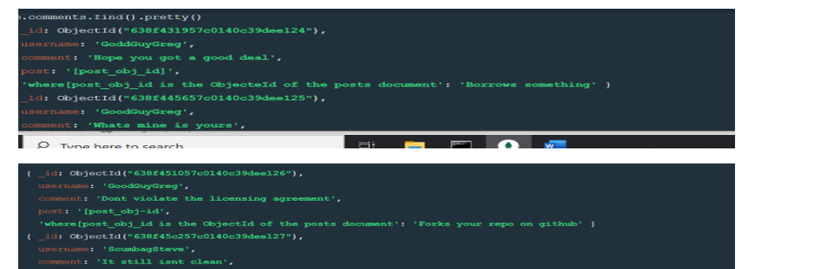

6.find all the comments that was author by “GoodGuyGreg”

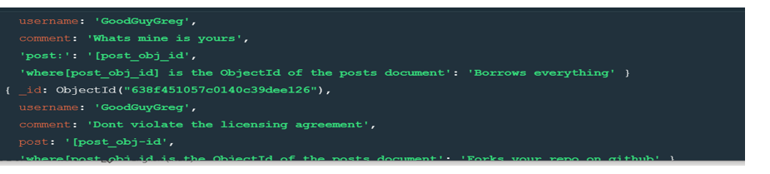

7.find all the comments that was author by “ScumbagSteve”

